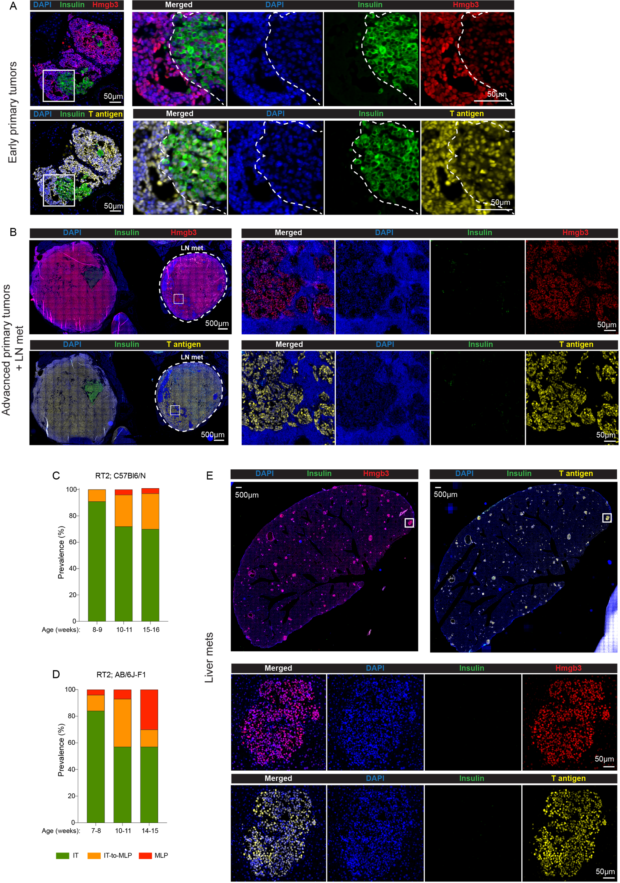

Supplementary Fig. S4
A. Representative images of Insulin, Hmgb3, and T-antigen immunostaining, alongside DAPI, of early pancreatic tumors in the RT2;AB/6J F1 mouse model of PanNET. The left panels for the top and bottom rows show immunostaining for DAPI/Insulin/Hmgb3, and DAPI/Insulin/T-antigen, respectively. The right panels are the magnified image of the area marked by a square.
B. Representative images of Insulin, Hmgb3, and T-antigen immunostaining, alongside DAPI, of late pancreatic tumor and lymph node (LN) metastasis in the RT2;AB/6J F1 mouse model of PanNETs. The left panels for the top and bottom rows show immunostaining for DAPI/Insulin/Hmgb3, and DAPI/Insulin/T-antigen, respectively. The right panels are the magnified image of the area marked by a square.
C, D. Abundance of the IT, IT-to-MLP transitional, and the MLP subtypes in different stages of PanNETs progression from RT2;C57Bl6/N (C) and RT2;AB/6J-F1 (D) mouse models.
E. Representative images of Insulin, Hmgb3, and T-antigen immunostaining, alongside DAPI, of liver metastases in the RT2;AB/6J F1 mouse model of PanNET. The left and right panels of the top row show immunostaining for DAPI/Insulin/Hmgb3, and DAPI/Insulin/T-antigen, respectively. The bottom panels are the magnified image of the area marked by a square.

