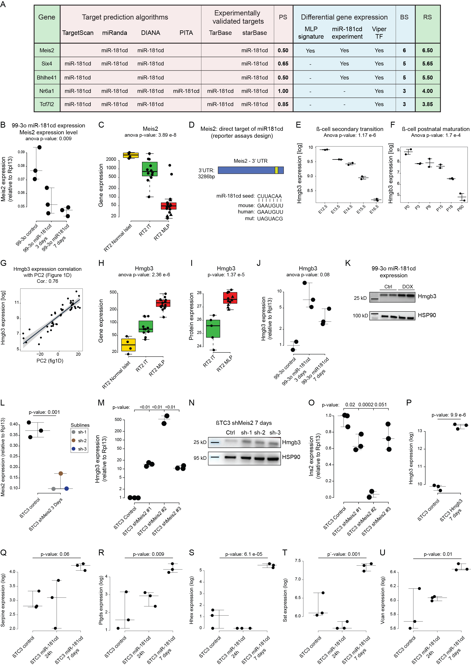
Supplementary Fig. S3
A. Top five ranked miR-181cd cluster gene targets as predicted by Bio-miRTa. The columns labeled “target prediction algorithms” and “experimentally validated targets” show the presence of an MRE for miR-181cd in the candidate target gene. The columns with the header “Functional analyses” indicate whether the candidate target genes were significantly differentially expressed in MLP versus IT RT2 tumor samples and downregulated upon miR-181cd overexpression in βTC3 cells, as well as whether they were predicted to be regulators according to the VIPER analysis (See Table S3 and Methods).
B. mRNA expression levels of Meis2 in 99-3o cells upon DOX-induced overexpression of miR-181cd.

C. mRNA expression of Meis2 in IT and MLP bulk tumor samples from the RT2 mouse model. Gene expression in normal islets from wild type mice is also shown as a metric for mRNA levels.
D. The MRE for miR-181cd in the 3′ UTR of Meis2 gene. The miRNA seed, and the MREs for mouse, human, and the mutated MREs used for the reporter assays, are shown.
E-F. mRNA expression of Hmgb3 during the secondary-transition phase of pancreatic development (E) and β-cell postnatal maturation (F).
G. Hmgb3 gene expression correlation with dedifferentiation trajectory (see PC2 in Fig. 1I).
H-I. mRNA (G; RNA-seq) and protein (H; quantified with MS) expression levels of Hmgb3 in IT and MLP tumor samples from the RT2 mouse model collected with LCM. Gene expression in normal islets from wild type mice is also shown for mRNA levels.
J. Hmgb3 mRNA expression in 99-3o cells upon DOX-induced miR-181cd overexpression.
K. Hmgb3 protein expression in 99-3o cells after two weeks of DOX-induced miR-181cd overexpression.
L. mRNA expression levels of Meis2 in βTC3 cells upon DOX-induced knock-down of Meis2 with three different miR-E-based shRNAs.
M-N. mRNA (M) and protein (N) levels of Hmgb3 expression in βTC3 cells after 7 days of DOX-induced knock-down of Meis2 with three different miR-E-based shRNAs.
O. Ins2 mRNA expression levels in βTC3 cells upon DOX-induced knock-down of Meis2 with three different miR-E-based shRNAs.
P. Hmgb3 mRNA expression levels of in βTC3 cells upon DOX-induced Hmgb3 overexpression.
Q-U. Illustrative mRNA expression levels of the MLP upregulated genes Serpine (Q), Ptgds (R), Hhex (S), Sst (T), and Vcan (U) in βTC3 cells upon DOX-induced Hmgb3 overexpression of miR-181cd.

