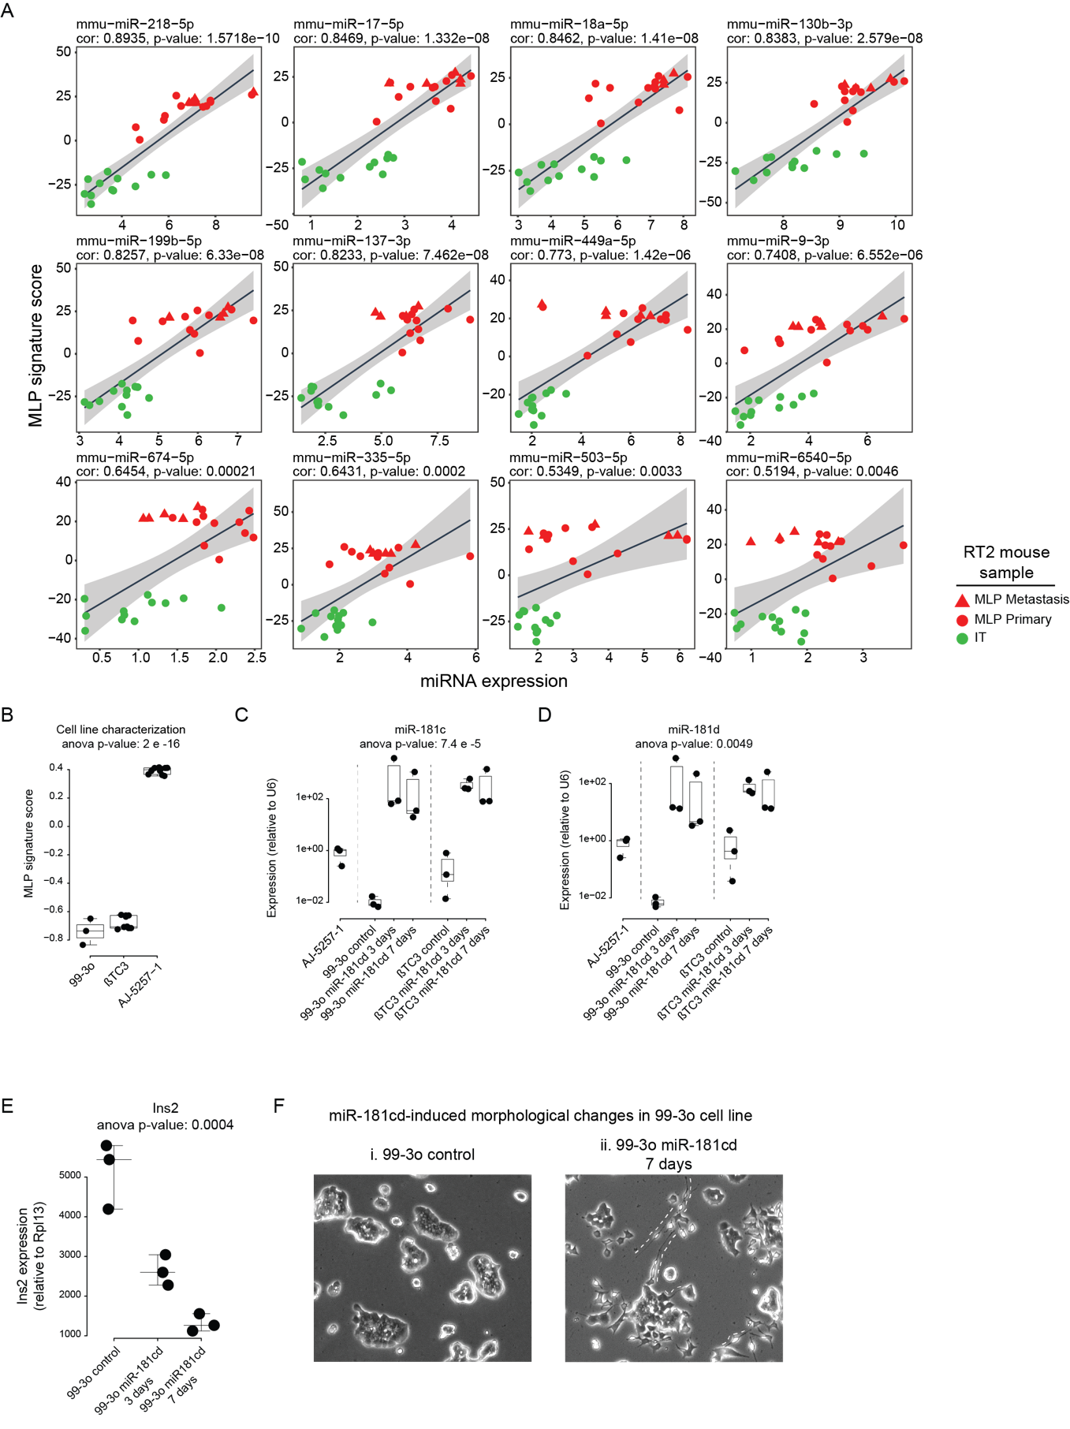

Supplementary Fig. S2
A. Scatter plots showing the correlation between expression of additional MLP-associated miRNAs (x-axis) and the MLP mRNA signature score (y-axis) in RT2 tumor samples.
B. MLP mRNA-signature score in the 99-3o and ßTC3 IT-like cell lines, and in the AJ-5257-1 MLP-like cell line.
C, D. Expression levels of miR-181c (C) and miR-181d (D) in 99-3o and βTC3 miR-181cd overexpressing cells, and the endogenous levels in AJ-5257-1 cells.
E. Insulin mRNA expression upon DOX-induced over-expression of miR-181cd in 99-3o cells.
F. Brightfield images of cancer cells: i. 99-3o control cells; ii. 99-3o cells 7 days post miR-181cd DOX-induced expression. The dashed lines illustrate miR-181cd-induced neuronal-like structures.

