Supplementary Data
Supplementary Figures and Tables.
Fig. S1.
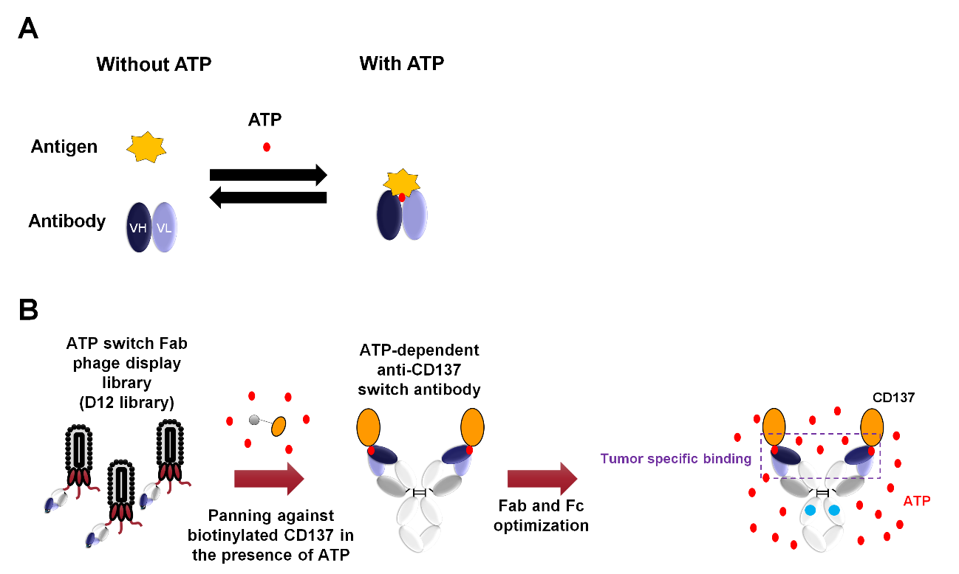
Generation of an ATP-dependent anti-CD137 switch antibody. (A) Concept of ATP-dependent switch antibody is described. (B) The lead switch antibody was selected from exATP switch Fab phage display library (D12 library) by panning using biotinylated antigen with ATP. After optimization, STA551, a novel ATP-dependent anti-CD137 agonist antibody was generated.

Fig. S2.
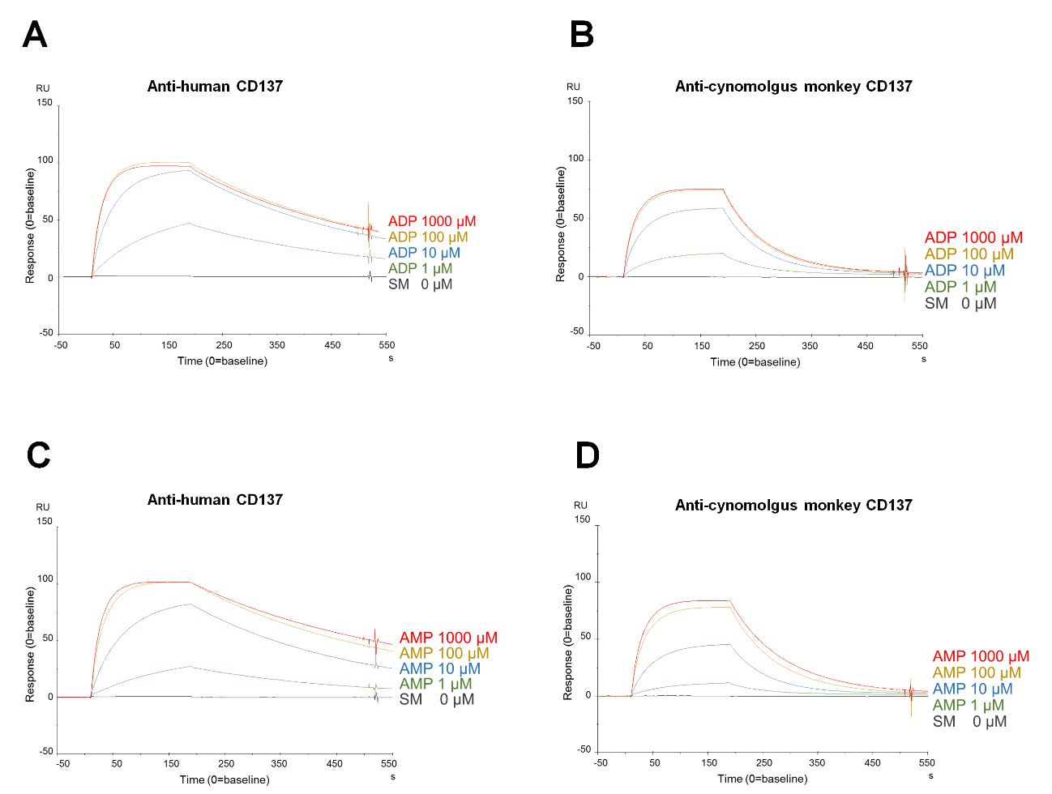
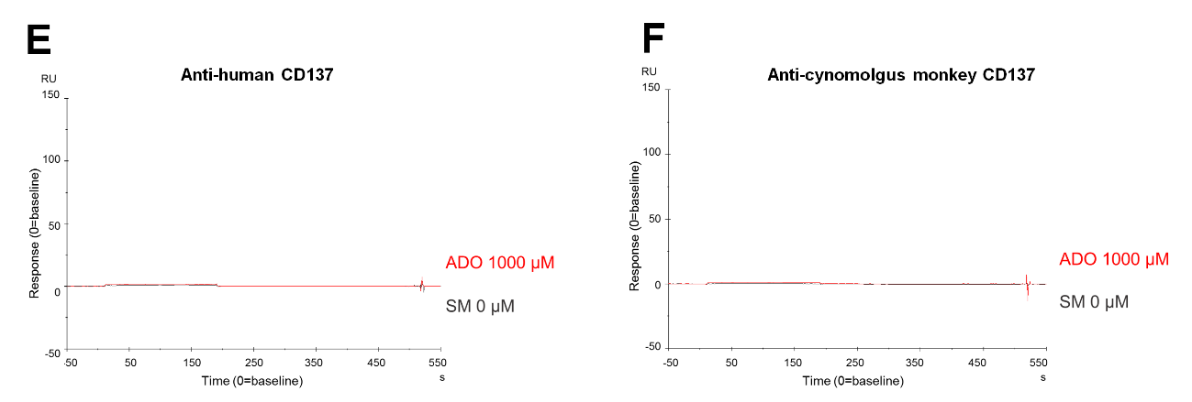Binding activity of STA551 to CD137. (A) Biacore sensorgram showing binding of STA551 to human CD137 and (B) cynomolgus monkey CD137 in the presence of ADP. (C) Binding to human CD137 and (D) cynomolgus monkey CD137 in the presence of AMP. (E) Binding to human CD137 and (F) cynomolgus monkey CD137 in the presence of ADO. Small molecules were at 1000 μmol/L (shown in red), 100 μmol/L (yellow), 10 μmol/L (blue), 1 μmol/L (green), 0 μmol/L (black). ATP: adenosine triphosphate, ADP: adenosine diphosphate, AMP: adenosine monophosphate, ADO: adenosine.

Fig. S3.
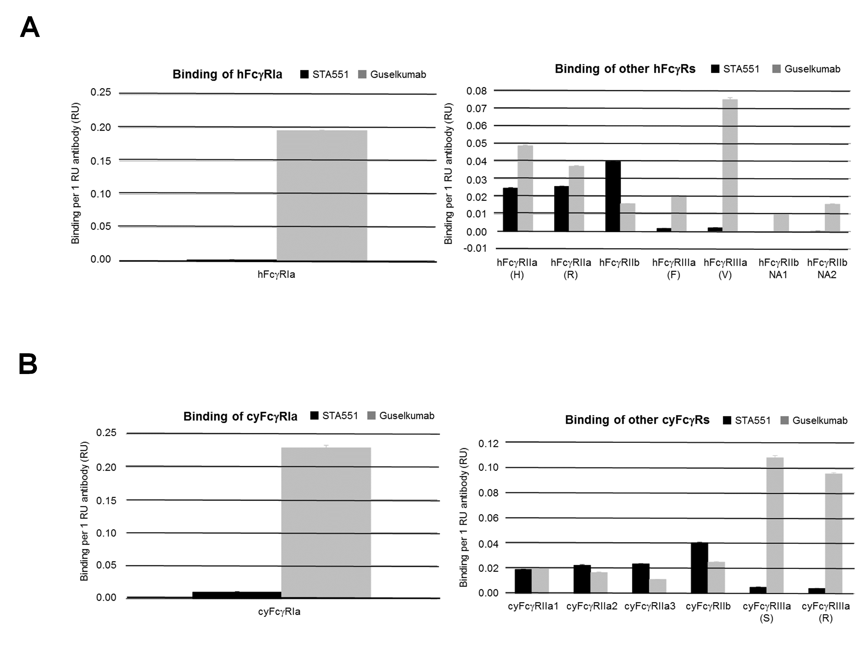
Binding activity of STA551 to Fcγ receptors. (A) Binding of STA551 to human FcγRs and (B) cynomolgus monkey FcγRs. The black bars indicate binding activity of STA551. The gray bars indicate the binding of guselkumab as an isotype control antibody. ATP: adenosine triphosphate, FcγR: Fc gamma receptor.

Fig. S4.
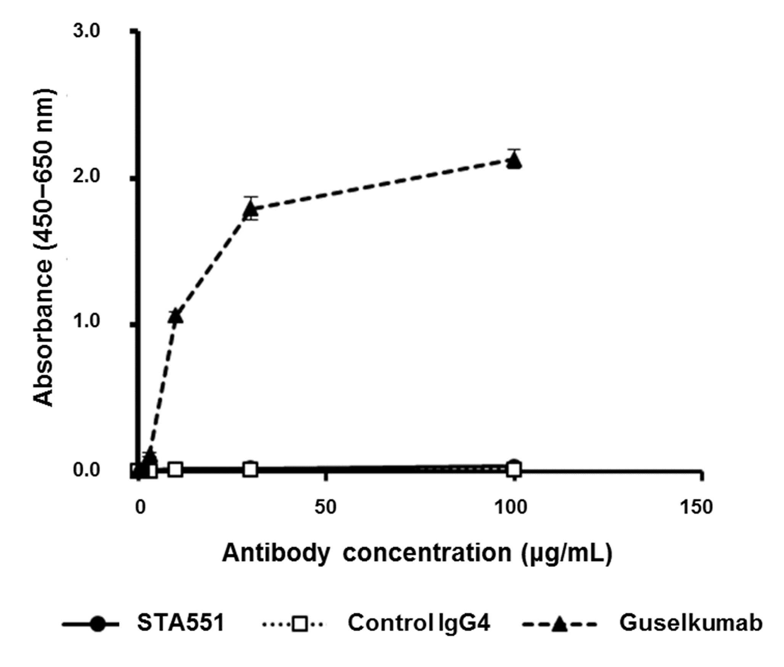Binding activity of STA551 to C1q. C1q binding to STA551, recombinant human IgG4 (control IgG4), or guselkumab (control IgG1) was measured by ELISA. Microplates coated with various concentrations of these antibodies were incubated with C1q protein. Antibody binding to C1q was revealed with HRP anti-C1q antibody. The symbol (●) indicates STA551, (□) control IgG4, and (▲) guselkumab. Each point represents mean ± SD (n=4). The bars depicting SD are shorter than the height of the symbols.

Fig. S5.
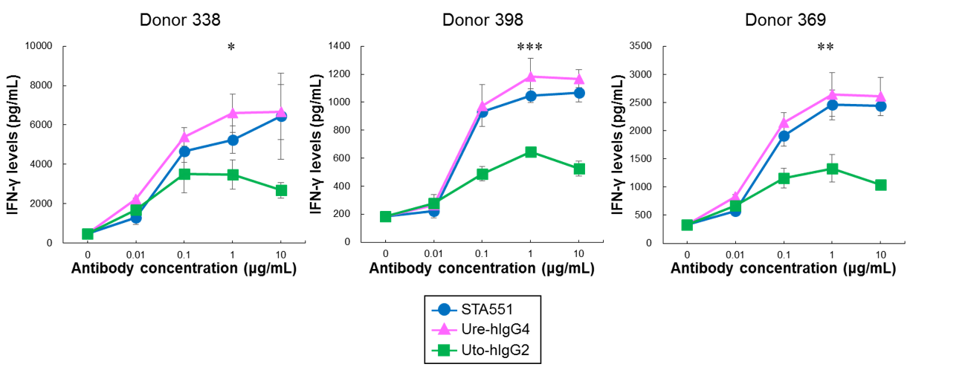
Comparison of STA551-, Ure-hIgG4- and Uto-hIgG2-co-stimulated IFN-γ releases from human CD8⁺ T cells. Human CD8⁺ T cells from three different donors were co-cultured with each antibody, human FcγRIIa-expressing CHO cells, and human FcγRIIb-expressing CHO cells in the presence of 100 μmol/L ATP. The IFN-γ concentrations in the medium were measured by ELISA. The blue circle indicates STA551, the pink triangle Ure-hIgG4, the green square Uto-hIgG2. Each point represents mean ± SD (n=3). *, **, ***: Statistical differences in IFN-γ levels between STA551 and Uto-hIgG2 at 1 μg/mL (*P < 0.05, **P < 0.01, ***P < 0.001 by t-test). IFN-γ: Interferon gamma, FcγR: Fc gamma receptor.

Fig. S6.
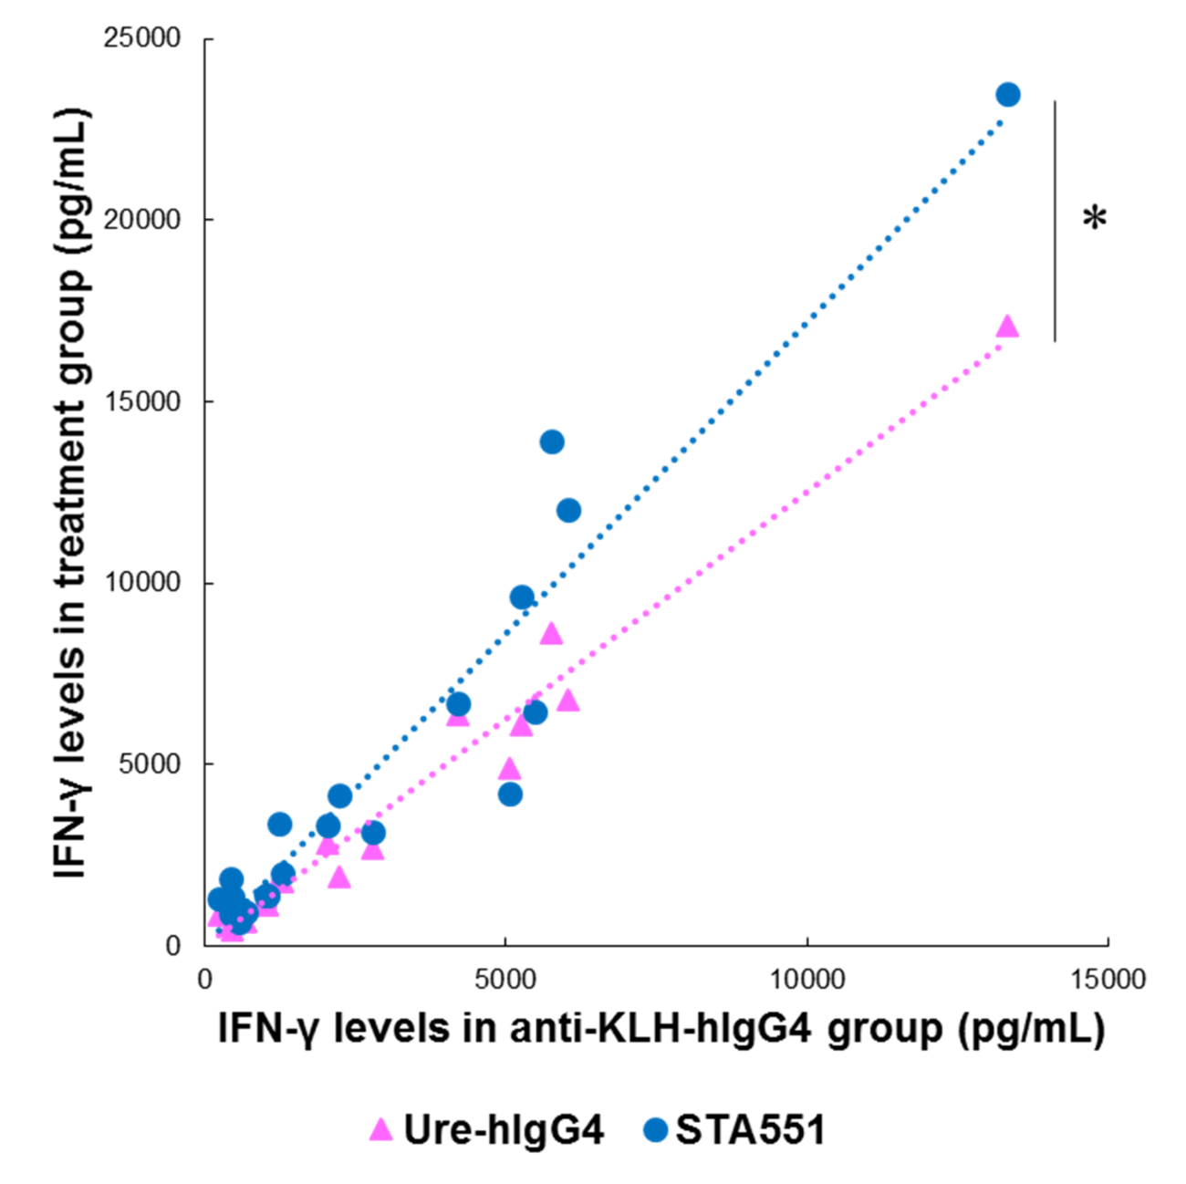
ANCOVA statistical analysis of IFN-γ release induced by STA551 or Ure-hIgG4. Human PBMCs from the fresh blood of 20 healthy donors were incubated with STA551 or Ure-hIgG4 in the presence of 250 μmol/L ATP. The IFN-γ concentrations in the medium were measured by ELISA. The blue circles indicate STA551, and the pink triangles Ure-hIgG4. X-axis shows IFN-γ release in anti-KLH-hIgG4 treatment group. X-axis values in blue and pink are from the same donors. Y-axis shows IFN-γ release in STA551 (blue) or Ure-hIgG4 (pink) treatment group. Anti-KLH-hIgG4, which does not bind to human CD137, was used as a negative control. Dotted line shows linear approximation of these groups. *: Statistical differences of IFN-γ levels between STA551 and Ure-hIgG4 (*P < 0.001 by ANCOVA). IFN-γ: Interferon gamma, PBMCs: peripheral blood mononuclear cells, ATP: adenosine triphosphate, ELISA: enzyme-linked immunosorbent assay.

Fig. S7.
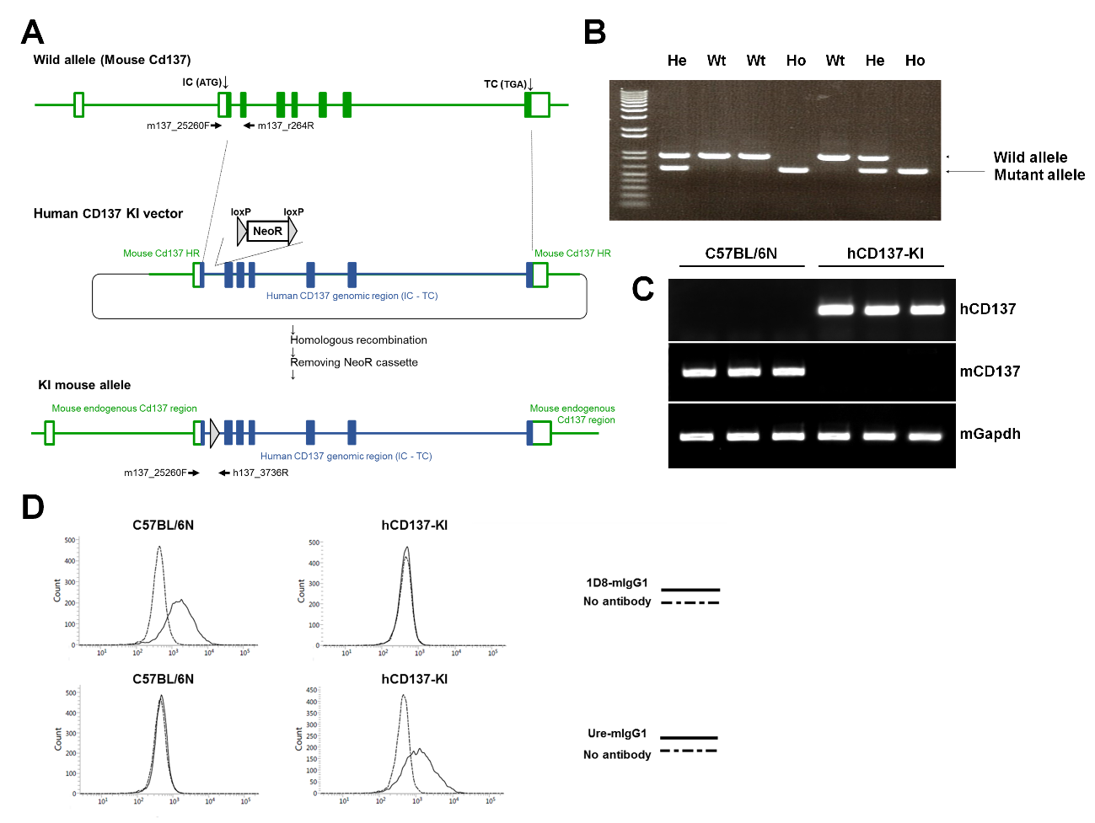
Establishment of human CD137 knock-in mice. (A) A vector construction and recombination strategy are shown. A human CD137 knock-in vector contains human CD137 genomic DNA encompassing the initial codon (ATG) to terminal codon (TGA) with NeoR cassette inserted into the 2nd intron, flanked by mouse homology arms. Arrows, PCR primers for genotyping. IC: initial codon, TC: terminal codon, HR: homology region, NeoR: neomycin resistance (B) Result of genotyping to confirm replacement of endogenous Cd137 with the human CD137 genomic DNA. Wild allele-specific product was detected as a signal of about 950 bp, whereas human CD137 knock-in allele-specific product was detected as a signal of about 600 bp. Wt: wild, He: hetero, Ho: homo (C) Result of RT-PCR analysis for mouse Cd137 or human CD137 expression in the stimulated spleen cells. Human CD137 and mouse Cd137 gene-specific products were detected as a signal of 500 bp and 493 bp, respectively. Human CD137 knock-in mice expressed only human CD137, whereas endogenous mouse Cd137 was not detected. (D) Each antibody (1D8-mIgG1 and Ure-mIgG1)-binding profile on CD3ε⁺ CD8⁺ CD4⁻ CD19⁻ T cells was analyzed by flow cytometry. The dotted line indicates staining with control (no antibody), and the solid line staining with each antibody. Staining by flow cytometry was examined for CD3/CD28 dynabeads-stimulated mouse spleen cells derived from human CD137 knock-in mice and wild type C57BL/6N mice.

Fig. S8.
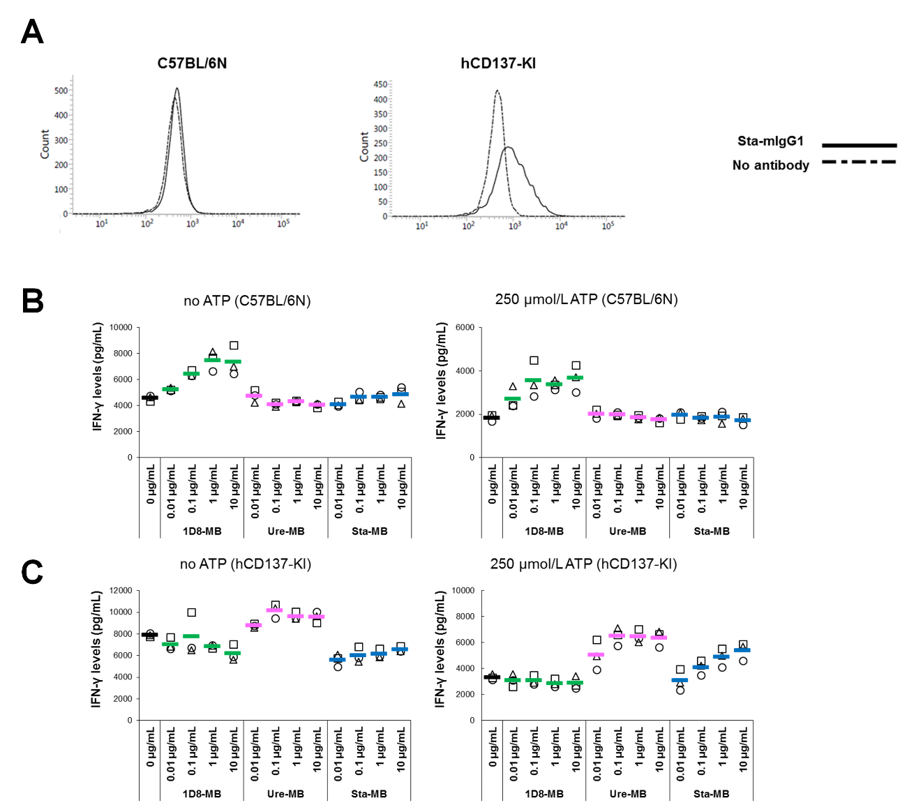
Confirmation of human CD137 function in knock-in mice. (A) Sta-mIgG1-binding profiles on CD3ε⁺ CD8⁺ CD4⁻ CD19⁻ T cells were analyzed by flow cytometry. The dotted line indicates staining with control (no antibody), and the solid line staining with each antibody. Staining by flow cytometry was examined for CD3/CD28 dynabeads-stimulated mouse spleen cells derived from human CD137 knock-in mice and wild type C57BL/6N mice. (B) IFN-γ cytokine concentration from spleen cells derived from wild type C57BL/6N mice and (C) human CD137 knock-in mice induced by each antibody (Sta-MB (blue), 1D8-MB (green) and Ure-MB (pink)) in the absence or presence of 250 μmol/L ATP were measured by AlphaLISA Mouse IFN-γ immunoassay. Each point represents individual replication (n=3). IFN-γ: Interferon gamma, ATP: adenosine triphosphate.

Fig. S9.
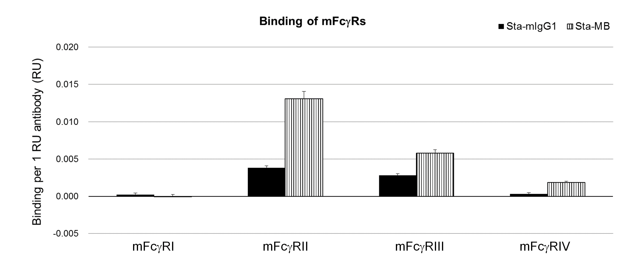
Binding activity of Sta-MB to mouse Fcγ receptors. Antibodies were captured onto the Biacore SA sensor surface immobilized with CaptureSelectTM Human Fab-lambda Kinetics Biotin Conjugate. Mouse Fcγ receptors were injected over sensor surface immobilized antibodies, then the binding amount of each Fcγ receptor was normalized by the amount of immobilized antibody.

Fig. S10.
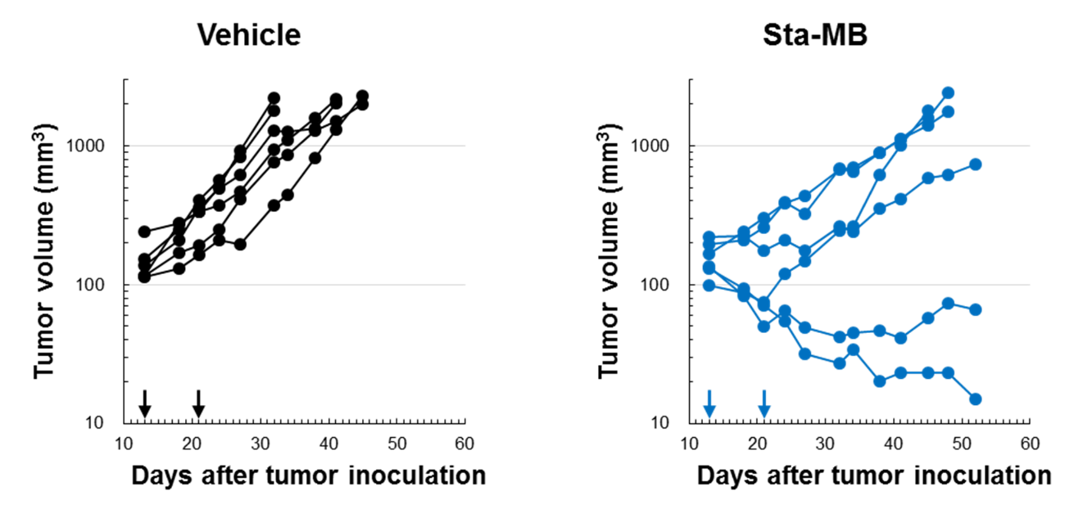
Long-term anti-tumor efficacy of Sta-MB in Colon38. Human CD137 knock-in mice bearing Colon38 were administered vehicle (black) or 2.5 mg/kg of Sta-MB (blue) on day 13 and 21 (n=6).

Fig. S11.
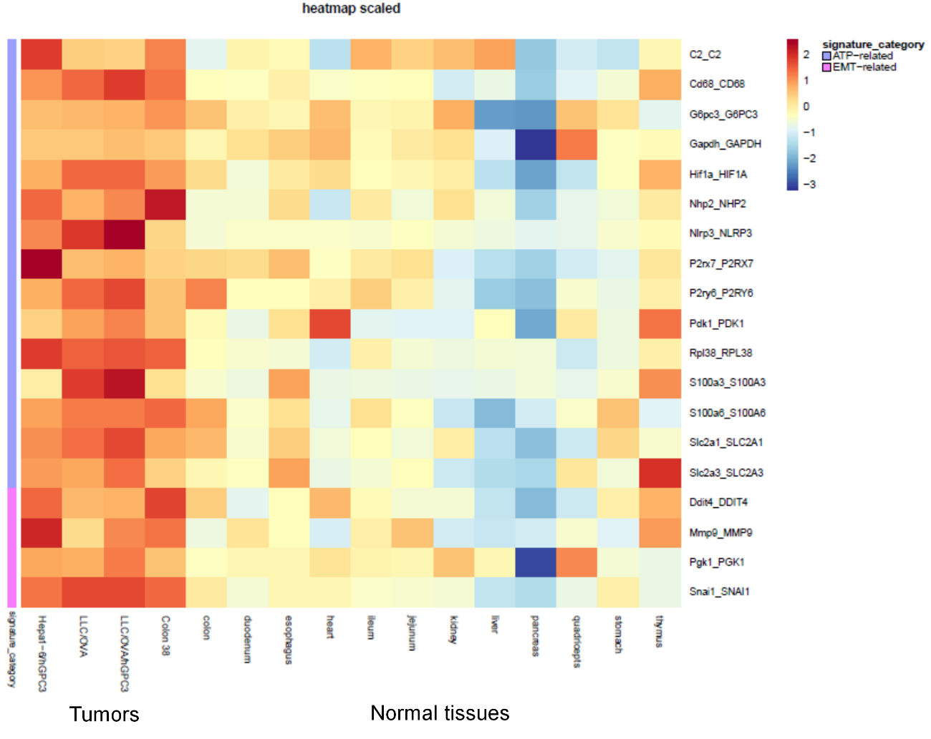
Expression of exATP related genes in tumors and normal tissues. Hepa1-6/hGPC3, LLC1/OVA, LLC1/OVA/hGPC3, and Colon38 tumors and normal tissues were used for RNA sequencing. Each group was tested in triplicate (n=3) except normal heart tissue (n=2). Among ATP-related genes, those statistically significantly up-regulated in tumor compared to normal tissues are shown. Z scores were calculated using log₂-transformed fragments per kilobase per million mapped reads (FPKM) normalized for all samples.

Fig. S12.
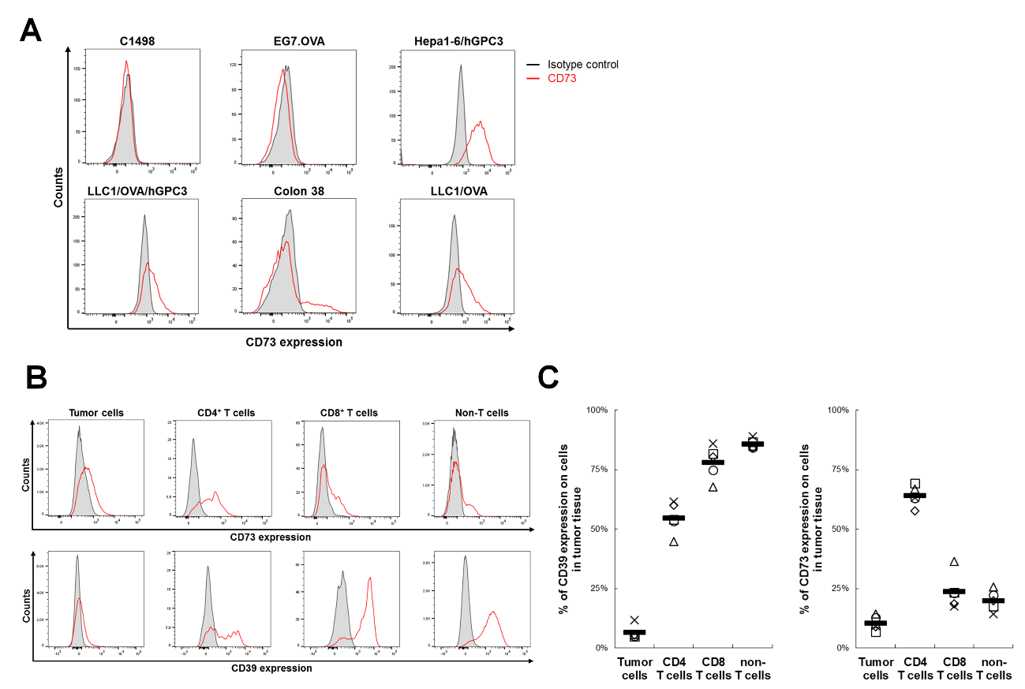
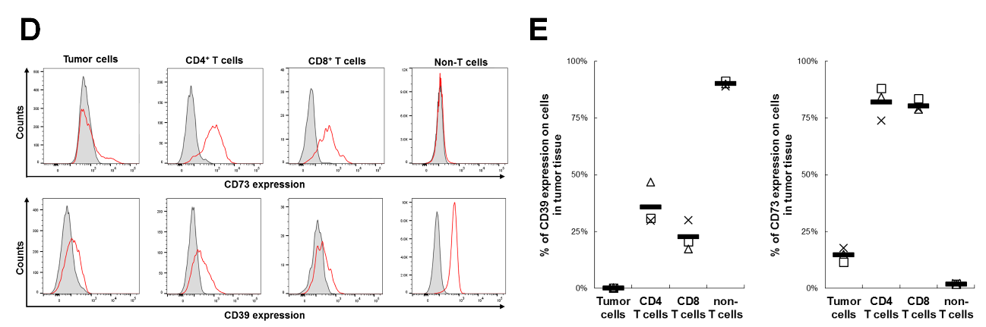Expression of CD39 and CD73 on tumor cells and tumor-infiltrating lymphocytes. (A) C1498, EG7.OVA, Hepa1-6/hGPC3, LLC1/OVA/hGPC3, Colon38, and LLC1/OVA cells were analyzed by flow cytometry. Histograms for the expression of CD73 on the tumor cells are shown. (B) CD39 and CD73 expression on human GPC3⁺ tumor cells and tumor-infiltrating lymphocytes (TILs) in LLC1/OVA/hGPC3-bearing human CD137 knock-in mice was analyzed by flow cytometry. Representative histogram for CD39 and CD73 expression on the cells is shown. (C) Ratio of CD39 or CD73 expression on LLC1/OVA/hGPC3 tumor cells and TILs calculated as the mean and individual values in each group are shown (n=5). (D) Representative histogram for CD39 and CD73 on CD45⁻ cells (mainly tumor cells) and TILs in Colon38-bearing human CD137 knock-in mice. (E) Ratio of CD39 or CD73 on Colon38 tumor cells and TILs are shown (n=3).

Fig. S13.
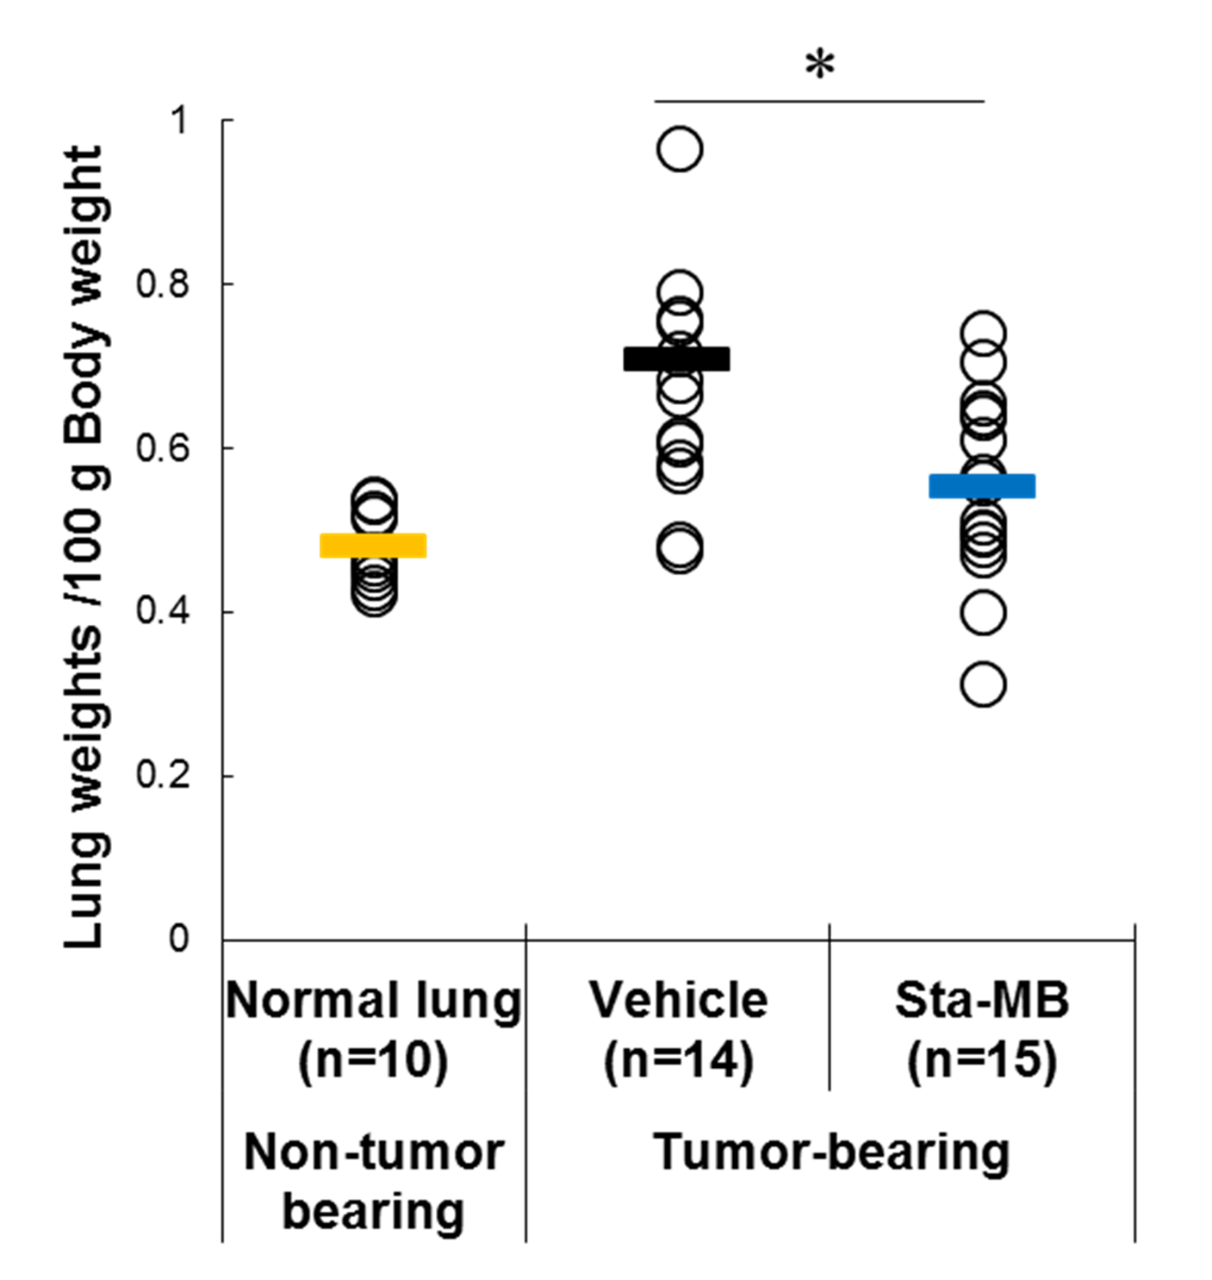
Anti-tumor efficacy of Sta-MB in human CD137 knock-in mice with LLC1/OVA lung metastasis. Human CD137 knock-in mice were inoculated intravenously with LLC1/OVA, and administered vehicle (black) and Sta-MB (blue) on day 7 and 14 after tumor inoculation. On day 18 after tumor inoculation, the weights of metastatic nodules in the lung and normal lung (yellow) from non-tumor bearing human CD137 knock-in mice were measured. The mean and individual values in each group are shown (n=10, 14, or 15). One mouse in vehicle group died on day 11. *: Statistical differences in lung weights between vehicle and Sta-MB (*P < 0.05 by t-test). Parametric t-test was selected by Bartlett's test for assessing the weight of metastatic nodules of each treatment.

Fig. S14.
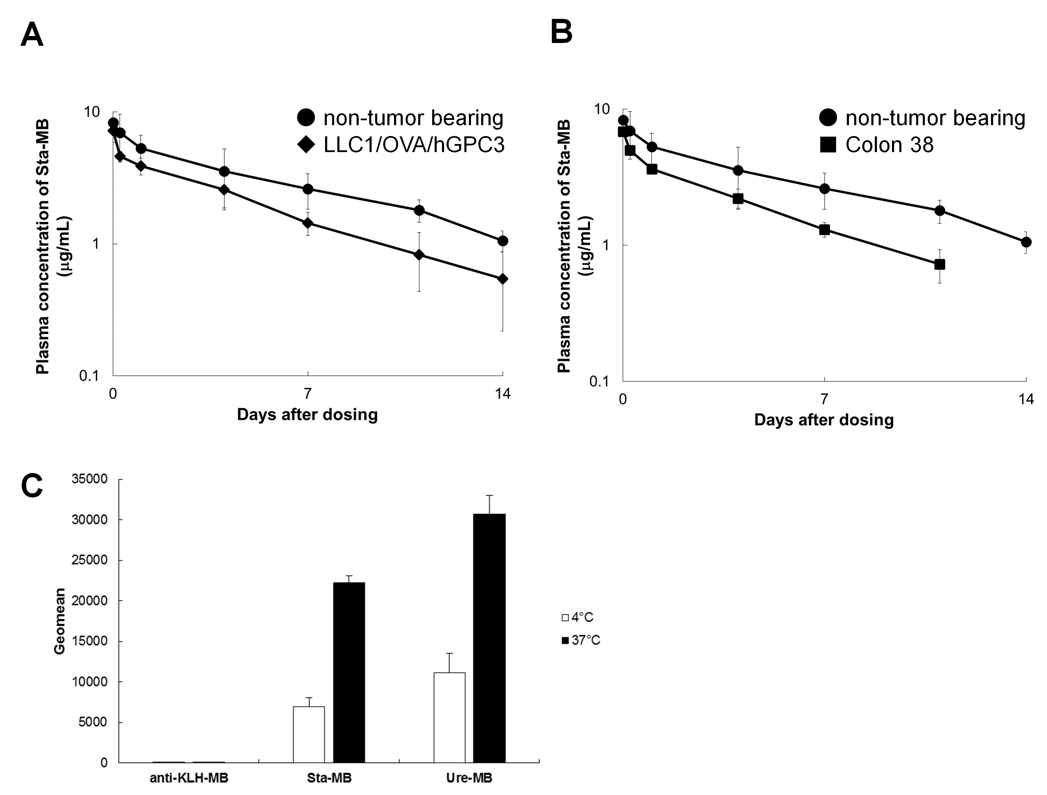
Pharmacokinetics of Sta-MB in human CD137 knock-in mice bearing tumors and internalization of Sta-MB. (A) Human CD137 knock-in mice (●) or human CD137 knock-in mice bearing LLC1/OVA/hGPC3 (◆) or (B) Colon38 (■) were administered Sta-MB at 0.3 mg/kg. Antibody concentration in plasma was determined. (C) Human CD137-expressing CHO cells were incubated with AF647-labeled anti-KLH-MB, Sta-MB, or Ure-MB at 4°C or 37°C. AF647 was analyzed by flow cytometry. Geometric mean fluorescence intensity of AF647 was calculated. Data represents the mean ± SD (n=3).
Fig. S15.
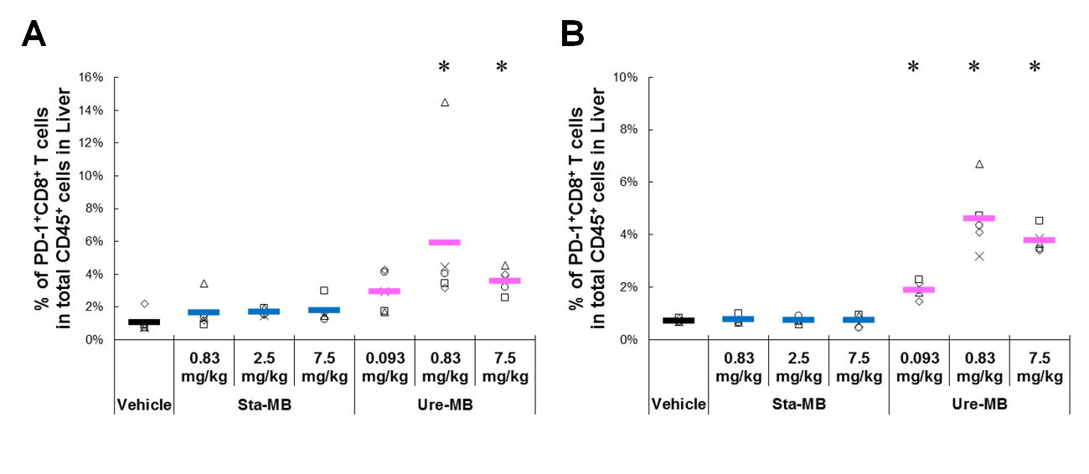
Systemic responses to Sta-MB or Ure-MB in human CD137 knock-in mice in liver. (A) Human CD137 knock-in mice bearing LLC1/OVA/hGPC3 and (B) Colon38 were administered vehicle, Sta-MB (blue) or Ure-MB (pink). Ratio of PD-1⁺ CD8⁺ T cells to whole CD45⁺ cells was measured by flow cytometry. The mean and individual values in each group are shown (n=5). *: Statistical analysis of CD8⁺ T cell activation between vehicle and Ure-MB (*P < 0.05 by Steel’s test).

Fig. S16.
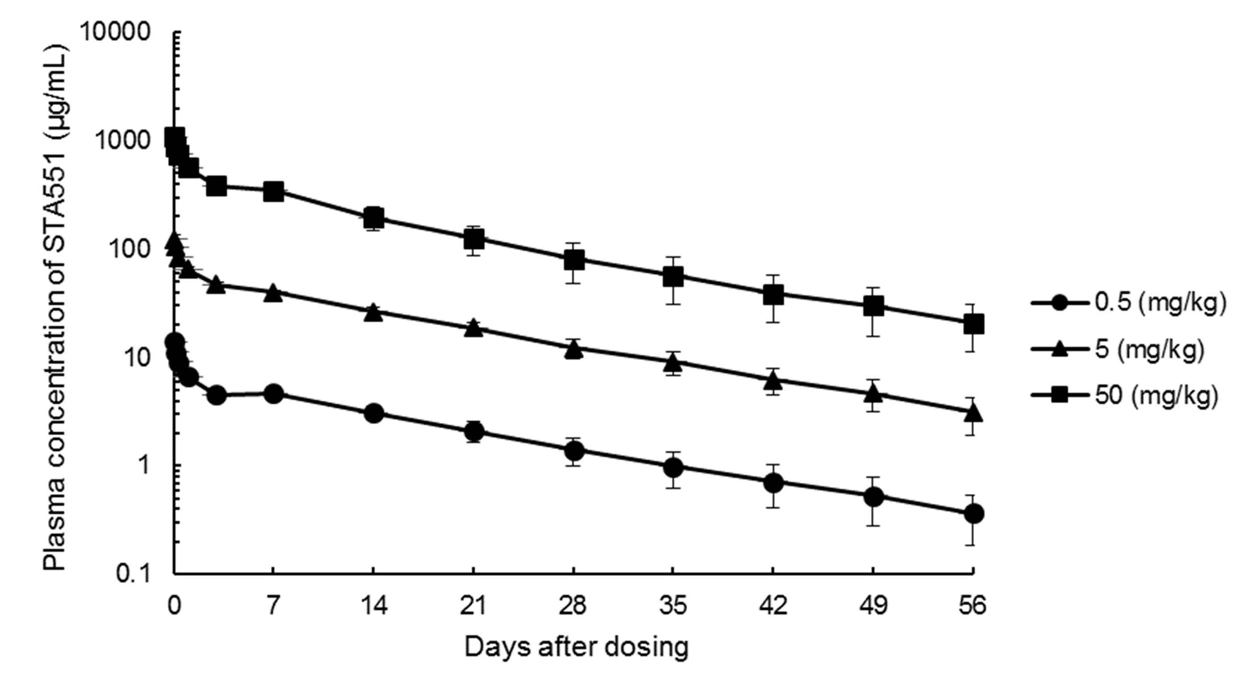
Pharmacokinetics of STA551 in cynomolgus monkeys. Plasma concentration-time profiles of STA551 after a single intravenous dose of 0.5, 5, and 50 mg/kg in male cynomolgus monkeys. Data represents the mean ± SD (n=4).

Fig. S17.
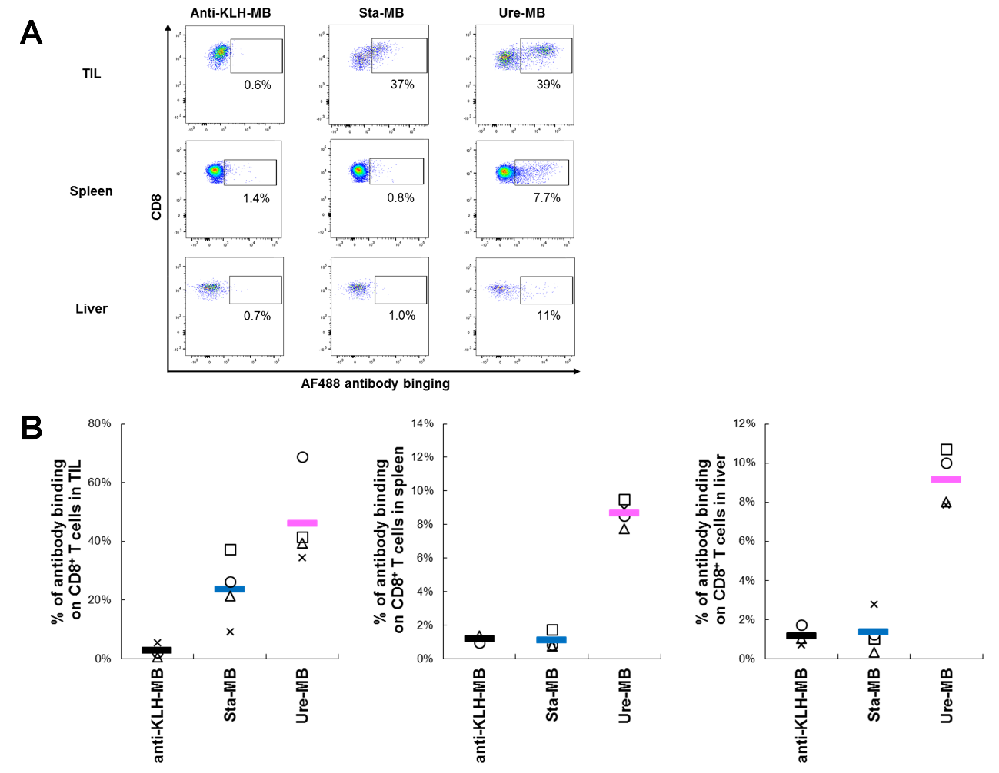
Antibody distribution to tumor, spleen, and liver. Human CD137 knock-in mice bearing Colon38 were administered Alexa Fluor 488 (AF488)-labeled anti-KLH-MB (black), Sta-MB (blue) or Ure-MB (pink). The frequency of AF488-labeled antibody-binding CD8⁺ T cells in tumor, spleen, and liver was calculated by flow cytometry. (A) Representative dot plots and (B) the mean and individual values (n=3 or 4) in each group are shown.

Fig. S18.
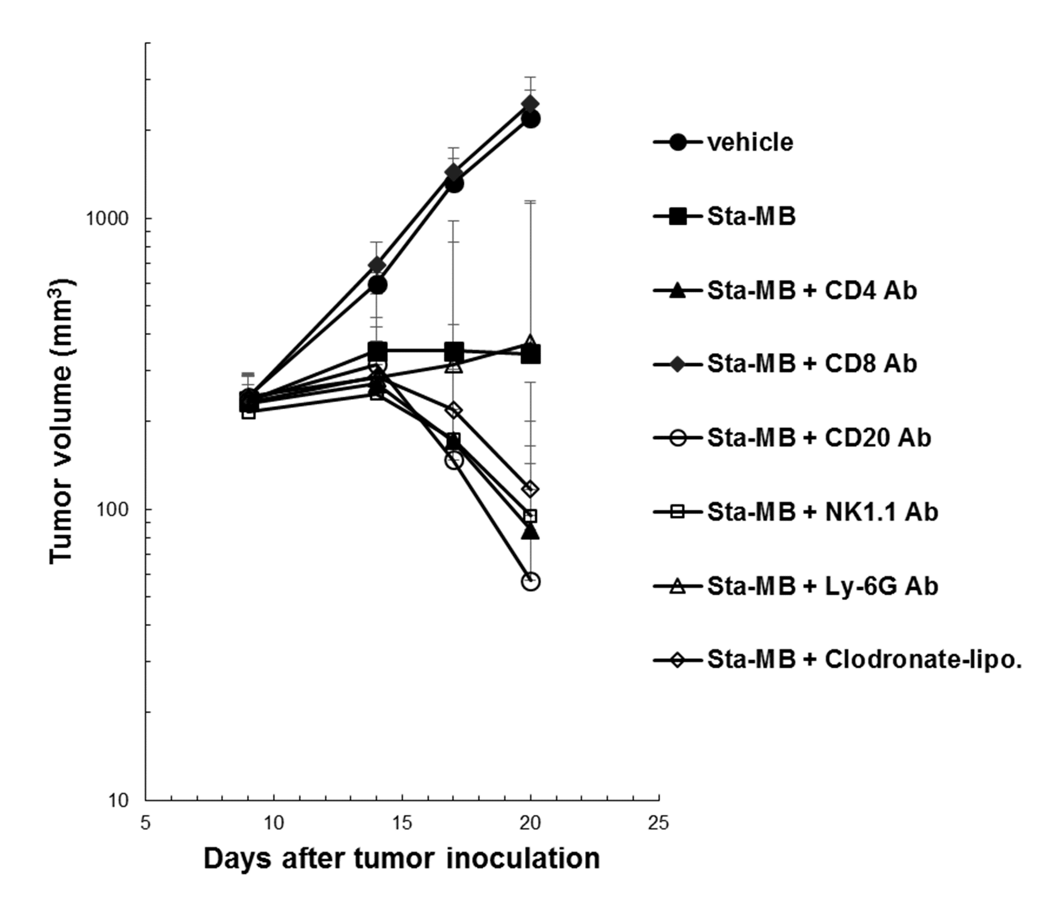
Impact of immune cell subsets depletion on anti-tumor efficacy. Immune cell subsets were depleted by intravenous administration of cell depleting antibody. Tumor volumes are calculated over time. The symbol (●) indicates vehicle, (■) Sta-MB, (▲) Sta-MB with anti-CD4 antibody, (◆) Sta-MB with anti-CD8 antibody, (○) Sta-MB with anti-CD20 antibody, (□) Sta-MB with anti-NK1.1 antibody, (△) Sta-MB with anti-Ly-6G antibody, and (◇) Sta-MB with clodronate liposome. Each point represents mean + SD (n=7 or 8).
Fig. S19.
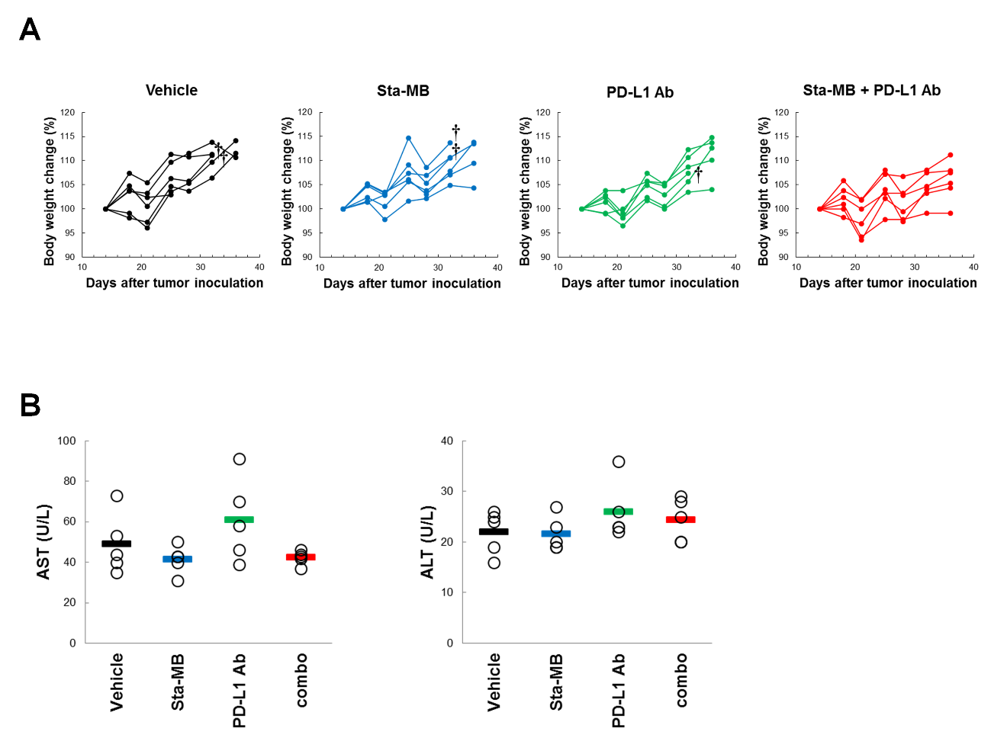
Systemic response to Sta-MB, anti-PD-L1, and their combination. (A) The Colon38 cells were inoculated subcutaneously into human CD137 knock-in mice. After palpable tumors were established, mice were randomized based on tumor volume and body weight. Subsequently, 2.5 mg/kg Sta-MB was intravenously and 10 mg/kg anti-PD-L1 Ab was intraperitoneally administered twice per week and body weight was measured twice per week. Body weight change was calculated. Each line indicates body weight changes in individual animals over the course of the study (n=6). †: Euthanasia due to the self-destruction of the tumor. (B) Four days after initiating administration of PD-L1 combination in Colon38 tumor models, blood was collected and serum levels of AST and ALT were measured. The mean and individual values in each group are shown (n=5). Ab: antibody, AST: aspartate transaminase, ALT: alanine transaminase.

Fig. S20.
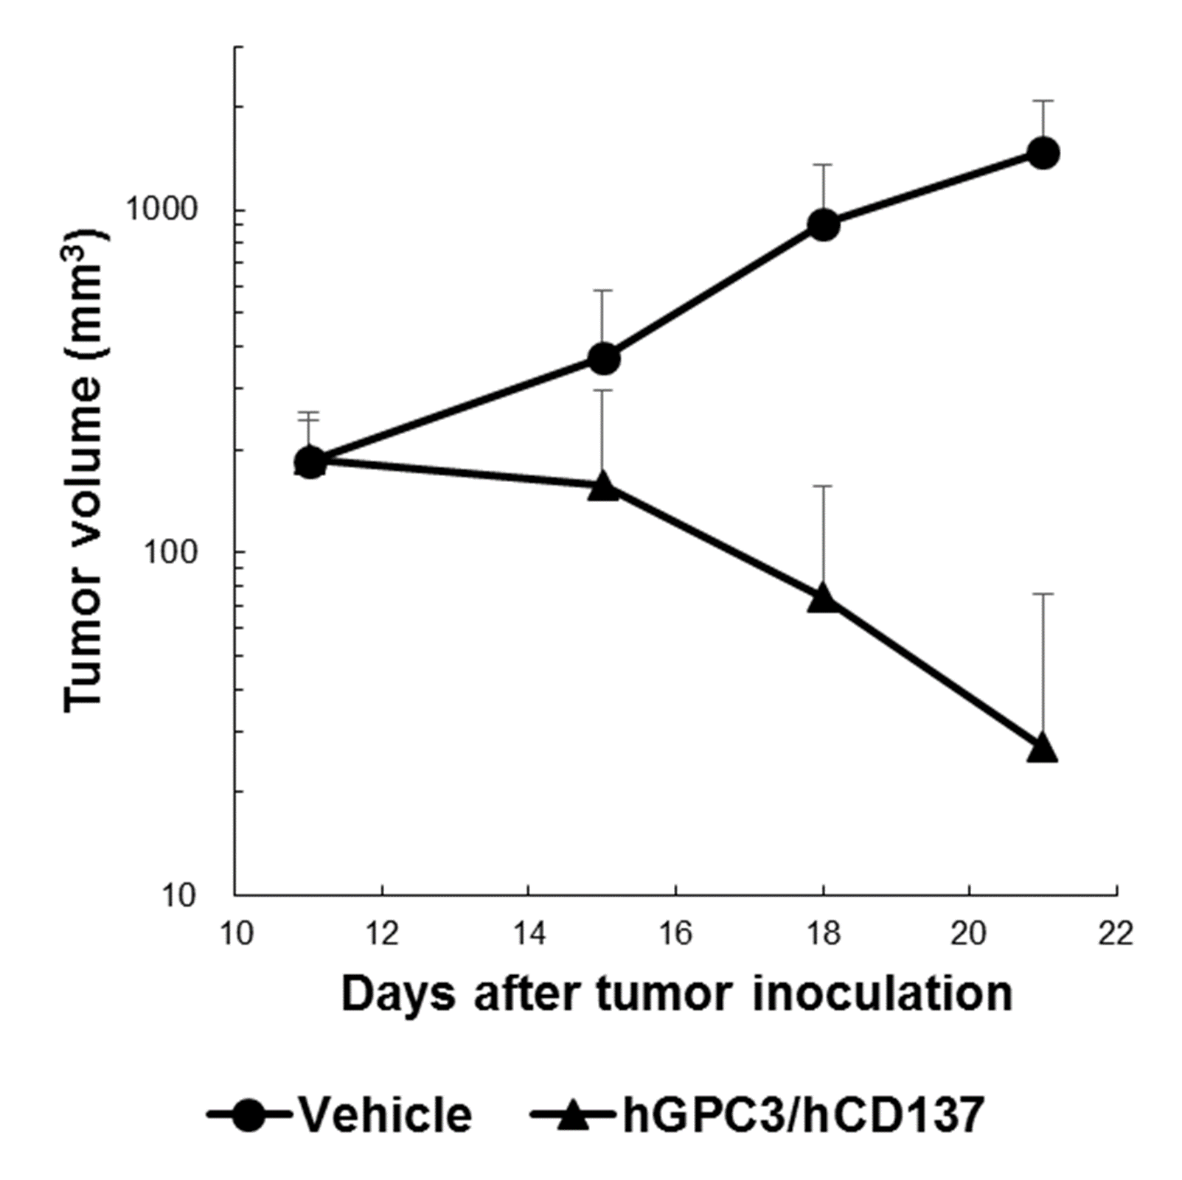
Anti-tumor efficacy of GPC3 targeting CD137 bispecific antibody. LLC1/OVA/hGPC3 cells were inoculated subcutaneously into human CD137 knock-in mice. After the tumors were established, mice were randomized based on tumor volume and body weight. Subsequently, 5 mg/kg anti-hGPC3/hCD137 bispecific antibody was intravenously administered twice per week. The symbol (●) indicates vehicle and (▲) anti-hGPC3/hCD137 bispecific antibody. Each point represents mean + SD (n=10). Human CD137 KI: human CD137 knock-in, hGPC3/hCD137: human GPC3/human CD137 bispecific antibody.

Fig. S21.
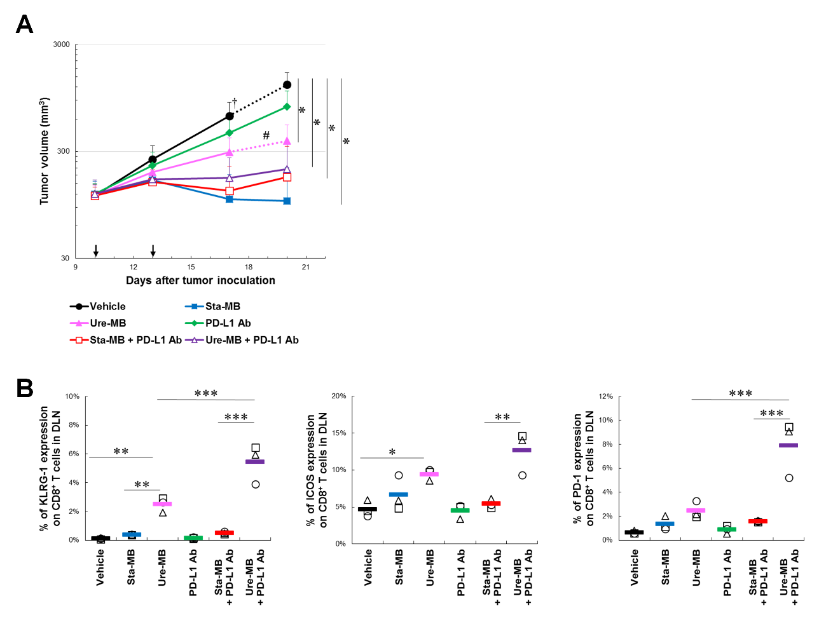
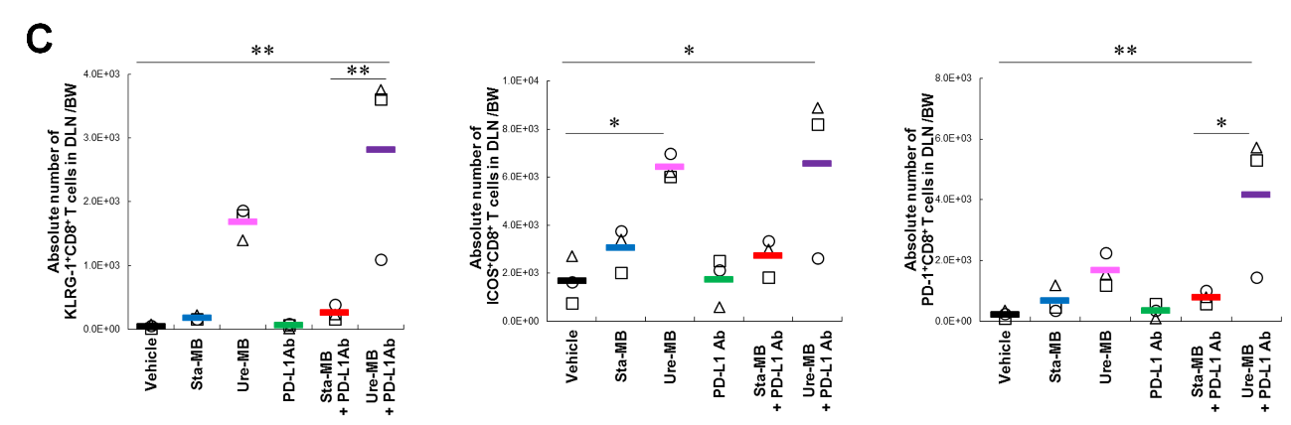
Combination efficacy of STA551 with anti-PD-L1 in LLC1/OVA. (A) Human CD137 knock-in mice bearing LLC1/OVA were administered vehicle (black), Sta-MB (blue), Ure-MB (pink), anti-mouse PD-L1 mAb (green), Sta-MB combination (red) or Ure-MB combination (purple) (n=8). Dashed lines in black and pink indicate average tumor volume (n=7) after euthanasia or death. *: Statistical analysis between vehicle and each group on day 20 (*P < 0.01 by Steel’s test). Non-parametric Steel’s test or parametric Dunnett’s test was selected by Bartlett's test for assessing tumor volumes of each treatment. †: Euthanasia due to self-destruction of the tumor. #: Death due to dissemination of tumor cells in the peritoneal cavity. (B) Ratio and (C) absolute number of PD-1, KLRG-1 and ICOS on CD8⁺ T cells to whole CD8⁺ T cells in draining lymph nodes were calculated by flow cytometry. The mean and individual values in each group are shown (n=3). *, **, ***: Statistical differences in expression levels for multiple-group comparisons (*P < 0.05, **P < 0.01, ***P < 0.001 by Tukey’s test).

Fig. S22.
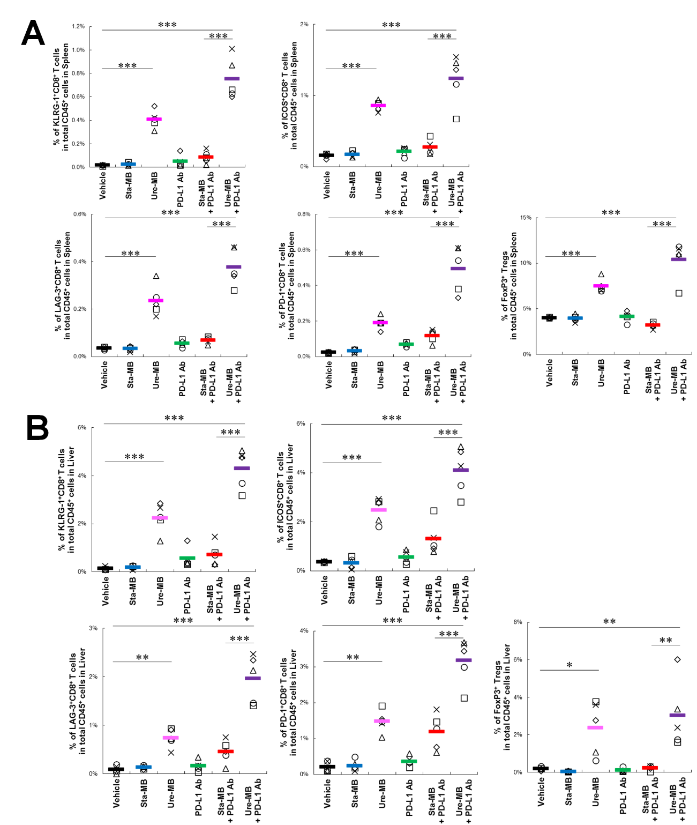
Systemic response to STA551 with anti-PD-L1 in human CD137 knock-in mice bearing Colon38 in liver and spleen. (A) Human CD137 knock-in mice bearing Colon38 were administered vehicle (black), Sta-MB (blue), Ure-MB (pink), anti-mouse PD-L1 mAb (green), Sta-MB combination (red) or Ure-MB combination (purple) (n=5). Ratio of LAG-3, PD-1, ICOS and KLRG-1 on CD8⁺ T cells and FoxP3⁺ Tregs to whole CD45⁺ cells in spleen and (B) liver were calculated by flow cytometry. The mean and individual values in each group are shown. *, **, ***: Statistical differences in expression levels for multiple-group comparisons (*P < 0.05, **P < 0.01, ***P < 0.001 by Tukey’s test). Tregs: regulatory T cells.

Table S1.
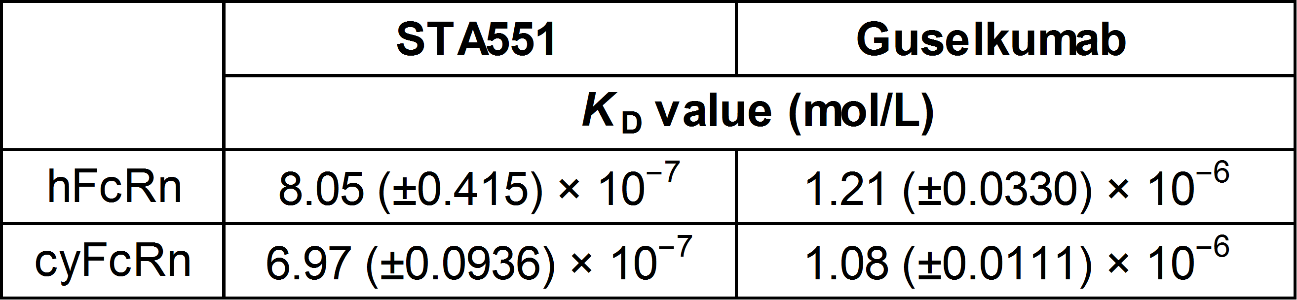
K_{D} for binding of STA551 and guselkumab to human and cynomolgus monkey FcRn. This table shows mean ± SD (n=3). Affinity of antibodies against human FcRn or cynomolgus monkey FcRn were assessed at 25°C using a Biacore T200 instrument. Antibodies were captured onto the Biacore SA sensor surface immobilized with CaptureSelectTM Human Fab-lambda Kinetics Biotin Conjugate. Human FcRn or cynomolgus monkey FcRn was prepared by two-fold serial dilution started from 3200 nmol/L. The sensor surface was regenerated using glycine 1.5 and 25 mmol/L NaOH. Affinity was determined by fitting the sensorgrams with steady state model using Biacore T200 Evaluation Software Version 3.0. K_{D}: dissociation constant, FcRn: neonatal Fc receptor.

Table S2.
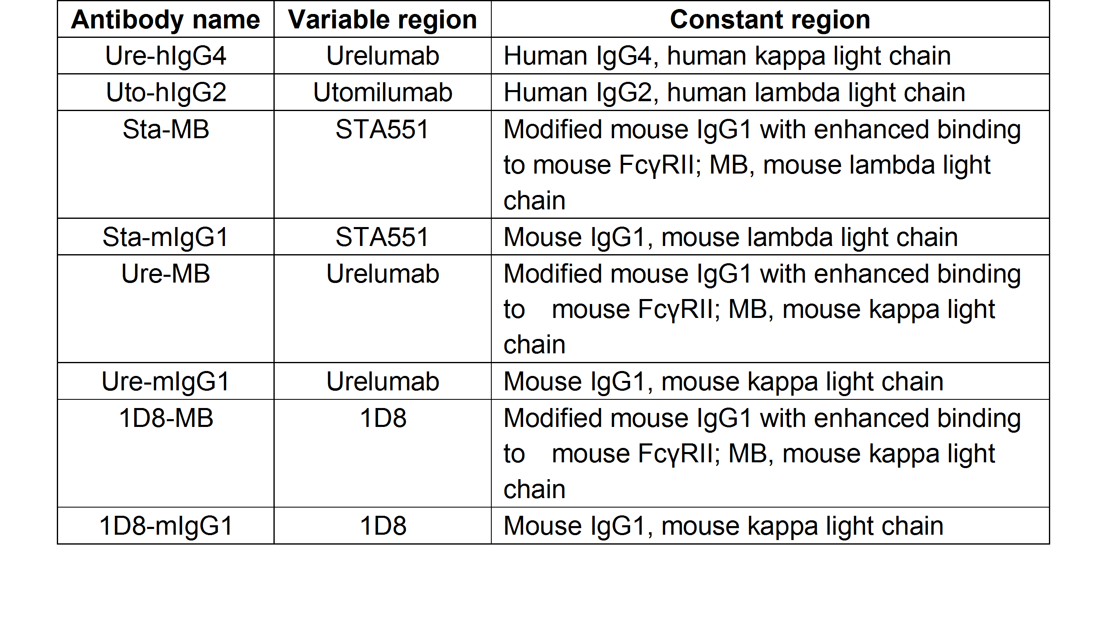
Description of anti-CD137 antibodies used in this paper.

Table S3.
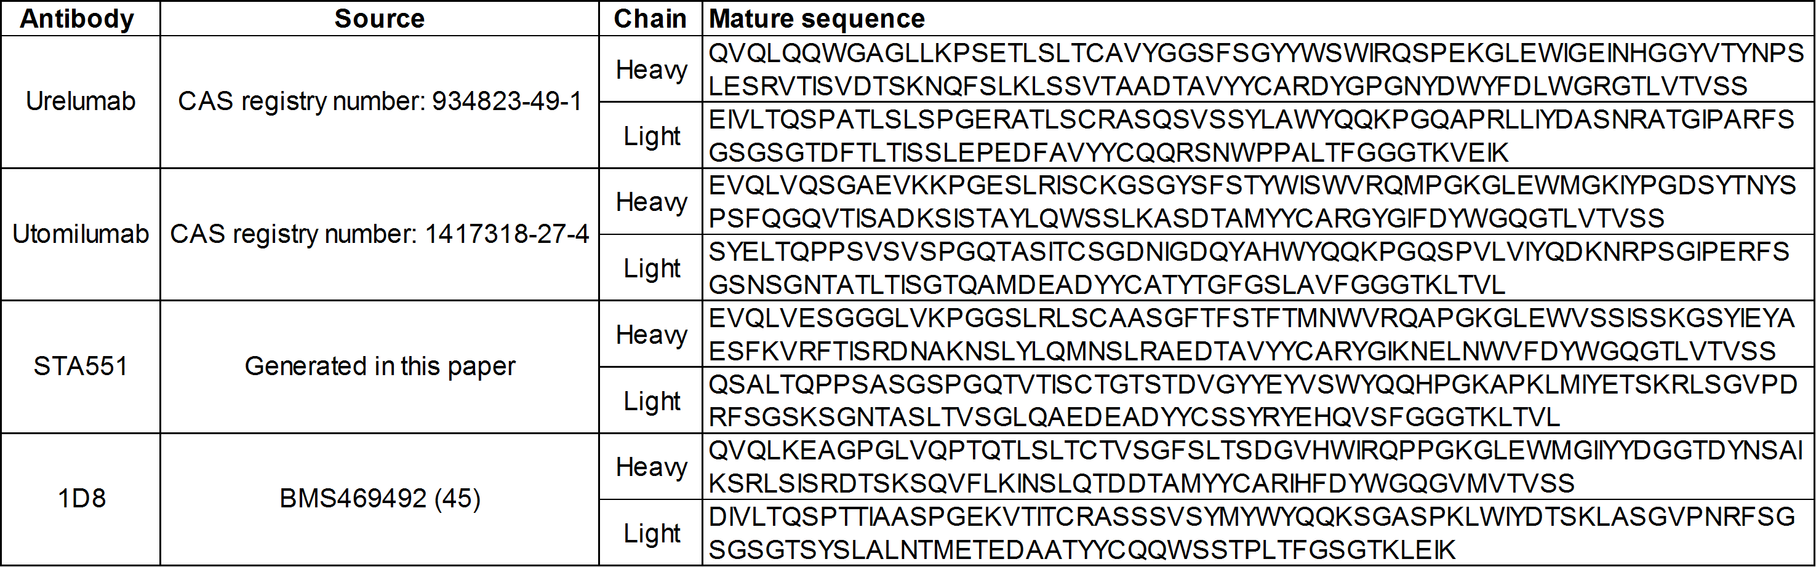
Overview of sequences used for antibody.

Table S4.
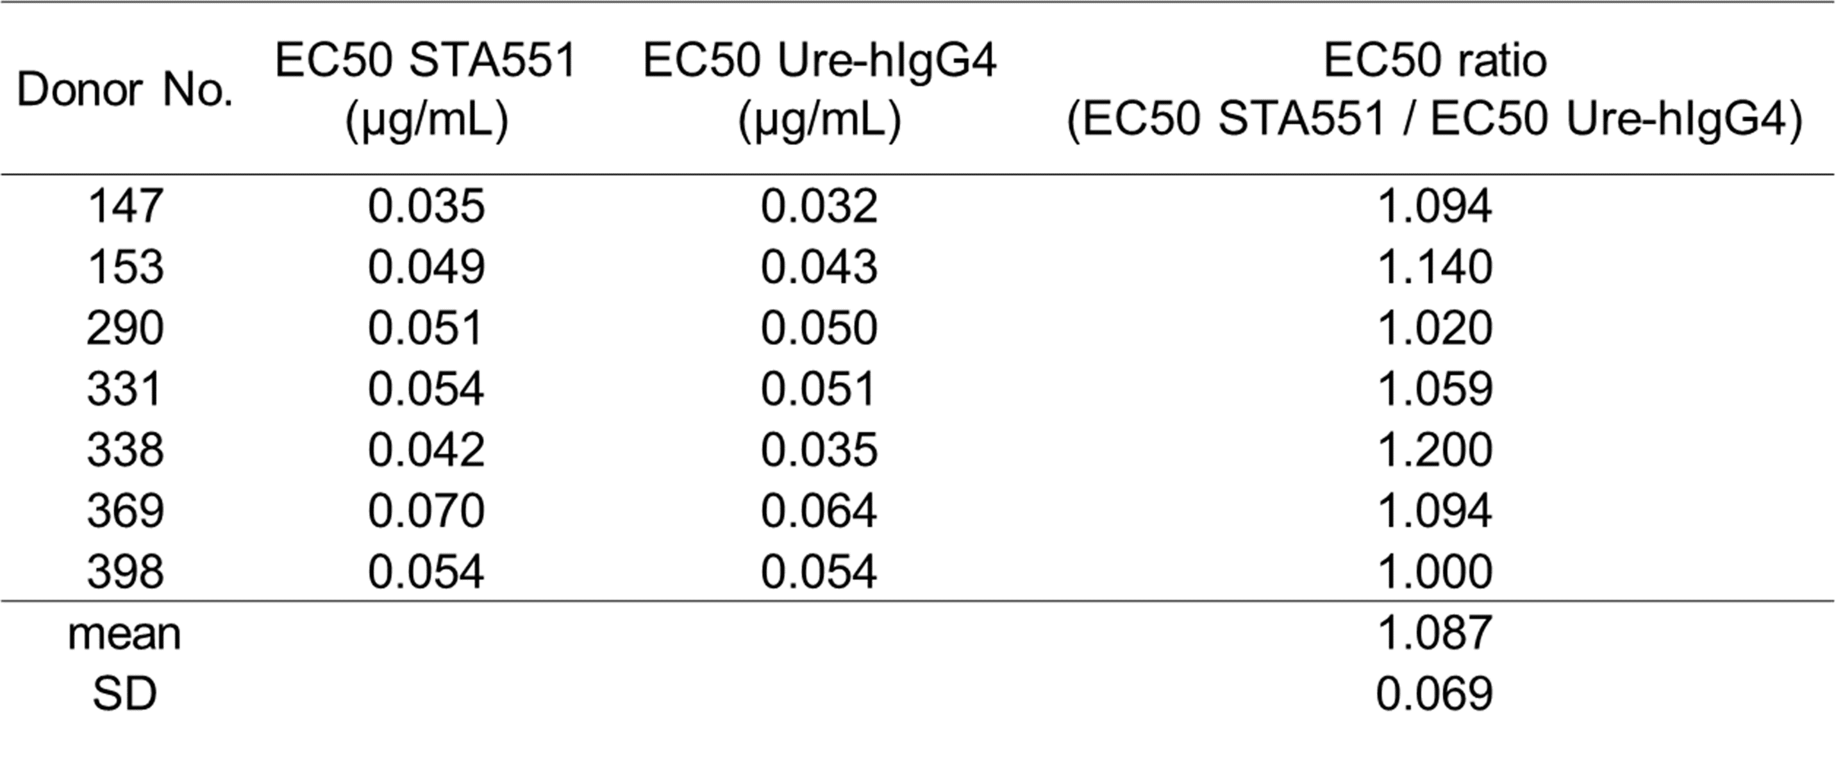
EC50 of STA551 and Ure-hIgG4 in vitro CD8⁺ T cell assay. Human CD8⁺ T cells from seven healthy donors were stimulated with anti-human CD3ε and anti-human CD28 antibodies, and then co-stimulated with STA551 or Ure-hIgG4, and human FcγRIIb-expressing CHO cells in the presence of 100 μmol/L ATP. After incubation, IFN-γ concentrations in the supernatants were measured by ELISA. Each EC50 was calculated. ATP: adenosine triphosphate, IFN-γ: Interferon gamma.

Table S5.
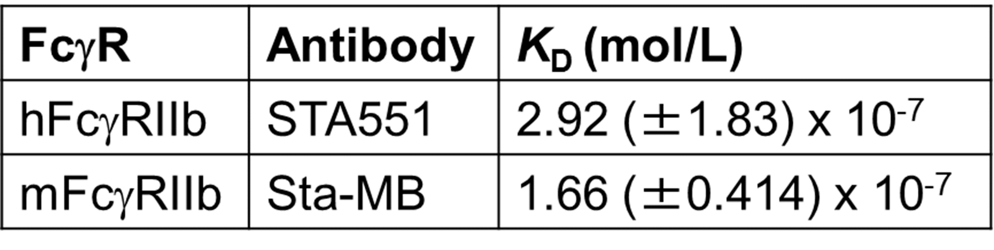
K_{D} for binding of STA551 and Sta-MB to human and mouse Fcγ receptor IIb-expressing CHO cells. This table shows means ± SD (n=3). Human and mouse FcγRIIb-expressing CHO cells were incubated with different concentrations of Alexa Fluor 647 (AF647)-labeled STA551 or AF647-labeled Sta-MB. After washing, cells were fixed and then AF647 was analyzed by flow cytometry. Geometric mean fluorescence intensity of AF647 was converted to number of molecules/cell using calibration curve of AF647 standard beads and moles of dye molecule per moles of dyed protein. K_{D} was calculated by Phoenix WinNonlin® 8.0. K_{D}: dissociation constant.

Table S6.
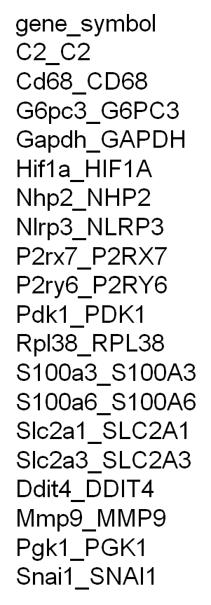
Genes used in RNA sequencing analysis on exATP related genes.
Table S7
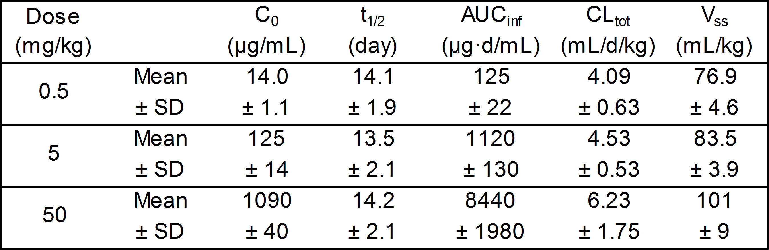
Pharmacokinetics of STA551 in cynomolgus monkeys. Pharmacokinetic parameters of STA551 after a single intravenous dose in male cynomolgus monkeys (n=4). C₀: back-extrapolated concentration immediately after intravenous injection, t_{1/2}: elimination half-life, AUC_{inf}: area under the plasma concentration-time curve from time zero extrapolated to infinity, CL_{tot}: total clearance, V_{ss}: volume of distribution at steady state, d: day.

Table S8.
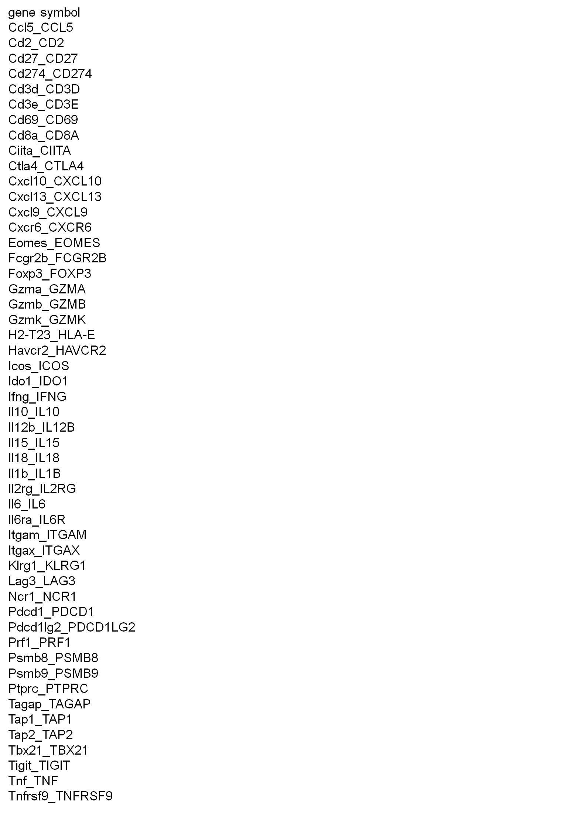Genes used in RNA sequencing analysis on response to treatment.
Supplementary Materials and Methods.

Antibody production
To obtain an antibody with the desired profile, variants were generated by site-directed mutagenesis. Recombinant antibodies (Table S2-3) were expressed using FreeStyle 293-F (Thermo Fisher Scientific), Expi 293-F cells (Thermo Fisher Scientific), or Chinese hamster ovary (CHO) stable expression cell lines and purified by affinity purification. Objective bispecific antibodies were generated by Fab-arm exchange. Gel filtration (GE Healthcare) was further conducted to remove high molecular weight species if necessary.

Measurement of binding of Fc gamma receptors to antibodies
All Fcγ receptors were prepared according to a previous report (49). Antibodies were captured onto the Biacore SA sensor surface immobilized with CaptureSelectTM Human Fab-lambda Kinetics Biotin Conjugate (Thermo Fisher Scientific). Human and cynomolgus monkey Fcγ receptors were injected over sensor surface captured antibodies then the binding amount of each Fcγ receptor per one RU of captured antibodies was calculated using the evaluation explorer function of Biacore T200 Evaluation Software 3.0. Mouse Fcγ receptors were injected over sensor surface immobilized antibodies and then the binding amount of each Fcγ receptor was normalized by the amount of immobilized antibodies.

Measurement of affinity against FcRn
Affinity of antibodies against human neonatal Fc receptors (FcRn) or cynomolgus monkey FcRn were assessed at 25°C using Biacore T200 instrument (GE Healthcare). Antibodies were captured onto the Biacore SA sensor surface immobilized with CaptureSelectTM Human Fab-lambda Kinetics Biotin Conjugate (Thermo Fisher Scientific). Human FcRn or cynomolgus monkey FcRn was prepared by two-fold serial dilution starting from 3200 nmol/L. Sensor surface was regenerated using Glycine 1.5 (GE Healthcare) and 25 mmol/L NaOH. Affinity was determined by fitting the sensorgrams for the steady state model using Biacore T200 Evaluation Software Version 3.0 (GE Healthcare). The binding affinity of antibodies to human and cynomolgus monkey FcRn at pH 6.0 was determined using Biacore T200 (GE Healthcare).

C1q binding assay
STA551, recombinant human IgG4 antibody (Bingo Biotech), or guselkumab (Tremfya, Janssen Pharmaceutical) was immobilized on each microwell. After blocking and incubating with human C1q protein (Merck Millipore), horseradish peroxidase (HRP) sheep anti-human C1q antibody (Bio-Rad Laboratories) was added. 3,3’,5,5’-tetramethylbenzidine (TMB) chromogen solution (Life Technologies) was used as a substrate. The reaction was stopped by addition of sulfuric acid solution. Absorbance was measured with a SpectraMax i3x plate reader (Molecular Devices).

Measurement of affinity against FcγRIIb-expressing CHO cells
Human and mouse FcγRIIb-expressing CHO cells were incubated with different concentrations of Alexa Fluor 647 (AF647)-labeled STA551 or AF647-labeled Sta-MB in 4°C for 1 hour. After washing to remove unbound antibodies, cells were fixed with 1% paraformaldehyde in 4°C for 10 minutes. AF647 was analyzed by FACS CantoII (BD Bioscience) and geometric mean fluorescence intensity (MFI) of AF647 was converted to the number of bound molecules per cell using the calibration curve of AF647 standard beads, Quantum™ MESF (Bangs Laboratories) and moles of dye molecule per moles of dyed protein. Dissociation constant (K_{D}) was estimated using Phoenix WinNonlin® 8.0 (Certara, Princeton) according to the following formula: Bound molecule (molecules/cell) = B_{max} × C_{total}/(C_{total}+ K_{D}) (50). C_{total} and C_{free} were confirmed to be almost equal. C_{total}: concentration of total antibodies, C_{free}: concentration of free antibodies.

Measurement of CD137 dependent internalization
Human CD137-expressing CHO cells were incubated with 0.1 μg/mL of AF647-labeled Sta-MB, Ure-MB, or anti-KLH-MB at 4°C or 37°C for 1 hour. After incubation, cells were washed with phosphate-buffered saline. Cells were fixed with 1% paraformaldehyde at 4°C for 10 minutes. AF647 was analyzed by FACS CantoII (BD Bioscience) and geometric MFI of AF647 was calculated (n=3).

In vitro CD8⁺ T cell assay with FcγRIIa and FcγRIIb expressing mixed cells
All human CD8⁺ T cells were purchased from Astarte Biologics. Human FcγRIIa-expressing CHO-DG44 cells (NIG44-hFcγRIIa-H cells) and human FcγRIIb-expressing CHO-DG44 cells (hFcγRIIb2-CHO-NIG44 cells) were established in Chugai Pharmaceutical. Human CD8⁺ T cells from three healthy donors were stimulated with a fixed concentration of immobilized anti-human CD3ε (1 μg/mL, clone SP34, BD Biosciences) and anti-human CD28 antibodies (5 μg/mL, clone CD28.2, BD Biosciences) for 6 hours, and then variable concentrations of STA551, Ure-hIgG4 or Uto-hIgG2 in the absence or presence of 100 μmol/L ATP with both NIG44-hFcγRIIa-H cells and hFcγRIIb2-CHO-NIG44 cells were added and incubated for 18 hours in AIM-V medium (Thermo Fisher Scientific) supplied with 5% human serum (Sigma-Aldrich). The reason why both NIG44-hFcγRIIa-H and hFcγRIIb2-CHO-NIG44-mixed cells were co-cultured with CD8⁺ T cells was to precisely evaluate agonistic activity on different types of IgG including human IgG2, which strongly binds human FcγRIIa. After incubation, the supernatants were harvested and the IFN-gamma (IFN-γ) concentrations in the medium were measured by ELISA.

Cytokine measurement
Human IFN-γ levels in supernatants were determined using Human IFN-gamma DuoSet ELISA (R&D SYSTEMS), and mouse IFN-γ levels in supernatants using AlphaLISA Mouse IFN-γ immunoassay kit (PerkinElmer). All cytokine measurement assays were carried out according to manufacturer protocols.

Establishment of human CD137 knock-in mice
Human CD137 knock-in mice were established by replacing endogenous Cd137 genomic DNA from the initial to terminal codon with the human counterpart, CD137. A bacterial artificial chromosome (BAC) genomic DNA clone carrying the human CD137 region was purchased from Thermo Fisher Scientific (Invitrogen Clones, RPCI11.C., Clone#902J21) (51). Human CD137 knock-in vector was constructed with this clone using Red/ET recombination technology (Gene Bridges) (52). As shown in Fig. S7A, 5’ upstream region of the initial codon (ATG) and 3’ downstream region of the terminal codon (TGA) of mouse Cd137 genome were seamlessly inserted into each end of the human CD137 genomic regions, respectively, in the knock-in vector. Neomycin resistance (NeoR) cassette flanked by two loxP sites was inserted into the 2nd intron of the human CD137 gene. The human CD137 knock-in vector and 2 pairs of ZFN mRNA (designed by SIGMA Aldrich) targeting exon 2 and exon 8 of mouse endogenous Cd137 were co-transfected into a C57BL/6N mouse embryonic stem (ES) cell line by using TransIT-mRNA Transfection Kit (Mirus Bio). The ES cells were selected in a culture medium containing G418 (Geneticin, Thermo Fisher Scientific). The homologous recombinant ES cell clone was injected into ICR or BALB/cA mouse (CLEA Japan) 8-cell or blastocyst embryos to generate chimera mice. The male chimera mice were bred with C57BL/6N female mice to obtain heterozygous knock-in mice which had floxed NeoR cassette. To remove the NeoR cassette, Cre recombinase mRNA was injected into the fertilized eggs of the heterozygous knock-in mice. After removal of the NeoR cassette, heterozygous mice were intercrossed to produce homozygous knock-in mice. Genotypes were analyzed by genomic PCR with the following primers: m137_25260F (5’- TGTCCTGTGCATGTGACATTTCGC -3’) and h137-3736R (5’- TATCTTGATTGATGTAGGAGATGA -3’) for knock-in allele; m137_25260F (5’- TGTCCTGTGCATGTGACATTTCGC -3’) and m137-r264R (5’- TGCAGACTGGATTGTATTTTCTGCA -3’) for wild allele (Fig. S7B). RT-PCR analysis was performed to determine mouse Cd137 and human CD137 gene expression. Primary spleen cells were cultured in complete RPMI1640 medium (Thermo Fisher Scientific) containing 10% fetal bovine serum and supplemented with the Cell Stimulation Cocktail (eBioscience) containing phorbol 12-myristate 13-acetate (PMA) and ionomycin. Total RNA samples prepared from stimulated spleen cells with RNeasy Mini Kit (QIAGEN) were reverse-transcribed with SuperScript III reverse-transcriptase (Thermo Fisher Scientific) to synthesize cDNA. PCRs were performed with the following gene-specific primers: h137_r293F (5’- CTCTGTTGCTGGTCCTCAA -3’) and h137-r792R (5’- AGGGGCAGGCGGGGTCACAGAGGATGCTCCC -3’) for human CD137; m137_r163F (5’- TTGTGCTGCTGCTAGTGGG -3’) and m137-r655R (5’- GGAGTCACAGAAATGGTGGTACTG -3’) for mouse Cd137 (Fig. S7C). To confirm human CD137 expression and cell activation by human CD137 agonist antibody, human CD137 expression on spleen cells was analyzed by flow cytometry and cell activation induced by anti-human CD137 agonist antibody was analyzed by IFN-γ ELISA as described in Fig. S7D and Fig. S8C. For flow cytometry analysis, spleen cells derived from wild type or human CD137 knock-in mice were stimulated with Dynabeads Mouse T-Activator CD3/CD28 (Thermo Fisher Scientific) for 24 hours in RPMI1640 medium (Sigma-Aldrich) containing 10% fetal bovine serum (Sigma-Aldrich). After incubation, beads were removed from spleen cells by magnetic separation. Antibodies to CD3ε (clone 145-2C11), CD8α (clone 53-6.7), CD4 (clone RM4-5), CD19 (clone 1D8/CD19), CD279 (clone 29F.A12), mouse IgG1 (clone RMG1-1), mouse CD137 (clone 17B5) (16), and human CD137 (clone 4B4-1) were purchased from BioLegend. The activated spleen cells were incubated in 100 μmol/L ATP buffer containing each antibody for 30 minutes at 4°C after treatment with mouse Fc receptor blocking reagent (Miltenyi Biotec). Cells were washed using 100 μmol/L ATP buffer and then incubated in 100 μmol/L ATP buffer containing secondary anti-mouse IgG1 antibody for 30 minutes at 4°C. Dead cells were stained by Zombie Aqua Fixable Viability Kit (BioLegend). Cells in 100 μmol/L ATP buffer were analyzed by FACSLyric (BD Bioscience). For cell activation analysis, spleen cells derived from wild type or human CD137 knock-in mice were stimulated with Dynabeads Mouse T-Activator CD3/CD28 for 6 hours and then variable concentrations of each anti-mouse or anti-human CD137 antibody in the absence or presence of 250 μmol/L ATP. After incubation, the supernatants were harvested and the IFN-γ concentrations in the medium were measured by ELISA. Although human CD137 does not bind to mouse CD137 ligand, no gross abnormalities were observed in the human CD137 knock-in mice. After several assessments using basic immunological tests, we established human CD137 knock-in mice (officially named C57BL/6N- Tnfrsf9^{em1(TNFRSF9)Csk} mice).

In vivo lung metastasis model
The LLC1/OVA cells were inoculated intravenously into the tail vein of human CD137 knock-in mice. On day 7 and 14 after tumor inoculation, Sta-MB or vehicle were intravenously administered. Lungs were harvested and the weight of metastatic nodules was measured on day 18.

Hematology analysis
Blood with heparin was collected via inferior vena cava in human CD137 knock-in mice. The counts of white blood cells (WBC), lymphocytes and platelets in blood were analyzed by XT-2000iV, automatic hematology analyzer (Sysmex).

In vivo humanized NOG mouse model
NOD/Shi-scid,IL-2RγKO Jic (NOG) mice (In-Vivo Science International) were irradiated 1 day before transplantation. Hematopoietic stem cells (HSC, ALLCELLS) were intravenously injected into NOG mice (1×10⁵ cells/mouse). Approximately 100 days after transplantation of HSCs, the establishment of humanized NOG (huNOG) mice was confirmed by assessing the presence of human CD45⁺ and human CD3⁺ cells in blood. NCI-H446 cancer cells were inoculated subcutaneously and tumor growth was monitored as previously described. After palpable tumors were established, animals were randomized, and antibodies were intravenously administered.

NanoString and RNA sequencing assay
LLC1/OVA/hGPC3, Colon38, LLC1/hGPC3, Hepa1-6/hGPC3, or LLC/OVA cells were inoculated subcutaneously into the flanks of human CD137 knock-in mice and C57BL/6 mice. After the tumors were established, tumors were removed from mice before the treatment and on day 3 (LLC1/hGPC3) or day 4 (LLC1/OVA/hGPC3 and Colon38) after the first dose and placed in RNAlater RNA Stabilization Reagent (QIAGEN). RNA was extracted from each tumor using the NucleoSpin RNA kit (Macherey-Nagel) or RNeasy Mini kit (QIAGEN). Gene-expression levels were assessed using PanCancer Mouse Immune Profiling (NanoString Technologies), which consists of 770 mouse immune-related genes, according to the manufacturer’s protocol. Digital counts of nCounter-based gene expression were performed with the nCounter MAX Analysis System (NanoString Technologies) and the Field of View (FOV) was set at 550. Normalization and data analysis was conducted with nSolver Analysis Software ver3.0 (nSolver 3.0, NanoString Technologies). For data analysis, immune-related genes were selected for their relevance to the CD8⁺ effector population (Cd8b1, Gzmb, Ifng, Prf1, and Cd3e). Normalization of RNA loading was performed with all positive control probes and housekeeping genes included in the panel. For immune cell profiling analysis, each immune cell score was calculated using the Advanced Analysis mode of nSolver 3.0. For RNA seqencing (RNA-seq) analysis, the RNA-seq reads were mapped to GRCm38 transcripts, and fragments per kilobase per million mapped reads (FPKM) was calculated based on RNA-seq by Expectation-Maximization (RSEM), version 1.2.31 (53). A group of exATP-related genes were selected based on previous reports (39,54-56). The gene sets included markers of purinergic receptors (P2RX7 etc.), hypoxia (HIF-1α etc.), signature of CD39 inhibition (RPL38 etc.), and EMT (SNAIl etc.) (Table S6). FASTQ files of RNA-seq of normal tissues were referenced in the literature (57), and expression profile (FPKM) was calculated with RSEM. We selected the genes up-regulated in tumor compared to normal tissues. T-test was conducted for each tumor cell line comparing the triplicates of the cell line and all normal tissue samples, and we selected genes for which p-values of any t-test were less than 0.05, as shown in Fig. S11. A group of immune-related genes were selected based on previous reports in cancer immunotherapies (58,59). The gene sets included markers of CD8⁺ effector population (CD8, CD278, KLRG-1, and Granzyme A etc.), antigen presentation (TAP1 and TAP2 etc.), mediators of immune checkpoint (PD-L1 and CTLA-4 etc.), and IFN-γ signature (IFN-γ etc.) (Table S8). Z-scores were calculated using log₂ transformed FPKM values. A heat map was drawn using NMF (development version downloaded on Aug. 1st, 2019) packaged in R (version 3.4.4, https://www.r-project.org/).

Immunohistochemistry
On day 2 after the first dose, tumors were excised, fixed in 10% neutral buffered formalin for 24 hours, embedded in paraffin, and sectioned to 4 μm thickness by Sliding Microtome SM2010R (Leica Microsystems). CD8 was stained by anti-CD8 alpha antibody (clone D4W2Z, Cell Signaling Technology) with OptiView DAB kit (Ventana Medical Systems) and PD-L1 was stained by polyclonal goat PD-L1 antibody (R&D systems) with ultraView DAB kit (Ventana Medical Systems) by a BenchMark XT auto-stainer (Ventana Medical Systems). Secondary antibodies (Ventana Medical Systems) were replaced with anti-rabbit-HQ and anti-HQ-HRP for CD8 and anti-goat-HRP for PD-L1. All the immunohistochemistry stained slides were digitally scanned at 20-fold objective magnification as a high-resolution digital image of the whole tissue using a pathology scanner (Aperio scanner console, version 102.0.4.6, Leica Biosystems) system for bright field microscopy. The number of immunohistochemistry-positive cells in tumor was calculated using the ‘Immune Cell v1.3’ algorithm for CD8 and ‘Membrane v1.7’ algorithm for PD-L1 within the HALOTM image analysis software (Indica Labs, v2.3). All tumor areas in each specimen were manually annotated and evaluated by a pathologist. The number of positive cells for each marker was expressed in the number per tumor area (mm²). Quality of positivity threshold by the digital image analysis was monitored by visual inspection.

Antibody distribution
Colon38 were inoculated subcutaneously into the flanks of human CD137 knock-in mice. After the tumors were established, tumors, livers, and spleens were removed from mice treated with Alexa Fluor 488 labeled anti-human CD137 antibodies or control antibody on day 1 after the treatment. Antibody labeling by Alexa Fluor 488 Antibody Labeling Kit (Thermo Fisher Scientific) was conducted according to the manufacturer’s protocol. Tumors or livers were digested, processed, and enriched into single cell suspensions with tumor or liver dissociation kit followed by red blood-cell lysis. All reagents in cell dissociation and blood-cell lysis were used in the presence of 100 μM ATP. Single cell suspensions from spleen were obtained with nylon mesh followed by red blood-cell lysis. AutoMACS Rinsing Solution (Miltenyi Biotec) containing 100 μM ATP and MACS BSA Stock Solution (Miltenyi Biotec) was used as buffer for staining. Cells were analyzed by LSRFortessa™ X-20.

Repeat dose toxicity study in cynomolgus monkeys
All cynomolgus monkey studies were conducted according to the policies of the IACUC using purpose-bred, naïve, cynomolgus monkeys of Cambodian origin. STA551 was administered intravenously at dose levels of 0 (control), 5, 30, and 150 mg/kg/week to male and female cynomolgus monkeys (3 males and 3 females per group) for 4 weeks. Comprehensive toxicity evaluation, including pathology, was completed. A detailed toxicity profile of STA551 is not described here, since it is beyond the scope of this report.

Pharmacokinetic studies
All mouse and cynomolgus monkey studies were conducted according to the policies of the IACUC. All mice received 7.5 mg/kg of Ure-MB or Sta-MB (Fig.3D). Tumor bearing or non-tumor bearing human CD137 knock-in mice received 0.3 mg/kg of Ure-MB or Sta-MB (Fig.S14A-B). The concentration of Sta-MB and Ure-MB in plasma in wild type mice and human CD137 knock-in mice was measured by an electrochemiluminescence immunoassay (ECLIA). Ure-MB was captured on a plate coated with human CD137 and detected using biotinylated anti-mouse IgG antibody and SULFO-TAG labeled streptavidin. Sta-MB was captured and detected in the presence of ADP in the same manner as Ure-MB. The concentration of STA551 in cynomolgus monkey plasma was measured by an ELISA. STA551 was captured on a plate coated with human CD137 in the presence of ADP and detected with anti-human IgG horseradish peroxidase conjugated antibody. Anti-STA551 antibodies in cynomolgus monkey plasma were detected by ELISA using biotin-labeled STA551 and digoxigenin-labeled STA551. Pharmacokinetics parameters were estimated using non-compartmental analysis (Phoenix WinNonlin® 6.4 Certara).

Antibody-mediated cell depletions
Cell subsets were depleted by intravenous administration of cell depleting antibody beginning one day before the first treatment of Sta-MB. CD8⁺ T cells, CD4⁺ T cells, NK cells, neutrophils, or macrophages were depleted with 500 μg of anti-CD8 antibody (clone 2.43), anti-CD4 antibody (clone GK1.5), anti-NK1.1 antibody (clone PK136), and anti-Ly-6G antibody (clone 1A8), twice a week. B cells were depleted with 250 μg of anti-CD20 antibody (clone SA271G2) once before the first treatment with Sta-MB. Macrophages were depleted with 300 μL of clodronate liposomes (Liposoma). Antibodies to CD8, CD4, NK1.1 and Ly-6G were purchased from BioXcell, and antibody to CD20 was purchased from BioLegend.

Liver enzyme analysis
After the tumors were established, mice were intravenously administered Sta-MB and intraperitoneally administered anti-PD-L1 antibody at day 0 and day 3. Four days after initiating treatment, blood was drawn and serum levels of alanine transaminase (ALT) and aspartate transaminase (AST) were measured by Automatic analyzer TBA-120FR (Canon Medical Systems).

Supplementary References.
49. Mimoto F, Igawa T, Kuramochi T, Katada H, Kadono S, Kamikawa T, et al. Novel asymmetrically engineered antibody Fc variant with superior FcγR binding affinity and specificity compared with afucosylated Fc variant. MAbs 2013;5(2):229-36.
50. Hulme EC, Trevethick MA. Ligand binding assays at equilibrium: validation and interpretation. Br J Pharmacol 2010;161(6):1219-37.
51. Osoegawa K, Mammoser AG, Wu C, Frengen E, Zeng C, Catanese JJ, et al. A bacterial artificial chromosome library for sequencing the complete human genome. Genome Res 2001;11(3):483-96.
52. Zhang Y, Buchholz F, Muyrers JP, Stewart AF. A new logic for DNA engineering using recombination in Escherichia coli. Nat Genet 1998;20(2):123-8.
53. Li B, Dewey CN. RSEM: accurate transcript quantification from RNA-Seq data with or without a reference genome. BMC Bioinformatics 2011;12:323.
54. Li X-Y, Moesta AK, Xiao C, Nakamura K, Casey M, Zhang H, et al. Targeting CD39 in Cancer Reveals an Extracellular ATP- and Inflammasome-Driven Tumor Immunity. Cancer Discov 2019;12:1754-1773.
55. Yang H, Geng Y-H, Wang P, Zhou Y-T, Yang H, Huo Y-F, et al. Extracellular ATP promotes breast cancer invasion and epithelial-mesenchymal transition via hypoxia-inducible factor 2α signaling. Cancer Sci 2019;110(8):2456-70.
56. Gombault A, Baron L, Couillin I. ATP release and purinergic signaling in NLRP3 inflammasome activation. Front Immunol 2012;3:414.
57. Söllner JF, Leparc G, Hildebrandt T, Klein H, Thomas L, Stupka E, et al. An RNA-Seq atlas of gene expression in mouse and rat normal tissues. Scientific Data 2017;4(1):170185.
58. Mariathasan S, Turley SJ, Nickles D, Castiglioni A, Yuen K, Wang Y, et al. TGFβ attenuates tumour response to PD-L1 blockade by contributing to exclusion of T cells. Nature 2018;554:544.
59. McDermott DF, Huseni MA, Atkins MB, Motzer RJ, Rini BI, Escudier B, et al. Clinical activity and molecular correlates of response to atezolizumab alone or in combination with bevacizumab versus sunitinib in renal cell carcinoma. Nat Med 2018;24(6):749-57.

