Supplemental Appendix

Supplemental Figures 2
Figure S1: Patient disposition 2
Figure S2: Cytokine-related TEAEs of interest by cycle (N=38) 3
Figure S3: Swimmers plots by tumor type for the response-evaluable population (n=37). 5
Figure S4: Neutrophils, lymphocytes, and neutrophil-to-lymphocyte ratio over time by response. 6
Figure S5: Intratumoral expression of immune pathway and cell-type score with BEMPEG plus NIVO. 7
Figure S6: Treatment with BEMPEG plus NIVO increases tumor immune infiltration and PD-L1 protein expression (by immunohistochemistry). 8
Figure S7. Combination therapy with BEMPEG plus NIVO does not affect B cells in the tumor. 9
Supplemental Tables 10
Table S1: Treatment exposure 10
Table S2: TEAEs (all-Grade in ≥10% of patients) 11
Table S3: Changes in gene expression in tumor biopsies from baseline to week 3 (P<0.05) 12
Supplemental Material 16
Definition of dose-limiting toxicity (DLT) 16
Biomarker methodology 16
Hydration guidelines 17

Supplemental Figures

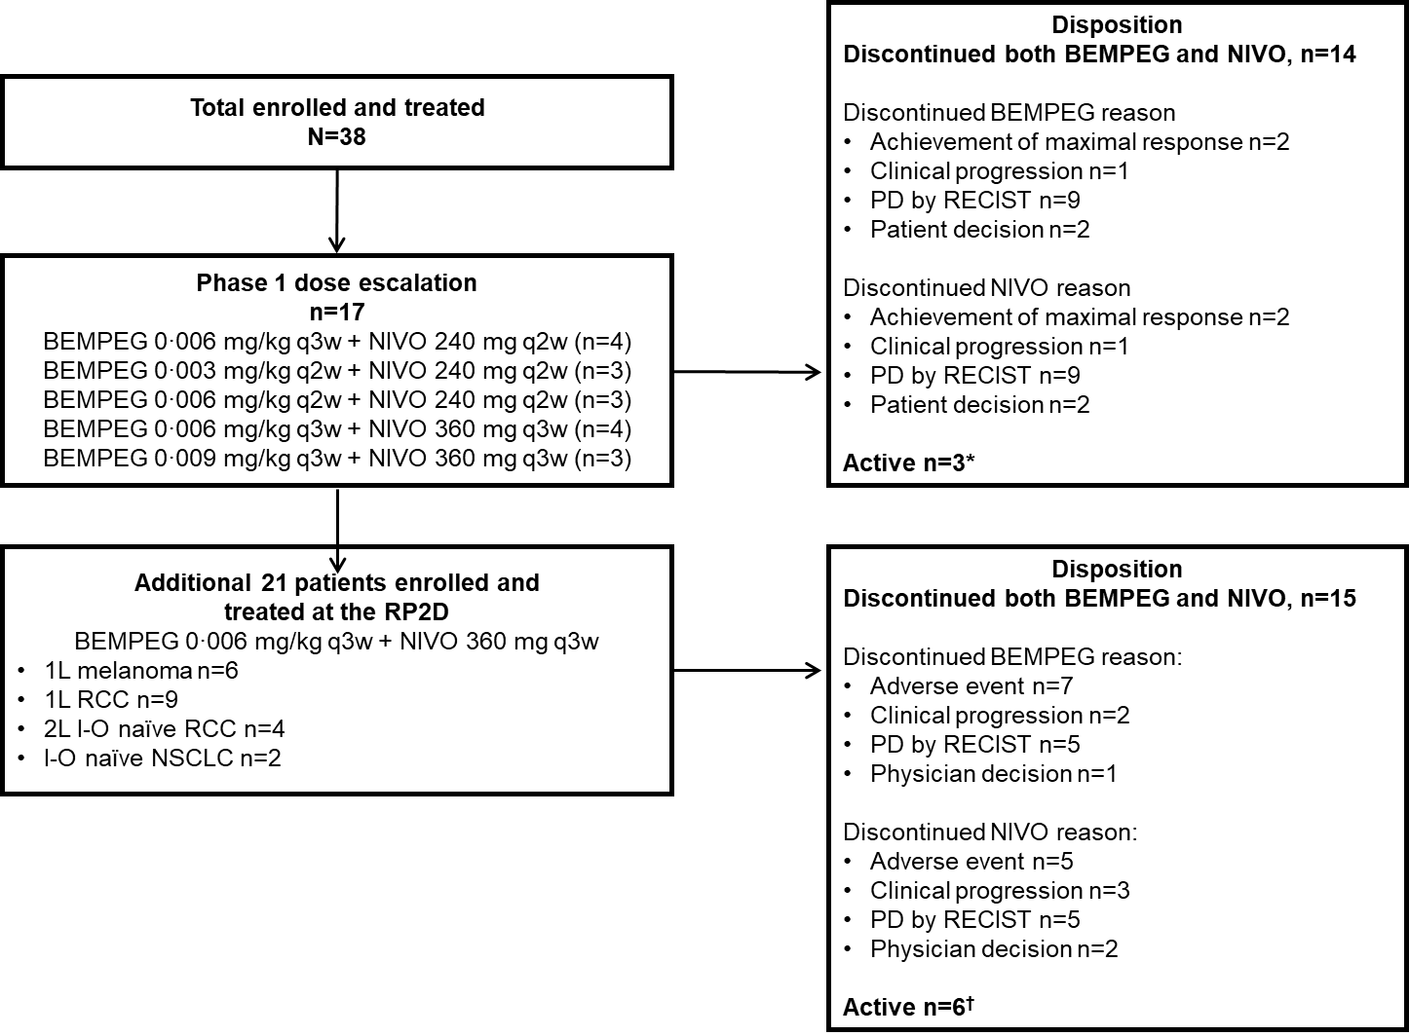

Figure S1: Patient disposition in the dose-escalation portion of PIVOT-02
*Of the three active patients, one discontinued BEMPEG but continued NIVO. †Of the six active patients, three discontinued BEMPEG but continued NIVO.
1L, first line; 2L, second line; BEMPEG, bempegaldesleukin; I-O, immunotherapy; NIVO, nivolumab; NSCLC, non-small cell lung carcinoma; PD, progressive disease; q2w, every 2 weeks; q3w, every 3 weeks; RCC, renal cell carcinoma; RECIST, Response Evaluation Criteria In Solid Tumors.

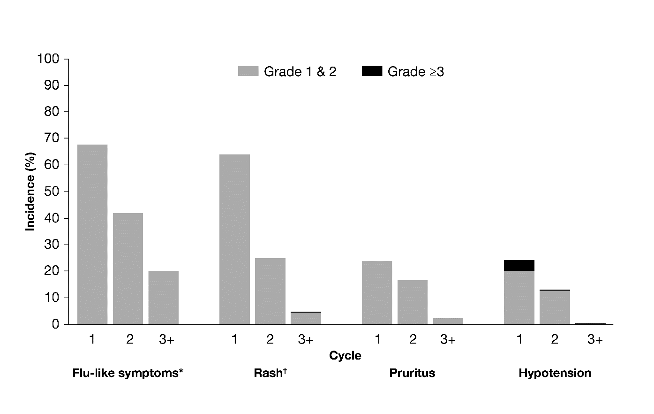

Figure S2: Cytokine-related TEAEs of interest by cycle (N=38)
*Includes the following preferred terms: chills, influenza-like illness, pyrexia.
†Includes the following preferred terms: erythema, rash, rash erythematous, rash generalized, rash macular, rash maculo-papular, rash maculovesicular, rash papular, rash pruritic, rash pustular, rash vesicular, and exfoliative rash.
TEAE, treatment-emergent adverse event.

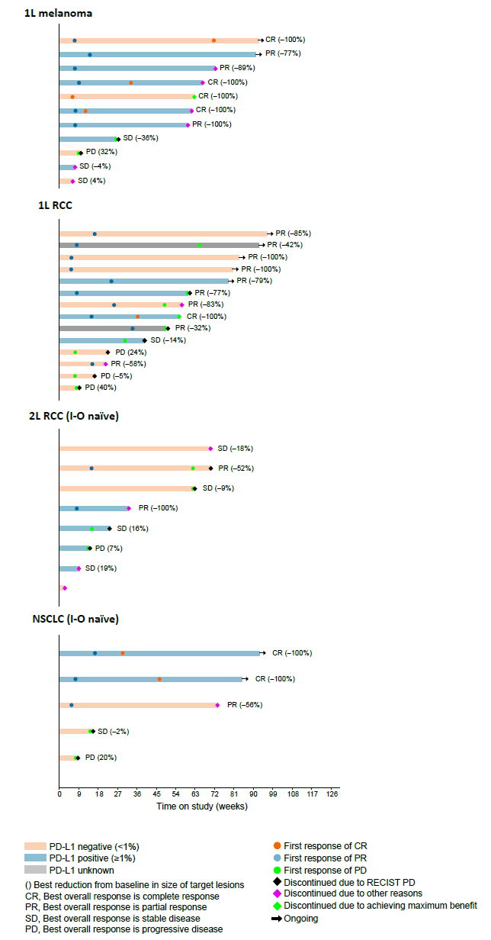
Figure S3: Swimmers plots by tumor type for the response-evaluable population (n=37). End of treatment is based on date and reason for discontinuing both BEMPEG and NIVO, whichever is later. Other reasons for end of treatment include adverse event, death, lost to follow-up, noncompliance of the patient, patient decision, physician decision, pregnancy, clinical progression, or sponsor decision. Patient may discontinue treatment due to non-target lesion progression or appearance of new lesion. Response evaluable population includes eligible patients who have at least one post-baseline assessment of tumor response. Best overall response per investigator assessment.
1L, first line; 2L, second line; BEMPEG, bempegaldesleukin; I-O, immunotherapy; NIVO, nivolumab; NSCLC, non-small cell lung carcinoma; PD-L1, programmed death ligand-1; RCC, renal cell carcinoma; RECIST, Response Evaluation Criteria In Solid Tumors.

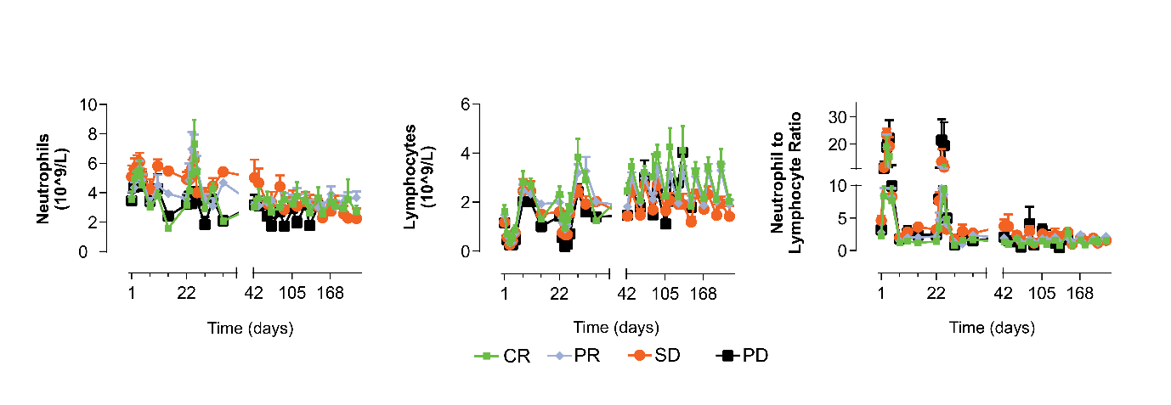
Figure S4: Neutrophils, lymphocytes, and neutrophil-to-lymphocyte ratio over time by response. Mean neutrophil and lymphocyte concentrations using standard hematology (complete blood count with differential). Patients received various dose combinations of BEMPEG plus NIVO in cycle 1, and BEMPEG at 0.006 mg/kg plus NIVO 360 mg q3w in cycle 1–11. Best overall clinical response by RECIST v1.1.

BEMPEG, bempegaldesleukin; CR, complete response; NIVO, nivolumab; PD, progressive disease.; PR, partial response; RECIST, Response Evaluation Criteria In Solid Tumors; SD, stable disease.

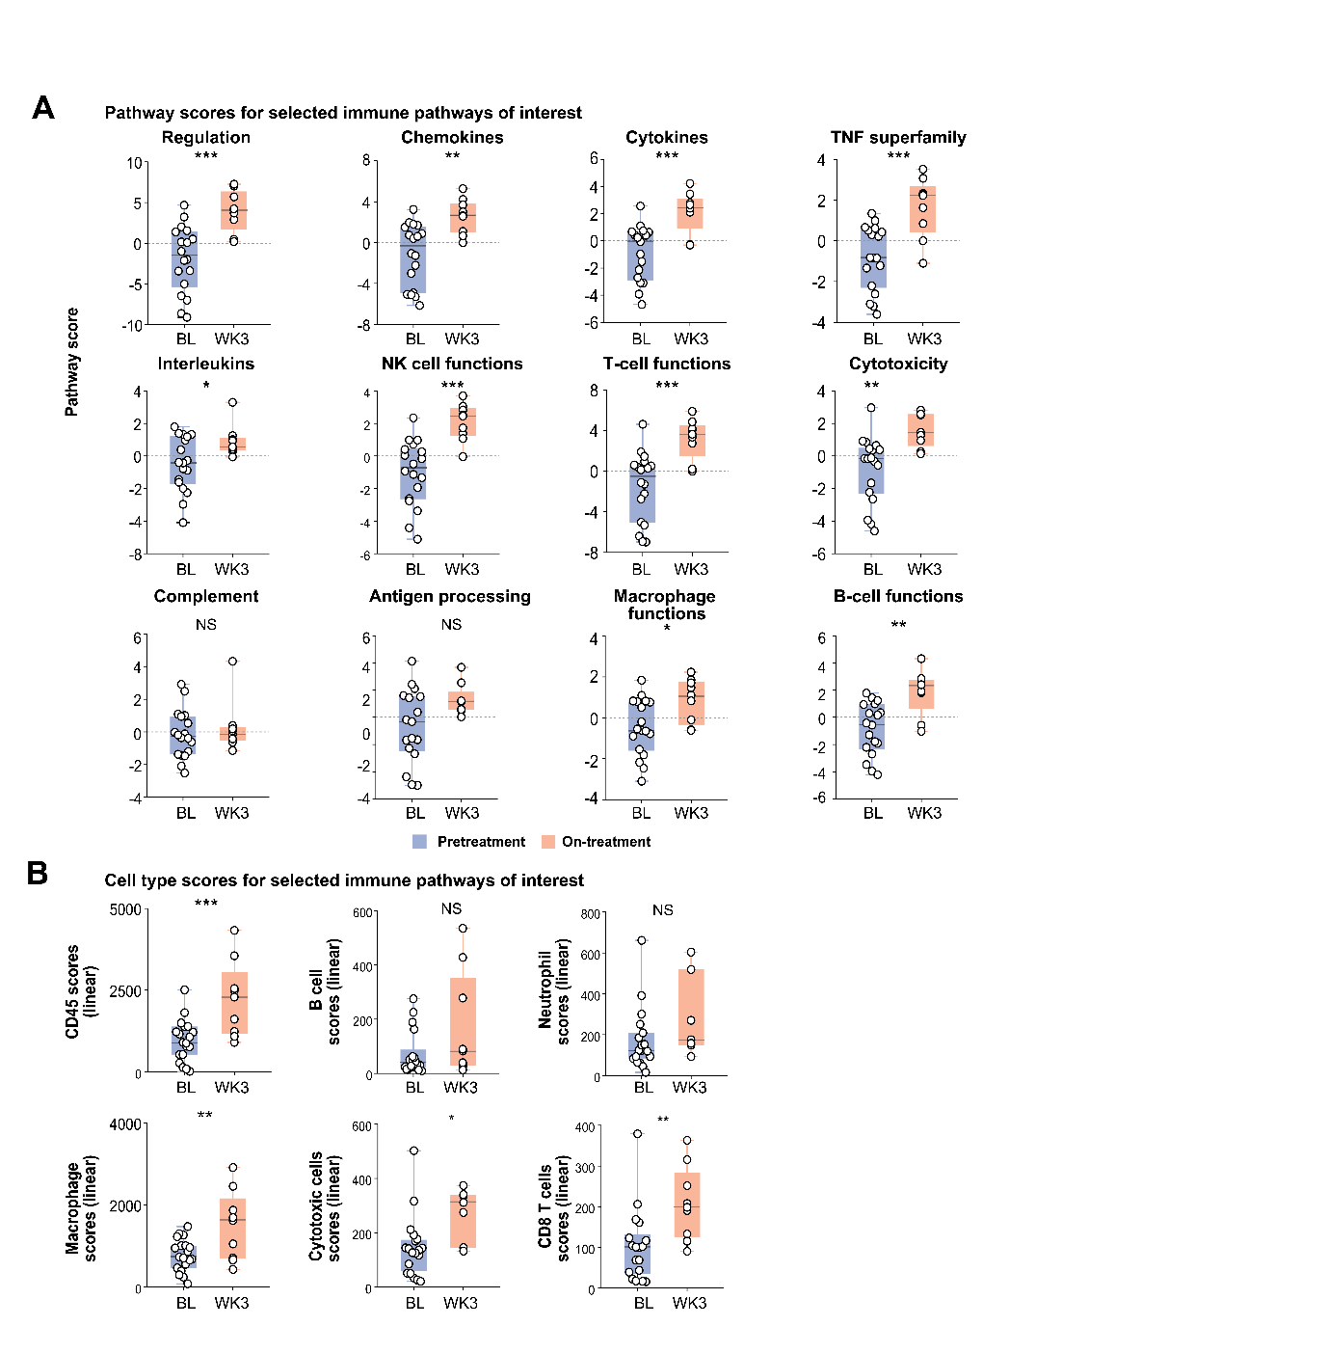

Figure S5: Intratumoral expression of immune pathway and cell-type score with BEMPEG plus NIVO. Gene analysis using the NanoString nSolver platform was performed pre- and on-treatment (week 3) for all patients with available tumor samples (19 baseline and 9 on-treatment tumor biopsies) to assess the effect of BEMPEG plus NIVO on selected immune pathways (A) and cell types (B). Unpaired t-test; * P≤0.05; ** P≤0.01; *** P≤0.001. Genes shown remained significant with multiple testing correction (Benjamini–Hochberg correction).

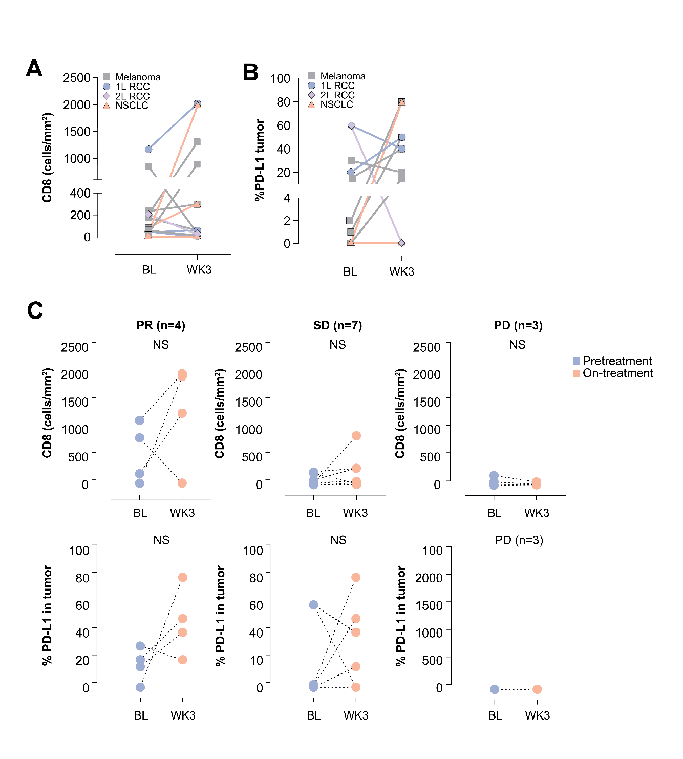

Figure S6: Treatment with BEMPEG plus NIVO increases tumor immune infiltration and PD-L1 protein expression (by immunohistochemistry). Compared with matched baseline biopsies, week 3 biopsies show (A) increases in intratumoral CD8⁺ T cells (n=14), and (B) increased tumor PD-L1 expression (n=13). (C) Changes in CD8⁺ and PD-L1 in tumor samples from baseline to week 3 according to best overall clinical response: PR, SD, PD (RECIST v1.1).
1L, first line; 2L, second line; BEMPEG, bempegaldesleukin; BL, baseline; NS, not significant; NIVO, nivolumab; NSCLC, non-small cell lung carcinoma; PD-L1, programmed death-ligand 1; PD, progressive disease; PR, partial response; RCC, renal cell carcinoma; SD, stable disease; WK, week.

Figure S7. Combination therapy with BEMPEG plus NIVO does not affect B cells in the tumor. Fourteen matched pre- and on-treatment tumor biopsies. Percentage of CD19⁺ B cells within total CD45⁺ cells and in total live cells before and after treatment (week 3) with BEMPEG plus NIVO for all patients (A) and split by response (B) Percentage of CD19⁺ B cells within total CD45⁺ cells and in total live cells at baseline according to response. Best overall response (RECIST v1.1) was complete or partial response for responders or stable disease or progressive disease for non-responders. Unpaired t-test with significance value of P<0.05.
BEMPEG, bempegaldesleukin; BL, baseline; NIVO, nivolumab; RECIST, Response Evaluation Criteria In Solid Tumors; wk3, week 3 of treatment.

Supplemental Tables

Table S1: Treatment exposure
 | Melanoma  n=11 | 1L RCC  n=14 | 2L RCC  (I-O naïve)  n=8 | NSCLC  (I-O naïve)  n=5 | Total  N=38
Total duration of exposure, months
Mean (SD) | 11.6 (7.44) | 12.4 (6.67) | 8.2 (6.48) | 12.6 (9.17) | 11.3 (7.11)
Median | 14.1 | 12.8 | 6.4 | 16.9 | 13.3
Q1, Q3 | 2.1, 16.6 | 5.2, 18.3 | 2.6, 15.2 | 3.5, 19.5 | 3.7, 16.9
Min, max | 1, 21 | 2, 22 | 1, 16 | 2, 21 | 1, 22
Total number of cycles
n | 11 | 14 | 8 | 5 | 38
Mean (SD) | 15.4 (9.47) | 16.7 (9.90) | 12.8 (10.94) | 13.4 (10.31) | 15.1 (9.76)
Median | 20.0 | 15.0 | 9.0 | 10.0 | 15.0
Q1, Q3 | 3.0, 22.0 | 8.0, 26.0 | 3.5, 24.0 | 7.0, 18.0 | 6.0, 22.0
Min, max | 3, 30 | 3, 37 | 1, 28 | 3, 29 | 1, 37
Number of cycles, n (%)
<6 | 3 (27.3) | 1 (7.1) | 3 (37.5) | 1 (20.0) | 8 (21.1)
≥6 | 8 (72.7) | 13 (92.9) | 5 (62.5) | 4 (80.0) | 30 (78.9)
I-O, immunotherapy; NSCLC, non-small cell lung carcinoma; RCC, renal cell carcinoma; SD, standard deviation.

Table S2: TEAEs (all-Grade in ≥10% of patients)
Preferred termª | All patients  (N=38) | Patients treated at the RP2D  (n=25)
At least one TEAE | 38 (100.0) | 25 (100.0)
Flu-like symptoms^{b} | 33 (86.8) | 20 (80.0)
Rash^{c} | 31 (81.6) | 21 (84.0)
Fatigue | 28 (73.7) | 19 (76.0)
Arthralgia | 22 (57.9) | 14 (56.0)
Diarrhea | 22 (57.9) | 13 (52.0)
Pruritus | 22 (57.9) | 14 (56.0)
Cough | 20 (52.6) | 15 (60.0)
Decreased appetite | 19 (50.0) | 12 (48.0)
Headache | 19 (50.0) | 12 (48.0)
Nausea | 19 (50.0) | 13 (52.0)
Nasal congestion | 18 (47.4) | 10 (40.0)
Edema peripheral | 17 (44.7) | 11 (44.0)
Dry skin | 14 (36.8) | 8 (32.0)
Hypotension | 14 (36.8) | 9 (36.0)
Constipation | 13 (34.2) | 8 (32.0)
Vomiting | 13 (34.2) | 7 (28.0)
Abdominal pain | 12 (31.6) | 8 (32.0)
Back pain | 12 (31.6) | 8 (32.0)
Myalgia | 12 (31.6) | 9 (36.0)
Dizziness | 10 (26.3) | 7 (28.0)
Hypothyroidism | 10 (26.3) | 7 (28.0)
Peripheral sensory neuropathy | 10 (26.3) | 6 (24.0)
Face edema | 9 (23.7) | 5 (20.0)
Flushing | 8 (21.1) | 2 (8.0)
Insomnia | 8 (21.1) | 5 (20.0)
Pain in extremity | 8 (21.1) | 6 (24.0)
Dyspepsia | 7 (18.4) | 4 (16.0)
Dysphonia | 7 (18.4) | 5 (20.0)
Dyspnoea | 7 (18.4) | 6 (24.0)
Oropharyngeal pain | 7 (18.4) | 4 (16.0)
Dry mouth | 6 (15.8) | 4 (16.0)
Dysgeusia | 6 (15.8) | 5 (20.0)
Malaise | 6 (15.8) | 3 (12.0)
Musculoskeletal pain | 6 (15.8) | 3 (12.0)
Vision blurred | 6 (15.8) | 4 (16.0)
Infusion related reaction | 5 (13.2) | 4 (16.0)
Musculoskeletal chest pain | 5 (13.2) | 5 (20.0)
Upper respiratory tract infection | 5 (13.2) | 3 (12.0)
Weight decreased | 5 (13.2) | 3 (12.0)
Flank pain | 4 (10.5) | 1 (4.0)
Hyperglycemia | 4 (10.5) | 3 (12.0)
Neck pain | 4 (10.5) | 4 (16.0)
Non-cardiac chest pain | 4 (10.5) | 4 (16.0)
Productive cough | 4 (10.5) | 4 (16.0)
Stomatitis | 4 (10.5) | 2 (8.0)
Urinary tract infection | 4 (10.5) | 3 (2.0)
All data are n (%).
ªPatients are only counted once under each preferred term.
^{b}Includes the following preferred terms: chills, influenza-like illness, pyrexia.
^{c}Includes the following preferred terms: erythema, rash, rash erythematous, rash generalized, rash macular, rash maculo-papular, rash maculovesicular, rash papular, rash pruritic, rash pustular, rash vesicular, exfoliative rash.
Note: TEAE include the adverse events related to either bempegaldesleukin or nivolumab.
RP2D, recommended phase 2 dose; TEAE, treatment-emergent adverse event.

Table S3: Changes in gene expression in tumor biopsies from baseline to week 3 (P<0.05)
Gene | Fold change | P-valueª
TRAF3 | 1.66 | <0.001
STAT4 | 4.11 | <0.001
PIK3CD | 1.91 | <0.001
MIF | 0.47 | <0.001
KLRC1 | 3.61 | <0.001
TLR6 | 1.97 | <0.001
ITGAL | 2.54 | <0.001
SH2D1A | 3.41 | <0.001
CD96 | 3.04 | <0.001
TBX21 | 2.85 | <0.001
CD6 | 3.62 | <0.001
LCP1 | 2.09 | <0.001
BATF | 3.89 | <0.001
CD247 | 3.19 | <0.001
TNF | 2.17 | 0.0010
SPN | 3.17 | 0.0011
CASP8 | 1.55 | 0.0011
SELPLG | 2.47 | 0.0012
IL16 | 2.25 | 0.0012
MICB | 1.91 | 0.0012
CD3E | 3.19 | 0.0012
GZMA | 2.65 | 0.0012
IL2RG | 2.59 | 0.0013
IL2RB | 3.35 | 0.0013
TARP | 2.55 | 0.0014
PIK3CG | 2.27 | 0.0015
LCK | 2.73 | 0.0015
PDCD1LG2 | 2.18 | 0.0016
ZAP70 | 3.31 | 0.0017
CD3G | 3.72 | 0.0017
CXCR3 | 2.50 | 0.0018
CD2 | 3.78 | 0.0018
INPP5D | 2.00 | 0.0019
IKBKE | 1.96 | 0.0020
JAK3 | 2.66 | 0.0023
BTK | 2.04 | 0.0023
IL12RB1 | 2.53 | 0.0023
CD7 | 3.93 | 0.0023
ITK | 3.83 | 0.0025
LYN | 1.68 | 0.0025
FLT3LG | 2.09 | 0.0026
TLR4 | 1.83 | 0.0027
MYD88 | 1.59 | 0.0028
CXCR6 | 4.72 | 0.0028
TNFRSF1B | 2.35 | 0.0030
CASP3 | 1.42 | 0.0031
CD3D | 2.76 | 0.0033
CD4 | 2.19 | 0.0035
GZMM | 4.97 | 0.0036
FYN | 1.73 | 0.0036
TNFSF13B | 1.70 | 0.0036
JAK2 | 1.49 | 0.0037
CARD11 | 1.76 | 0.0038
CD48 | 2.33 | 0.0039
CASP1 | 1.48 | 0.0039
CR1 | 3.97 | 0.0039
KLRK1 | 2.99 | 0.0040
NFATC1 | 1.62 | 0.0040
CLEC4A | 2.36 | 0.0041
PRF1 | 3.16 | 0.0046
CD33 | 3.23 | 0.0047
KLRG1 | 4.82 | 0.0048
POU2F2 | 2.22 | 0.0049
SLAMF6 | 4.54 | 0.0049
CTLA4 | 8.81 | 0.0050
PTPRC | 2.07 | 0.0051
LILRB2 | 2.46 | 0.0052
GZMH | 3.51 | 0.0053
APP | 0.66 | 0.0055
CD244 | 4.06 | 0.0055
TNFRSF18 | 4.89 | 0.0056
NCF4 | 2.05 | 0.0057
LILRB3 | 4.16 | 0.0058
CD8A | 2.42 | 0.0058
IRF8 | 2.24 | 0.0058
ICOS | 4.34 | 0.0059
TLR8 | 2.55 | 0.0062
GPI | 0.63 | 0.0064
ETS1 | 1.58 | 0.0064
KLRD1 | 3.68 | 0.0066
CCR5 | 2.56 | 0.0069
FOXP3 | 6.09 | 0.0069
IL10RA | 1.88 | 0.0070
CX3CL1 | 0.36 | 0.0072
CD38 | 2.53 | 0.0074
CD5 | 3.51 | 0.0074
IL4R | 1.28 | 0.0076
IL18R1 | 1.98 | 0.0077
ISG20 | 2.01 | 0.0080
LILRB1 | 2.04 | 0.0081
CYLD | 1.39 | 0.0084
IL21R | 3.82 | 0.0086
MTMR14 | 1.36 | 0.0087
TNFAIP3 | 2.32 | 0.0087
NOTCH1 | 1.35 | 0.0088
RUNX3 | 2.36 | 0.0088
NLRC5 | 1.84 | 0.0088
NLRP3 | 2.29 | 0.0090
CSF2RB | 2.54 | 0.0093
CNOT10 | 1.28 | 0.0094
IL2RA | 6.25 | 0.0096
TNFRSF8 | 4.25 | 0.0098
CCR2 | 2.20 | 0.0099
ILF3 | 0.80 | 0.0106
NOD1 | 1.40 | 0.0108
PPIA | 0.62 | 0.0111
GZMB | 4.20 | 0.0112
IRF1 | 1.70 | 0.0112
KLRB1 | 3.96 | 0.0116
ENTPD1 | 1.80 | 0.0117
NOD2 | 2.21 | 0.0118
CD53 | 1.78 | 0.0122
LAIR2 | 2.37 | 0.0125
RELB | 1.48 | 0.0127
SELL | 3.12 | 0.0127
ATG7 | 1.57 | 0.0129
CCL5 | 2.32 | 0.0137
CXCL14 | 0.17 | 0.0138
IFNAR2 | 1.28 | 0.0138
LTB | 3.53 | 0.0139
ITGA4 | 1.50 | 0.0139
MAP3K1 | 1.24 | 0.0141
LILRA5 | 2.49 | 0.0141
LTA | 3.68 | 0.0142
IL10 | 3.37 | 0.0143
CD99 | 1.48 | 0.0152
CD37 | 2.33 | 0.0152
CD28 | 5.45 | 0.0153
NFATC2 | 1.72 | 0.0154
TIGIT | 3.62 | 0.0157
TLR5 | 1.81 | 0.0160
TANK | 1.22 | 0.0160
TNFRSF4 | 2.46 | 0.0161
CYBB | 2.00 | 0.0162
HCK | 1.80 | 0.0163
IFNA7 | 0.00 | 0.0166
NFKB2 | 1.46 | 0.0170
CLEC7A | 1.72 | 0.0172
TGFB2 | 0.42 | 0.0175
LY96 | 1.56 | 0.0179
ICAM3 | 1.69 | 0.0183
IL18RAP | 5.29 | 0.0184
LILRA1 | 2.88 | 0.0189
FADD | 1.56 | 0.0201
C3AR1 | 1.80 | 0.0202
ARG2 | 0.04 | 0.0214
LY86 | 1.90 | 0.0219
AMICA1 | 2.76 | 0.0223
TXK | 3.35 | 0.0223
HLA-DQB1 | 3.20 | 0.0228
IFNG | 3.81 | 0.0231
GNLY | 2.14 | 0.0234
ITGB2 | 1.96 | 0.0239
CTSS | 1.94 | 0.0240
CD40LG | 4.22 | 0.0241
IKBKB | 1.58 | 0.0243
CCR4 | 5.74 | 0.0245
TLR3 | 0.41 | 0.0245
CD58 | 1.24 | 0.0248
MAPK1 | 0.84 | 0.0253
TCF7 | 2.96 | 0.0256
CD86 | 1.91 | 0.0262
IRF4 | 2.56 | 0.0263
BTLA | 3.69 | 0.0265
PDCD1 | 3.62 | 0.0266
IRF5 | 1.64 | 0.0267
COL3A1 | 3.20 | 0.0269
NCR1 | 5.24 | 0.0270
C1QA | 1.78 | 0.0273
CD163 | 1.97 | 0.0273
IL7R | 2.35 | 0.0274
NFATC3 | 1.24 | 0.0279
CD24 | 0.39 | 0.0281
HLA-DQA1 | 2.60 | 0.0283
KLRC2 | 4.80 | 0.0292
EOMES | 2.43 | 0.0294
SOCS1 | 1.62 | 0.0295
CSF1R | 2.04 | 0.0307
IRF2 | 1.29 | 0.0309
LAG3 | 3.63 | 0.0313
TNFSF8 | 1.67 | 0.0321
MAP3K5 | 1.56 | 0.0326
CD8B | 2.11 | 0.0327
CARD9 | 2.10 | 0.0328
CD79B | 2.75 | 0.0336
LY9 | 3.52 | 0.0340
PYCARD | 1.41 | 0.0340
CD84 | 1.72 | 0.0340
FCGR2A | 1.74 | 0.0349
ITGA6 | 0.68 | 0.0362
CXCL9 | 3.04 | 0.0372
ELK1 | 1.55 | 0.0373
TGFB1 | 1.40 | 0.0383
TLR7 | 1.85 | 0.0387
ERCC3 | 0.87 | 0.0388
SPA17 | 0.60 | 0.0389
CCND3 | 1.45 | 0.0403
REL | 1.44 | 0.0405
CXCL13 | 3.24 | 0.0407
G6PD | 1.31 | 0.0414
BST1 | 1.43 | 0.0417
ZNF143 | 1.20 | 0.0420
ECSIT | 0.67 | 0.0427
CD1D | 2.49 | 0.0432
ITGA2 | 0.59 | 0.0438
C1QB | 1.82 | 0.0440
SLAMF7 | 2.14 | 0.0442
TNFSF12 | 1.33 | 0.0451
IL17RA | 1.41 | 0.0455
DEFB1 | 0.10 | 0.0457
CAMP | 9.51 | 0.0459
EPCAM | 0.38 | 0.0474
SIGIRR | 1.38 | 0.0474
FCGR3A | 1.61 | 0.0475
CCR7 | 9.40 | 0.0478
NCAM1 | 0.34 | 0.0486
MRC1 | 2.50 | 0.0492
CD80 | 2.11 | 0.0493
ªP values calculated using a one-sided t-test.
Biopsies (baseline: 19; on-treatment: 9) were analyzed for changes in gene expression across 760 genes. BEMPEG plus NIVO treatment significantly (P≤0.05, unadjusted for multiplicity) changed expression levels in 218 genes, leading to up-regulation in 197 genes, and down-regulation in 21 genes.

Supplemental Material

Definition of dose-limiting toxicity (DLT)
A DLT was defined as any Grade ≥3 non-hematologic adverse event (AE), deemed related or possibly related to study drug, occurring within the DLT window that does not resolve to Grade 1 or baseline within 7 days; any Grade 4 drug-related hematologic AE that is clinically significant; any Grade 4 nausea or vomiting; any Grade ≥2 myocarditis or uveitis; any Grade ≥3 pneumonitis or neurotoxicity; or any Grade ≥3 drug-related hypotension lasting >48 hours following drug administration, cytokine release syndrome, capillary leak syndrome, pulmonary edema, symptomatic hypereosinophilic syndrome, or qualifying drug-induced liver injury.
The following Grade 3 or 4 AEs should not be considered a DLT: endocrinopathy AEs, such as adrenal insufficiency, adrenocorticotropic hormone deficiency, hyper- or hypothyroidism, that resolve or are adequately controlled with physiologic hormone replacement (corticosteroids, thyroid hormones) or glucose intolerance managed with glucose-controlling agents; asymptomatic amylase or lipase elevations; lymphopenia <14 days in duration or not associated with clinical manifestations; electrolyte imbalances/abnormalities that are not associated with clinical sequelae and are corrected with supplementation/appropriate management within 72 hours of their onset; tumor flare defined as local pain, irritation, or rash localized at sites of known or suspected tumor; Grade 3 nausea or vomiting that can be medically managed to ≤Grade 2 within 72 hours; Grade 3 hypotension during cycles 1 or 2 that lasts ≤48 hours post-dose; fatigue that improves to ≤Grade 2 within 7 days.

Biomarker methodology

Tumor biopsies
Tumor biopsies (archival and fresh) were obtained at baseline and after cycle one between days 15–21 for: flow cytometry analysis of regulatory T cells (Tregs), CD8⁺ and CD4⁺ T cells, and NK cells (fresh only); immunohistochemistry (IHC) analysis of immune markers, including PD-L1 and CD8 expression; gene expression profiling; and T-cell receptor (TCR) sequencing.

Flow cytometry
To characterize CD4⁺, CD8⁺ T cells, natural killer cells, and Tregs in the blood and in the tumor, peripheral blood mononuclear cells and tumor tissue were stained and analyzed using flow cytometry as previously described (Bentebibel S, et al. A first-in-human study and biomarker analysis of NKTR-214, a novel IL2βγ-biased cytokine, in patients with advanced or metastatic solid tumors. Cancer Discov 2019; 9:711–21).

Immunohistochemistry
Multiplex immunofluorescence staining was performed using Vectra® (PerkinElmer, Richmond, CA, USA). IHC analysis for immune markers, included PD-L1 (Mosaic Laboratories, Lake Forest, CA, USA; rabbit anti-human antibody clone 28-8) and CD8 (mouse anti-human antibody clone C8/144B, Mosaic Laboratories) expression. Tumor tissue was tested centrally to determine PD-L1 expression: PD-L1-positive tumors were defined as staining on ≥1% of tumor cells, provided a minimum of 100 tumor cells were evaluable in the sample. In the case of insufficient tumor tissue, local pathology data were used to assess baseline PD-L1 status. Tumor T-cell infiltration was determined at baseline and on-treatment (week 3), with lower baseline T-cell infiltration defined as containing <150 cells/mm², the median number of CD8⁺ T-cells observed at baseline.

NanoString nCounter gene expression
NanoString nCounter® gene expression assay was performed on RNA extracted from tumor biopsies using the RNeasy Micro Kit (Qiagen) followed by hybridization with code sets. Samples were scanned using the nCounter® Digital Analyzer as per the manufacturer's instructions (NanoString Technologies, Seattle, WA). Gene expression was analyzed using Human PanCancer Immune Profiling Panel. The expression levels of each gene were normalized to those of control genes using a customary software (Precision for Medicine) and corrected for false discovery using the Benjamini–Hochberg method. Pathway and cell type gene analysis were performed and normalized using NanoString's software nSolver v3.0.22 with the Advanced Analysis Module v2.0.

TCR sequencing analysis
Fresh tumor tissue was used to evaluate T-cell fraction and clonality using TCR sequencing as previously described (Bentebibel S, et al. A first-in-human study and biomarker analysis of NKTR-214, a novel IL2βγ-biased cytokine, in patients with advanced or metastatic solid tumors. Cancer Discov 2019; 9:711–21).

Hydration guidelines
Important safety information and hydration instructions are to be provided to patients.
Consideration should be given to withholding antihypertensive medications including diuretics, as well as other drugs with hypotensive properties (e.g., alpha blockers for benign prostatic hyperplasia), particularly when therapy involves multiple antihypertensive drugs and classes other than thiazide diuretics. Study patients who are on medications with antihypertensive effects for the treatment of coronary artery disease (egg, beta-blockers, calcium channel blockers, nitrates, etc.) should be able to temporarily withhold these drugs. If withholding antihypertensive medications, withhold no less than 12 hours and no more than 48 hours prior to each dose of BEMPEG. Antihypertensive medications may be reinstituted in between doses of BEMPEG at any time as clinically indicated (e.g. based on blood pressure monitoring result).
Adequate hydration mitigates the development of hypotension associated with BEMPEG administration. Unless medically contraindicated, patients should be given at least one liter of IV fluids on the day of each dosing of BEMPEG. For the next 3 days (days 2–4) after BEMPEG administration, instruct patients to drink at least 2 liters per day of self-administered oral hydration. Advise patients to restrain from strenuous activity and avoid long hot showers and saunas for days 1 to 4 of every cycle. Per clinical judgment, IV fluids may be administered in any cycle. The Investigator may decide to forego administering IV fluids to a patient if this is deemed in the best interest of the patient (e.g. evidence of fluid overload).
Patients with pre-existing adrenal impairment requiring corticosteroid supplementation may be at increased risk for hypotensive episodes during treatment with BEMPEG. For these patients, it may be necessary to provide additional corticosteroid support.

