Supplementary figures

A
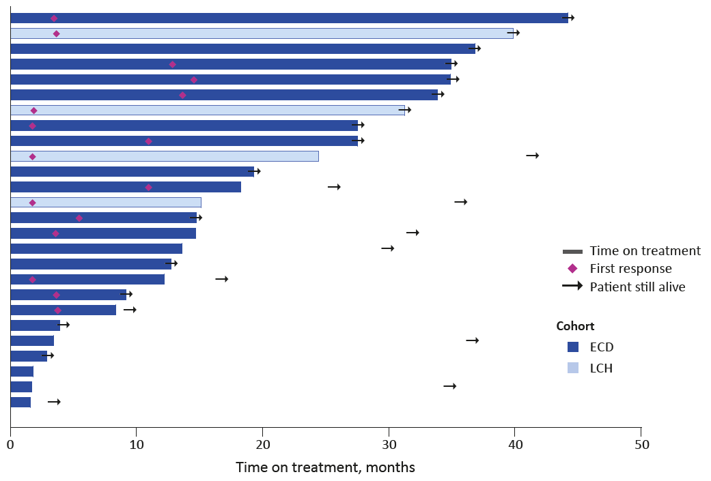
B
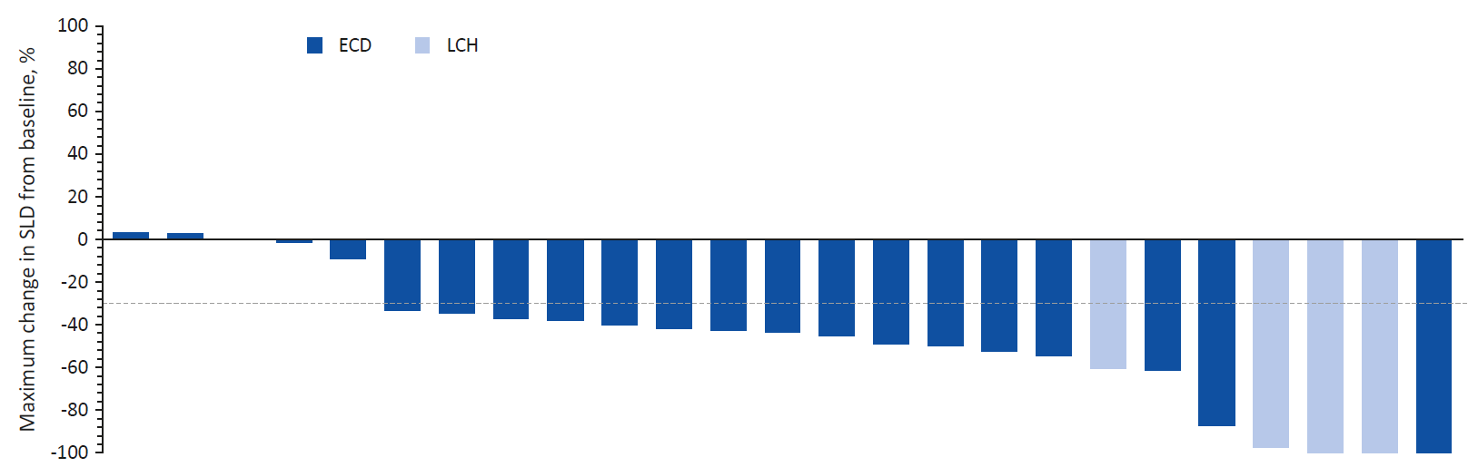
Supplementary Figure S1. A, Tumor response to vemurafenib in patients with non-histiocytic tumors. Plot of time on treatment and time to first response, in individual patients. B, Waterfall plot of maximum percent decrease from baseline in the sum of diameters of target tumors based on investigator assessment in patients with non-histiocytic tumors and measurable disease. The dashed line at -30% represents the cut-off for RECIST response.
*>100%.

A
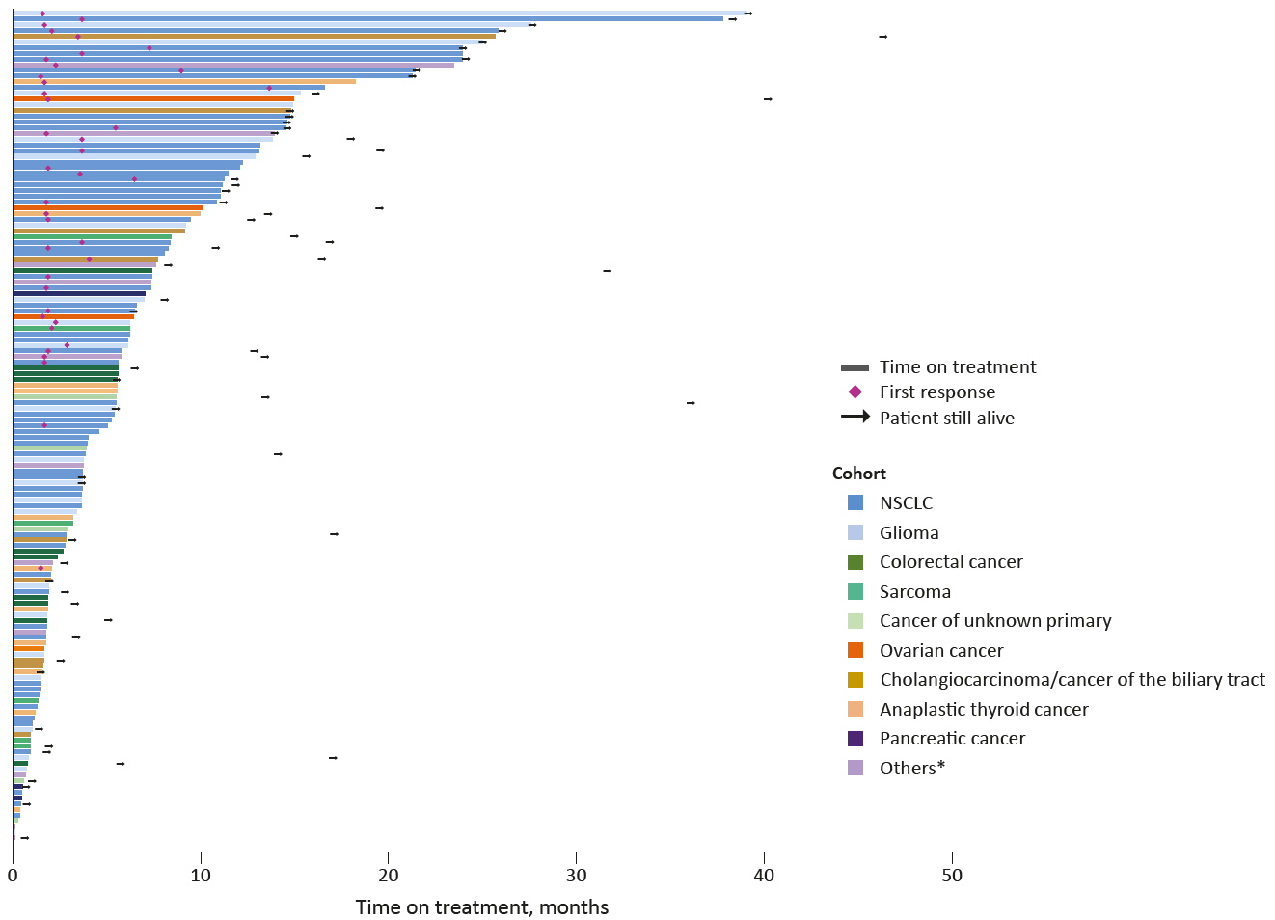
B
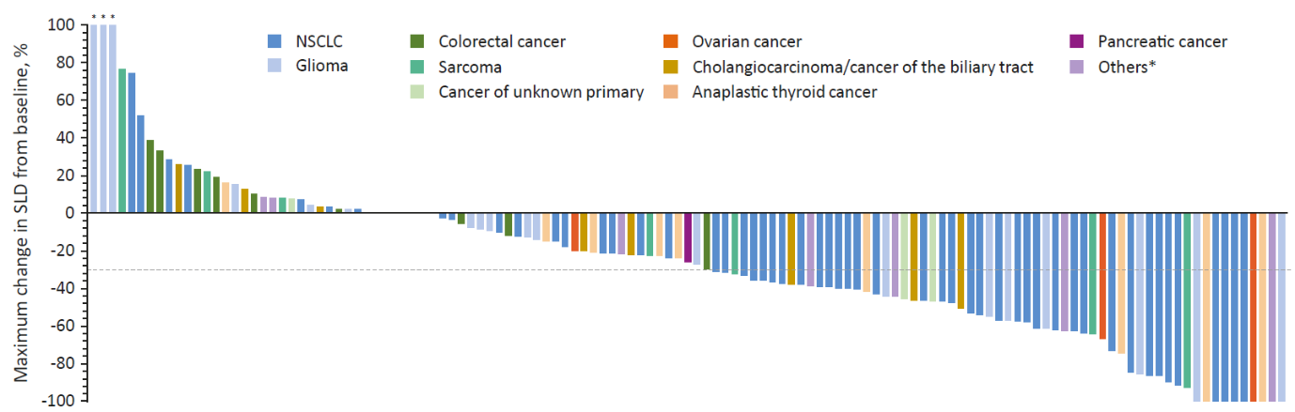
Supplementary Figure S2. A, Tumor response to vemurafenib in patients with non-histiocytic tumors. Plot of time on treatment and time to first response, in individual patients. B, Waterfall plot of maximum percent decrease from baseline in the sum of diameters of target tumors based on investigator assessment in patients with non-histiocytic tumors and measurable disease. The dashed line at -30% represents the cut-off for RECIST response.
*>100%.

