Mondello and Tadros et al., Supplementary Materials
Selective inhibition of HDAC3 targets synthetic vulnerabilities and activates immune surveillance in lymphoma.

Contents
Figure S1: Sanger sequencing of CRISPR-modified RL isogenic clones.
Figure S2: Location of differentially acetylated histones with respect to coding genes.
Figure S3: H3K18Ac and H3K27me3 changes in CREBBP^{R1446C} clones.
Figure S4: ssGSEA of the CREBBP mutation signature in primary sorted FL B-cells.
Figure S5: Redundancy of CREBBP and EP300 at the MHC class II and PD-L1 loci.
Figure S6: Genetically engineered mouse model of Crebbp KAT mutation.
Figure S7: Knock-down of HDAC3 in RL cells.
Figure S8: High-throughput screening of Romidepsin and SAHA in DLBCL cell lines.
Figure S9: Induction of p21 expression by HDAC3 inhibition in CREBBP wild-type cell lines.
Figure S10: qPCR analysis of BCL6 target genes in PDX models treated with BRD3308.
Figure S11: Validation of increased H3K27Ac by ChIP-qPCR.
Figure S12: Dose titration of BRD3308 in WT and R1446C isogenic cell lines.
Figure S13: Toxicity of HDAC inhibitors to activated CD4 and CD8 T-cells.
Figure S14: Induction of MHC class II and PD-L1 in PDX models treated with BRD3308.
Figure S15: ELISPOT analysis of IFNγ production in co-culture assays.
Figure S16: Phenotyping of CRISPR modified cell lines.
Supplementary Methods

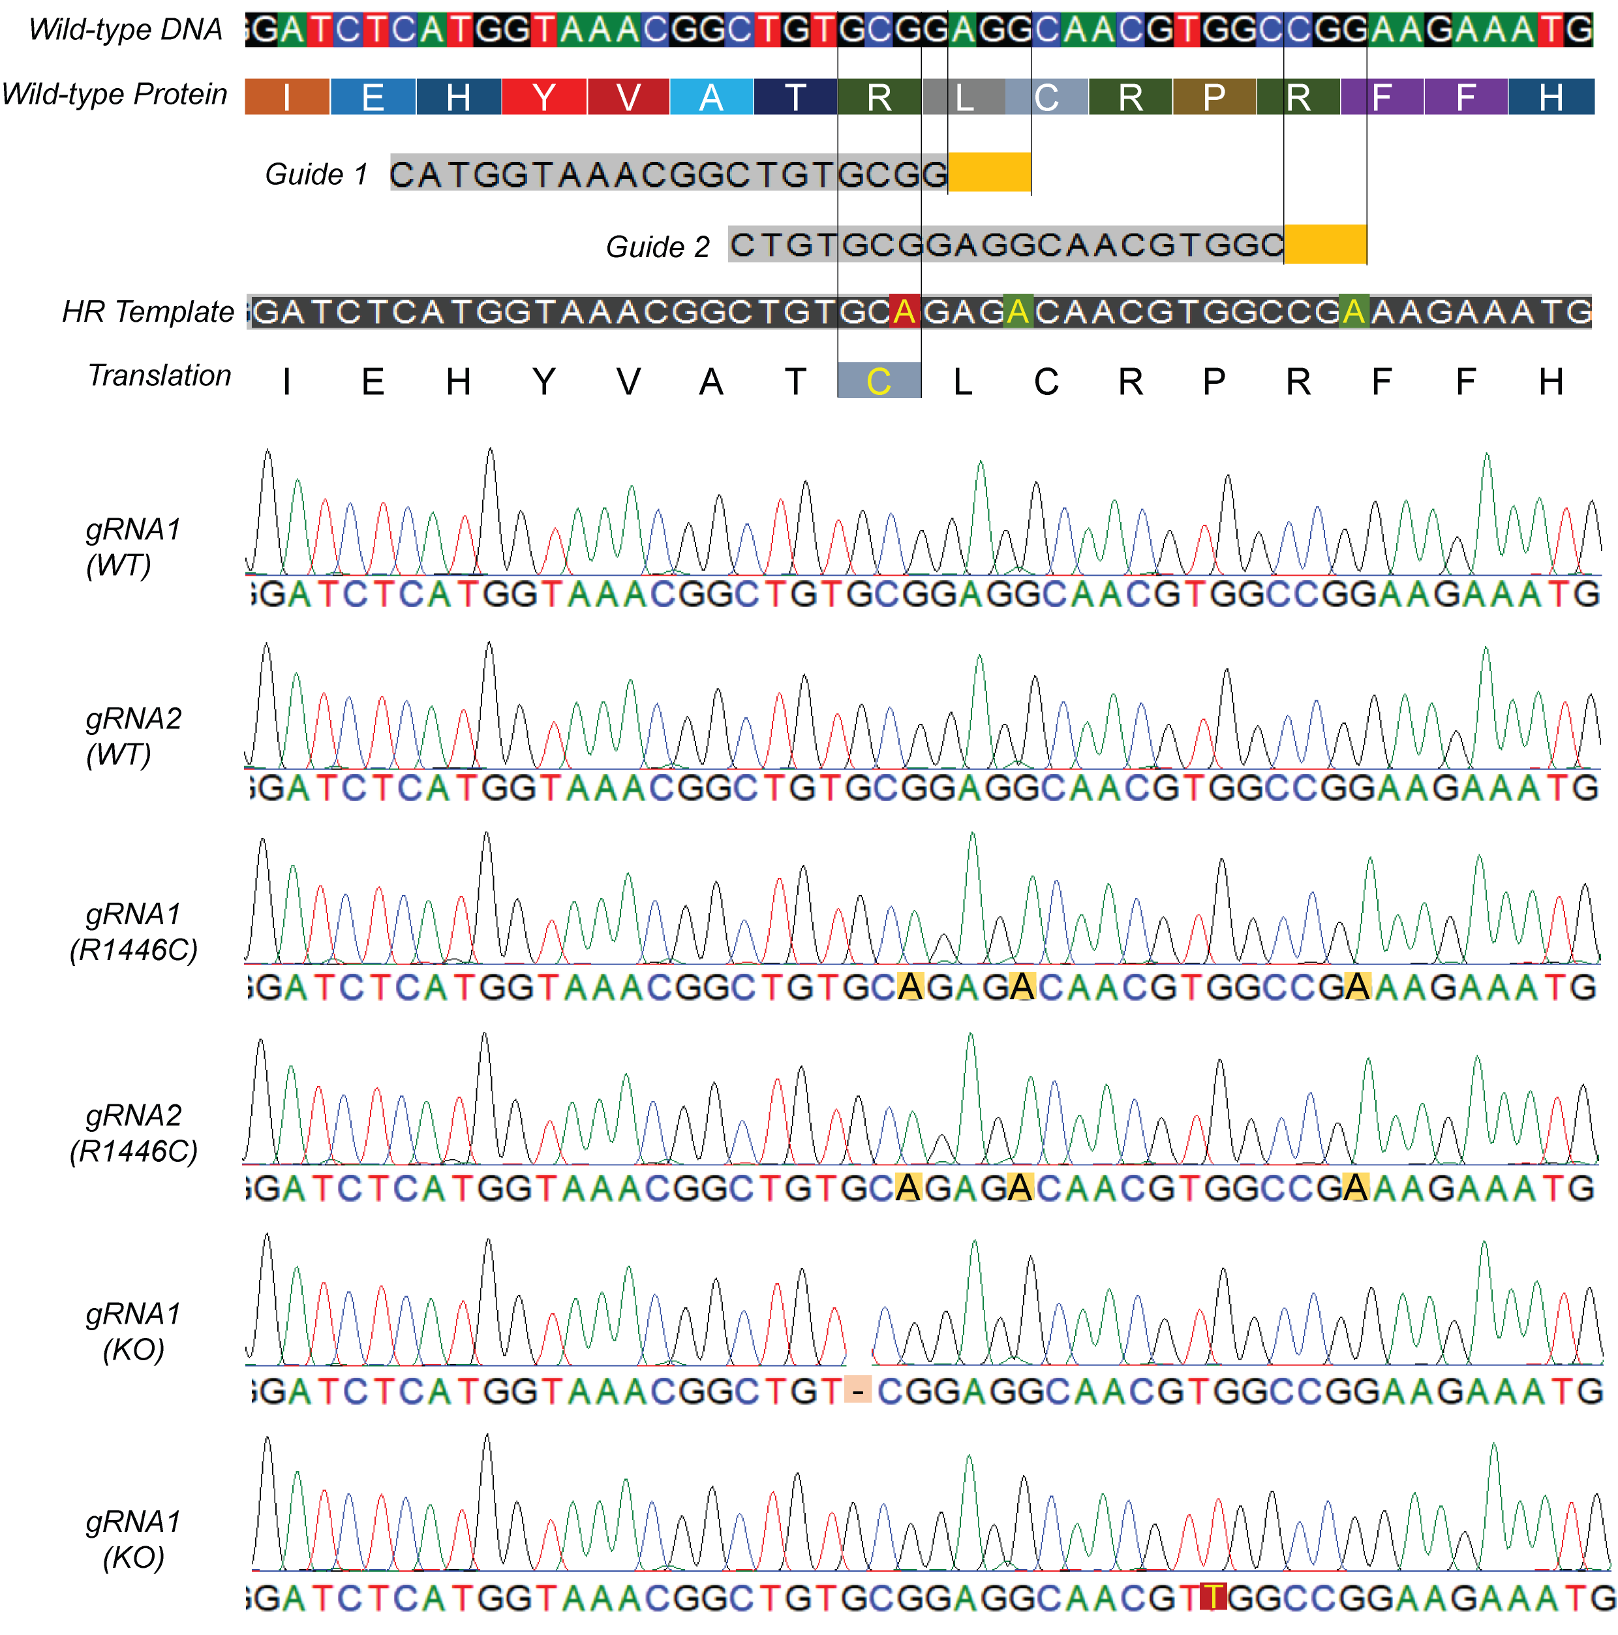
Figure S1: Sanger sequencing of CRISPR-modified RL isogenic clones. Sanger sequencing of the targeted region identified cells that remained wild-type (WT), those that incorporated the HR-template encoded nucleotide changes into both alleles (R1446C) and those that introduced homozygous frameshift mutations (KO). Isogenic clones generated with each unique guide-RNA (gRNA) were used as direct comparators.

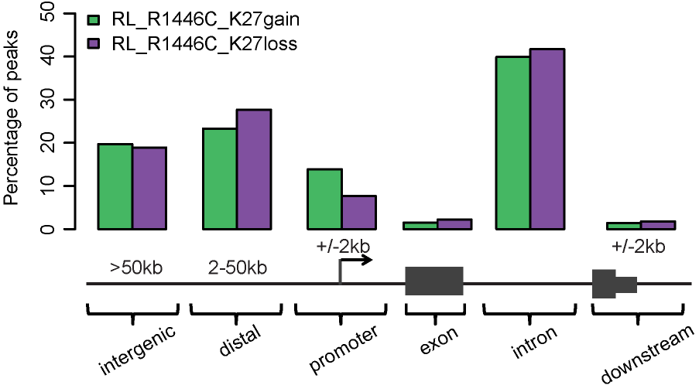
Figure S2: Location of differentially acetylated histones with respect to coding genes. Regions of H3K27Ac gain and loss are shown according to their orientation to the nearest transcription start site. These regions most commonly affected intronic enhancers a distal or intergenic enhancers.

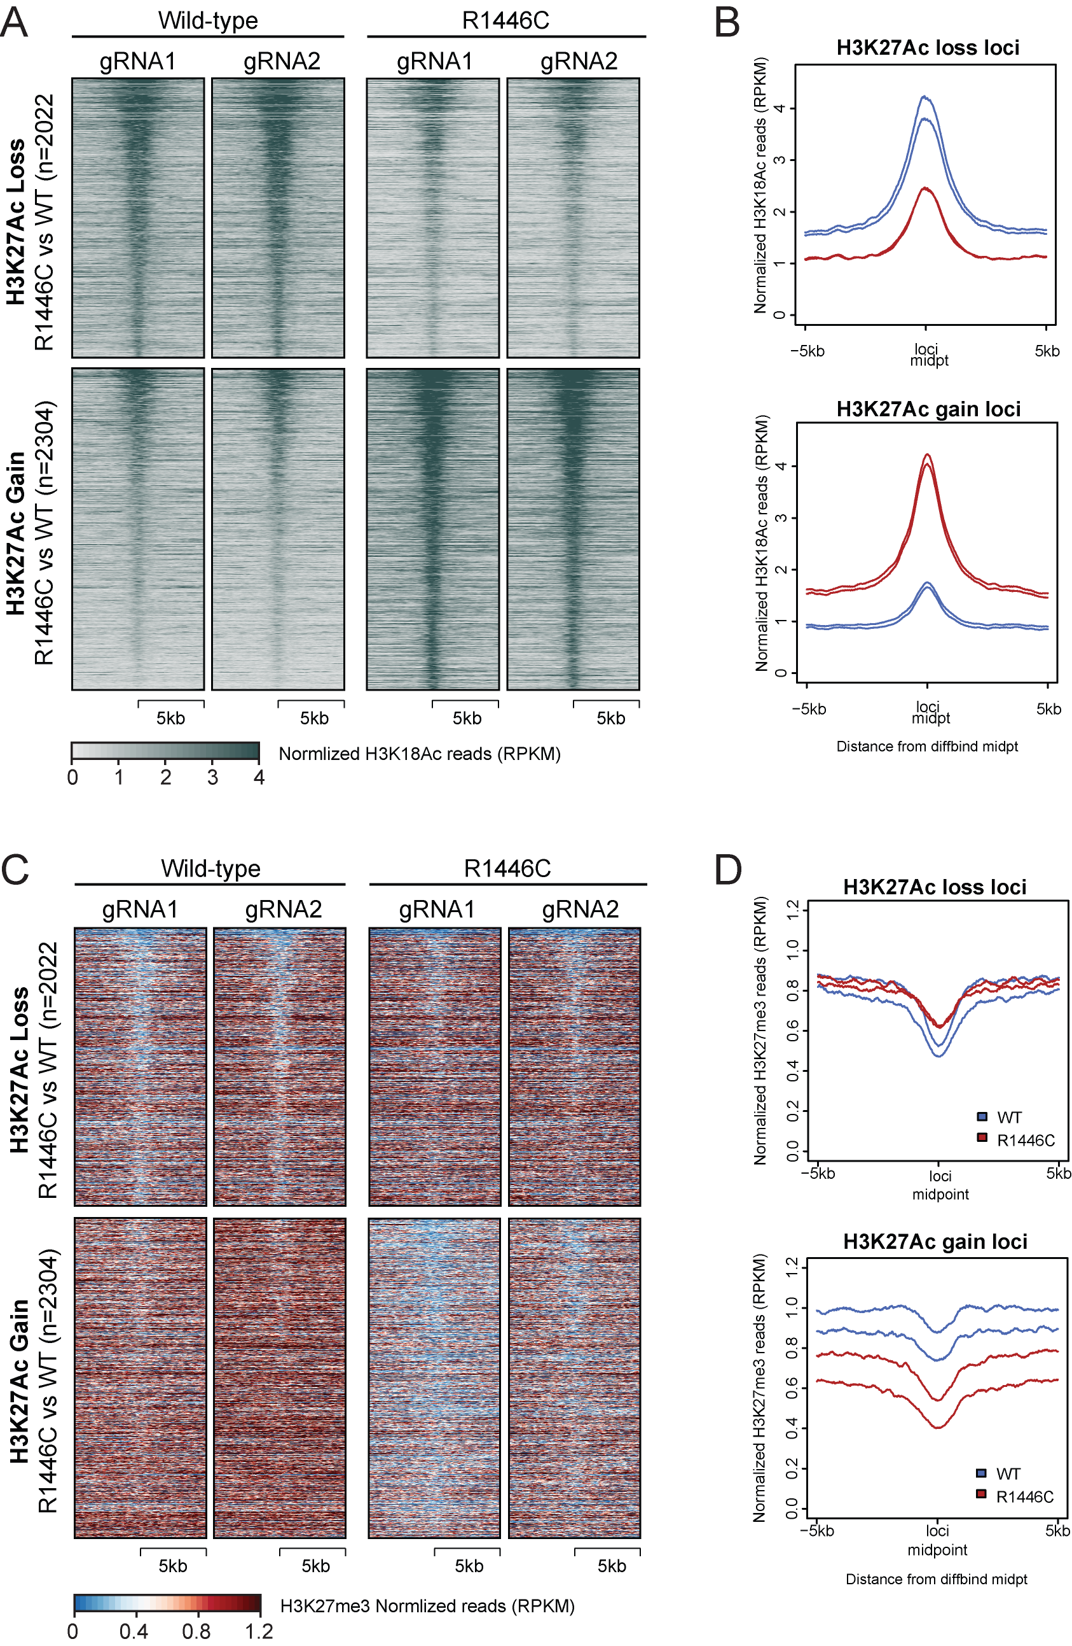
Figure S3: H3K18Ac and H3K27me3 changes in CREBBP^{R1446C} clones. A-B) Heatmaps (A) and density plots (B) show the signal for H3K18Ac over the regions with significantly decreased (above) or increased (below) H3K27Ac in CREBBP^{R1446C} cells compared to isogenic WT controls. C-D) Heatmaps (C) and density plots (D) show the signal for H3K27me3 over the regions with significantly decreased (above) or increased (below) H3K27Ac in CREBBP^{R1446C} cells compared to isogenic WT controls.
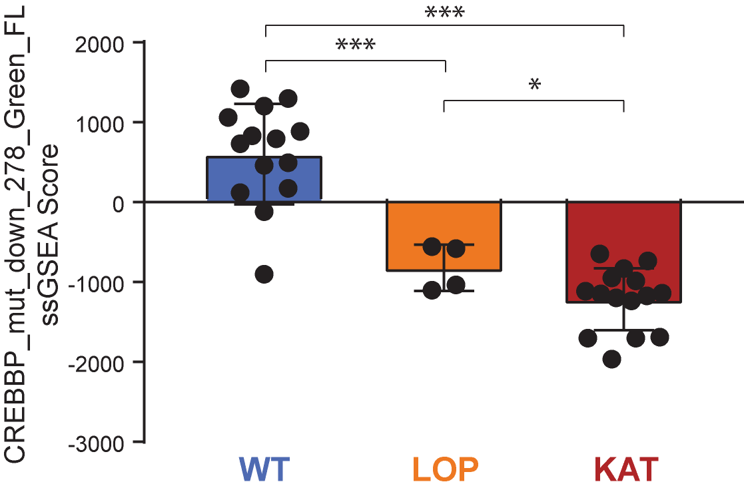
Figure S4: ssGSEA of the CREBBP mutation signature in primary sorted FL B-cells. Single sample GSEA (ssGSEA) scores for the genes found to be down-regulated in association with CREBBP mutation in sorted primary FL tumor B-cells. These are plotted for the same sorted primary FL tumor B-cells for which the signature was defined¹, but is now shown with the CREBBP mutant tumors separated into those with loss-of-protein (LOP) mutations vs lysine acetyltransferase (KAT) domain missense mutations. The ssGSEA scores for the LOP mutation tumors are significantly lower than WT tumors, but significantly higher than the KAT mutation tumors (*P<0.05, ***P<0.001).

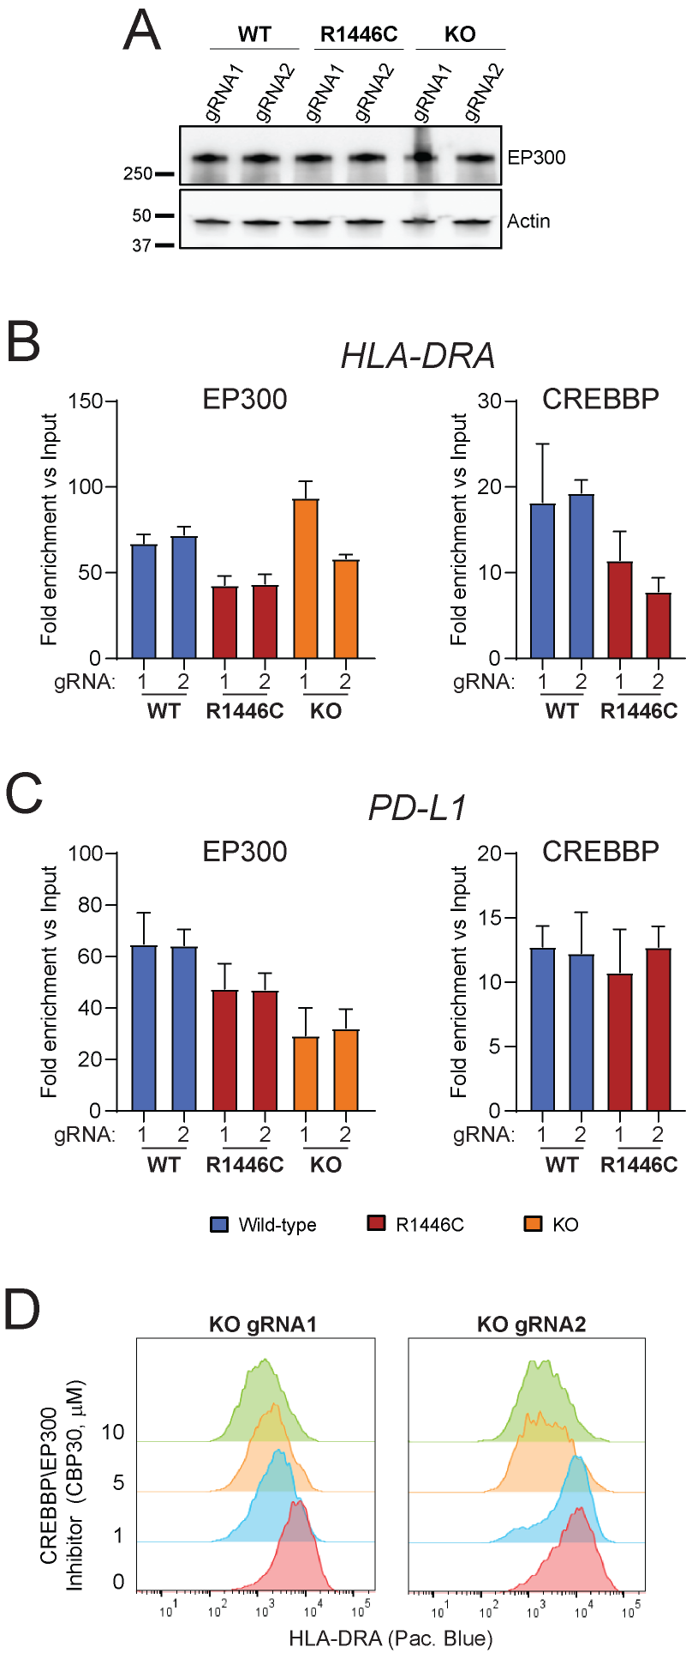
Figure S5: Redundancy of CREBBP and EP300 at the MHC class II and PD-L1 loci. A) A western blot showing EP300 protein expression in the CRISPR edited cell lines. B-C) ChIP-qPCR quantification of the binding of EP300 (left) and CREBBP (right) to HLA-DRA (A) and PD-L1 (B) regulatory elements that are differentially regulated by CREBBP^{R1446C} mutation. D) Flow cytometry of MHC class II expression following 72h treatment of CREBBP^{KO} cells with increasing concentrations of the CREBBP/EP300 inhibitor, CBP30². A reduction in MHC class II in these CREBBP-null cells may be attributed inhibition of EP300.
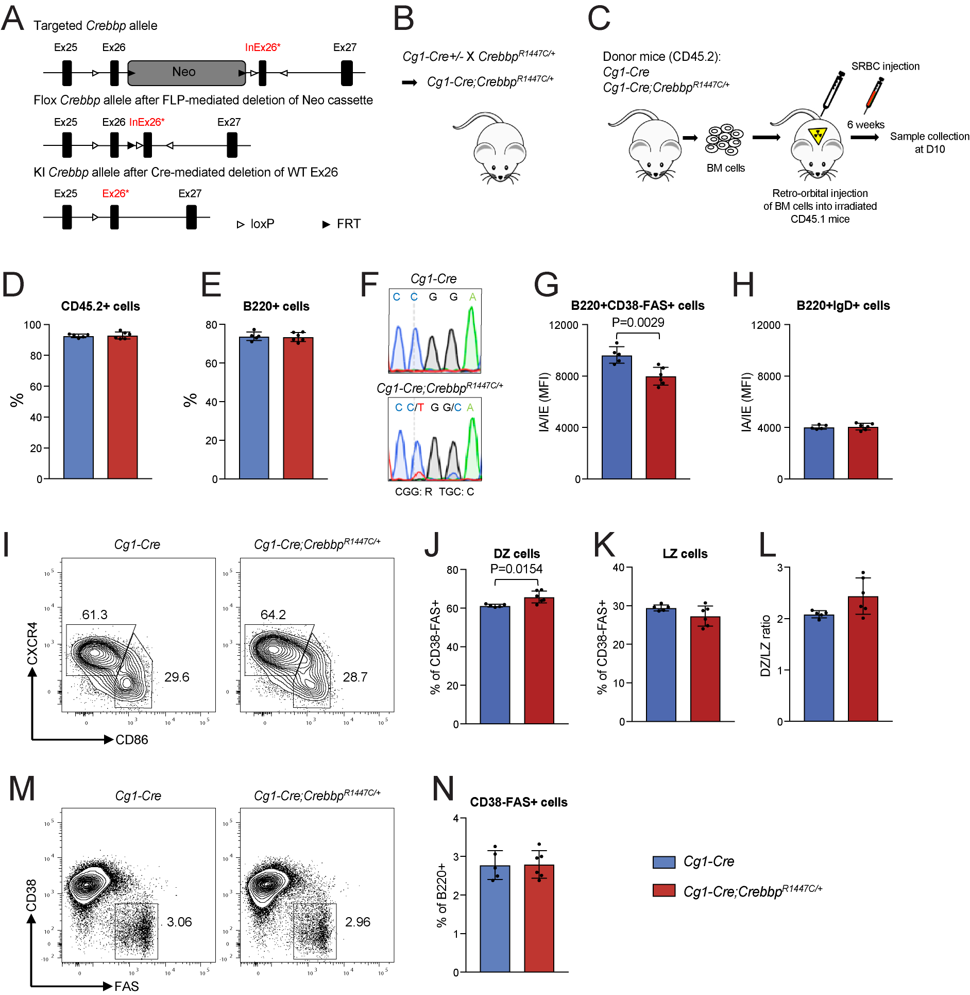
Figure S6: Genetically engineered mouse model of Crebbp KAT mutation. A-C) Generation of Crebbp-R1447C conditional knock-in mice. (A) Schematic representation of Crebbp targeted allele, conditional KI (flox) allele, and KI allele. In the targeted allele, a single loxP site was inserted in the intron before exon 26. A neomycin (Neo) cassette flanked by FRT sites along with an inverted exon 26 with point mutations flanked by two mutant loxP sites (loxP71-InEx26*-loxP66) was inserted into intron 26-27 of the Crebbp allele. The Neo cassette was removed by crossing with FLP mice. In the presence of Cre recombinase, the mutated exon 26 is expressed to replace the wild-type (WT) exon 26. (B) Breeding scheme of germinal center (GC) B cell specific Crebbp-R1447C mice (Cγ1-Cre;Crebbp^{R1447C/+}) by crossing Crebbp^{R1447C/+} mice with Cγ1-Cre+/- mice. (C) Schematic diagram of sheep red blood cell (SRBC) immunization study in Crebbp R1447C cohort mice generated by bone marrow transplantation. D-F) Flow cytometry of transplanted mice showed the same frequencies of CD45.2+ cells (D) and total B220+ B-cells (E) in mice transplanted with bone marrow cells from Cγ1-Cre (blue) and Cγ1-Cre;Crebbp^{R1447C/+} (red) mice. F) Sanger sequencing of cDNA from sorted GC B cells of Cγ1-Cre and Cγ1-Cre;Crebbp^{R1447C/+} mice indicates the introduction of R1447C. G-H) Flow cytometry of D10 splenocytes from Cγ1-Cre (blue) and Cγ1-Cre;Crebbp^{R1447C/+} (red) mice show a significant reduction of MHC class II (Ia/Ie) on GC B-cells (G), but not naïve B-cells (H). I-L) Light zone and dark zone B-cell frequencies were assessed by flow cytometry of D10 splenocytes from Cγ1-Cre (blue) and Cγ1-Cre;Crebbp^{R1447C/+} (red) mice, which showed a significant increase in the frequency of dark-zone GC B-cells. M-N) The frequency of GC B-cells was assessed in D10 splenocytes from Cγ1-Cre (blue) and Cγ1-Cre;Crebbp^{R1447C/+} (red) mice and found not to be significantly different. All bars graphs show the mean ± s.d. Significance was tested using a 2-tailed Student’s T-test; *P<0.05, **P<0.01, ***P<0.001.

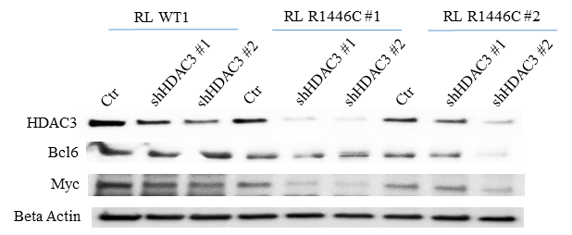

Figure S7: Knock-down of HDAC3 in RL cells. Knock-down of HDAC3 using two unique shRNA hairpins was validated by western blot. Knock-down was able to significantly reduce HDAC3 expression in all cell lines, though the initial level was higher in wild-type cells.

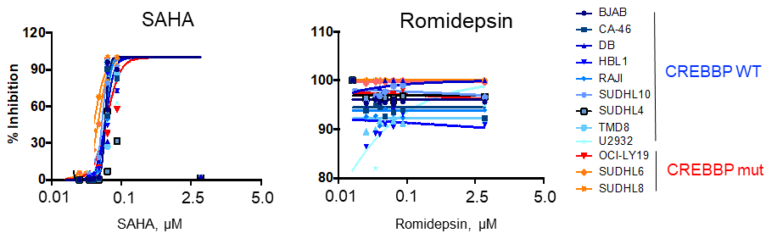
Figure S8: High-throughput screening of Romidepsin and SAHA in DLBCL cell lines. The effect of SAHA and Romidepsin on growth inhibition of DLBCL cell lines was obtained from high-throughput screening of a library of inhibitors. CREBBP wild-type and mutant cell lines cannot be distinguished because these inhibitors showed a high level of toxicity at the lowest doses.
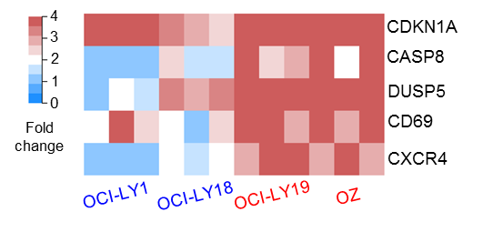
Figure S9: Induction of p21 expression by HDAC3 inhibition in CREBBP wild-type cell lines. qPCR was used to investigate the expression of BCL6 target genes in CREBBP wild-type (blue) and mutant (red) cell lines following treatment with BRD3308. The data are represented as fold change compared to vehicle control. It can be seen that CDKN1A expression is induced in both wild-type and mutant cell lines, while other BCL6 target genes tend to be preferentially induced only in CREBBP mutant cell lines.

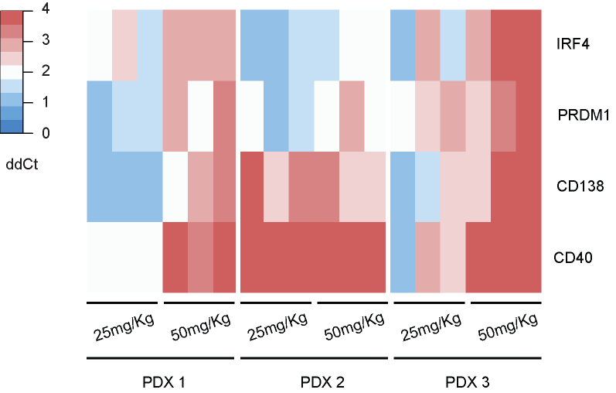
Figure S10: qPCR analysis of BCL6 target genes in PDX models treated with BRD3308. Treatment of PDX tumors in vivo was associated with increased expression of B-cell terminal differentiation genes, as determined by qPCR. The heat map displays the ΔΔC_{T} value of each gene, compared between tumors from treated and untreated mice.
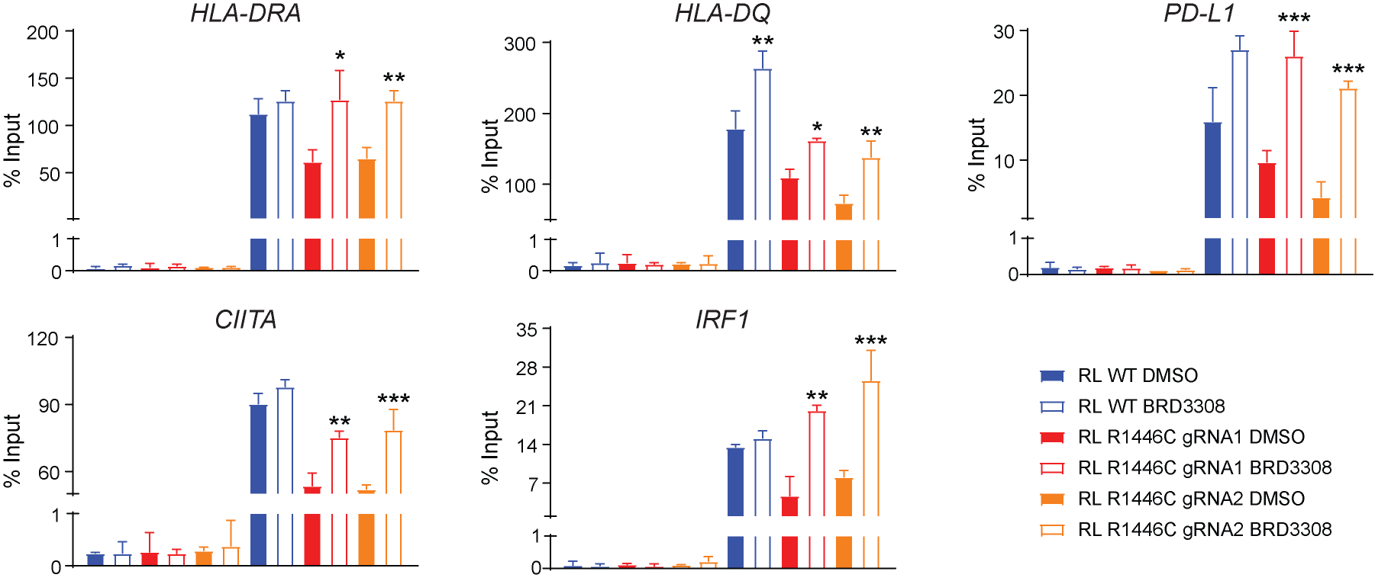
Figure S11: Validation of increased H3K27Ac by ChIP-qPCR. The increased H3K27Ac signal at selected interferon-responsive gene loci following treatment with BRD3308 were validated using ChIP-qPCR. The data represent the mean +/- SEM of triplicate experiments (T-test *P<0.05, **P<0.01, ***P<0.001)

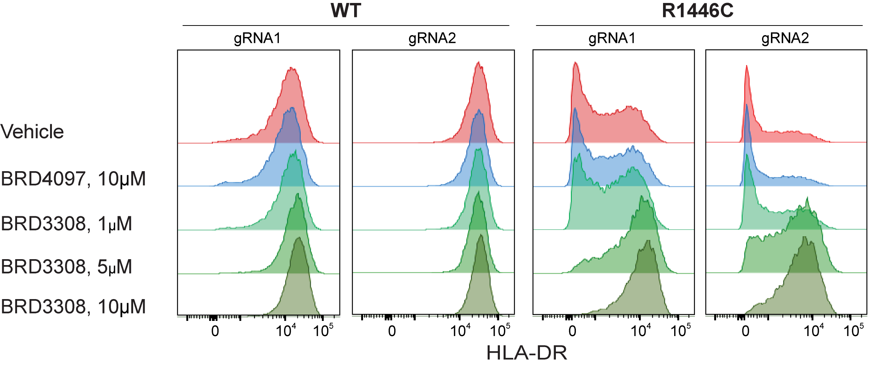Figure S12: Dose titration of BRD3308 in WT and R1446C isogenic cell lines. Flow cytometry for HLA-DR shows an increase in MHC class II expression in both wild-type (WT) and mutant (R1446C) cells, with the magnitude being observably greater in the mutant setting.
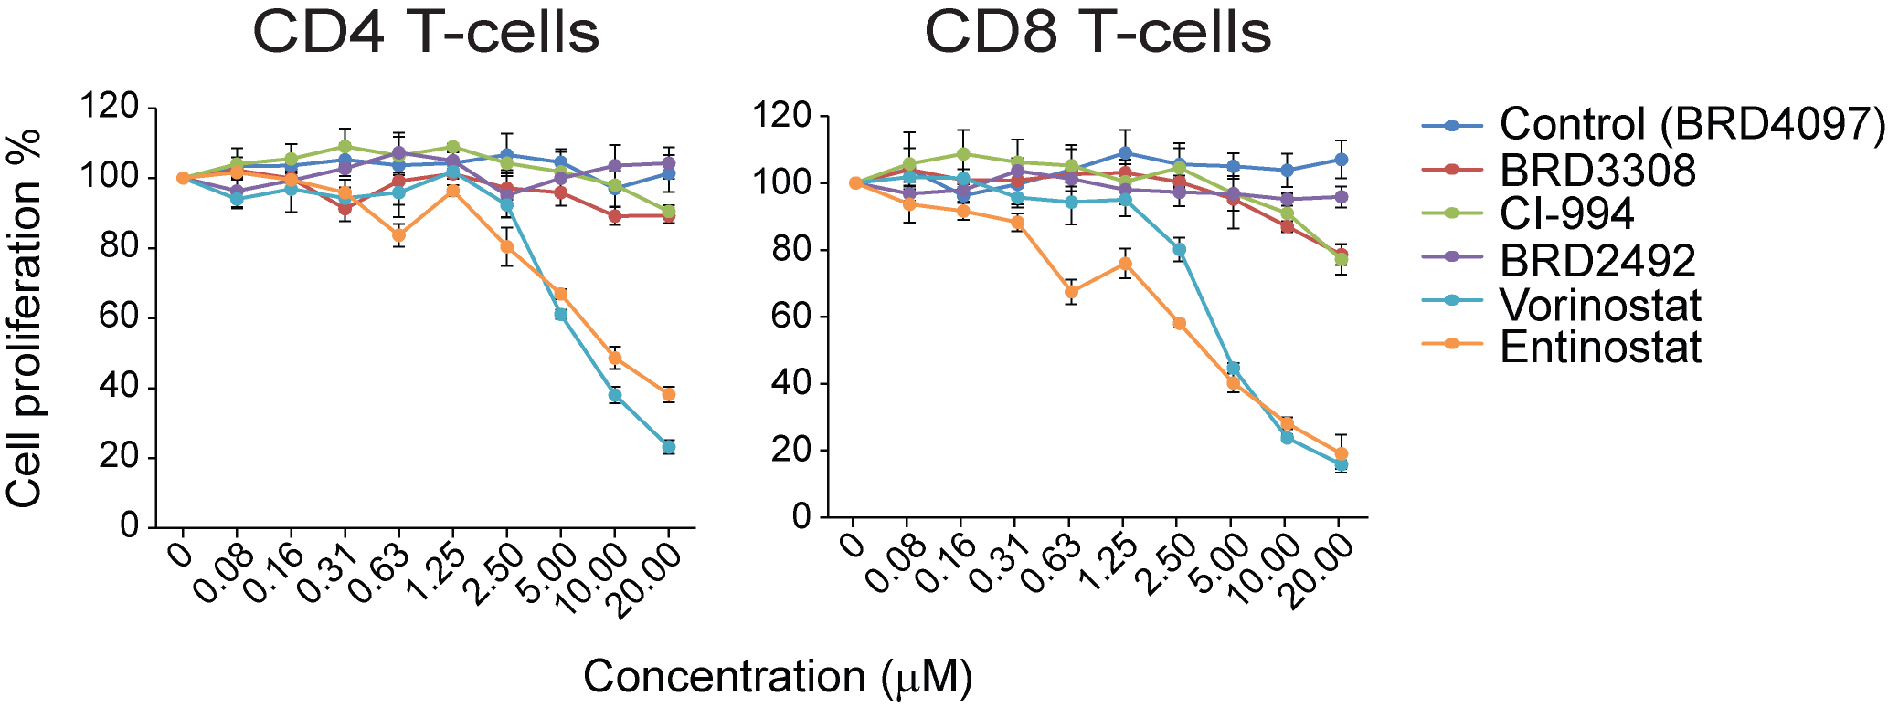
Figure S13: Toxicity of HDAC inhibitors to activated CD4 and CD8 T-cells. Healthy peripheral blood-derived CD4 or CD8 T-cells were exposed to a concentration gradient of HDAC inhibitors with varying specificities with stimulation using CD3 and CD28 cross-linking antibodies. The less specific HDAC inhibitors, Vorinostat and Entinostat, were toxic to T-cells at the higher doses while more selective inhibitors including BRD3308 were not.

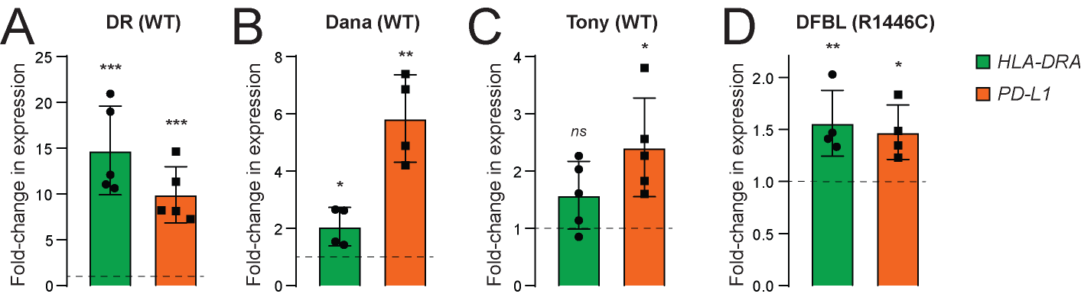
Figure S14: Induction of MHC class II and PD-L1 in PDX models treated with BRD3308. qPCR analysis of HLA-DRA (green) and PD-L1 (orange) expression, normalized to GAPDH, in PDX models from mice treated with 25mg/kg BRD3308 relative to those from vehicle control treated mice. The models included CREBBP wild-type tumors that were implanted subcutaneously (DR [A], Dana [B], Tony [C]), and a CREBBP R1446C mutant tumor that was implanted within the renal capsule (DFBL [D]). Differences in expression were tested by comparing the ΔCT values from vehicle control vs BRD3308 treated tumors with a one-sided Student’s T-test (ns, not significant; *P<0.05; **P<0.01; ***P<0.001).

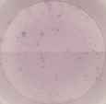
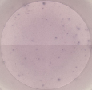
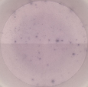
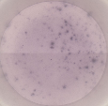
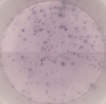
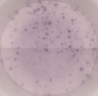
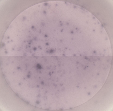
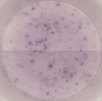
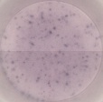
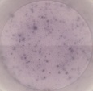
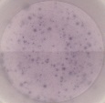
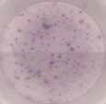
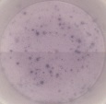
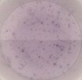
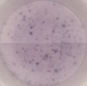
DMSO
BRD3308
1 μM
BRD3308
5 μM
BRD3308
10 μM
BRD3308
15 μM
OCI-LY18 + TIL
Figure S15: ELISPOT analysis of IFNγ production in co-culture assays. Images are provided of the ELISPOT data that are summarized in Figure 7C.

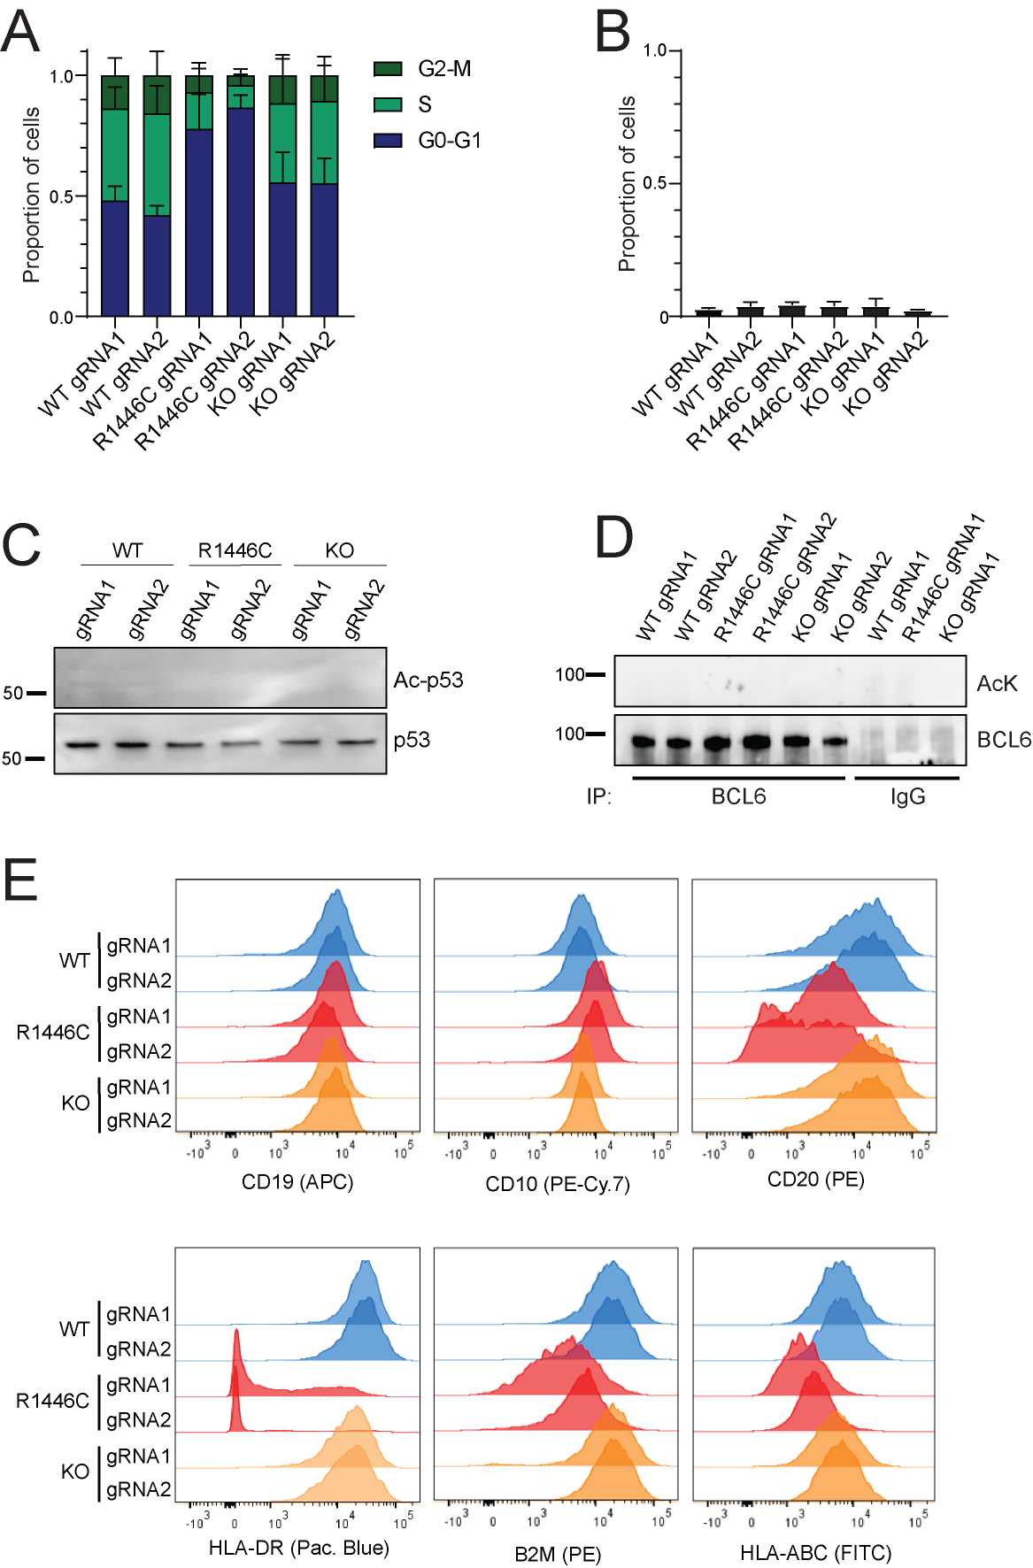
Figure S16: Phenotyping of CRISPR modified RL cells. A) Cell cycle analysis from 3-4 replicated of BrdU incorporation assays are shown for the CRISPR modified RL cell lines. Fewer cycling cells were observed in CREBBP^{R1446C} cells. B) The baseline fraction of apoptotic cells is shown from 3 replicates of Annexin-V/TOPRO-3 staining. No difference in apoptosis was observed. C) Western blot analysis of CRISPR modified RL cells performed for acetylated and total-p53. No acetylation of p53 was detected in any of the cells. D) Immunoprecipitation western blot for BCL6. The BCL6 protein was immunoprecipitated from CRISPR modified RL cells and analyzed for acetylation using an acetyl-lysine (AcK) antibody. The blot was stripped and re-probed for using a BCL6 antibody. No acetylation of BCL6 was detected in any of the cells. E) Immunophenotyping of CRISPR modified RL cells was performed by flow cytometry of B-cell surface antigens (CD19, CD10, CD20) and antigen presentation machinery (HLA-DR as shown in Figure 1, B2M, HLA-A/B/C). Reductions in CD20, MHC class I (B2M and HLA-A/B/C) and MHC class II were observed in CREBBP^{R1446C} cells.

SUPPLEMENTARY MATERIALS AND METHODS
Histone deacetylase inhibitors. A previously described HDAC3-selective inhibitor, BRD3308, and its inactive analogue, BRD4097, were supplied by KDAc therapeutics³. Other HDAC inhibitors were synthesized according to their published structures. These included Vorinostat, Entinostat, BRD2492 and CI-994.

CRISPR/Cas9 modification of the RL cell line. The RL cell-line was purchased from ATCC (CRL-2261) and was selected due to it harboring the BCL2 translocation that is characteristic of follicular and GCB-like diffuse large B-cell lymphoma, without the presence of MYC translocation. This cell line also possesses EZH2 (Y641N) and HIST1H1E mutations (A120T and A134V), but is wild-type for EP300. Two unique guide RNA (gRNA) sequences (gRNA1, CATGGTAAACGGCTGTGCGG; gRNA2, CTGTGCGGAGGCAACGTGGC) that were proximal to the codon for the R1446 hotspot were cloned into the pSpCas9(BB)-2A-GFP vector (pX458, Addgene plasmid #48138, gift from Feng Zhang)⁴. A 181bp single stranded oligonucleotide homologous recombination template was manufactured (IDT) that encoded TGC>TGT and TTC>TTT silent substitutions to remove the PAM sites for Cas9, as well as a CGC>TGC substitution that encodes the R1446C amino acid change (sequence below). A total of 1µg of either of the two pX458 vectors and 10pm of HR template was transfected by electroporation into 2.5x10⁶ cells using an AMAXA nucleofector device (Program O-017, Kit V). Single GFP-positive cells were sorted into 96-well round-bottomed plates 3-4 days after transfection and single cell colonies expanded. Genomic DNA was extracted from each clone using QiaAmp DNA mini kit (Qiagen), the targeted region amplified by PCR (CBP-F, TGGAAAGAGGAGCTTTGGAG; CBP-R, TTGCAGCCTGAATGACAGAG), and mutation status evaluated by Sanger sequencing. The process was repeated for until point mutants were retrieved from each of the two gRNAs, totaling 742 single clones over a 1 year period. Cells that received the construct but remained wild-type (CREBBP^{WT}), and cells that introduced homozygous frameshift mutations (CREBBP^{KO}) were selected from the same experiment as the CREBBP^{R1446C} cells for each gRNA. The selected clones were validated by STR typing (Genetica), and evaluated by targeted sequencing of 380 recurrently mutated genes as described previously⁵ and low-pass whole-genome sequencing to ensure no genomic deviation was observed in comparison to the parental cell line (data not shown). All cells were maintained as sub-confluent culture in RPMI medium with 10% FBS and PenStrep, routinely tested for Mycoplasma, and re-validated by Sanger sequencing prior to each set of experiments. The cell lines will be made available to investigators at not-for-profit institutions through a material transfer agreement.
>R1446C_HR_Template: TTTGAGGGATACCCTGAGTTAAACATGTGCCTCCTTCCCACAGGCGTGTGTACATTTCTTATCTGGATAGTATTCATTTCTTTCGGCCACGTTGTCTCTGCACAGCCGTTTACCATGAGATCCTTATTGGATATTTAGAGTATGTGAAGAAATTAGGGTGAGTTTGGATTAAATTATTTGG

Validation and phenotyping of CRISPR/Cas9 edited RL clones. Potential off-target sites of each guide RNA were determined by BLAST, and all sites with ≥16/20 nucleotide match to either of the gRNA sequences was interrogated by Sanger sequencing. The primer sequences for these 18 loci are in Table S13. All of the CRISPR clones utilized in this study were identical in sequence to the parental RL cell line for all of these loci, indicating that no off-target editing has occurred. Cell cycle was quantified using an APC BrdU Flow Kit (BD Biosciences) and apoptosis using Annexin-V/TOPRO-3 assay (BD Biosciences) (Figure S16A-B). Acetylation of p53 was assessed using by western blot using Acetyl-p53(Lys382) and p53 (clone 7F5) antibodies (Cell Signaling Technology) (Figure S16C). Acetylation of BCL6 was performed by immunoprecipitation with BCL6 antibody (clone D4I2V) and western blot with acetylated-lysine antibody and BCL6 antibody (Cell Signaling Technology) (Figure S16D). All cell lysis and immunoprecipitation buffers contained 5mM sodium butyrate to inhibit deacetylase activity. Immunophenotyping was performed by single color flow cytometry with CD19 APC (Clone HIB19), CD10 PE-Cy7 (Clone HI10a), CD20 PE (Clone L27), HLA-DR Pacific Blue (Clone L243), B2M FITC (Clone TU99), and HLA-A/B/C FITC (Clone G46-2.6) antibodies, analyzed on a BD Fortessa flow cytometer (Figure S16E).

DLBCL cell lines. Human embryonic kidney 293T cells, and the human diffuse large B-cell lymphoma (DLBCL)-derived cell lines SUDHL-4, SUDHL-5, SUDHL-6 and Farage were purchased from ATCC. Human DLBCL cell lines OCI-Ly1, OCI-Ly7, OCI-Ly10, OCI-Ly18, OCI-Ly19, OZ, DOHH-2, HT and RIVA were from the DSMZ German collection of microorganisms and cell cultures. DLBCL cell lines TMD8, HBL-1, U2932, and MD901 were provided by Jose Angel Martinez-Climent, Centre for Applied Medical Research (CIMA), Pamplona, Spain. OCI-Ly3 was provided by Dr Anas Younes, Memorial Sloan Kettering Cancer Center, New York, USA. All human cell lines were identified and authenticated by DNA genotyping before use. DNA extraction, short tandem repeat profiling, and comparison with known cell line profiles from ATCC were performed by Bio-Synthesis Inc. 293T cells were grown in DMEM supplemented with 10% FBS (Invitrogen) and 1% penicillin-streptomycin (Invitrogen). DLBCL cell lines OCI-Ly1, OCI-Ly3, OCI-Ly7, OCI-Ly10, OCI-Ly18 and OCI-Ly19 were grown in Iscove’s medium (Invitrogen), 10% FBS, and 1% penicillin-streptomycin. DLBCL cell lines SUDHL-4, SUDHL-5, SUDHL-6, DOHH-2, TMD8, HBL-1, U2932, MD901, HT, OZ, Farage and RL were cultured in 90% RPMI medium (Invitrogen), 10% FBS, 2 mM glutamine, and 1% penicillin-streptomycin. All cell lines were cultured at 37°C in a humidified atmosphere of 5% CO2. These cell lines have also been routinely tested for mycoplasma contamination in the laboratory.

ChIP-sequencing. Drug treatments: For baseline status, RL CREBBP^{WT}, CREBBP^{KO} and CREBBP^{R1446C} cells were maintained in sub-confluent culture, washed and cells pelleted for RNA extraction. For drug treatments, CREBBP^{WT} and CREBBP^{R1446C} cells were treated with either 10µM of BRD3308 or the inactive control (BRD4097) for 72h, washed and pelleted.
Antibody: Polyclonal antibodies specific for H3K27Ac were purchased from Diagenode and validated for specificity on an Absurance Complete Core Histone Antibody Specificity Array (Millipore).
ChIP: Cells were washed twice in PBS then fixed in 1% formaldehyde for 10 min at 37ºC on a shaker. The reaction was quenched by adding glycine to a final concentration of 0.15M for 5 min at 37ºC on a shaker, the cells pelleted by centrifugation and washed twice in ice cold PBS. The cells were lysed in 140µL of lysis buffer ( 10 mM Tris pH 8.0 at 4ºC, 0.1x PBS, 6 mM EDTA, 0.5% SDS, 1X PI) per 3 million cells for 30 min on ice. The cells were sonicated using Covaris M220 (Woburn, Massachusetts, USA), the cell debris pelleted by centrifugation for 10 min 21000 g at 4ᵒC, and the chromatin-containing supernatant transferred to a new tube with 10% of the volume being reserved as input control. Antibodies for H3K27Ac (4 µg) were coupled to 30 µl of magnetic protein G beads per IP and the beads washed and resuspended in 150 µl of binding/blocking buffer (1X PBS, 0.1% Tween, 0.2% BSA). Chromatin was diluted 5X with dilution buffer (10 mM Tris pH 8.0 at 4ºC, 140 mM NaCl, 1% Triton x-100, 0.1% DOC, 1 mM EDTA, 1X PI) to bring SDS level back to 0.2%, aliquoted it into microcentrifuge tubes containing DynaBeads protein G coupled to H3K27ac Antibody, and rotated overnight at 4 °C. The supernatant was removed and the beads were suspended in100 µl of ice-cold RIPA buffer (1X PBS, 1% NP-40, 0.5% DOC, 0.1% SDS, 1X PI), mixed by pipetting, and the beads and supernatant transferred to pre-chilled PCR tubes. Then we placed the PCR tubes on the DynaMag magnet allowing the beads to adhere to the magnet for 30 s, aspirated the supernatant and discard it. We washed the beads five times with 100 µl of ice-cold RIPA buffer, twice with 100 µl of ice-cold RIPA-500 buffer (RIPA, 360 mM NaCl), twice with 100 µl of ice-cold LiCl wash buffer (10 mM Tris pH 8.0 at 4ºC, 1 mM EDTA, 250 mM LiCl, 0.5% NP-40, 0.5% DOC), once with 100 µl of ice-cold 1× TE buffer. To elute protein-DNA complexes from the beads, we removed the tubes from the magnet and added 50 µl of direct elution buffer ((10 mM Tris pH 8.0 at RT, 5 mM EDTA, 300 mM NaCl, 0.5% SDS) containing 1 µl RNase and 5 µl Proteinase K and incubated the samples and the input samples in PCR machine for 4h 37C, 4h 50C and 16h 65C. We included the input samples from this step forward. Next day, we placed the microcentrifuge tubes on the DynaMag magnet for 2min, transferred the supernatant to a new tubes and discarded protein G magnetic beads. The DNA was isolated using 75 µl of SPRI beads (Beckman Coulter) per 50 µl of sample and evaluated using a TapeStation 4200 instrument (Agilent).
Library preparation and sequencing: Next generation sequencing libraries were prepared using KAPA Hyper Prep Kits (Roche) and TruSeq adapters (Bioo-Scientific) and amplified using 6-8 cycles of PCR. To remove the large fragments (> 500 bp) that may interfere with sequencing we performed size selection after library amplification using AmPure beads (Beckman Coulter). The libraries were evaluated using a TapeStation 4200 instrument (Agilent), quantified using Qubit dsDNA kit (Thermo Fisher) and 6-plexed for sequencing. Each multiplexed pool was sequenced on a single lane of a HiSeq4000 instrument (Illumina) using 2x100bp reads at the MD Anderson Sequencing and Microarray Facility.
Data analysis: The data were mapped using BWA, peaks called using MACS2 (FC>2 and q-value<0.001)⁶, and differential binding analyses performed using DiffBind (FC>4 and q-value<0.1). DiffBind: differential binding analysis of ChIP-Seq peak data (Bioconductor). For gene set enrichment analyses, the gene with the closest transcription start site to the peak was used. Read density heatmaps were prepared using the deepTools package after filtering out duplicate reads and normalizing using RPKM⁷.

Public ChIP-seq dataset. Raw FASTQ files from previously published ChIP-seq of H3K27Ac, CREBBP and BCL6 in germinal center B-cells⁸ was downloaded from the sequence read archive (SRP093282). Data were mapped to hg19 using BWA and converted to wig format for heatmaps.

RNA-sequencing. Drug treatments: For baseline status, RL CREBBP^{WT}, CREBBP^{KO} and CREBBP^{R1446C} cells were maintained in sub-confluent culture, washed and cells pelleted for RNA extraction. For drug treatments, CREBBP^{WT} and CREBBP^{R1446C} cells were treated with either 10µM of BRD3308 or the inactive control (BRD4097) for 72h, washed and pelleted.
Library Preparation: For RL CRISPR clones, RNA was isolated using AllPrep DNA/RNA kits (Qiagen) and evaluated for quality on a Tapestation 4200 instrument (Agilent). Total RNA (1µg) was used for library preparation with KAPA HyperPrep RNA kits with RiboErase (Roche) and TruSeq adapters (Bioo Scientific). Libraries were validated on a Tapestation 4200 instrument (Agilent), quantified by Qubit dsDNA kit (Life Technologies), 6-plexed, and sequenced on a HiSeq4000 instrument at the MD Anderson Sequencing and Microarray Facility using 2x100bp reads. For DLBCL cell line experiments, RNA-seq libraries were prepared using the Illumina TruSeq RNA sample kits, according to the manufacturer’s instructions, and validated using the Agilent Technologies 2100 Bioanalyzer and Quant-iT™ dsDNA HS Assay (Life Technologies). Libraries were sequenced on a HiSeq2000 instrument (Illumina) using 1x50 bp reads.
Data analysis: Reads were aligned with STAR (PMID: 23104886) and annotated to RefSeq using the Rsubread package⁹. Differential expression was called using edgeR generalized linear models¹⁰, using thresholds of fold-change > 1.5 and Benjamini-Hochberg corrected p-value < 0.01. Gene set enrichment was assessed using the GSEA algorithm, a computational method based on the Kolmogorov-Smirnov test¹¹. Unsupervised pathway analysis was performed using information-theoretic pathway analysis approach as described in Goodarzi et al.¹². Briefly, pathways that are informative about non-overlapping gene groups were identified. Pathways annotations were used from the Biological Process annotations of the Gene Ontology database (http://www.geneontology.org), KEGG¹³, MSigDB¹⁴, and signature categories from the Staudt Lab Signature database¹⁵. Only human-curated annotations were used from the Geno Ontology database and only pathways with 5 genes or more, and with 300 genes or less were evaluated. This pathway analysis estimates how informative each pathway is about the target gene groups, and applies a randomization-based statistical test to assess the significance of the highest information values. We use the default significance threshold of p<0.005. We estimated the false discovery rate (FDR) by randomizing the input profiles iteratively on shuffled profiles with identical parameters and thresholds, finding that the FDR was always less than 5%. For each informative pathway, we determined the extent to which the pathway was over-represented in the target gene group, using the hypergeometric distribution, as described in Elemento et al.¹⁶.

Analysis of outcome in primary follicular lymphoma. De-identified time-to-progression (TTP) and overall survival (OS) data were provided for 258 follicular lymphoma patients from the German Lymphoma Study Group (GLSG) and British Columbia Cancer Agency (BCCA), for which CREBBP mutations had been previously described¹⁷. The cases were broken into the following categories: (i) Wild-type [n=83], defined as those with no detected CREBBP mutations; (ii) KAT domain point mutation [n=121], defined as those with one or more amino acid substitutions within the lysine acetyltransferase domain of CREBBP; (iii) loss-of-protein mutation [n=27], those with nonsense or frameshift mutations in CREBBP. A total of 27 cases were excluded from the analysis due to the presence of mutations in both categories (n=8) or splice site mutations of unknown function (n=19). The difference in survival between the KAT domain point mutation and LOP mutation groups was tested using a log-rank (Mantle-Cox) test.

In vitro proliferation assay. Cells were seeded in 96-well plates at 50,000 cell/100 μl/well with either vehicle (DMSO 0.1%) or increasing concentrations of drugs. Cell proliferation was assessed with the fluorescent redox dye CellTiter-Blue (Promega). The reagent was added to the culture medium at 1:5 dilution, according to manufacturer`s instructions. Procedures to determine the effects of certain conditions on cell proliferation and apoptosis were performed in 3 independent experiments. The 2-tailed Student t test and Wilcoxon Rank test were used to estimate the statistical significance of differences among results from the 3 experiments. Significance was set at P < .05. The PRISM software was used for the statistical analyses.

RT-qPCR. RNA was prepared using Trizol extraction (Invitrogen). cDNA was prepared using cDNA synthesis kit (Thermo Scientific) and detected by fast SyberGreen (Applied Biosystems) on 7900HT Fast Real-Time PCR System (Applied Biosystems). We normalized gene expression to HPRT1 or GAPDH and expressed values relative to control using the ΔΔCT method. Results were represented as fold expression with the standard deviation for 2 series of triplicates. Primers used for ChIP and cDNA qPCR are shown in Table S12.

Chromatin immunoprecipitation (ChIP) qPCR. Chromatin Preparation: RL CREBBP^{WT} and CREBBP^{R1446C} cells were treated with 10µM BRD3308 or control (Vehicle, DMSO; Inactive compound, BRD4097) for 72 hours, washed, and fixed with methanol-free formaldehyde (Thermo Scientific/Pierce Cat. No. 28908) at a final concentration of 1% for 8-10 minutes at room temperature. The crosslinking reaction was quenched by adding 1/10th the crosslinking volume of 1.25M glycine and 1M Tris-HCl, pH 8.0 and inverting the tube 5 times. The cells were then pelleted and washed twice in 1mL of cold PBS. After washing the pellet, SDS buffer supplemented with protease inhibitors was added to lyse the cells and the nuclei pelleted by centrifugation. The supernatant was aspirated by pipette and the nuclei resuspended in 1mL of IP buffer. The 1mL nuclei lysates were transferred into a Covaris milliTUBE (Covaris, 520130) and sheared the chromatin (Time: 1200 sec, Power: 140W, Bursts per sec: 200) using the E220 Covaris.
ChIP: After sonication, transferred the sheared chromatin into a DNA LoBind Tube, 1.5mL. Antibodies were added at 1:100 dilution and incubated with sheared chromatin overnight, rotating at 4C. After overnight incubation, Protein A/G Dynabeads (mixed 1:1) were added and incubated for an additional 2 hours while rotating at 4C. Using a magnetic stand, discarded the supernatant and washed the beads with salt buffers, rotating for 5 minutes at 4C with each wash. (The order of the salt washes is Mixed Micelle, Buffer 500, LiCl, and finally TBS.) After the final salt wash, spun down tubes and added 50 uL of elution buffer, rotating at room temperature for 15 minutes. Kept the eluent and decrosslinked by adding 2 uL of 5M NaCl and incubating for at least 4 hours at 65C. Chromatin was incubated overnight at 4°C with 2 µg of specific antibodies [H3K27Ac, Active Motif; CREBBP, Sata Cruz sc-369; EP300, Santa Cruz sc-584] or nonspecific IgG (Santa Cruz, Santa Cruz, CA). Immunocomplexes were precipitated by incubation overnight with protein G-conjugated beads. Immunoprecipitates were washed and crosslinks were reversed by heating to 65°C for 6 hours and then treated with proteinase K for 1 h at 55°C. Chromatin was purified using QiaQuick PCR clean-up columns. qPCR: ChIP-qPCR was performed using SYBR green (Applied Biosystems) on a 7900HT Fast Real-Time PCR System (Applied Biosystems) using the primers listed in Table S12. Data were normalized to 2% input control and enrichment calculated using the 2-ΔΔCT method.

Immunohistology PDX and mice organs were fixed in 4% formaldehyde and embedded in paraffin. Deparaffinized slides were antigen retrieved in citrate buffer pH6.4 and endogenous peroxidase (HRP) activity was blocked by treating the sections with 3% hydrogen peroxide in methanol. Indirect 28 immunohistochemistry was performed with antispecies-specific biotinylated secondary antibodies followed by avidin–horseradish peroxidase or avidin-AP, and developed by Vector Blue or DAB color substrates (Vector Laboratories). Sections were counterstained with hematoxylin if necessary. The following antibodies were used: MHC II clone L243. Photomicrographs were examined using a Zeiss Axioskop imaging microscope. ImageJ 1.44o software (NIH) was used to quantify germinal center areas.

T-cell viability assay. Human PB CD4+ T cells and CD8+ T cells were purchased from StemCell Technologies (Cambridge, MA). Cells were suspended in RPMI medium containing 10% human serum and were seeded on 96-well plates (3 × 10⁴ cells/100 μL) and treated with different concentrations of BRD4097, BRD3308, CI-994, BRD2492, Vorinostat, Entinostat (ranging from 0.625 µM to 160 µM) along with DMSO as a control. Cells were treated with chemicals in presence or absence of Cytostim (Miltenyi Biotec 130-092-173). The live cells were counted after 72 hours incubation by CellTiter-Glo Luminescent Cell Viability Assay (Promega G7570). All experiments were performed in triplicate. All data were analyzed using GraphPad 7 (GraphPad Software, La Jolla, CA), expressed as mean ± SD.

Western blotting. Cells were pelleted by centrifugation, washed once with ice-cold PBS, and lysed on ice for 30 min using the Cell Signaling lysis buffer (#9803) according to manufacturer`s extraction protocol. A total of 30 ug of protein was denatured in Laemli buffer at 95C for 5 minutes and western immunoblotting was performed using the Biorad system (TGX 4-15% gels). Transfer was performed using the Trans Blot turbo system (Biorad, Hercues, CA) into PVDF membranes. Images were acquired by using the BioRad Imaging Chemidoc MP system. Secondary anti-rabbit and anti-mouse HRP-conjugated antibodies were purchased from Biorad (#170-6515, #170-6516). Proteins were detected using the following antibodies purchased from Cell Signaling Technology: p21 (#2947), H3K27Ac (#9677), HDAC3 (#3949), IRF1 (#8478), pstat1 Y701 (#9167), STAT1 (#9172).

shRNA knockdown. shRNA was expressed from a Tet-regulated lentivirus using the miR-E Vector LT3GEPIR, provided by Dr. Zuber(26). In brief, this vector includes a Tet3G promoter, driving expression of EGFP with the 3’ UTR modified with an shRNA target sequence embedded in a miR-30 backbone. In addition, this vector constitutively expresses a puromycin resistance gene and the 3rd generation Tet-transactivator from the PGK promoter, coupled with an IRES sequence. miR-E shRNAs for HDAC3 and CDKN1A (see sequences below) were designed by DSIR-Sensor rule.(26) and cloned into the lentiviral expression vector LT3GEPIR.

Lentiviral particles were generated using a 2nd generation system in HEK293FT cells in 6 well plates. The LT3GEPIR vector expressing the desired shRNA sequence was co-transfected with psPAX2, MD2.G and pSuper expressing shRNA to DGCR8 at a ratio of 7:7:2:1, with a total of 19μl DNA per well. A calcium phosphate transfection system was used to express the plasmids. Media was changed on the 6 well plates the morning following transfection and media collected from the cells at 48 and 72 hours following transfection. This media containing lentiviral particles was centrifuged at 1000rpm for 5 minutes to remove cell debris and filtered through a 0.45 μM filter. This filtered media was used without freezing to infect the target cell population using a spinfection protocol. Viral supernatant was added to 1 million cells in a 50ml conical tube with polybrene (8 μg/ml) and centrifuged at 2000g for 2 hours. Media was then change and the cells returned to normal growth conditions. Puromycin (1 μg/ml) was added 48 hours after infection. Doxycycline (2 μg/ml) was added following selection and protein knockdown measured at 3rd day.
The RNAi sequences of shRNA generated using the DSIR-Sensor rule are as follows:
Ctrl (RENILLA.713) TAGATAAGCATTATAATTCCTA
HDAC3.1898 TTATTGGATAAAAACAGTGGTA
HDAC3.1139 TTTTCAAAGATTGTCTGGCGGA

For CDKN1A shRNA we used pLKO.1-puro, and infected cells were selected with puromycin treatment (1 μg/ml). Mature antisense sequences of shRNA used were:
CDKN1A#1 TAAGGCAGAAGATGTAGAGCG
CDKN1A#2 AAAGTCGAAGTTCCATCGCTC

Flow cytometric analysis. Cells were stained using PE-Cy7 or FITC conjugated anti-PD-L1 (BioLegend), Pacific Blue or FITC conjugated HLA DR (Clone L243, BioLegend) or isotype control mouse IgG. Data were acquired on a MacsQuant (Miltenyi Biotec) or Fortessa (BD) flow cytometer and analyzed using FlowJo software package (TreeStar).

ELISA. Human supernatant was collected after 24, 48 and 72 hours treatment with BRD3308 and analyzed by INF-g ELISA KIT (Abcam #ab46025-1).

Promoter-based studies. GLuc luciferase promoter was obtained from Genecoepia (GeneCoepia Rockville) with the IRF1-responsive promoter from HLA-A cloned upstream of the GLuc enzyme. Normalization was done to SEAP (under the constitutively active SV40 promoter). Cells were seeded at 1 x 10⁶ and treated with indicated drugs for 12 and 24 hours. Luminescence quantitation was assayed using the Secrete-Pair Dual Luminescence Assay Kit (GeneCoepia Rockville).

Ex vivo killing assay. The tumors obtained from OCI-LY18 xenograft implanted in NSG mice, which were injected later with PBMC to make TILs, were dissociated to single cells using a phosphate buffer containing Collagenase A (25000 U/mL), Dispase II (12.5 U/mL), DNAse (500 U/mL). CD3+ tumor-infiltrating lymphocytes (TIL) were positively selected using CD3 microbeads (Miltenyi Biotech, Gladbach, Germany), according to the manufactures’s protocol. T cells were cultures at a concentration of 0.2x10⁶ cells/ml in a 96 flat-bottom well plate with 250 μl/well of RPMI (Cambrex, Verviers, Belgium) containing 10% human serum, 1% PenStrep (Cambrex), 1% Glutamine (Cambrex) and 1% Hepes buffer (Cambrex). T-cell expansion was performed with a single administration of immunomagnetic microbeads coated with mouse anti-human CD3 and CD28 mAb (Dynabeads® CD3/CD28 T Cell Expander or Dynabeads® ClinExVivo CD3/28, Dynal Biotech ASA, Oslo, Norway) according to the manufacturer’s instruction, rhIL2 (3000 U/mL) plus rhIL15 (15 ng/ mL) for 5 days. OCI-LY18 cells were treated with BRD3308 at 10 μM for 3 days, then the cells were spin down and resuspended in fresh media with or without T cells at a ratio of 1:10. After 24 hours co-culture, cell viability was analyzed using CellTiter Blue.

Blocking MHC class I and MHC class II antibody assay. OCI-LY18 and CD3+ TIL were isolates as explained for the ex vivo killing assay. OCI-LY18 cells were treated with BRD3308 at 10 μM for 3 days, then the cells were spin down and resuspended in fresh media with T cells at a ratio of 1:10 with either isotype Ig, or blocking Ab against HLA-ABC W6/32 (life Technologies #MA 119027), HLA-DR/DP/DQ (Thermo Fisher Scientific #BDB555557) at 10μg/ml or the combination of the two. After 24 hours co-culture, cell viability was analyzed using CellTiter Blue (Promega).

ELISPOT assay. OCI-LY18 and CD3+ TIL were isolates as explained for the ex vivo killing assay. OCI-LY18 cells were treated with BRD3308 at 10 μM for 3 days, then the cells were spin down and resuspended in fresh media, irradiated with 15.000 rad and co-culture with CD3+ TIL at a ratio of 1:10 overnight. INF-g production was determined by ELISPOT assay (Thermo Fisher Scientific #EL285).

Blocking Interferon gamma assay. Three CREBBP wild type (LY-1, LY-7, HT), two CREBBP mutant (Farage, OZ), and RL CREBBP CRISPR point mutant and isogenic control cells were treated with either DMSO or BRD3308 at 10 μM in association with either isotope Ig (BioLegend #400124) or blocking Ab against INF-g at 10μg/ml (BioLegend #506513). After 3 days cells were stained using the following fluorescent-labeled antibodies to HLA-DR or PD-L1.

Patient Derived Xenograft (PDX) studies. Six weeks old NSG female mice were implanted subcutaneously with tumor specimens from three lymphoma PDX models (NY-DR2, DANA and TONY). For the efficacy study, treatments started when tumors reached 100 mm3. Mice (12/group) were randomized and dosed via oral gavage with BRD3308 (25 mg/kg) or control vehicle (0.5% methyl cellulose, 0.2% tween 80) twice daily for 21 consecutive days. Mice were observed daily throughout the treatment period for signs of morbidity/mortality. Tumors were measured twice weekly using calipers, and volume was calculated using the formula length × width² × 0.52. Body weight also was also assessed twice weekly. Mice were cared for in accordance with guidelines approved by the Memorial Sloan Kettering Cancer Center Institutional Animal Care and Use Committee and Research Animal Resource Center.

In vitro organoid culture. Established PDTX samples were subcutaneously injected into NSG mice and allowed to grow until the tumor volume reached 1<1,500x mm3. PDTX lines were previously analyzed and molecularly annotated (Sandra and Edward Meyer Cancer Center PDTX Shared Resource). Once the tumors reached sufficient volume, the mice were euthanized and tumors extracted. The tumors were then dissociated to single cells using a phosphate buffer containing Collagenase A (25000 U/mL), Dispase II (12.5 U/mL), DNAse (500 U/mL). Single cells were then stained with CFSE according to the manufacturer’s protocol using 167 nM CFSE in PBS/5% FBS. CFSE stained cells were then washed and mixed with irradiated 40LB cells (3,000 rads gamma irradiation) at a 10:1 ratio of Primary:40LB. The cell mixture was then used to fabricate organoids in a 96-well plate similar to the methods described in Purwada et al 2015, with 20 µL organoids containing 3% silicate nanoparticles and a 5% gelatin in IMDM medium solution. The organoids were cultured in IMDM medium containing 20% FBS supplemented with antibiotics and normocin (Invivogen) for 6 days, doubling the volume of medium after 3 days. The cell mixture was exposed to 4 1:3 serial dilutions of BRD3308 starting at 5 µM or vehicle control (DMSO) in triplicate for 6 days, treating a second time at 3 days. After 6 days of exposure, cell viability and proliferation were assessed by flow cytometry using DAPI staining and CFSE dilution as described above.

Immunofluorescence imaging of IµBcl6;Ezh2^{Y641F}. The immunofluorescent staining was performed at Molecular Cytology Core Facility of Memorial Sloan Kettering Cancer Center using Discovery XT processor (Ventana Medical Systems). The tissue sections were deparaffinized with EZPrep buffer (Ventana Medical Systems), antigen retrieval was performed with CC1 buffer (Ventana Medical Systems). Sections were blocked for 30 minutes with Background Buster solution (Innovex), followed by avidin-biotin blocking for 8 minutes (Ventana Medical Systems). Sections were incubated with either anti- CD4 (R&D Systems, cat#AF554, 2ug/ml) or anti-PD-L1 (R&D Systems cat#AF1019, 2ug/ml) or B220 (BD Biosciences, cat# 550286, 0.3ug/ml) or CD8 (eBiosciences cat# 14-0808, 2.5ug/ml) for 5 hours, followed by 60 minutes incubation with biotinylated horse anti-goat IgG (forCD4 and PD-L1) (Vector cat#BA-9500) or biotinylated goat anti-rat IgG (for CD8 and B220) (Vector labs, cat#BA9400) at 1:200 dilution. The detection was performed with Streptavidin-HRP D (part of DABMap kit, Ventana Medical Systems), followed by incubation with Tyramide Alexa 488 (Invitrogen, cat# B40953) prepared according to manufacturer instruction with predetermined dilutions. After staining slides were counterstained with DAPI (Sigma Aldrich, cat# D9542, 5 ug/ml) for 10 min and coverslipped with Mowiol. The slides were scanned with a Pannoramic Flash P250 Scanner (3DHistech,Hungary) using a 20x/0.8NA objective lens. The fluorescence channels were imaged using DAPI, FITC, and TRITC filters sequentially with manually adjusted exposure times. Images were then exported into .tifs using Caseviewer (3DHistech,Hungary) to be analyzed.

Supplementary References
1 Green, M. R. et al. Mutations in early follicular lymphoma progenitors are associated with suppressed antigen presentation. Proceedings of the National Academy of Sciences of the United States of America 112, E1116-1125, doi:10.1073/pnas.1501199112 (2015).
2 Hammitzsch, A. et al. CBP30, a selective CBP/p300 bromodomain inhibitor, suppresses human Th17 responses. Proceedings of the National Academy of Sciences of the United States of America 112, 10768-10773, doi:10.1073/pnas.1501956112 (2015).
3 Wagner, F. F. et al. An Isochemogenic Set of Inhibitors To Define the Therapeutic Potential of Histone Deacetylases in beta-Cell Protection. ACS Chem Biol 11, 363-374, doi:10.1021/acschembio.5b00640 (2016).
4 Ran, F. A. et al. Genome engineering using the CRISPR-Cas9 system. Nature protocols 8, 2281-2308, doi:10.1038/nprot.2013.143 (2013).
5 Garcia-Ramirez, I. et al. Crebbp loss cooperates with Bcl2 over-expression to promote lymphoma in mice. Blood 129, 2645-2656, doi:10.1182/blood-2016-08-733469 (2017).
6 Zhang, Y. et al. Model-based analysis of ChIP-Seq (MACS). Genome biology 9, R137, doi:10.1186/gb-2008-9-9-r137 (2008).
7 Ramirez, F., Dundar, F., Diehl, S., Gruning, B. A. & Manke, T. deepTools: a flexible platform for exploring deep-sequencing data. Nucleic acids research 42, W187-191, doi:10.1093/nar/gku365 (2014).
8 Zhang, J. et al. The Crebbp Acetyltransferase is a Haploinsufficient Tumor Suppressor in B Cell Lymphoma. Cancer discovery, doi:10.1158/2159-8290.CD-16-1417 (2017).
9 Liao, Y., Smyth, G. K. & Shi, W. The Subread aligner: fast, accurate and scalable read mapping by seed-and-vote. Nucleic acids research 41, e108, doi:10.1093/nar/gkt214 (2013).
10 Robinson, M. D., McCarthy, D. J. & Smyth, G. K. edgeR: a Bioconductor package for differential expression analysis of digital gene expression data. Bioinformatics 26, 139-140, doi:10.1093/bioinformatics/btp616 (2010).
11 Subramanian, A. et al. Gene set enrichment analysis: a knowledge-based approach for interpreting genome-wide expression profiles. Proceedings of the National Academy of Sciences of the United States of America 102, 15545-15550, doi:10.1073/pnas.0506580102 (2005).
12 Goodarzi, H., Elemento, O. & Tavazoie, S. Revealing global regulatory perturbations across human cancers. Molecular cell 36, 900-911, doi:10.1016/j.molcel.2009.11.016 (2009).
13 Kanehisa, M., Sato, Y., Kawashima, M., Furumichi, M. & Tanabe, M. KEGG as a reference resource for gene and protein annotation. Nucleic acids research 44, D457-462, doi:10.1093/nar/gkv1070 (2016).
14 Liberzon, A. et al. Molecular signatures database (MSigDB) 3.0. Bioinformatics 27, 1739-1740, doi:10.1093/bioinformatics/btr260 (2011).
15 Shaffer, A. L. et al. A library of gene expression signatures to illuminate normal and pathological lymphoid biology. Immunol Rev 210, 67-85, doi:10.1111/j.0105-2896.2006.00373.x (2006).
16 Elemento, O., Slonim, N. & Tavazoie, S. A universal framework for regulatory element discovery across all genomes and data types. Molecular cell 28, 337-350, doi:10.1016/j.molcel.2007.09.027 (2007).
17 Jurinovic, V. et al. Clinicogenetic risk models predict early progression of follicular lymphoma after first-line immunochemotherapy. Blood 128, 1112-1120, doi:10.1182/blood-2016-05-717355 (2016).

