Supplementary data

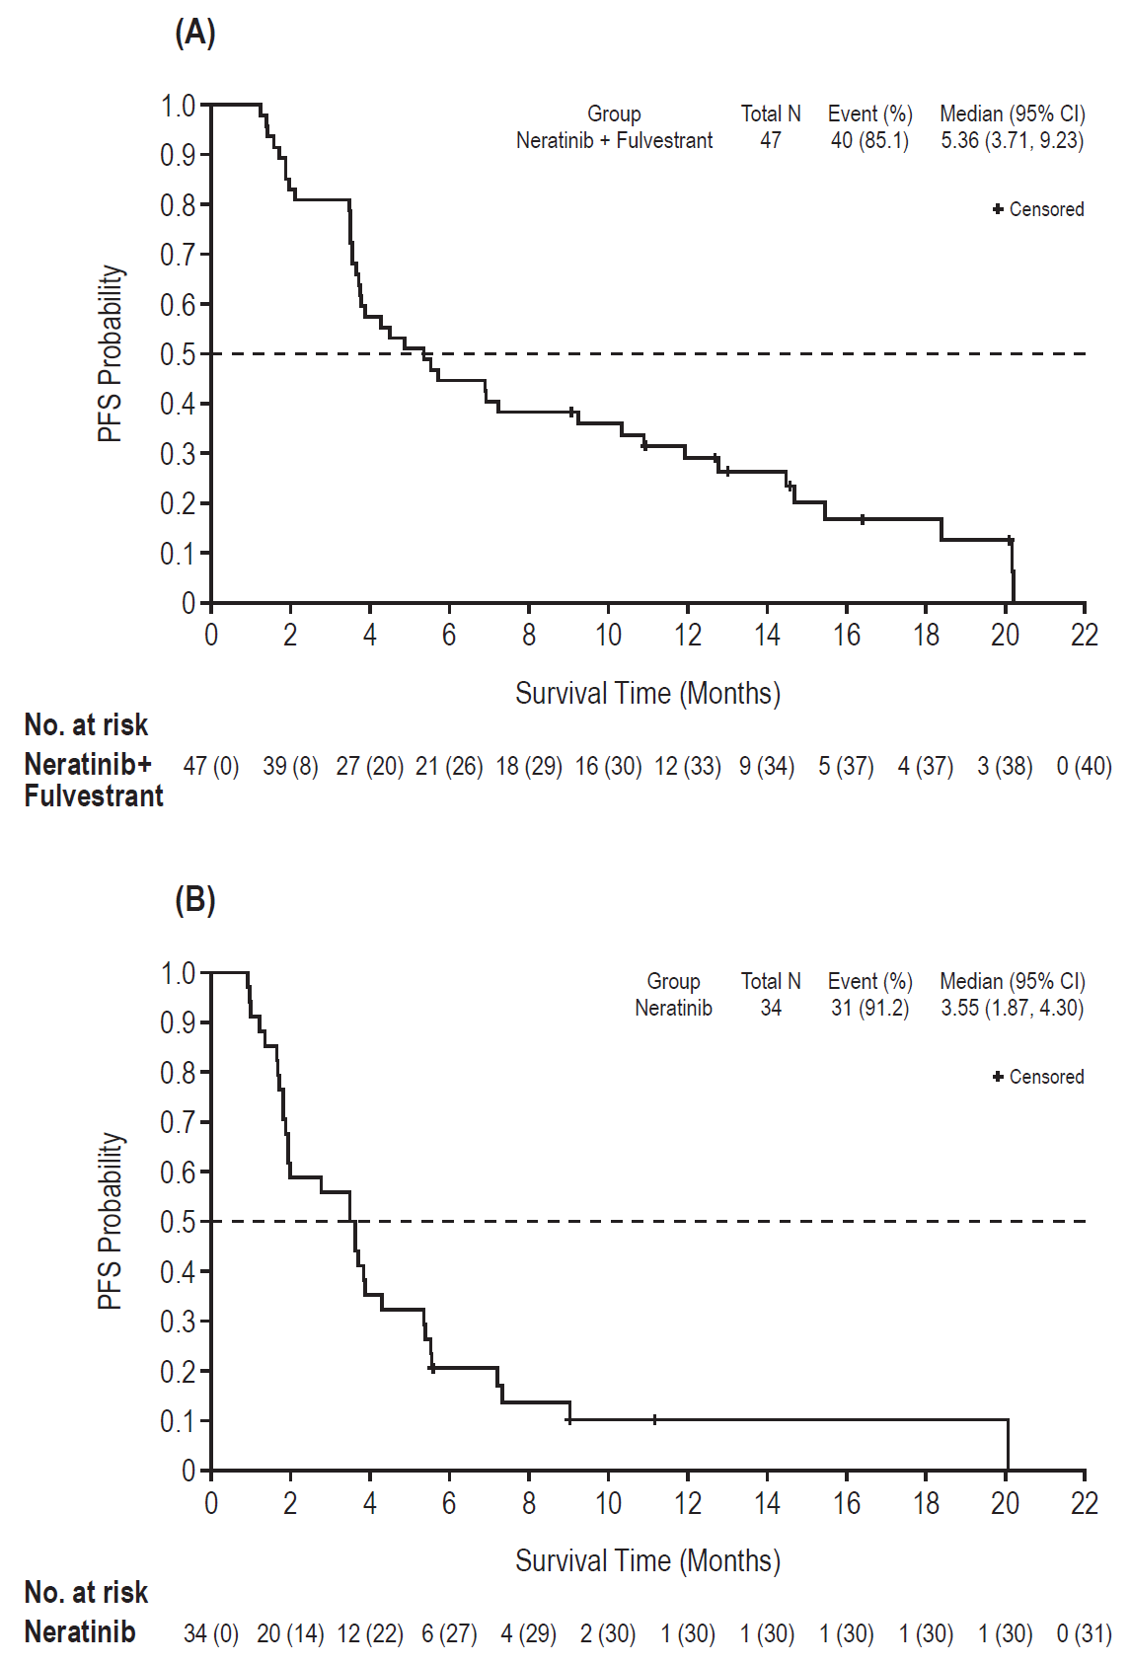

Supplementary Figure S1. PFS of (A) neratinib plus fulvestrant combination cohort and (B) neratinib monotherapy cohort.
CI, confidence interval; PFS, progression-free survival.

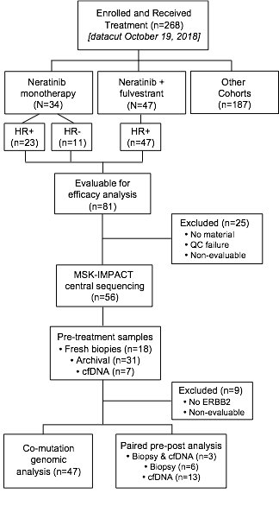

Supplementary Figure S2. Overall sequencing CONSORT diagram. Flow diagram of study patients and analyzed biospecimens processed through and selected for central sequencing using MSK-IMPACT and Guardant360.
cfDNA, cell-free DNA; FFPE, formalin-fixed paraffin-embedded; MSK-IMPACT, Memorial Sloan Kettering-Integrated Mutation Profiling of Actionable Cancer Targets; QC, quality control.

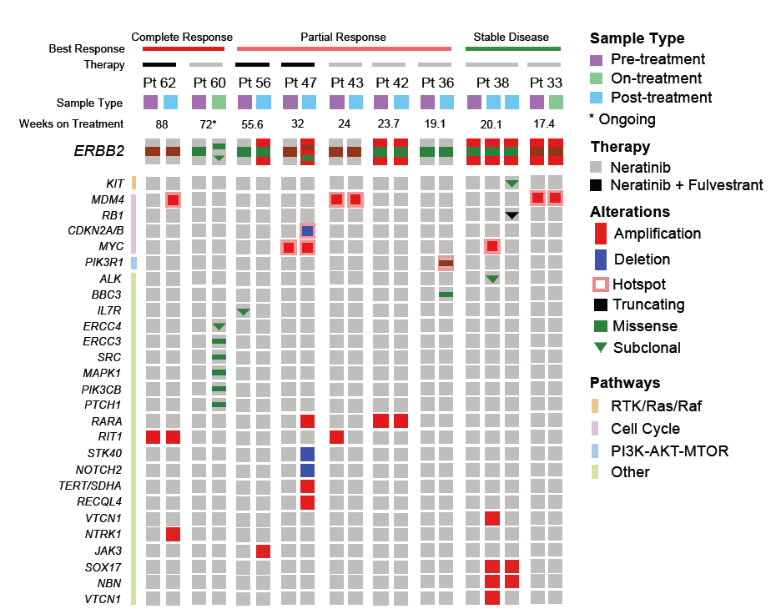

Supplementary Figure S3. Comprehensive OncoPrint of nine patients with paired pre- and post-treatment tissue sequencing showing acquired alterations in the post-treatment tumor.

Supplementary Table S1. Patient disposition
Patients, n (%) | Neratinib monotherapy  (n=34) | Neratinib + fulvestrant on Day 1  (n=47)
Patients enrolled | 34 (100) | 47 (100)
Enrolled and received study drug | 34 (100) | 47 (100)
Patients received study drug and continuing treatment | 0 | 8 (17.0)
Patients discontinued treatment | 34 (100) | 38 (80.9)
Death | 0 | 1 (2.1)
Disease progression | 32 (94.1) | 34 (72.3)
Adverse event | 0 | 1 (2.1)
Withdrawal of consent | 1 (2.9) | 0
Other | 1 (2.9) | 2 (4.3)
Patients ended study | 25 (73.5) | 21 (44.7)
Death | 23 (67.6) | 17 (36.2)
Withdrawal of consent | 1 (2.9) | 2 (4.3)
Lost to follow-up  Other | 1 (2.9)  0 | 1 (2.1)  1 (2.1)

Supplementary Table S2. HER2 mutational characteristics
Domain | No. of patients (%)
 | All patients (n=81) | Neratinib monotherapy (n=34) | Neratinib + fulvestrant combination therapy (n=47)
PKD hotspot | 48 (59.3) | 22 (64.7) | 26 (55.3)
Exon 20 insertion hotspot | 15 (18.5) | 6 (17.6) | 9 (19.1)
S310 hotspot | 10 (12.3) | 3 (8.8) | 7 (14.9)
Other hotspot | 2 (2.5) | 0 | 2 (4.3)
Other non-hotspot | 6 (7.4) | 3 (8.8) | 3 (6.4)
PKD, protein kinase domain.

Supplementary Table S3. Treatment efficacy and impact of prior fulvestrant and CDK4/6 inhibitor-containing therapy on treatment outcome

 | Neratinib monotherapyª |  | Neratinib + fulvestrant
Prior fulvestrant | Yes | No | Yes | No
All patients (intent to treat)^{b} | (n=12) | (n=11) | (n=25) | (n=22)
Confirmed overall objective response^{c}, n (%)  Complete response  Partial response  Overall objective response rate (95% CI) | 4 (33.3)  2 (16.7)  2 (16.7)  33.3 (9.9–65.1) | 0  0  0  0 (0–28.5) | 4 (16.0)  0  4 (16.0)  16.0 (4.5–36.1) | 10 (45.5)  4 (18.2)  6 (27.3)  45.5 (24.4–67.8)
Clinical benefit rate^{d}, % (95% CI) | 50.0 (21.1–78.9) | 9.1 (0.2–41.3) | 36.0 (18.0–57.5) | 59.1 (36.4–79.3)
Time to event (months), median (95% CI)  Progression-free survival  Duration of response | 4.8 (1.7, 9.0)  6.5 (3.7–NA) | 3.5 (1.3–3.7)  NA | 3.7 (3.5–6.9)  16.6 (9.2–16.6) | 8.2 (3.8–14.5)  7.4 (3.9–NA)
Prior CDK4/6 inhibitor | Yes | No | Yes | No
All patients (intent to treat)^{b} | (n=2) | (n=21) | (n=20) | (n=27)
Confirmed overall objective response^{c}, n (%)  Complete response  Partial response  Overall objective response rate (95% CI) | 0  0  0  0 (0–84.2) | 4 (19.0)  2 (9.5)  2 (9.5)  19.0 (5.4–41.9) | 6 (30.0)  1 (5.0)  5 (25.0)  30.0 (11.9–54.3) | 8 (29.6)  3 (11.1)  5 (18.5)  29.6 (13.8–50.2)
Clinical benefit rate^{d}, % (95% CI) | 0 (0–84.2) | 33.3 (14.6–57.0) | 40.0 (19.1–63.9) | 51.9 (31.9–71.3)
Time to event (months), median (95% CI)  Progression-free survival  Duration of response | 2.8 (1.8–3.7)  NA | 3.6 (1.8–5.4)  6.5 (3.7–NA) | 4.1 (1.9–10.9)  NA (4.5–NA) | 6.9 (3.6–14.5)  9.0 (3.9–16.6)

CDK, cyclin-dependent kinase; CI, confidence interval; NA, Not available; RECIST, Response Evaluation Criteria in Solid Tumors.
ªEstrogen receptor-positive patients only. ^{b}Response is based on investigator-assessment per RECIST (version 1.1), in patients with measurable disease, or positron-emission tomography response criteria in patients without measurable disease. ^{c}Confirmed no less than 4 weeks after the criteria for response were initially met. ^{d}Clinical benefit defined as confirmed best overall response of complete response, partial response of any duration, or stable disease lasting for ≥24 weeks.

Supplementary Table S4. Adverse eventsª
Event | Neratinib monotherapy (n=34) |  | Neratinib + fulvestrant (n=47) |  | All patients (n=81)
 | Any grade | Grade ≥3 | Any grade | Grade ≥3 | Any grade | Grade ≥3
Any adverse event | 33 (97.1) | 16 (47.1) | 47 (100) | 23 (48.9) | 80 (98.8) | 39 (48.1)
Diarrhea | 26 (76.5) | 9 (26.5) | 40 (85.1) | 11 (23.4) | 66 (81.5) | 20 (24.7)
Fatigue | 16 (47.1) | 0 | 12 (25.5) | 0 | 28 (34.6) | 0
Nausea | 15 (44.1) | 0 | 21 (44.7) | 0 | 36 (44.4) | 0
Constipation | 14 (41.2) | 0 | 15 (31.9) | 0 | 29 (35.8) | 0
Vomiting | 13 (38.2) | 1 (2.9) | 10 (21.3) | 1 (2.1) | 23 (28.4) | 2 (2.5)
Abdominal pain | 8 (23.5) | 1 (2.9) | 8 (17.0) | 0 | 16 (19.8) | 1 (1.2)
Decreased appetite | 8 (23.5) | 0 | 13 (27.7) | 0 | 21 (25.9) | 0
AST increased | 7 (20.6) | 3 (8.8) | 3 (6.4) | 1 (2.1) | 10 (12.3) | 4 (4.9)
Arthralgia | 6 (17.6) | 0 | 6 (12.8) | 0 | 12 (14.8) | 0
Pyrexia | 6 (17.6) | 0 | 4 (8.5) | 0 | 10 (12.3) | 0
Anemia | 5 (14.7) | 2 (5.9) | 6 (12.8) | 1 (2.1) | 11 (13.6) | 3 (3.7)
Dyspnea | 5 (14.7) | 2 (5.9) | 6 (12.8) | 1 (2.1) | 11 (13.6) | 3 (3.7)
Headache | 5 (14.7) | 0 | 6 (12.8) | 0 | 11 (13.6) | 0
ALT increased | 4 (11.8) | 1 (2.9) | 2 (4.3) | 0 | 6 (7.4) | 1 (1.2)
Dehydration | 4 (11.8) | 2 (5.9) | 2 (4.3) | 0 | 6 (7.4) | 2 (2.5)
Pruritus | 4 (11.8) | 0 | 4 (8.5) | 0 | 8 (9.9) | 0
Rash | 4 (11.8) | 0 | 7 (14.9) | 0 | 11 (13.6) | 0
Abdominal distension | 4 (11.8) | 0 | 2 (4.3) | 0 | 6 (7.4) | 0
Dry skin | 3 (8.8) | 0 | 9 (19.1) | 0 | 12 (14.8) | 0
Back pain | 3 (8.8) | 1 (2.9) | 8 (17.0) | 0 | 11 (13.6) | 1 (1.2)
Insomnia | 2 (5.9) | 0 | 5 (10.6) | 0 | 7 (8.6) | 0
Peripheral edema | 1 (2.9) | 0 | 7 (14.9) | 0 | 8 (9.9) | 0
Weight decreased | 1 (2.9) | 0 | 5 (10.6) | 0 | 6 (7.4) | 0
Hot flash | 0 | 0 | 5 (10.6) | 0 | 5 (6.2) | 0
ªRegardless of attribution, occurring in ≥10% of patients.
ALT, alanine aminotransferase; AST, aspartate aminotransferase.

Supplementary Table S5. Outcomes in patients with concurrent HER2 and HER3 mutations
Patient | BOR | PFS (weeks) | ERBB2 domain | Mutation
 |  |  |  | ERBB2 | ERBB3
3 | PD | 3.6 | Extracellular hotspotª | S310F/D582N | E332K
12 | PD | 7.6 | Kinase domain, hotspot | L755S | E928G
20 | SD | 11.2 | Kinase domain, non-hotspot | L841V | K329I
24 | SD | 14.0 | Kinase domain, hotspot | L755S | E928G
36 | uPR | 14.0 | Kinase domain, hotspot | L869R | E928G
39 | uPR^{b} | 15.6 | Kinase domain, hotspot | L869R | E928G
56 | uPR | 14.0 | Juxtamembrane, hotspot | V697L | K329E
79 (ongoing) | cCR | 52.0 | Extracellular hotspot | S310F | K329E/S846I
BOR, best overall response; c, confirmed; CR, complete response; PD, progressive disease; PR, partial response; SD, stable disease; Tx, treatment; u, unconfirmed.
ªRefers to S310F mutation; D582N occurs in the extracellular domain and is a non-hotspot mutation. ^{b}According to positron-emission tomography response.

Supplementary Table S6. Acquired ERBB2 sequencing results from paired tumor and cfDNA analysis
Patient | BOR  (Tx duration, wks) | Pre-treatment |  |  | Post-treatment
 |  | ERBB2 | Tissue AF | Plasma AF | ERBB2 | Plasma AF | Tissue AF
47 | cPR (32) | G778_P780dup | 0.51 | 0.04 | G778_P780dup  I767M  Amplification  S310Y | 0.41  0.0034  Detected  ND | 0.56  ND  Detected  0.44
36 | uPR (64.1) | L869R | 0.68 | 0.06 | L869R  S310Y  D769Y  L755S  T798I | 0.14  0.0015  0.0009  0.0022  0.0096 | 0.44  ND  ND  ND  ND
56 | uPR (16.0) | V697L | 0.14 | 0.018 | V697L  Amplification | 0.0058  ND | 0.74  Detected
45 | SD (30.1) | L755S  L755P | 0.29  ND | 0.045  0.0086 | L755S  L755P  T862A  S310F | 0.24  0.14  0.0017  0.0022 | NA
17 | PD (9.0) | L755S | 0.09 | 0.06 | L755S  D769H  K1171N  D1016Y  D1089Y  D962H | 0.14  0.0017  0.002  0.0029  0.0039  0.0042 | NA
59 | cPR (88.0) | V777L | 0.21 | 0.015 | V777L  T798I | 0.02  0.0057 | NA
57 | SD (88.6) | G776V | 0.05 | 0.053 | G776V  I767M | 0.11  0.0018 | NA
60 | cCR (80.0) | S310F | 0.10 | NA | S310F  L785F | NA | 0.11  0.10
AF, allele frequency; BOR, best overall response; c, confirmed; cfDNA, cell-free DNA; CR, complete response; NA, not available; ND, not detected; PD, progressive disease; PR, partial response; SD, stable disease; Tx, treatment; u, unconfirmed.

Supplementary Table S7. PET Response Criteria
Response category | Based on sum of SUV_{max} from 1 to 5 target lesions. Each target lesion with initial SUV_{max} of >1.5 × normal liver background SUV_{max}
Complete metabolic response (CMR) | Reduction of SUV_{max} of all target lesions to less than normal liver background SUV_{max} (for non-brain lesions) or less than normal brain background SUV_{max} (for brain lesions)  AND  The reduction of all other FDG-avid lesions consistent with disease to less than normal liver background SUV_{max}
Partial metabolic response (PMR) | Sum of SUV_{max} of all target lesions is decreased by ≥30% compared to baseline sum of SUV_{max} of all target lesions  AND  No new lesions
Stable metabolic disease (SMD) | Not satisfying the criteria for CMR, PMR, PMD, or NE
Progressive metabolic disease (PMD) | Sum of SUV_{max} of all target lesions is increased by ≥30%  OR  Appearance of one or more unequivocal new FDG-avid lesions
Not evaluable (NE) | Missing FDG-PET series or incomplete anatomy at follow-up timepoint  A PET/CT scanner change from baseline  Variation in FDG uptake time ≥15 minutes compared to baseline  Change in reconstruction algorithm
CT, computed tomography; FDG-PET, ¹⁸F-fluorodeoxyglucose positron-emission tomography; SUV_{max}, maximum standardized uptake value.

