Supplementary Material

Table of Contents
Alphabetical list of participants by institution 2
Precision Analysis 8
Supplemental Table S1. Baseline demographic and clinical characteristics. 9
Supplemental Table S2: Distribution of matched and unmatched cohorts stratified by exposure of interest (EOI) 12
Supplemental Table S3: Goodness of fit and variance inflation factors. 13
Supplemental Table S4: Racial and ethnic characteristics of patients receiving remdesivir. 14
Supplemental Table S5: Descriptive statistics for each variable of the matched data (N=1322) 15
Supplemental Table S6: Results of the logistic regression analysis with elastic-net and horeshoe regularization 16
Supplemental Table S7: Results of the horseshoe regularization analysis conditional on baseline COVID-19 severity with 50% credible intervals. 18
Supplemental Table S8: Results of mediation analysis. 19
Supplemental Table S9: Additional covariates from the mortality models 20
Supplementary Table S10: Data elements in the CCC19 data collection form. 23
Supplementary Table S11: Derived variables. 29
Supplemental Figure S1: UpSet plot of treatment exposures in hospitalized patients. 32
Supplemental Figure S2: UpSet plot of treatment exposures in never-hospitalized patients. 33
Supplemental Figure S3: Propensity score matching results 34
Supplemental Figure S4: Determination of standard deviation for propensity score matching 35

Alphabetical list of participants by institution

Bolded = site PI/co-PIs); site co-Is are listed alphabetically by last name

Keith Stockerl-Goldstein, MD; Ryan Monahan, MBA; Alice Y. Zhou, MD, PhD (Alvin J. Siteman Cancer Center at Washington University School of Medicine and Barnes-Jewish Hospital, St. Louis, MO, USA)

Balazs Halmos, MD; Amit K. Verma, MBBS; Benjamin A. Gartrell, MD; Sanjay Goel, MBBS (Albert Einstein College of Medicine, Montefiore Medical Center, Bronx, NY, USA)

Michael A. Thompson, MD, PhD, FASCO (Aurora Cancer Care, Advocate Aurora Health, Milwaukee, WI, USA)

Philip E. Lammers, MD, MSCI (Baptist Cancer Center, Memphis, TN, USA)

Susan Yackzan, PhD, APRN, AOCN (Baptist Healthcare System, IN/KY, USA)

Sanjay G. Revankar, MD, FIDSA (The Barbara Ann Karmanos Cancer Institute at Wayne State University School of Medicine, Detroit, MI, USA)

Ekokobe Fonkem, DO (Barrow Neurological Institute, Phoenix, AZ, USA)

Jonathan Loree, MD, MS, FRCPC; Irene Yu, MD, FRCPC (BC Cancer, Vancouver, BC, Canada)

Wenxin (Vincent) Xu, MD; Jaymin M. Patel, MD (Beth Israel Deaconess Medical Center, Boston, MA, USA)

Matthew H. Kulke, MD (Boston Medical Center, Boston, MA, USA)

Orestis A. Panagiotou, MD, PhD; Pamela C. Egan, MD; Dimitrios Farmakiotis, MD; Hina Khan, MD; Adam J. Olszewski, MD (Brown University and Lifespan Cancer Institute, Providence, RI, USA)

Arturo Loaiza-Bonilla, MD, MSEd, FACP (Cancer Treatment Centers of America, AZ/GA/IL/OK/PA, USA)

Salvatore A. Del Prete, MD; Anne H. Angevine, MD; Michael H. Bar, MD, FACP; Anthony P. Gulati, MD; K. M. Steve Lo, MD; Jamie Stratton, MD; Paul L. Weinstein, MD (Carl & Dorothy Bennett Cancer Center at Stamford Hospital, Stamford, CT, USA)

John M. Nakayama, MD; Jill Barnholtz-Sloan, PhD; Paolo Caimi, MD; Jorge Garcia, MD (Case Comprehensive Cancer Center at Case Western Reserve University/University Hospitals, Cleveland, OH, USA)

Bertrand Routy, MD, PhD (Centre Hospitalier de l'Université de Montréal, Montreal, QC, Canada)

Paul Fu, Jr., MD, MPH, FAAP, FAMIA; Geoffrey Shouse, DO, PhD; Jack West, MD (City of Hope Comprehensive Cancer Center, Duarte, CA, USA)

Shilpa Gupta, MD; Nathan A. Pennell, MD, PhD, FASCO; Scott J. Dawsey, MD; Christopher A. Lemmon, MD (Cleveland Clinic, Cleveland, OH, USA)

Ang Li, MD, MS (Dan L Duncan Comprehensive Cancer Center at Baylor College of Medicine, Houston, TX, USA)

Thomas Lad, MD (Cook County Hospital, Chicago, IL, USA)

Toni K. Choueiri, MD; Ziad Bakouny, MD, MSc; Gabrielle Bouchard, BS; Fiona Busser, BA; Catherine Curran, BA; George D. Demetri, MD, FASCO; Kaitlin Kelleher, BA; Pier Vitale Nuzzo, MD, PhD; Andrew Schmidt, MD; Grace Shaw, BA; Jack (John) Steinharter, MS; Eli Van Allen, MD (Dana-Farber Cancer Institute, Boston, MA, USA)

Tian Zhang, MD, MHS; Susan Halabi, PhD, FASCO (Duke Cancer Institute at Duke University Medical Center, Durham, NC, USA)

John C. Leighton Jr, MD, FACP (Einstein Healthcare Network, Philadelphia, PA, USA)

Andrea J. Zimmer, MD (Fred and Pamela Buffett Cancer Center at Nebraska Medicine and the University of Nebraska Medical Center, Omaha, NE, USA)

Gary H. Lyman, MD, MPH, FASCO, FRCP; Petros Grivas, MD, PhD; Ali Raza Khaki, MD; Elizabeth T. Loggers, MD, PhD; Michael Schweizer, MD; Shaveta Vinayak, MD, MS; Michael Wagner, MD; Albert Yeh, MD (Fred Hutchinson Cancer Research Center/University of Washington/Seattle Cancer Care Alliance, Seattle, WA, USA)

Na Tosha Gatson, MD, PhD (Geisinger Health System, PA, USA)

Stephen Liu, MD; Subha Madhavan, PhD (Georgetown Lombardi Comprehensive Cancer Center at Georgetown University, Washington, DC, USA)

Lori Rosenstein, MD (Gundersen Health System, WI, USA)

Aly-Khan A. Lalani, MD, FRCPC (Hamilton Health Sciences, Hamilton, ON, Canada)

Ankit Kansagra, MD (Harold C. Simmons Comprehensive Cancer Center at the University of Texas Southwestern Medical Center, Dallas, TX, USA)

Peter P. Yu, MD, FACP, FASCO; Jessica M. Clement, MD; Ahmad Daher, MD; Mark Dailey, MD; Rawad Elias, MD; Emily Hsu, MD; Alvaro Menendez, MD; Joerg Rathmann, MD; Oscar Serrano, MD (Hartford HealthCare Cancer Institute, Hartford, CT, USA)

Clara Hwang, MD; Shirish M. Gadgeel, MD (Henry Ford Cancer Institute, Henry Ford Hospital, Detroit, MI, USA)

Jessica Hawley, MD; Dawn Hershman, MD, MS, FASCO (Herbert Irving Comprehensive Cancer Center at Columbia University, New York, NY, USA)

Daniel Y. Reuben, MD; Antonio Giordano, MD, PhD; Sara Matar, MD; Sarah Mushtaq, MD (Hollings Cancer Center at the Medical University of South Carolina, Charleston, SC, USA)

Eric H. Bernicker, MD (Houston Methodist Cancer Center, Houston, TX, USA)

Heloisa P. Soares, MD, PhD; Neeraj Agarwal, MD; Umang Swami, MD, MS (Huntsman Cancer Institute at the University of Utah, Salt Lake City, UT, USA)

John Deeken, MD (Inova Schar Cancer Institute, Fairfax, VA, USA)

Mark A. Lewis, MD; Terence D. Rhodes, MD; David M. Gill, MD; Clarke A. Low; MD (Intermountain Health Care, Salt Lake City, UT, USA)

Sandeep H. Mashru, MD; Abdul-Hai Mansoor, MD (Kaiser Permanente Northwest, OR/WA, USA)

Sarah Nagle, MD; Shannon McWeeney, PhD; Eneida R. Nemecek, MD, MS, MBA (Knight Cancer Institute at Oregon Health and Science University, Portland, OR, USA)

Paul E. Oberstein, MD (Laura and Isaac Perlmutter Cancer Center at NYU Langone Health, New York, NY, USA)

Howard A. Zaren, MD, FACS (Lewis Cancer & Research Pavilion @ St. Joseph's/Candler, Savannah, GA, USA)

Gayathri Nagaraj, MD (Loma Linda University Cancer Center, Loma Linda, CA, USA)

Stephanie Berg, DO (Loyola University Medical Center, Maywood, IL, USA)

Alicia K. Morgans, MD, MPH; Firas Wehbe, MD, PhD; Jessical Altman, MD; Michael Gurley, BA; Mary F. Mulcahy, MD (Lurie Cancer Center at Northwestern University, Chicago, IL, USA)

Eric B. Durbin, DrPH, MS (Markey Cancer Center at the University of Kentucky, Lexington, KY, USA)

Amit A. Kulkarni, MD; Heather H. Nelson, PhD, MPH (Masonic Cancer Center at the University of Minnesota, Minneapolis, MN, USA)

Rachel P. Rosovsky, MD, MPH; Kerry Reynolds, MD; Aditya Bardia, MD; Genevieve Boland, MD, PhD, FACS; Justin Gainor, MD; Leyre Zubiri, MD, PhD (Massachusetts General Hospital Cancer Center, Boston, MA, USA)

Thorvardur R. Halfdanarson, MD; Tanios Bekaii-Saab, MD; Zhuoer Xie, MD, MS (Mayo Clinic, AZ/FL/MN, USA)

Ruben A. Mesa, MD, FACP; Mark Bonnen, MD; Daruka Mahadevan, MD, PhD; Amelie Ramirez, DrPH, MPH; Mary Salazar, ANP; Dimpy Shah, MD, PhD (Mays Cancer Center at UT Health San Antonio MD Anderson Cancer Center, San Antonio, TX, USA)

Nathaniel Bouganim, MD, FRCP(C); Arielle Elkrief, MD, FRCP(C); Donald C. Vinh, MD, FRCP(C) (McGill University Health Centre, Montreal, QC, Canada)

Gregory J. Riely, MD, PhD; Elizabeth V. Robilotti MD, MPH; Rimma Belenkaya, MA, MS; John Philip, MS (Memorial Sloan Kettering Cancer Center, New York, NY, USA)

Rulla Tamimi, MS (Meyer Cancer Center at Weill Cornell Medicine, New York, NY, USA)

Craig J. Gordon, DO (Michigan Center of Medical Research, Farmington Hills, MI, USA)

Bryan Faller, MD (Missouri Baptist Medical Center, St. Louis, MO, USA)

Roohi Ismail-Khan, MD, MSc; Rohit K. Jain, MD, MPH (Moffitt Cancer Center, Tampa, FL, USA)

Rana R. McKay, MD; Archana Ajmera, MSN, ANP-BC, AOCNP; Angelo Cabal, BS; Justin A. Shaya, MD (Moores Comprehensive Cancer Center at the University of California, San Diego, La Jolla, CA, USA)

Lisa B. Weissmann, MD (Mount Auburn Hospital, Cambridge, MA, USA)

Jeanna Knoble, MD; (Mary) Grace Glace, RN; Cameron Rink, PhD, MBA; Karen Stauffer, RN; Rosemary Zacks, RN (Mount Carmel Health System, Columbus, OH, USA)

M. Wasif Saif, MD (Northwell Health Cancer Institute, Zucker School of Medicine and Feinstein Institutes, Manhasset, NY, USA)

Sibel Blau, MD (Northwest Medical Specialties, Tacoma, WA, USA)

Daniel G. Stover, MD; James L. Chen, MD; Maryam B. Lustberg, MD, MPH; Sarah Wall, MD (The Ohio State University Comprehensive Cancer Center, Columbus, OH, USA)

Melanie Clark, MD (Parkview Research Center, Fort Wayne, IN, USA)

Monika Joshi, MD, MRCP; Harry Menon, DO, MPH; Marc A. Rovito, MD, FACP (Penn State Health/Penn State Cancer Institute/St. Joseph Cancer Center, PA, USA)

Elizabeth A. Griffiths, MD; Amro Elshoury, MBBCh (Roswell Park Comprehensive Cancer Center, Buffalo, NY, USA)

Janice M. Mehnert, MD; Salma Jabbour, MD; Mansi Shah, MD (Rutgers Cancer Institute of New Jersey at Rutgers Biomedical and Health Sciences, New Brunswick, NJ, USA)

Gerald Batist, MD, FACP, FRCP(C); Erin Cook (Segal Cancer Centre, Jewish General Hospital, McGill University, Montreal, QC, Canada)

Babar Bashir, MD, MS; Christopher McNair, PhD; Vasil Mico (Sidney Kimmel Cancer Center at Thomas Jefferson University, Philadelphia, PA, USA)

Catherine Handy Marshall, MD, MPH; Nilo Azad, MD; Marcus Messmer, MD; Jarushka Naidoo, MBBCh (Sidney Kimmel Comprehensive Cancer Center at Johns Hopkins University, Baltimore, MD, USA)

Amit Sanyal, MD (SSM Health Cancer Care, St. Charles, MO, USA)

Sumit A. Shah, MD, MPH; Michael J. Glover, MD; Alokkumar Jha, PhD; Lidia Schapira, MD, FASCO; Julie T. Y. Wu, MD, PhD (Stanford Cancer Institute at Stanford University, Palo Alto, CA, USA)

Suki Subbiah, MD (Stanley S. Scott Cancer Center at LSU Health Sciences Center, New Orleans, LA, USA)

Daniel Flora, MD; Barbara Logan, MS (St. Elizabeth Healthcare, Edgewood, KY, USA)

Gilberto de Lima Lopes Jr., MD, MBA, FAMS, FASCO (Sylvester Comprehensive Cancer Center at the University of Miami Miller School of Medicine, Miami, FL, USA)

Karen Russell, MD, FACP; Brittany Stith, RN, BSN, OCN, CCRP (Tallahassee Memorial Healthcare, Tallahassee, FL, USA)

Matthias Weiss, MD, PhD (ThedaCare Cancer Care, Appleton, WI, USA)

David Chism, MD; Susie Owenby, RN, CCRP (Thompson Cancer Survival Center, Knoxville, TN, USA)

Deborah B. Doroshow, MD, PhD; Matthew D. Galsky, MD (Tisch Cancer Institute at the Icahn School of Medicine at Mount Sinai, New York, NY, USA)

Julie Fu, MD (Tufts Medical Center Cancer Center, Boston and Stoneham, MA, USA)

Jonathan Riess, MD, MS (UC Davis Comprehensive Cancer Center at the University of California at Davis, CA, USA)

Vadim S. Koshkin, MD (UCSF Helen Diller Family Comprehensive Cancer Center at the University of California at San Francisco, CA, USA)

William A. Wood, MD, MPH (UNC Lineberger Comprehensive Cancer Center, Chapel Hill, NC, USA)

Christine Bestvina , MD; Ardaman Shergill, MD (The University of Chicago Comprehensive Cancer Center, Chicago, IL, USA)

Trisha Wise-Draper, MD, PhD; Syed Ahmad, MD; Shuchi Gulati, MD; Jordan Kharofa, MD; Michelle Marcum, MS (University of Cincinnati Cancer Center, Cincinnati, OH, USA)

Daniel W. Bowles, MD; Maheen Abidi, MD (University of Colorado Cancer Center, Aurora, CO, USA)

Pramod K. Srivastava, MD, PhD; Aakash Desai, MD, MPH; Emily Hsu, MD (University of Connecticut, Farmington, CT, USA)

Merry-Jennifer Markham, MD, FACP, FASCO; Rohit Bishnoi, MD; Chintan Shah, MD (University of Florida Health Cancer Center, Gainesville, FL, USA)

Jared D. Acoba, MD; Young Soo Rho, MD, CM (University of Hawai'i Cancer Center, Honolulu, HI, USA)

Lawrence E. Feldman, MD; Kent Hoskins, MD; Gerald Gantt Jr., MD; Mahir Khan, MD; Ryan Nguyen, DO; Mary Pasquinelli, APN, DNP; Candice Schwartz, MD; Neeta Venepalli, MD (University of Illinois Hospital & Health Sciences System, Chicago, IL, USA)

Praveen Vikas, MD (University of Iowa Holden Comprehensive Cancer Center, Iowa City, IA, USA)

Elizabeth Wulff-Burchfield, MD; Anup Kasi MD, MPH (The University of Kansas Cancer Center, Kansas City, KS, USA)

Robert C.G. Martin, II, MD, PhD, FACS; Neal Bhutiani, MD, PhD (University of Louisville James Graham Brown Cancer Center, Louisville, KY, USA)

Saurabh Dahiya, MBBS, FACP (University of Maryland Marlene and Stewart Greenebaum Comprehensive Cancer Center, Baltimore, MD, USA)

Christopher R. Friese, PhD, RN, AOCN, FAAN; Leslie A. Fecher, MD (University of Michigan Rogel Cancer Center, Ann Arbor, MI, USA)

Talal Hilal, MD (University of Mississippi Medical Center, Jackson, MS, USA)

Carla Casulo, MD (University of Rochester Medical Center, Rochester, NY, USA)

Andy Futreal, BS, PhD; Vivek Subbiah, MD; Vikram Narayan, MD; Sabitha Prabhakaran, PhD; Sanjay S. Shete, PhD; Nizar M. Tannir, MD, FACP (The University of Texas MD Anderson Cancer Center, Houston, TX, USA)

Narjust Duma, MD (University of Wisconsin Carbone Cancer Center, Madison, WI, USA)

Blanche H. Mavromatis, MD; Qamar U. Zaman, MD (UPMC Western Maryland, Cumberland, MD, USA)

Jeremy L. Warner, MD, MS, FAMIA, FASCO; Erin A. Gillaspie, MD, MPH; Daniel Hausrath, MD; Douglas B. Johnson, MD, MSCI; Xuanyi Li, BA; Sanjay Mishra, MS, PhD; Sonya A. Reid, MBBS, MPH; Brian I. Rini, MD, FACP, FASCO; Samuel M. Rubinstein, MD; Yu Shyr, PhD; Carmen C. Solorzano, MD, FACS; Matthew Tucker, MD; Karen Vega-Luna (Vanderbilt-Ingram Cancer Center at Vanderbilt University Medical Center, Nashville, TN, USA)

Hagen F. Kennecke, MD, MHA, FRCPC; David Aboulafia, MD (Virginia Mason Cancer Institute, Seattle, WA, USA)

Matthew Puc, MD; Theresa Carducci, MSN, RN, CCRP; Sandy DiLullo, BSN, RN, CCRP; Susan Van Loon, RN, CTR, CCRP (Virtua Health, Marlton, NJ, USA)

Umit Topaloglu, PhD, FAMIA (Wake Forest Baptist Comprehensive Cancer Center, Winston-Salem, NC, USA)

Robert L. Rice, MD, PhD (WellSpan Health, York, PA, USA)

Christine Pilar, BS, CCRC, ACRP-PM (Wentworth-Douglass Hospital, Dover, NH, USA)

Axel Grothey, MD (West Cancer Center, Memphis, TN, USA)

Prakash Peddi, MD; Lane Rosen, MD; Briana Barrow, BSc, CCRC (Willis-Knighton Cancer Center, Shreveport, LA, USA)

Mehmet Asim Bilen, MD (Winship Cancer Institute of Emory University, Atlanta, GA, USA)

Navid Hafez, MD, MPH; Roy Herbst, MD, PhD; Patricia LoRusso, DO, PhD; Tyler Masters, MS; Catherine Stratton, BA (Yale Cancer Center at Yale University School of Medicine, New Haven, CT, USA)

Raju Vaddepally, MD (Yuma Regional Medical Center, Yuma, AZ, USA)

Precision Analysis
The precision analysis was completed using the 5,000 computer simulations based on the generalized linear model (GLM).
Observed data:
 | Negative control | Positive control | HCQ alone | HCQ + anything
Sample size | 1321 | 327 | 179 | 359
Mortality | 115 | 59 | 44 | 111
Mortality rate | 0.09 | 0.18 | 0.25 | 0.31

Taking HCQ alone vs negative control as an example, we first generated 179 binary outcomes with the mortality rate of 0.25 for HCQ alone group and generated 1,321 binary outcomes with the mortality rate of 0.09 for the negative control group. Then, we performed the logistic regression analysis to estimate the odds ratio (OR) of HCQ alone vs negative control. Replicating the procedure 5,000 times, we obtained 5,000 ORs, ORs’ average and 95% confidence interval. Below are the simulation results.
Ratio of standard error (SE) of estimated OR to estimated OR [mean, 95% CI] is from logistic regression analysis based on 5,000 replications. SE of estimated OR is obtained using the Delta method, i.e., exp(beta.hat)*se(beta.hat).
 | Negative control | Positive control | HCQ alone | HCQ + anything
Negative control
Positive control | 0.17 (0.16-0.19)
HCQ alone | 0.20 (0.19-0.21) | 0.23 (0.21-0.24)
HCQ + anything | 0.15 (0.14-0.16) | 0.18 (0.18-0.20) | 0.21 (0.20-0.22)

Supplemental Table S1. Baseline demographic and clinical characteristics.
 | All patients | Hydroxy-chloroquine | Azithromycin | Remdesivir | High-dose systemic cortico-steroids | Tocilizumab | Other COVID-19 treatments^{e} | No treatment
Total | 2186 (100) | 538 (25) | 485 (22) | 124 (6) | 109 (5) | 94 (4) | 90 (4) | 1321 (60)
On clinical trialª | 134 (6) | 7 (1) | 2 (<1) | 86 (69) | 0 (0) | 5 (5) | 37 (41) | N/A
Age
Median, IQR | 67, 57-77 | 70, 61-79 | 69, 60-78 | 68, 58-76 | 69, 61-77 | 67.5, 61-77 | 69.5, 61-76 | 65, 54-76
<65 | 956 (44) | 181 (34) | 183 (38) | 50 (40) | 41 (38) | 36 (38) | 30 (33) | 646 (49)
65-74 | 559 (26) | 161 (30) | 133 (27) | 40 (32) | 32 (29) | 31 (33) | 34 (38) | 311 (24)
75+ | 671 (31) | 196 (36) | 169 (35) | 34 (27) | 36 (33) | 27 (29) | 26 (29) | 364 (28)
Sex
Female | 1105 (51) | 241 (45) | 221 (46) | 54 (44) | 55 (50) | 43 (46) | 34 (38) | 706 (53)
Male | 1078 (49) | 297 (55) | 264 (54) | 70 (56) | 54 (50) | 51 (54) | 56 (62) | 612 (46)
Missing | 3 (<1) |  |  |  |  |  |  | 3 (<1)
Race/ethnicity
Non-Hispanic White | 1115 (51) | 247 (46) | 257 (53) | 65 (52) | 47 (43) | 44 (47) | 46 (51) | 693 (52)
Hispanic | 334 (15) | 76 (14) | 56 (12) | 25 (20) | 10 (9) | 9 (10) | 13 (14) | 217 (16)
Non-Hispanic Black | 476 (22) | 152 (28) | 126 (26) | 18 (15) | 37 (34) | 31 (33) | 23 (26) | 247 (19)
Other | 200 (9) | 56 (10) | 39 (8) | 8 (6) | 12 (11) | 7 (7) | 4 (4) | 120 (9)
Missing | 61 (3) | 7 (1) | 7 (1) | 8 (6) | 3 (3) | 3 (3) | 4 (4) | 44 (3)
Region of patient residence
US-Northeast | 1011 (46) | 289 (54) | 234 (48) | 58 (47) | 47 (43) | 53 (56) | 45 (50) | 574 (43)
US-Midwest | 597 (27) | 147 (27) | 143 (29) | 25 (20) | 42 (39) | 29 (31) | 27 (30) | 357 (27)
US-South | 275 (13) | 66 (12) | 74 (15) | 16 (13) | 11 (10) | 8 (9) | 10 (11) | 168 (13)
US-West | 303 (14) | 36 (7) | 34 (7) | 25 (20) | 9 (8) | 4 (4) | 8 (9) | 222 (17)
Smoking Status
Never | 1149 (53) | 246 (46) | 241 (50) | 64 (52) | 41 (38) | 42 (45) | 41 (46) | 731 (55)
Current or Former | 958 (44) | 275 (51) | 231 (48) | 53 (43) | 64 (59) | 46 (49) | 46 (51) | 541 (41)
Missing | 79 (4) | 17 (3) | 13 (3) | 7 (6) | 4 (4) | 6 (6) | 3 (3) | 49 (4)
Comorbidities
Obesity | 705 (32) | 183 (34) | 178 (37) | 48 (39) | 50 (46) | 48 (51) | 35 (39) | 394 (30)
Diabetes mellitus | 643 (29) | 209 (39) | 175 (36) | 39 (31) | 38 (35) | 35 (37) | 25 (28) | 338 (26)
Hypertension | 1258 (58) | 377 (70) | 320 (66) | 82 (66) | 68 (62) | 70 (74) | 63 (70) | 675 (51)
Pulmonary | 471 (22) | 147 (27) | 127 (26) | 36 (29) | 39 (36) | 25 (27) | 25 (28) | 239 (18)
Cardiovascular | 709 (32) | 198 (37) | 176 (36) | 44 (35) | 43 (39) | 38 (40) | 33 (37) | 396 (30)
Renal | 389 (18) | 135 (25) | 110 (23) | 11 (9) | 24 (22) | 17 (18) | 17 (19) | 198 (15)
ECOG Performance Status
0 | 749 (34) | 133 (25) | 143 (29) | 44 (35) | 23 (21) | 22 (23) | 23 (26) | 515 (39)
1 | 563 (26) | 175 (33) | 131 (27) | 30 (24) | 31 (28) | 30 (32) | 31 (34) | 311 (24)
2+ | 352 (16) | 97 (18) | 61 (13) | 16 (13) | 21 (19) | 16 (17) | 12 (13) | 202 (15)
Unknown | 506 (23) | 127 (24) | 143 (29) | 34 (27) | 33 (30) | 26 (28) | 23 (26) | 284 (21)
Missing | 16 (1) | 6 (1) | 7 (1) |  | 1 (1) |  | 1 (1) | 9 (1)
Malignancy type^{b}
Solid tumors | 1781 (81) | 417 (78) | 390 (80) | 89 (72) | 85 (78) | 63 (67) | 60 (67) | 1107 (84)
Breast | 455 (21) | 94 (17) | 93 (19) | 15 (12) | 20 (18) | 13 (14) | 8 (9) | 297 (22)
Prostate | 368 (17) | 103 (19) | 87 (18) | 18 (15) | 17 (16) | 12 (13) | 17 (19) | 212 (16)
Gastrointestinal | 290 (13) | 67 (12) | 62 (13) | 17 (14) | 12 (11) | 12 (13) | 10 (11) | 186 (14)
Thoracic | 169 (8) | 54 (10) | 39 (8) | 9 (7) | 13 (12) | 11 (12) | 7 (8) | 90 (7)
Gynecologic | 143 (7) | 31 (6) | 31 (6) | 7 (6) | 7 (6) | 3 (3) | 5 (6) | 93 (7)
Solid tumors, NOS | 506 (23) | 105 (20) | 107 (22) | 30 (24) | 25 (23) | 19 (20) | 21 (23) | 320 (24)
Hematologic malignancies | 470 (22) | 141 (26) | 114 (24) | 38 (31) | 27 (25) | 36 (38) | 32 (36) | 251 (19)
Lymphoid neoplasms | 272 (12) | 82 (15) | 68 (14) | 23 (19) | 13 (12) | 19 (20) | 19 (21) | 146 (11)
Plasma cell disorders | 95 (4) | 34 (6) | 27 (6) | 10 (8) | 10 (9) | 11 (12) | 11 (12) | 42 (3)
Myeloid neoplasms | 98 (4) | 25 (5) | 19 (4) | 5 (4) | 5 (5) | 6 (6) | 2 (2) | 57 (4)
Hematologic malignancy, NOS | 12 (1) | 1 (<1) | 1 (<1) | 1 (1) | 0 (0) | 0 (0) | 1 (1) | 10 (1)
Cancer Status
Remission/NED | 1115 (51) | 258 (48) | 261 (54) | 61 (49) | 48 (44) | 36 (38) | 42 (47) | 682 (52)
Active, progressing | 239 (11) | 70 (13) | 52 (11) | 15 (12) | 21 (19) | 16 (17) | 8 (9) | 135 (10)
Active, stable/responding | 607 (28) | 149 (28) | 124 (26) | 36 (29) | 24 (22) | 31 (33) | 27 (30) | 375 (28)
Unknown | 214 (10) | 60 (11) | 47 (10) | 11 (9) | 16 (15) | 11 (12) | 13 (14) | 120 (9)
Missing | 11 (1) | 1 (<1) | 1 (<1) | 1 (1) |  |  |  | 9 (1)
Active cancer treatment^{c}
None | 1457 (67) | 359 (67) | 338 (70) | 77 (62) | 72 (66) | 56 (60) | 63 (70) | 866 (66)
Cytotoxic | 269 (12) | 69 (13) | 56 (12) | 19 (15) | 7 (6) | 8 (9) | 6 (7) | 165 (12)
Non-cytotoxic | 424 (19) | 102 (19) | 84 (17) | 24 (19) | 25 (23) | 28 (30) | 19 (21) | 268 (20)
Unknown | 36 (2) | 8 (1) | 7 (1) | 4 (3) | 5 (5) | 2 (2) | 2 (2) | 22 (2)
Baseline COVID-19 severity
Mild | 1037 (47) | 60 (11) | 121 (25) | 13 (10) | 22 (20) | 14 (15) | 10 (11) | 876 (66)
Moderate | 876 (40) | 356 (66) | 259 (53) | 70 (56) | 61 (56) | 47 (50) | 51 (57) | 360 (27)
Severe | 273 (12) | 122 (23) | 105 (22) | 41 (33) | 26 (24) | 33 (35) | 29 (32) | 85 (6)
Concomitant medications
Aspirin or other antiplatelet agents | 682 (31) | 191 (36) | 194 (40) | 52 (42) | 44 (40) | 37 (39) | 33 (37) | 364 (28)
Anticoagulation | 1087 (50) | 414 (77) | 353 (73) | 104 (84) | 91 (83) | 79 (84) | 76 (84) | 456 (35)
Statins | 927 (42) | 265 (49) | 244 (50) | 64 (52) | 59 (54) | 46 (49) | 39 (43) | 505 (38)
Low-dose steroids^{d} | 184 (8) | 55 (10) | 42 (9) | 22 (18) | 14 (13) | 12 (13) | 11 (12) | 94 (7)
ªFor all patients, this is the number of patients on any trial for treatment of COVID-19. For each specific exposure, this is the number of patients reported to be on a trial of that particular treatment.
^{b}Percentages may add up to more than 100 because some patients had multiple malignancies.
^{c}Defined as receipt of antineoplastic therapy within four (4) weeks of COVID-19 diagnosis.
^{d}Defined as up to 20 mg/day in prednisone dose equivalents.
^{e}Includes patients enrolled in blinded randomized controlled trials e.g., of remdesivir.
* Percentages are shown in parentheses; percentages may not add up to 100 due to rounding.

Supplemental Table S2: Distribution of matched and unmatched cohorts stratified by exposure of interest (EOI); percentages may not add up to 100 due to rounding. HCQ: hydroxychloroquine; PSM: Propensity score matching
Characteristic | HCQ with PSM, n (%)ª | HCQ unmatched, n (%) | HCQ without severe cases, n (%) | HCQ, active cancer only, n (%) | Remdesivir, n (%) | High-dose sytemic corticosteroids, n (%)
EOI alone | 179 (14) | 179 (8) | 151 (8) | 69 (8) | 57 (3) | 18 (1)
EOI + any other exposure | 359 (27) | 359 (16) | 265 (14) | 150 (18) | 67 (3) | 91 (4)
Negative controls | 544 (41) | 1321 (60) | 1236 (65) | 510 (60) | 1321 (60) | 1321 (60)
Positive controls | 240 (18) | 327 (15) | 261 (14) | 117 (14) | 741 (34) | 756 (35)
Total | 1322 (100) | 2186 (100) | 1913 (100) | 846 (100) | 2186 (100) | 2186 (100)

ªThis is a representative sample of one of the ten runs of the model; exact numbers of positive and negative controls fluctuate slightly across runs due to multiple data imputation.

Supplemental Table S3: Goodness of fit and variance inflation factors.

Model | C-statistic | Number of variables with VIF > 5
Predictors of HCQ+AZ treatment | 0.72 | 0
Predictors of remdesivir treatment | 0.70 | 0
Predictors of any COVID-19 treatment | 0.75 | 0
Predictors of mortality in HCQ-exposed patients, PSM | 0.79 | 0
Predictors of mortality in HCQ-exposed patients, unmatched | 0.86 | 0
Predictors of mortality in HCQ-exposed patients, without severe cases | 0.86 | 0
Predictors of mortality in HCQ-exposed patients, active cancer only | 0.86 | 0
Predictors of mortality in HCQ-exposed patients, remission/NED only | 0.88 | 0
Predictors of mortality in remdesivir-exposed patients | 0.86 | 0
Predictors of mortality in high-dose systemic corticosteroid-exposed patients | 0.86 | 0

Supplemental Table S4: Racial and ethnic characteristics of patients receiving remdesivir.

 | Non-Hispanic white | Non-Hispanic Black | Hispanic | Other | Missing
On trial | 44 | 13 | 16 | 8 | 5
Off trial¹ | 21 | 5 | 9 | 0 | 3
¹Includes compassionate use prior to May 1, 2020 and emergency use authorization (EUA) after May 1, 2020; limits of temporal resolution in the CCC19 registry do not allow for distinguishing between these two uses.

Supplemental Table S5: Descriptive statistics for each variable of the matched data (N=1322). This table is from one of the ten model runs; absolute numbers change very slightly from run to run and are averaged in the model output. Absolute numbers are shown in parentheses.
 | Negative control  (N=544) | Positive control  (N=240) | HCQ alone  (N=179) | HCQ + any other exposure  (N=359)
Death | 0.19 (101) | 0.22 (54) | 0.25 (44) | 0.31 (111)
Age, median (IQR) | 71 (60-81) | 70 (60-80) | 73 (64.5-81.5) | 69 (60.5-77)
Sex
Male | 0.50 (271) | 0.54 (129) | 0.53 (94) | 0.57 (203)
Race
Non-Hispanic White | 0.52 (285) | 0.53 (128) | 0.41 (74) | 0.49 (176)
Hispanic | 0.14 (74) | 0.13 (31) | 0.18 (32) | 0.13 (47)
Non-Hispanic Black | 0.25 (136) | 0.24 (57) | 0.26 (46) | 0.30 (106)
Other | 0.09 (49) | 0.10 (24) | 0.15 (27) | 0.08 (30)
Region
US Northeast | 0.49 (264) | 0.47 (112) | 0.63 (112) | 0.49 (177)
US Midwest | 0.27 (147) | 0.27 (64) | 0.21 (38) | 0.30 (109)
US South | 0.13 (73) | 0.13 (31) | 0.07 (12) | 0.15 (54)
US West | 0.11 (60) | 0.14 (33) | 0.09 (17) | 0.05 (19)
Smoking
Current or Former | 0.47 (257) | 0.49 (117) | 0.53 (95) | 0.53 (189)
Obesity | 0.29 (159) | 0.36 (87) | 0.27 (49) | 0.37 (134)
Diabetes mellitus | 0.33 (181) | 0.32 (76) | 0.38 (68) | 0.40 (142)
Pulm. comorbidities | 0.24 (129) | 0.25 (61) | 0.23 (41) | 0.30 (107)
Card. comorbidities | 0.41 (224) | 0.40 (97) | 0.37 (67) | 0.36 (131)
Renal comorbidities | 0.21 (113) | 0.20 (47) | 0.27 (48) | 0.24 (87)
Hypertension | 0.62 (340) | 0.68 (164) | 0.72 (129) | 0.69 (248)
ECOG performance
0 | 0.26 (141) | 0.29 (69) | 0.22 (39) | 0.27 (96)
1 | 0.25 (137) | 0.25 (61) | 0.33 (59) | 0.33 (119)
2+ | 0.24 (131) | 0.18 (43) | 0.26 (47) | 0.14 (50)
Unknown | 0.25 (135) | 0.28 (67) | 0.19 (34) | 0.26 (94)
Cancer status
Remission/NED | 0.49 (266) | 0.50 (121) | 0.49 (87) | 0.48 (171)
Active, progressing | 0.13 (72) | 0.12 (29) | 0.12 (21) | 0.14 (49)
Active, stable/responding | 0.26 (144) | 0.26 (63) | 0.27 (48) | 0.28 (102)
Unknown | 0.11 (62) | 0.11 (27) | 0.13 (23) | 0.10 (37)
Baseline COVID-19 severity
Mild | 0.20 (109) | 0.08 (18) | 0.07 (13) | 0.13 (47)
Moderate | 0.64 (350) | 0.65 (157) | 0.77 (138) | 0.61 (218)
Severe | 0.16 (85) | 0.27 (65) | 0.16 (28) | 0.26 (94)
Anticoagulants or antiplatelet agents | 0.76 (414) | 0.87 (209) | 0.77 (137) | 0.87 (312)
Supplemental Table S6: Results of the logistic regression analysis with elastic-net and horeshoe regularization. Elastic-net regularization was performed with a mixing parameter of 0.5; horseshoe regularization with 50% credible intervals. A standard deviation of 0.3 was used in the two-group matching.
Characteristic | Multivariable AOR (95% CI)  Elastic-net | Multivariable AOR (95% CI)  Horseshoe
Treatment group
Negative control | Reference | Reference
Positive control | 1.09 (0.72-1.65) | 1.11 (0.73-1.68)
HCQ alone | 1.19 (0.76-1.86) | 1.18 (0.75-1.84)
HCQ + any other exposure | 2.16 (1.52-3.09) | 2.20 (1.53-3.15)
Age, per decade | 1.31 (1.50-1.72) | 1.37 (1.57-1.81)
Sex
Female | Reference | Reference
Male | 1.22 (0.91-1.63) | 1.26 (0.94-1.69)
Region
US Northeast | Reference | Reference
US Midwest | 0.64 (0.45-0.91) | 0.65 (0.45-0.92)
US South | 0.68 (0.43-1.09) | 0.70 (0.44-1.11)
US West | 0.81 (0.47-1.41) | 0.80 (0.46-1.39)
Smoking status
Never | Reference | Reference
Current or Former | 1.18 (0.86-1.61) | 1.20 (0.88-1.63)
Obesity
Non-Obese | Reference | Reference
Obese |  | 1.32 (0.96-1.81)
Renal comorbidities
0 | Reference | Reference
1 | 1.17 (0.85-1.61)
Hypertension
0 | Reference | Reference
1 | 1.17 (0.84-1.62)
ECOG performance status
0 | Reference | Reference
1 | 1.51 (0.95-2.39) | 1.55 (0.98-2.45)
2+ | 3.94 (2.48-6.27) | 4.07 (2.55-6.48)
Unknown | 2.04 (1.29-3.23) | 2.13 (1.34-3.38)
Cancer status
Remission/NED | Reference | Reference
Active, progressing | 2.55 (1.63-4.00) | 2.48 (1.58-3.90)
Active, stable/responding | 1.42 (0.98-2.06) | 1.42 (0.98-2.06)
Unknown | 1.46 (0.93-2.29) | 1.44 (0.91-2.27)
Baseline COVID-19 severity
Mild | Reference | Reference
Moderate | 2.16 (1.07-4.38) | 2.32 (1.14-4.74)
Severe | 7.75 (3.72-16.16) | 8.39 (3.99-17.62)
Anticoagulants or antiplatelet agents
Unexposed | Reference | Reference
Exposed |  | 0.72 (0.48-1.10)

Supplemental Table S7: Results of the horseshoe regularization analysis conditional on baseline COVID-19 severity with 50% credible intervals. A standard deviation of 0.3 was used in the two-group matching.

Characteristic | Multivariable AOR (95% CI)
 | “Moderate” | “Moderate + Severe”
Treatment group
Negative control | Reference | Reference
Positive control | 1.22 (0.71-2.11) | 1.18 (0.77-1.81)
HCQ alone | 1.26 (0.73-2.19) | 1.01 (0.63-1.60)
HCQ + any other exposure | 3.04 (1.91-4.86) | 2.20 (1.51-3.19)
Age, per 10 years | 1.36 (1.62-1.93) | 1.31 (1.50-1.73)
Sex
Female | Reference | Reference
Male | 1.17 (0.81-1.69) | 1.29 (0.95-1.74)
Region
US Northeast | Reference | Reference
US Midwest | 0.58 (0.37-0.92) | 0.63 (0.43-0.91)
US South | 0.71 (0.38-1.34) | 0.76 (0.47-1.22)
US West | 0.91 (0.42-1.97) | 0.98 (0.56-1.69)
Obesity
Non-Obese | Reference | Reference
Obese | 1.78 (1.18-2.69) | 1.47 (1.06-2.03)
ECOG performance status
0 | Reference | Reference
1 | 1.67 (0.87-3.23) | 1.29 (0.80-2.09)
2+ | 5.07 (2.60-9.88) | 3.75 (2.32-6.05)
Unknown | 2.96 (1.51-5.78) | 1.86 (1.15-3.01)
Cancer status
Remission/NED | Reference | Reference
Active, progressing | 3.10 (1.79-5.35) | 2.21 (1.40-3.48)
Active, stable/responding | 1.80 (1.13-2.87) | 1.36 (0.92-2.00)
Unknown | 1.53 (0.82-2.87) | 1.52 (0.95-2.43)
Anticoagulants or antiplatelet agents
Unexposed |  | Reference
Exposed |  | 0.76 (0.49-1.17)

Supplemental Table S8: Results of mediation analysis. Mediator: binary variable (Negative control + positive control vs. HCQ alone + HCQ plus other drugs). Independent variable: baseline COVID-19 severity (treated as a binary variable); Outcome: mortality. ACME: Average Causal Mediation Effects; ADE: Average Direct Effect

 | Estimate (95% CI)
ACME (treated) | 0.0060 (-0.0003-0.02)
ADE (treated) | 0.1591 (0.1033-0.21)
Total Effect | 0.1612 (0.1082-0.21)
Prop. Mediated (treated) | 0.0369 (-0.0016-0.12)

Supplemental Table S9: Additional covariates from the mortality models

Characteristic | HCQ with PSM, AOR (95% CI) | HCQ, AOR (95% CI)ª | HCQ without severe cases, AOR (95% CI)ª | Remdesivir, AOR (95% CI)ª | High-dose sytemic corticosteroids, AOR (95% CI)ª
Age^{b} | 1.60 (1.38-1.86) | 1.56 (1.36-1.80) | 1.58 (1.34-1.87) | 1.52 (1.32-1.74) | 1.53 (1.34-1.76)
Sex
Female | Ref | Ref | Ref | Ref | Ref
Male | 1.24 (0.92-1.67) | 1.26 (0.94-1.67) | 1.17 (0.83-1.64) | 1.3 (0.98-1.73) | 1.3 (0.97-1.72)
Race/ethnicity
Non-Hispanic white | Ref | Ref | Ref | Ref | Ref
Hispanic | 1.39 (0.85-2.27) | 1.29 (0.82-2.02) | 1.29 (0.75-2.21) | 1.29 (0.82-2.02) | 1.25 (0.8-1.96)
Non-Hispanic Black | 1.22 (0.85-1.76) | 1.22 (0.86-1.74) | 1.18 (0.77-1.80) | 1.2 (0.85-1.71) | 1.21 (0.85-1.72)
Other | 1.00 (0.59-1.69) | 1.13 (0.69-1.87) | 1.08 (0.58-2.02) | 1.06 (0.64-1.76) | 1.08 (0.66-1.78)
Region of patient residence
US-Northeast | Ref | Ref | Ref | Ref | Ref
US-Midwest | 0.65 (0.44-0.95) | 0.65 (0.46-0.93) | 0.64 (0.42-0.97) | 0.68 (0.48-0.96) | 0.65 (0.46-0.93)
US-South | 0.71 (0.43-1.15) | 0.72 (0.45-1.15) | 0.74 (0.41-1.33) | 0.75 (0.47-1.2) | 0.74 (0.47-1.18)
US-West | 0.88 (0.51-1.53) | 0.94 (0.6-1.49) | 1.02 (0.58-1.79) | 0.94 (0.59-1.49) | 0.89 (0.56-1.41)
Smoking status
Never smoker | Ref | Ref | Ref | Ref | Ref
Current or former smoker | 1.21 (0.89-1.66) | 1.23 (0.91-1.66) | 1.2 (0.84-1.71) | 1.22 (0.9-1.64) | 1.19 (0.89-1.61)
Obesity
Not obese | Ref | Ref | Ref | Ref | Ref
Obese | 1.31 (0.95-1.81) | 1.23 (0.9-1.68) | 1.39 (0.95-2.02) | 1.25 (0.91-1.71) | 1.23 (0.9-1.69)
Diabetes mellitus
Not present | Ref | Ref | Ref | Ref | Ref
Present | 0.99 (0.73-1.35) | 1.04 (0.77-1.4) | 1.11 (0.78-1.59) | 1.05 (0.78-1.42) | 1.07 (0.79-1.44)
Pulmonary comorbidities
Not present | Ref | Ref | Ref | Ref | Ref
Present | 0.95 (0.68-1.34) | 0.94 (0.68-1.31) | 0.88 (0.59-1.31) | 0.97 (0.7-1.34) | 0.94 (0.68-1.31)
Cardiovascular comorbidities
Not present | Ref | Ref | Ref | Ref | Ref
Present | 1.09 (0.79-1.51) | 1.05 (0.77-1.42) | 1.08 (0.75-1.57) | 1.03 (0.76-1.4) | 1.03 (0.76-1.39)
Renal comorbidities
Not present | Ref | Ref | Ref | Ref | Ref
Present | 1.18 (0.85-1.65) | 1.19 (0.86-1.64) | 1.18 (0.81-1.72) | 1.15 (0.83-1.59) | 1.2 (0.87-1.66)
Hypertension
Not present | Ref | Ref | Ref | Ref | Ref
Present | 1.17 (0.83-1.65) | 1.16 (0.84-1.61) | 1.08 (0.73-1.59) | 1.15 (0.83-1.59) | 1.17 (0.84-1.61)
ECOG performance status
0 | Ref | Ref | Ref | Ref | Ref
1 | 1.48 (0.92-2.38) | 1.57 (1-2.46) | 1.57 (0.88-2.82) | 1.61 (1.02-2.53) | 1.61 (1.02-2.53)
2+ | 3.99 (2.48-6.42) | 4.2 (2.67-6.62) | 4.82 (2.68-8.66) | 4.05 (2.56-6.39) | 4.07 (2.57-6.43)
Unknown | 2.09 (1.29-3.38) | 2.06 (1.3-3.26) | 2.5 (1.38-4.54) | 2.14 (1.36-3.38) | 2.09 (1.32-3.31)
Cancer status
Remission/NED | Ref | Ref | Ref | Ref | Ref
Active, progressing | 2.55 (1.60-4.06) | 2.69 (1.75-4.13) | 3.06 (1.86-5.05) | 2.72 (1.77-4.17) | 2.63 (1.71-4.03)
Active, stable or responding | 1.43 (0.99-2.06) | 1.45 (1.02-2.06) | 1.75 (1.15-2.66) | 1.47 (1.04-2.08) | 1.48 (1.04-2.09)
Unknown | 1.43 (0.90-2.28) | 1.64 (1.05-2.57) | 1.87 (1.08-3.25) | 1.53 (0.98-2.41) | 1.54 (0.98-2.42)
Baseline COVID-19 severity
Mild | Ref | Ref | Ref | Ref | Ref
Moderate | 2.11 (1.03-4.32) | 5.04 (3.12-8.13) | 4.13 (2.54-6.72) | 5.05 (3.14-8.12) | 5.11 (3.17-8.24)
Severe | 7.78 (3.63-16.68) | 17.38 (10.32-29.26) | N/A | 18.79 (11.18-31.58) | 18.25 (10.85-30.7)
Aspirin/APA/Anticoagulation
Absent | Ref | Ref | Ref | Ref | Ref
Present | 0.67 (0.43-1.02) | 0.84 (0.58-1.22) | 1.15 (0.73-1.8) | 0.89 (0.61-1.3) | 0.85 (0.58-1.23)
ªUnmatched controls
^{b}Risk per decade

Supplementary Table S10: Data elements in the CCC19 data collection form. These variables are current as of June 29th, 2020 and do not include free text response elements. Note that the survey contains extensive branching logic; not every patient will have every one of these elements completed. ABNL: abnormal (outside normal reference range); ATC: Anatomical Therapeutic Classification; HI: above normal reference range; LO: below normal reference range; N: No; NA: not applicable; NAACCR: North American Association of Central Cancer Registries; NCIT: National Cancer Institute Thesaurus; OMOP: Observational Medical Outcomes Partnership Data Model; PHIN VADS: Public Health Information Network Vocabulary Access and Distribution System; SNOMED-CT: Systematized Nomenclature of Medicine, Clinical Terms; UNK: Unknown; WNL: within normal limits; Y: Yes

Variable Name | Description | Value Set or Terminology | Category
aspirin_dose |  | SNOMED-CT | Baseline clinical details
bcg_vax | History of BCG vaccine? | Y/N/UNK | Baseline clinical details
bl_anticoag_reason | Why anticoag at baseline? | SNOMED-CT | Baseline clinical details
bl_anticoag_type | Anticoag at baseline? | ATC | Baseline clinical details
blood_type | ABO blood type | Direct coding + UNK | Baseline clinical details
blood_type_rh | Rh blood type | Direct coding + UNK | Baseline clinical details
bmi |  | Numeric, kg/m2 | Baseline clinical details
comorbid_no | number of comorbidities | Integer + UNK | Baseline clinical details
concomitant_meds |  | ATC | Baseline clinical details
ecog_status |  | Direct coding + UNK | Baseline clinical details
gcsf | G-CSF within 2 weeks of diagnosis? | Y/N/UNK | Baseline clinical details
height |  | Numeric, units not specified | Baseline clinical details
influenza_vax | Seasonal flu vaccine? | Y/N/UNK | Baseline clinical details
o2_requirement |  | Y/N/UNK | Baseline clinical details
recent_surgery |  | Y/N/UNK | Baseline clinical details
significant_comorbidities |  | SNOMED-CT | Baseline clinical details
smoking_product |  | SNOMED-CT | Baseline clinical details
smoking_status |  | Custom | Baseline clinical details
steroid_specific_2 | Steroid dosing | Custom | Baseline clinical details
surgery_timing |  | Custom | Baseline clinical details
weight |  | Numeric, units not specified | Baseline clinical details
adt | Has patient had ADT? | Y/N/UNK | Cancer details
bcg_intraves_ever |  | Y/N/UNK | Cancer details
cancer_status |  | Custom | Cancer details
cancer_timing |  | Custom | Cancer details
cancer_type |  | NCIT | Cancer details
cancer_type_2 | 2nd maligancy type (if applicable) | NCIT | Cancer details
clinical_trial |  | Y/N/UNK | Cancer details
gleason | Gleason score | NAACCR | Cancer details
gleason_source |  | NAACCR | Cancer details
hospice |  | Y/N/UNK | Cancer details
hx_treatment | Timing of cancer treatment | Custom | Cancer details
intravesicular_bcg |  | Y/N/UNK | Cancer details
irae_past |  | Y/N/UNK | Cancer details
mets_sites | Sites of metastatic cancer | NAACCR | Cancer details
mets_yn | Metastatic at COVID-19 diagnosis? | Y/N/UNK | Cancer details
multiple_ca |  | Y/N/UNK | Cancer details
on_treatment | On recent cancer treatment | Y/N/UNK | Cancer details
orchiectomy | Has patient had bilateral orchiectomy? | Y/N/UNK | Cancer details
other_irae |  | Y/N/UNK | Cancer details
pneumonitis | Concurrent irAE pneumonitis? | Custom | Cancer details
prior_tx | prior lung-toxic therapy? | HemOnc | Cancer details
prostate_tx | Prostate cancer therapy | RxNorm | Cancer details
radiotherapy |  | Y/N/UNK | Cancer details
recent_treatment | Most recent anti-cancer treatment | Custom | Cancer details
stage |  | NAACCR | Cancer details
transplant_cellular_therapy |  | Custom | Cancer details
transplant_cellular_timing |  | Custom | Cancer details
treatment_context |  | HemOnc | Cancer details
treatment_intent |  | Custom | Cancer details
treatment_modality |  | HemOnc | Cancer details
what_immunotherapy |  | HemOnc | Cancer details
berlin_2 | Berlin criteria if ARDS | Direct coding + UNK | COVID-19 details
berlin_yn | Berlin criteria collected? | Y/N/UNK | COVID-19 details
c19_anticoag_reason | Purpose of anticoagulation | Custom | COVID-19 details
c19_anticoag_type | Type of anticoagulant used | ATC | COVID-19 details
c19_aspirin_dose |  | SNOMED-CT | COVID-19 details
c19_bleeding |  | SNOMED-CT-modified | COVID-19 details
c19_complications_card |  | SNOMED-CT | COVID-19 details
c19_complications_gi |  | SNOMED-CT | COVID-19 details
c19_complications_other |  | SNOMED-CT | COVID-19 details
c19_complications_pulm |  | SNOMED-CT | COVID-19 details
c19_complications_systemic |  | SNOMED-CT | COVID-19 details
c19_workup_why | Reason for COVID-19 workup | Custom | COVID-19 details
c19_workup_why_2 | Reason for COVID-19 workup | Custom | COVID-19 details
coinfection |  | SNOMED-CT | COVID-19 details
coinfection_yn |  | Y/N/UNK | COVID-19 details
complications_severity |  | Custom | COVID-19 details
covid_19_diagnosis |  | Custom | COVID-19 details
covid_19_dx_interval | Time since COVID-19 diagnosis | Custom | COVID-19 details
covid_19_treatment |  | ATC/HemOnc/OMOP/RxNorm | COVID-19 details
covid_19_treatment_trial |  | Y/N/UNK | COVID-19 details
covid_19_trial_tx | Treatment(s) on trial | ATC/HemOnc/OMOP/RxNorm | COVID-19 details
covid_19_tx_interleukin | Anti-interleukin treatments | ATC | COVID-19 details
covid_19_tx_tnf | TNF-alpha treatments | ATC | COVID-19 details
current_status | ADT status | Custom | COVID-19 details
current_status_clinical | Clinical status | Custom | COVID-19 details
current_status_retro | Clinical status | Custom | COVID-19 details
current_status_v2 | Clinical status | Custom | COVID-19 details
days_to_death |  | Integer | COVID-19 details
dx_year | year of COVID-19 diagnosis | Integer | COVID-19 details
hosp_los | floor LOS | Integer, days | COVID-19 details
hosp_los_2 | floor LOS if transferred to ICU | Integer, days | COVID-19 details
hosp_status |  | Custom | COVID-19 details
icu_los |  | Integer, days | COVID-19 details
labs | Timepoint when labs were drawn | Custom | COVID-19 details
mortality |  | Y/N/NA/UNK | COVID-19 details
neg_test | was initial COVID-19 test negative | Y/N/UNK | COVID-19 details
o2_policy | Policy on intubation? | Y/N/UNK | COVID-19 details
o2_requirement_c19 |  | Y/N/UNK | COVID-19 details
prbc | PRBC transfusions given? | Y/N/UNK | COVID-19 details
resp_failure_tx |  | Custom | COVID-19 details
sepsis_pressors | Pressors for sepsis or HoTN? | Y/N/UNK | COVID-19 details
severity_of_covid_19 |  | Custom | COVID-19 details
steroid_specific | Steroid dosing | Custom | COVID-19 details
symptoms |  | SNOMED-CT | COVID-19 details
symptoms_none_why | Why tested? | Y/N/UNK | COVID-19 details
timing_of_report | Real-time or retrospective? | Custom | COVID-19 details
worst_complications_severity | Retrospective worst complications | Custom | COVID-19 details
worst_status_clinical | Retrospective worst clinical status | Custom | COVID-19 details
age | age in decades | Custom | Demographics
age_exact |  | Integer | Demographics
city | city of healthcare delivery | N/A (free text) | Demographics
country_of_patient_residen |  | Custom | Demographics
ethnicity |  | PHIN VADS | Demographics
facility | facility of healthcare delivery | N/A (free text) | Demographics
gender |  | Custom | Demographics
hcw | health care worker | Y/N/UNK | Demographics
insurance | Insurance type | Custom | Demographics
race |  | PHIN VADS | Demographics
state_of_patient_residence |  | Direct coding (US abbreviations) | Demographics
berlin_fu | Berlin criteria if ARDS | Direct coding + UNK | Follow-up details
berlin_yn_fu | Berlin criteria collected? | Y/N/UNK | Follow-up details
c19_addl_treatment |  | Y/N/UNK | Follow-up details
c19_anticoag_reason_fu | Purpose of anticoagulation | Custom | Follow-up details
c19_anticoag_type_fu | Type of anticoagulant used | ATC | Follow-up details
c19_aspirin_dose_fu |  | SNOMED-CT | Follow-up details
c19_bleeding_fu |  | SNOMED-CT-modified | Follow-up details
c19_complications_card_fu |  | SNOMED-CT | Follow-up details
c19_complications_gi_fu |  | SNOMED-CT | Follow-up details
c19_complications_other_fu |  | SNOMED-CT | Follow-up details
c19_complications_pulm_fu |  | SNOMED-CT | Follow-up details
c19_complications_systemic_fu |  | SNOMED-CT | Follow-up details
cancer_status_fu |  | Custom | Follow-up details
cancer_tx_fu | Was treatment modified d/t COVID-19? | Y/N/UNK | Follow-up details
complications_severity_fu |  | Custom | Follow-up details
covid_19_status_fu |  | Custom | Follow-up details
covid_19_treatment_fu |  | ATC/HemOnc/OMOP/RxNorm | Follow-up details
covid_19_treatment_trial_fu |  | Y/N/UNK | Follow-up details
covid_19_trial_tx_fu |  | ATC/HemOnc/OMOP/RxNorm | Follow-up details
covid_19_tx_interleukin_fu |  | ATC | Follow-up details
covid_19_tx_tnf_fu | x+[@[Variable / Field Name]] | ATC | Follow-up details
current_status_clinical_fu |  | Custom | Follow-up details
current_status_fu |  | Custom | Follow-up details
days_to_death_fu |  | Integer | Follow-up details
fu_weeks |  | Numeric, weeks | Follow-up details
hosp_los_fu |  | Integer, days | Follow-up details
hosp_los_fu_2 |  | Integer, days | Follow-up details
hosp_status_fu |  | Y/N/UNK | Follow-up details
hospice_fu |  | Y/N/UNK | Follow-up details
hotn_pressors_fu |  | Y/N/UNK | Follow-up details
icu_los_fu |  | Integer, days | Follow-up details
o2_requirement_fu |  | Y/N/UNK | Follow-up details
resp_failure_tx_fu |  | Custom | Follow-up details
steroid_specific_fu | Steroid dosing | Custom | Follow-up details
timing_of_report_weeks |  | Numeric, weeks | Follow-up details
who_ordinal_scale | WHO Ordinal Scale for Clinical Improvement | Custom | Follow-up details
worst_complications_severity_fu |  | Custom | Follow-up details
aec | absolute eosinophil count | Numeric, per uL | Laboratory values
aec_range |  | LO/WNL/HI/UNK | Laboratory values
alc | absolute lymphocyte count | Numeric, per uL | Laboratory values
alc_range |  | LO/WNL/HI/UNK | Laboratory values
alt |  | NL/ABNL/UNK | Laboratory values
alt_numeric |  | Numeric, units/L | Laboratory values
anc | absolute neutrophil count | Numeric, per uL | Laboratory values
anc_range |  | LO/WNL/HI/UNK | Laboratory values
aptt | activated partial thromboplastin time | NL/ABNL/UNK | Laboratory values
aptt_numeric |  | Numeric, s | Laboratory values
ast |  | NL/ABNL/UNK | Laboratory values
ast_numeric |  | Numeric, units/L | Laboratory values
bnp |  | NL/ABNL/UNK | Laboratory values
bnp_numeric |  | Numeric, pg/mL | Laboratory values
creat | creatinine | NL/ABNL/UNK | Laboratory values
creat_numeric |  | Numeric, mg/dL | Laboratory values
crp | C-reactive protein | NL/ABNL/UNK | Laboratory values
crp_numeric |  | Numeric, specify units | Laboratory values
ddimer |  | NL/ABNL/UNK | Laboratory values
ddimer_numeric |  | Numeric, specify units | Laboratory values
fibrinogen |  | NL/ABNL/UNK | Laboratory values
fibrinogen_numeric |  | Numeric, mg/dL | Laboratory values
hgb | hemoglobin | Numeric, g/dL | Laboratory values
hgb_range |  | LO/WNL/HI/UNK | Laboratory values
hiv_cd4 | CD4+ T-cell count | Numeric | Laboratory values
hiv_vl | HIV viral load | Numeric | Laboratory values
hs_trop | high-sensitivity troponin | NL/ABNL/UNK | Laboratory values
hs_trop_numeric |  | Numeric, pg/mL | Laboratory values
il6 |  | NL/ABNL/UNK | Laboratory values
il6_numeric |  | Numeric, pg/mL | Laboratory values
ldh | lactate dehydrogenase | NL/ABNL/UNK | Laboratory values
ldh_numeric |  | Numeric, specify units | Laboratory values
other_lab |  | NL/ABNL/UNK | Laboratory values
plt | platelets | Numeric, per 10^3/uL | Laboratory values
plt_range |  | LO/WNL/HI/UNK | Laboratory values
pt | prothrombin time | NL/ABNL/UNK | Laboratory values
pt_numeric |  | Numeric, s | Laboratory values
tbili | total bilirubin | NL/ABNL/UNK | Laboratory values
tbili_numeric |  | N/A (free text) | Laboratory values
tni | troponin I | NL/ABNL/UNK | Laboratory values
tni_numeric |  | Numeric, ng/mL | Laboratory values
wbc_numeric |  | Numeric, per 10^9/L | Laboratory values
wbc_range |  | LO/WNL/HI/UNK | Laboratory values
ccc19 |  | Y/N | Metadata
ccc19_institution |  | Integer | Metadata
patient_id | CCC19 institution non-PHI ID | Integer | Metadata
record_id |  | Integer | Metadata
practice_setting |  | Custom | Respondent details
role | primary managing hem/onc? | Y/N | Respondent details
role_2 | expand if role = N | Custom | Respondent details

Supplementary Table S11: Derived variables. In order to conduct the analysis, transformations were necessary to create derived variables. Raw variable names are shown in italics and are described in Supplementary Table S1. Rules are applied in order.

Derived variable name | Description
Age | - If age_exact exists, keep  - If age_exact does not exist and age equals “Older than 90” 90  - If age_exact does not exist and age equals “18-29”, “30-39”, “40-49”, “50-59”, “60-69”, “70-79”, or “80-89” take the midpoint of the age interval as the age
Sex | - If gender equals female, keep  - If gender equals male, keep  - If gender equals other or prefer not to say missing
Race/ethnicity | - If race has white checked AND ethnicity equals NOT Hispanic or Latino OR unknown/not reported White non-Hispanic  - If race has black or African American checked AND ethnicity equals NOT Hispanic or Latino OR unknown/not reported Black non-Hispanic  - Any other race choice is assigned Other/Unknown  - If ethnicity equals Hispanic or Latino Hispanic
Region of patient residence | - If state_of_patient_residence equals ME, NH, VT, MA, RI, CT, PA, NY, or NJ US-Northeast  - If state_of_patient_residence equals WI, MI, IL, IN, OH, MO, ND, SD, NE, KS, MN, or IA US-Midwest  - If state_of_patient_residence equals DE, MD, DC, VA, WV, NC, SC, GA, FL, TN, KY, MS, AL, OK, TX, LA, or AR US-South  - If state_of_patient_residence equals ID, MT, WY, NV, UT, CO, AZ, NM, AK, WA, OR, CA, or HI US-West
Smoking status | - If smoking_status equals never smoker, keep  - If smoking_status equals current smoker or “former smoker, NOS” OR “former smoker, quit less than 1 year ago” OR “former smoker, quit between 1 and 5 years ago” OR “former smoker, quit between 6 and 10 years ago” OR “former smoker, quit more than 10 years ago” current or former smoker  - If smoking_status equals unknown missing
Obesity | - If significant_comorbidities has obesity OR morbid obesity checked Obese  - If significant_comorbidities does not have either obesity or morbid obesity checked AND has at least one other choice checked Not obese  - If bmi has a value that is greater than or equal to 30 kg/m² Obese  - If height and weight have values and bmi is missing, calculate BMI. If calculated BMI has a value that is greater than or equal to 30 kg/m² Obese  - If significant_comorbidities does not have any choices checked and height, weight, and bmi are missing Missing
Diabetes mellitus | - If significant_comorbidities has diabetes mellitus checked Present  - If significant_comorbidities does not have diabetes mellitus checked Absent  - If significant_comorbidities does not have any choices except for “Unknown” checked Unknown  - If significant_comorbidities does not have any choices checked Missing
Hypertension | - If significant_comorbidities has hypertension checked Present  - If significant_comorbidities does not have hypertension checked Absent  - If significant_comorbidities does not have any choices except for “Unknown” checked Unknown  - If significant_comorbidities does not have any choices checked Missing
Pulmonary comorbidities | - If significant_comorbidities has ANY of the following checked: “13645005”, “19829001”, “195967001”, “84004001”, or “427046006” Present  - If significant_comorbidities does not have any of #1 checked Absent  - If significant_comorbidities does not have any choices except for “Unknown” checked Unknown  - If significant_comorbidities does not have any choices checked Missing
Cardiovascular comorbidities | - If significant_comorbidities has ANY of the following checked: “53741008”, “56265001”, “42343007”, “698247007”, “49436004”, “400047006”, “275526006” Present  - If significant_comorbidities does not have any of #1 checked Absent  - If significant_comorbidities does not have any choices except for “Unknown” checked Unknown  - If significant_comorbidities does not have any choices checked Missing
Renal comorbidities | - If significant_comorbidities has ANY of the following checked: “90708001”, “723190009”, “46177005”, “236435004” Present  - If significant_comorbidities does not have any of #1 checked Absent  - If significant_comorbidities does not have any choices except for “Unknown” checked Unknown  - If significant_comorbidities does not have any choices checked Missing
Cancer status | - If cancer_status equals “remission/NED”, keep  - If cancer_status equals “active disease, responding to treatment” OR “active disease, stable” present, stable or responding to treatment  - If cancer_status equals “active disease, progressing”, keep  - If cancer_status equals “unknown”, keep
ECOG performance status | - If ecog_status equals 0, keep  - If ecog_status equals 1, keep  - If ecog_status equals 2, 3, or 4 2+  - If ecog_status equals unknown, keep
Baseline severity of COVID-19 | - If severity_of_covid_19_v2 equals 1 (Mild – no hospitalization required) Mild  - If severity_of_covid_19_v2 equals 2 (Moderate – hospitalization indicated) Moderate  - If severity_of_covid_19_v2 equals 3 (Severe – ICU admission indicated) Severe
Anticoagulation, aspirin, or other anti-platelet agent exposure (ever/never) | - If concomitant_meds OR covid_19_treatment OR covid_19_treatment_fu have ANY of the following checked: “B01A”, “N02BA”, or “B01AC” Yes  - If concomitant_meds AND covid_19_treatment AND covid_19_treatment_fu have NONE of the following checked: “B01A”, “N02BA”, or “B01AC” No  - If concomitant_meds AND covid_19_treatment AND covid_19_treatment_fu do not have any choices except for “Unknown” checked Unknown  - If concomitant_meds AND covid_19_treatment AND covid_19_treatment_fu do not have any choices checked Missing
Hydroxychloroquine for treatment of COVID-19 | - Assign all exposures as Missing  - If covid_19_treatment OR covid_19_treatment_fu OR covid_19_trial_tx OR covid_19_trial_tx_fu have hydroxychloroquine checked Yes  - If covid_19_treatment AND covid_19_treatment_fu have hydroxychloroquine unchecked and exposure is Missing No  - If covid_19_treatment AND covid_19_treatment_fu do not have any choices except for “Unknown” checked and exposure is No or Missing Unknown  - If covid_19_treatment AND covid_19_treatment_fu do not have any choices checked and exposure is No Missing
Azithromycin for treatment of COVID-19 | - Assign all exposures as Missing  - If covid_19_treatment OR covid_19_treatment_fu OR covid_19_trial_tx OR covid_19_trial_tx_fu have azithromycin checked Yes  - If covid_19_treatment AND covid_19_treatment_fu have azithromycin unchecked and exposure is Missing No  - If covid_19_treatment AND covid_19_treatment_fu do not have any choices except for “Unknown” checked and exposure is No or Missing Unknown  - If covid_19_treatment AND covid_19_treatment_fu do not have any choices checked and exposure is No Missing
Remdesivir for treatment of COVID-19 | - Assign all exposures as Missing  - If covid_19_treatment OR covid_19_treatment_fu OR covid_19_trial_tx OR covid_19_trial_tx_fu have remdesivir checked Yes  - If covid_19_treatment AND covid_19_treatment_fu have remdesivir unchecked and exposure is Missing No  - If covid_19_treatment AND covid_19_treatment_fu do not have any choices except for “Unknown” checked and exposure is No or Missing Unknown  - If covid_19_treatment AND covid_19_treatment_fu do not have any choices checked and exposure is No Missing
Tocilizumab for treatment of COVID-19 | - Assign all exposures as Missing  - If covid_19_treatment OR covid_19_treatment_fu OR covid_19_trial_tx OR covid_19_trial_tx_fu have tocilizumab checked Yes  - If covid_19_treatment AND covid_19_treatment_fu have tocilizumab unchecked and exposure is Missing No  - If covid_19_treatment AND covid_19_treatment_fu do not have any choices except for “Unknown” checked and exposure is No or Missing Unknown  - If covid_19_treatment AND covid_19_treatment_fu do not have any choices checked and exposure is No Missing
High-dose systemic corticosteroids for treatment of COVID-19 | - Assign all exposures as Missing  - If steroid_specific OR steroid_specific_fu have 2 (More than 20 mg/day but less than 1 mg/kg/day) OR 3 (Equal to or greater than 1 mg/kg/day) checked Yes  - If covid_19_treatment OR covid_19_treatment_fu have systemic corticosteroids checked AND steroid_specific OR steroid_specific_fu have 1a (10 mg/day or below [low dose]) OR 1b (More than 10 mg/day up to 20 mg/day) checked AND exposure is Missing No  - If covid_19_treatment AND covid_19_treatment_fu have systemic corticosteroids unchecked AND exposure is Missing No  - If covid_19_treatment AND covid_19_treatment_fu do not have any choices except for “Unknown” checked AND exposure is No OR Missing Unknown  - If covid_19_treatment AND covid_19_treatment_fu do not have any choices checked and exposure is No Missing
Other treatments for COVID-19 | - Assign all exposures as Missing  - If covid_19_treatment OR covid_19_treatment_fu have any of the following checked: “RXCUI-2393”, “ATC-J05AE08”, “ATC-J05AR10”, “L04AA37”, “ATC-L04AC”, “ATC-L04AB”, or “B05AX03” Yes  - If covid_19_treatment AND covid_19_treatment_fu have all of the above unchecked and exposure is Missing No  - If covid_19_trial_tx OR covid_19_trial_tx_fu have anything checked other than hydroxychloroquine, azithromycin, remdesivir, tocilizumab, systemic corticosteroids, or unknown Yes  - If covid_19_treatment AND covid_19_treatment_fu do not have any choices except for “Unknown” checked and exposure is No or Missing Unknown  - If covid_19_treatment AND covid_19_treatment_fu do not have any choices checked and exposure is No Missing
Death | - If current_status_retro equals “Died” or current_status_v2 equals “Died” or current_status equals “None – patient is deceased” Yes  - If current_status_retro NOT equals “Died” AND current_status_v2 NOT equals “Died” AND current_status NOT equals “None – patient is deceased” No  - If covid_19_status_fu equals “Died” or current_status_fu equals “None – patient is deceased” or fu_reason equals “Death” Yes  - If none of the above are met Unknown
Death within 30 days | - If Death (derived) equals Yes and calculated time to death based on interval from diagnosis to timing of most recent report is less than or equal to 30 days Yes  - If Death (derived) equals Yes and mortality is set to 0 (patient was not alive 30 days after diagnosis) Yes  - If Death (derived) equals Yes and a follow-up form is present with fu_weeks equals “Approximately 30 days after COVID-19 diagnosis” AND the fu_reason equal to “Death” OR covid_19_status_fu equals “Died” OR current_status_fu equals “None – patient is deceased” Yes  - If Death (derived) equals Yes and a follow-up form is present with fu_weeks equals “All other time intervals” AND timing_of_report_weeks is less than or equal to four AND the fu_reason equal to “Death” OR covid_19_status_fu equals “Died” OR current_status_fu equals “None – patient is deceased” Yes  - If Death (derived) equals Yes and days to death is present and is less than or equal to 30 days Yes  - If Death (derived) equals Yes and days to death is present and is greater than 30 days No

Supplemental Figure S1: UpSet plot of treatment exposures in hospitalized patients.
This includes n=1243 (57%) patients known to be hospitalized at some point during their COVID-19 illness.
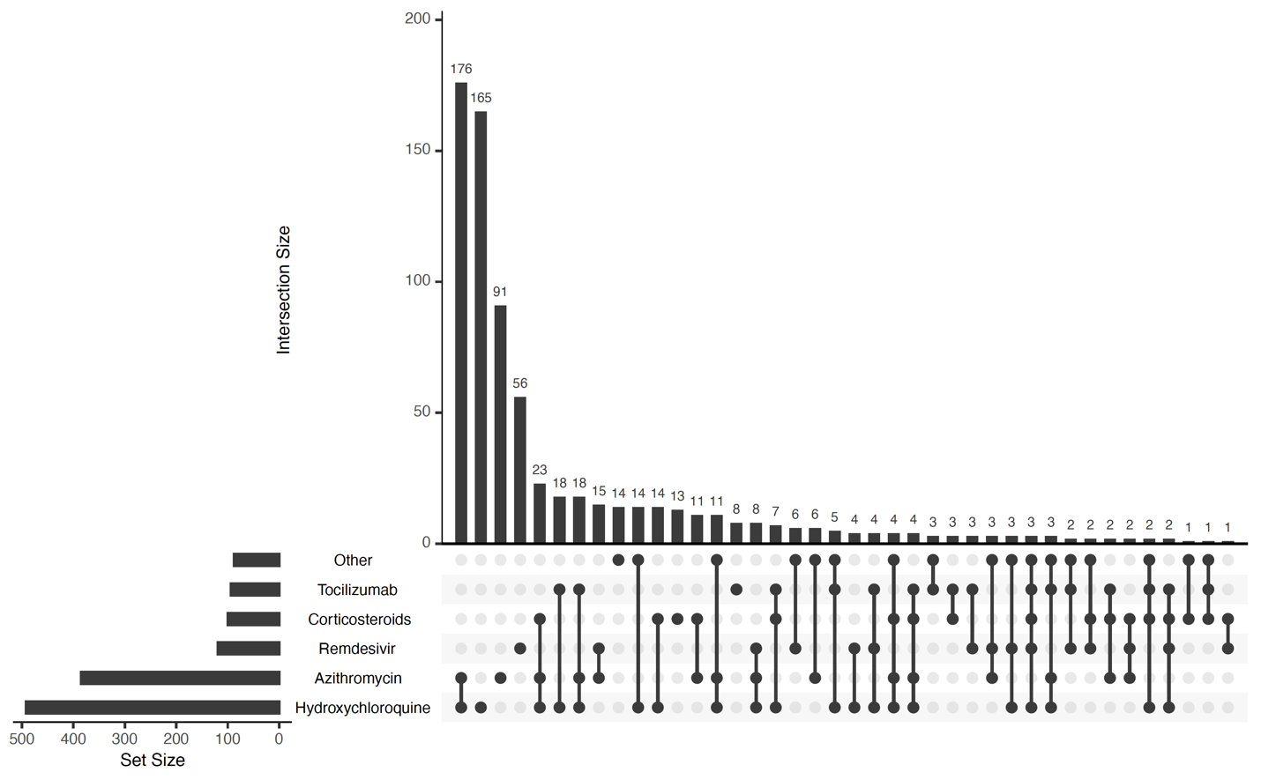

Supplemental Figure S2: UpSet plot of treatment exposures in never-hospitalized patients.
This includes n=569 (26%) patients known not to be hospitalized during the course of their COVID-19 illness (up until the time of last reporting). It does not include n=24 (1%) patients with unknown hospitalization status, or n=350 (16%) patients with missing hospitalization status.
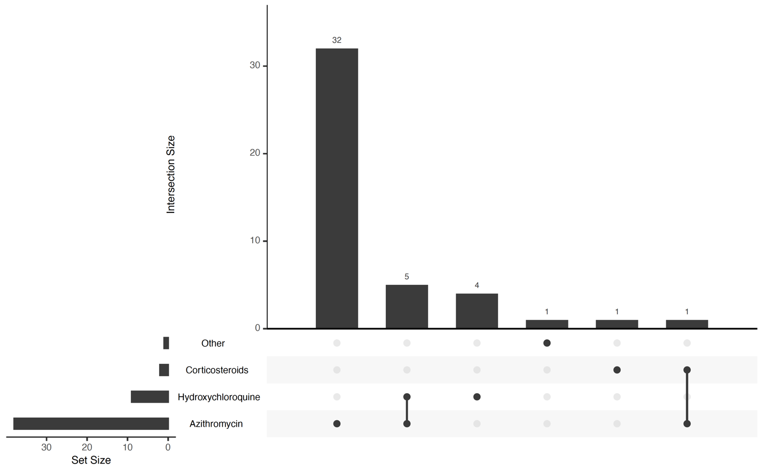

Supplemental Figure S3: Propensity score matching results. Distributions of propensity scores of HCQ alone, HCQ plus anything, Negative control, and Positive control before (left) and after (right) matching using the nearest-neighbor method with a 1:2 ratio and 0.3 standard deviation.

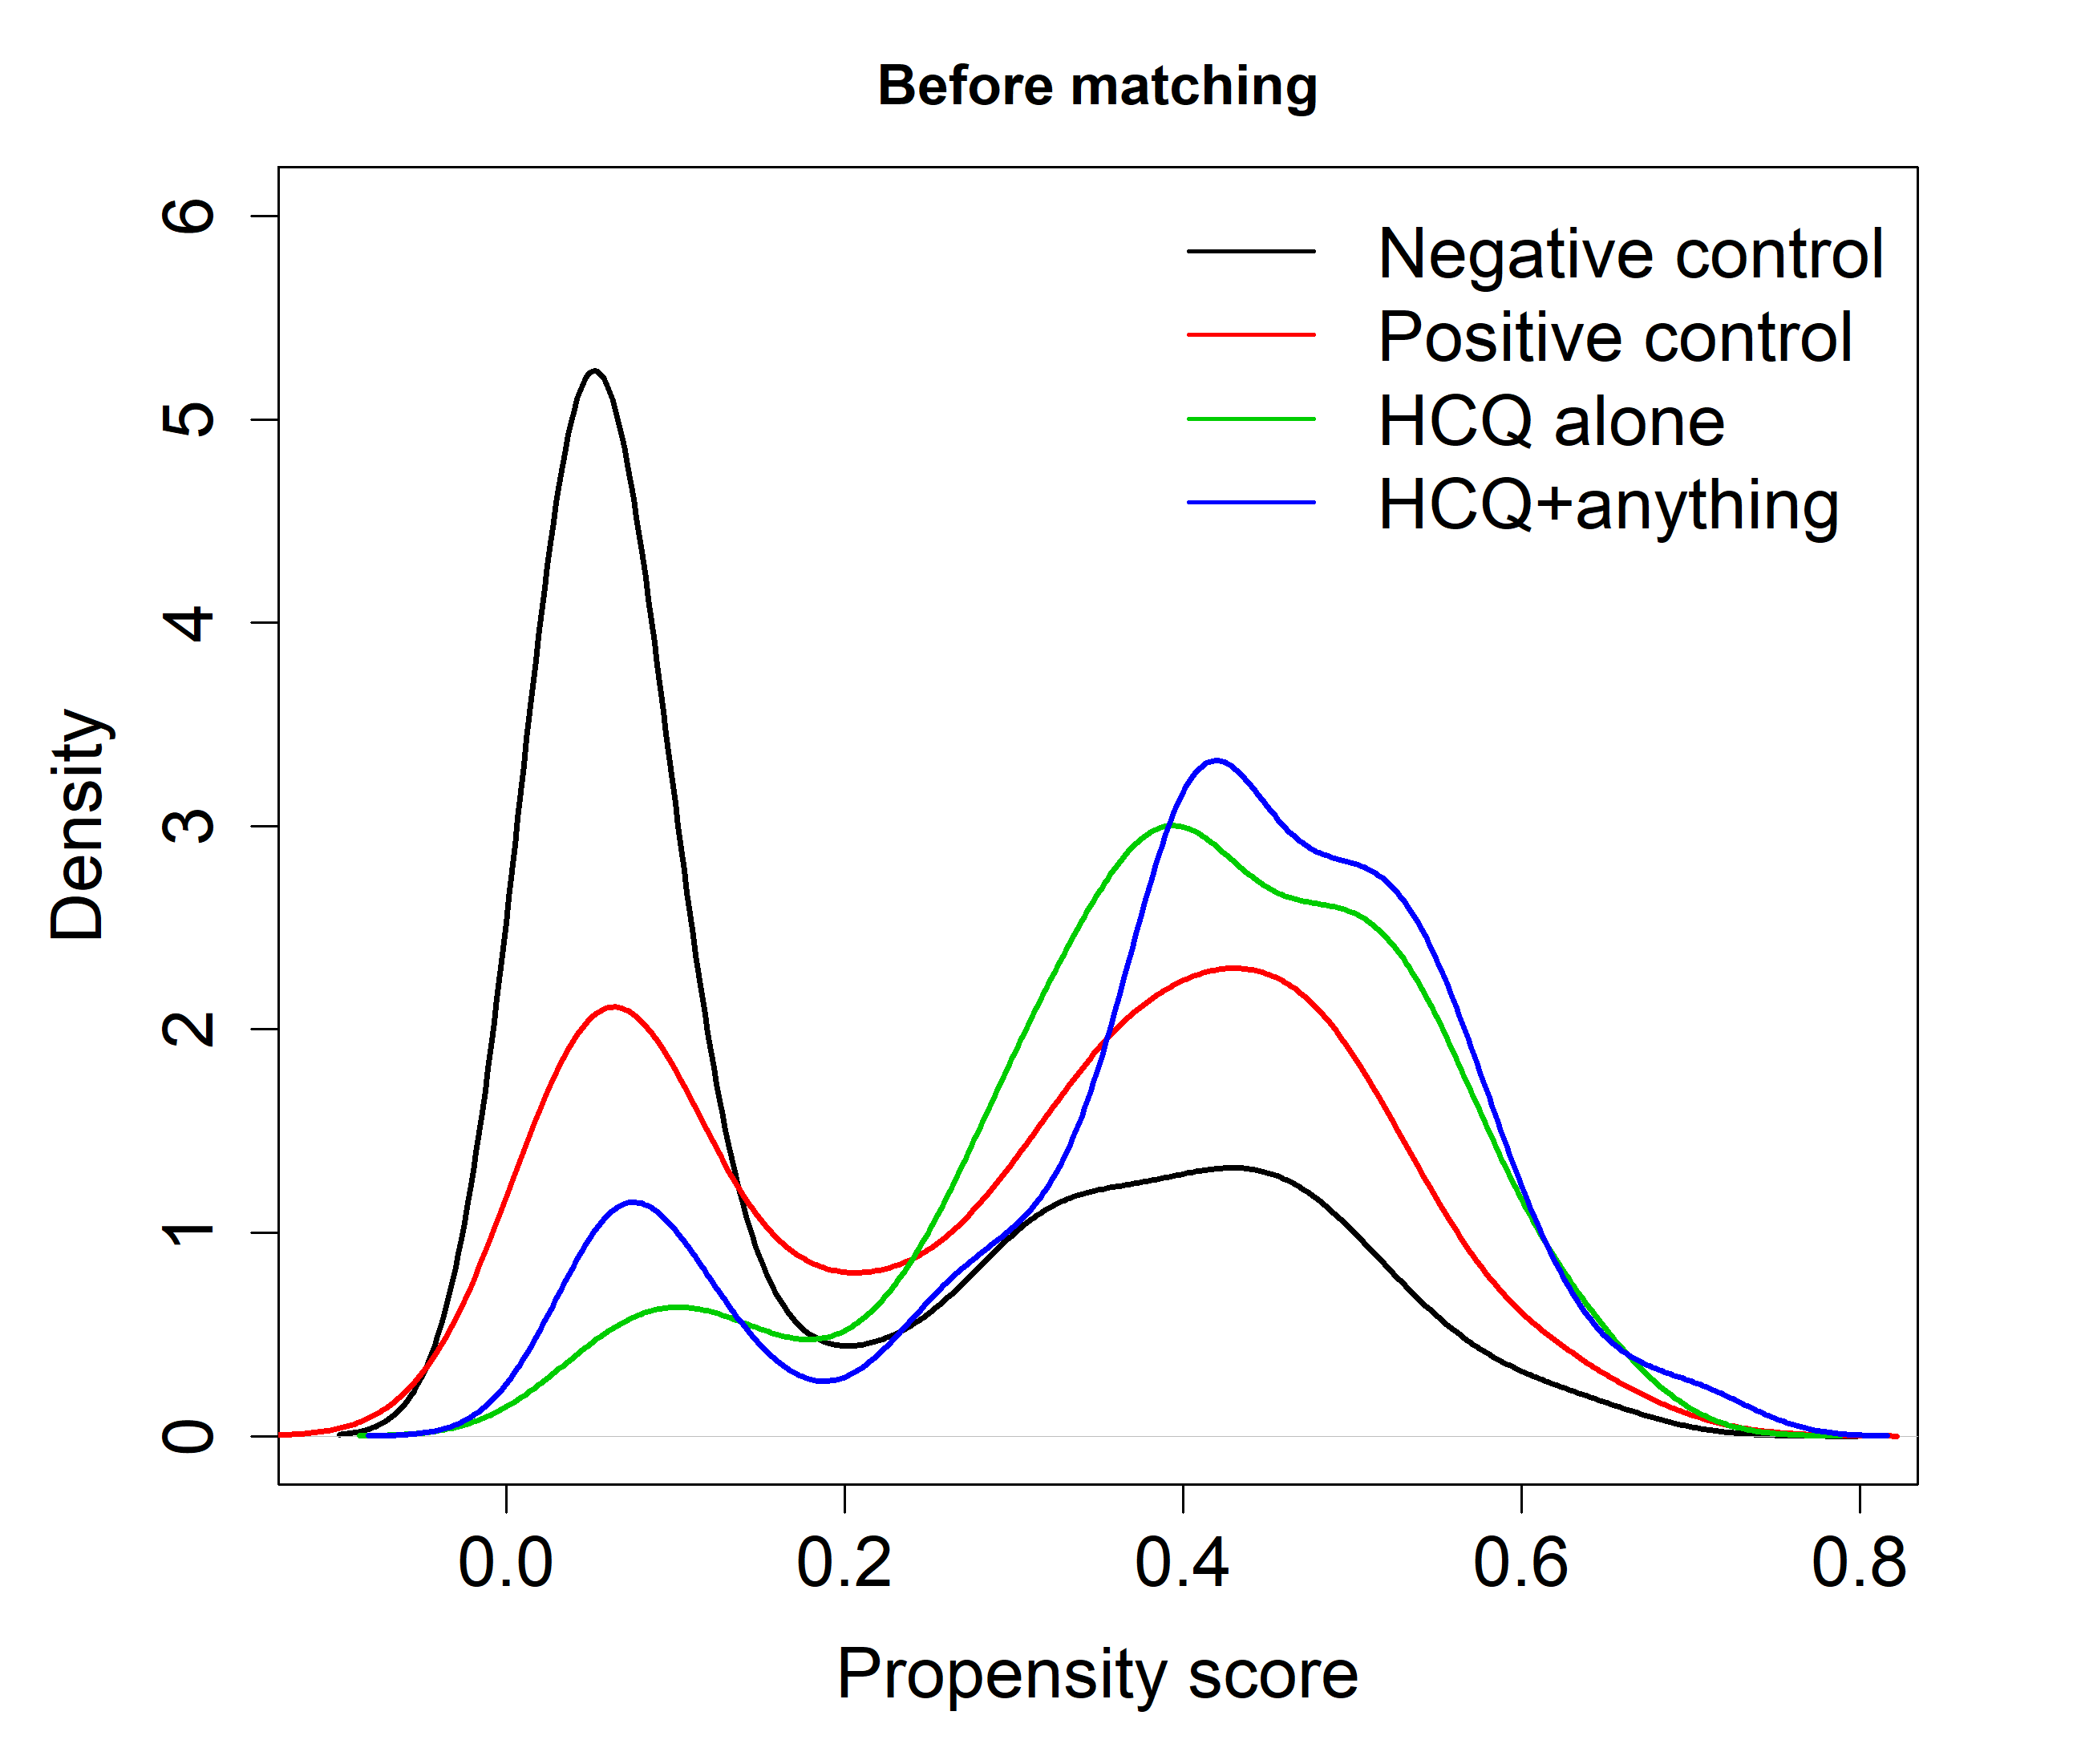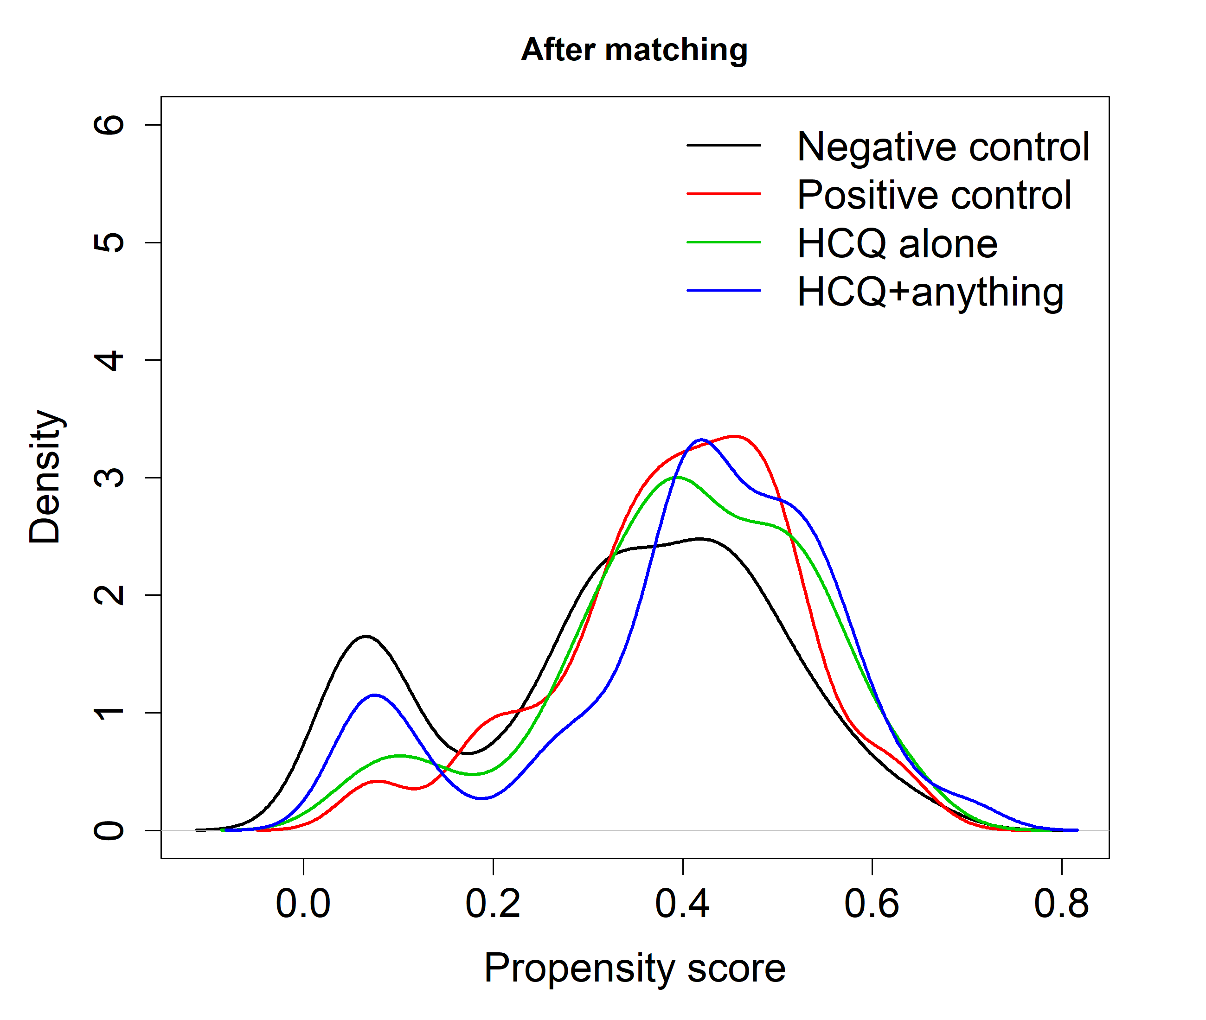

Supplemental Figure S4: Determination of standard deviation for propensity score matching. Loss of events (mortality) and maximum mean difference of propensity scores between the four treatment groups, which are obtained from two-group propensity score matching using the nearest-neighbor method with a 1:2 ratio (treated units: control units) and different multipliers of standard deviation.
