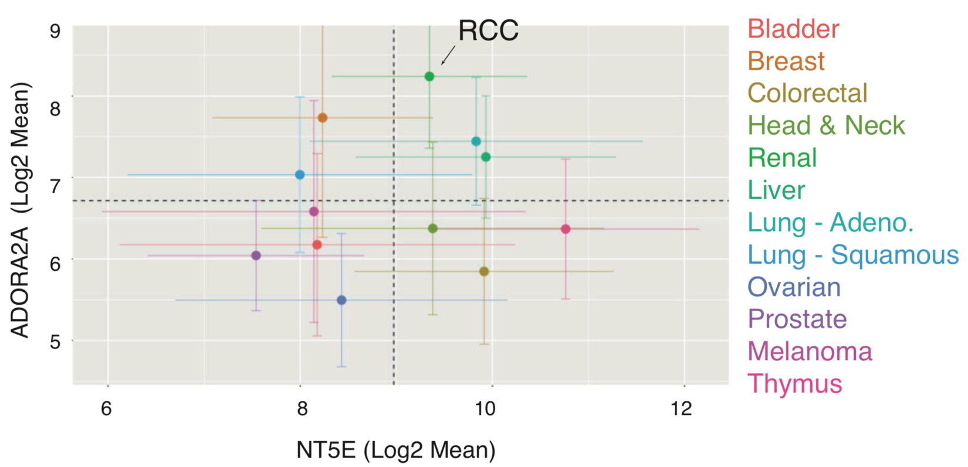

FIGURE S1: Expression of A2AR (ADORA2A) and CD73 (NT5E) in various solid tumors.

Analysis of ADORA2A and NT5E expression levels based on RNASeq data extracted from The Cancer Genome Atlas (TCGA). Error bars represent the 95% confidence intervals.

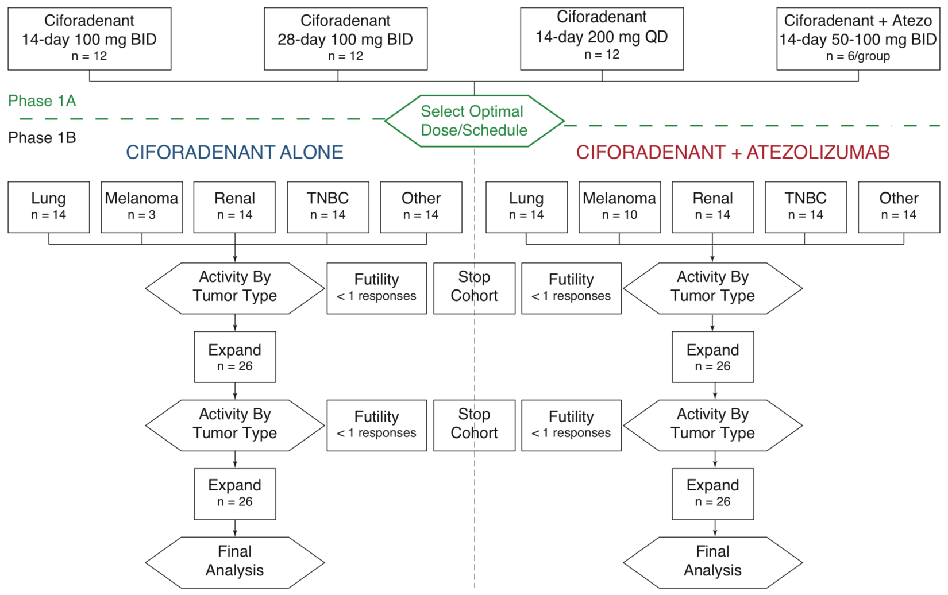

FIGURE S2: Overall study design schematic.

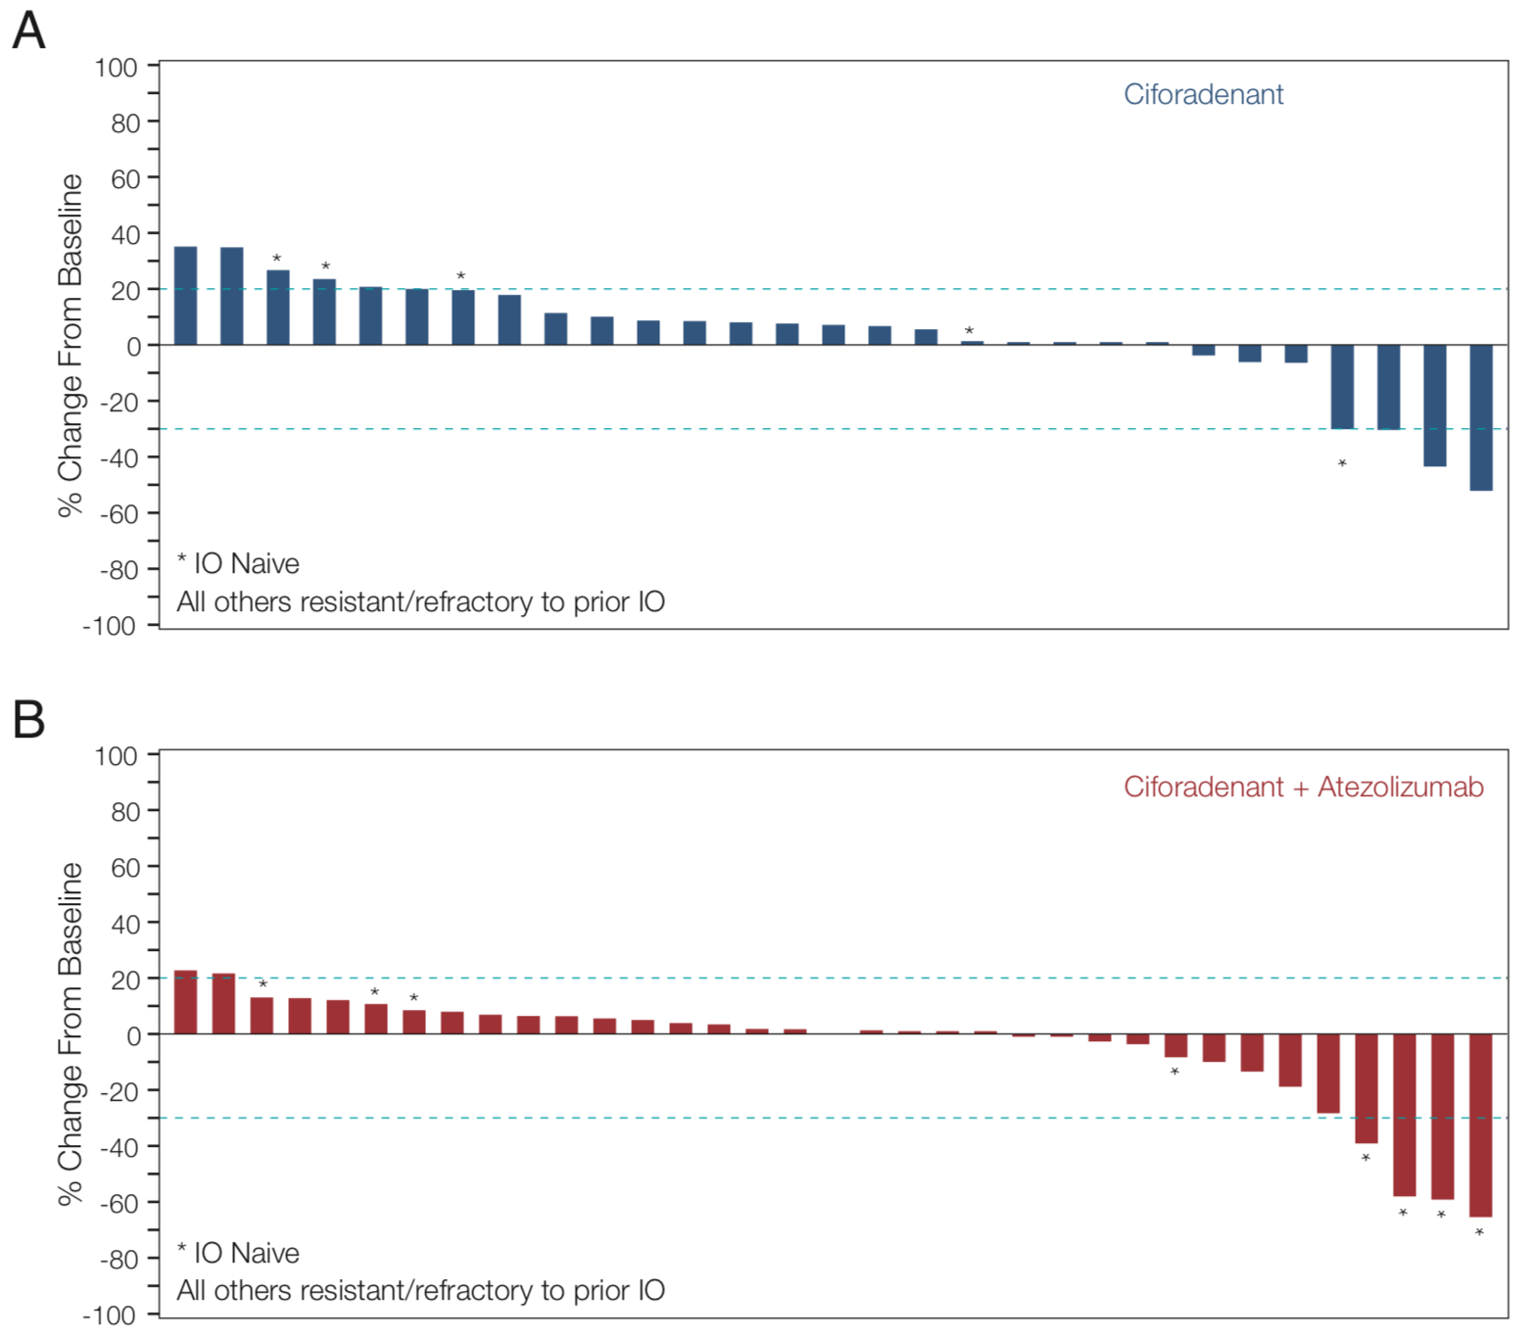

FIGURE S3: Waterfall plot of patients treated with Ciforadenant (A) only or Ciforadenant + Atezolizumab (B).

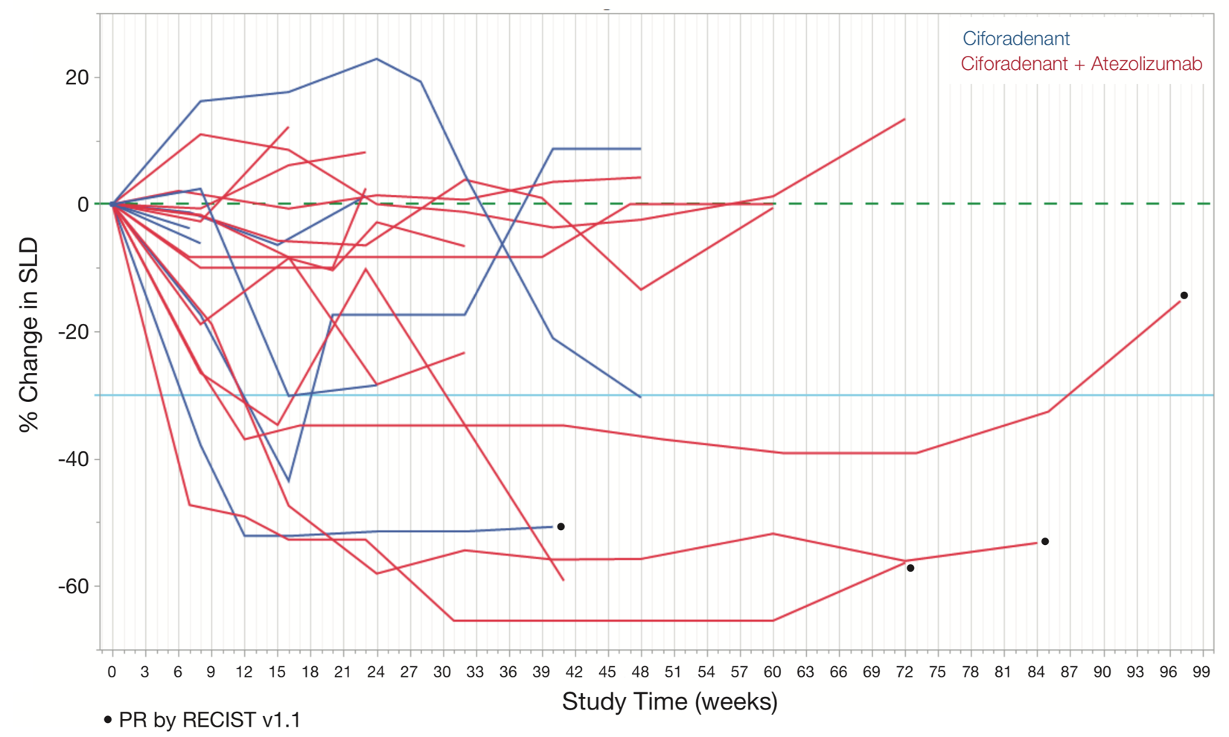

FIGURE S4: Spider plots of tumor response duration and kinetics in patients demonstrating tumor regression following treatment with ciforadenant or ciforadenant plus atezolizumab.

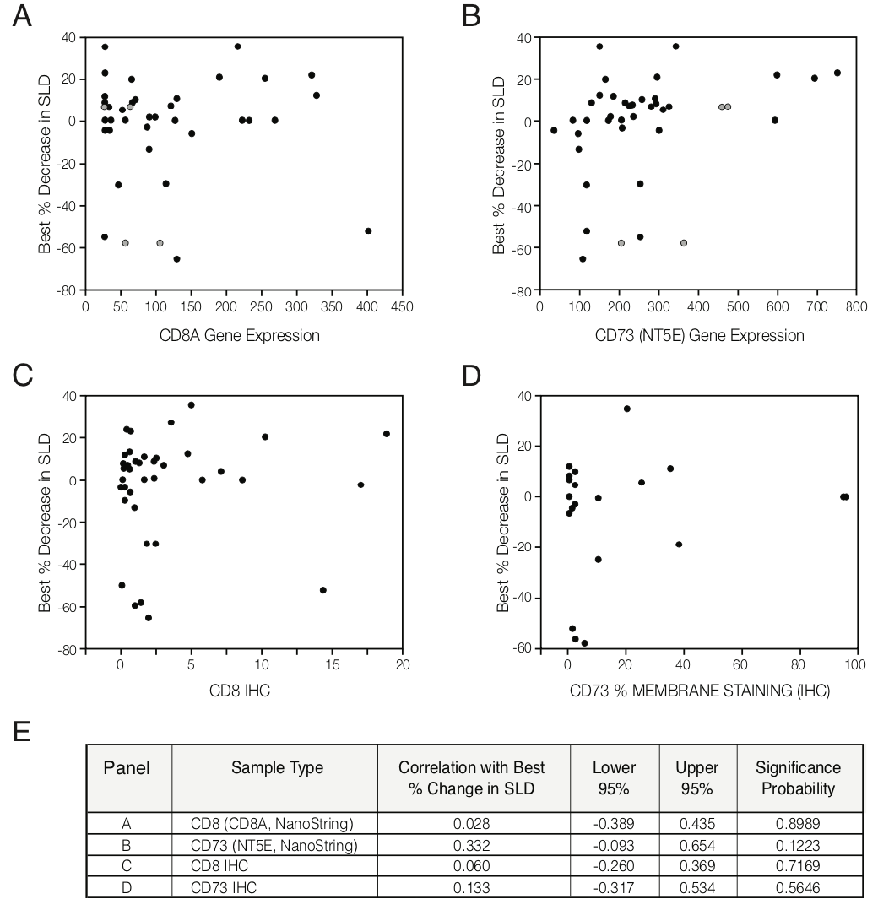

FIGURE S5: Lack of correlation between CD73 or CD8 expression and tumor response
A-B) Scatter plots showing relationship between CD8 (A) or CD73 (B) expression levels by NanoString and best percent change in the sum of the longest tumor dimensions (SLD). Grey circles represent independent measurement from different cores taken from the same patient. C-D) Scatter plots showing relationship between CD8 (C) or CD73 (D) percent membrane staining and best percent change in the SLD. E) Statistical summary demonstrating lack of association with CD8 or CD73 level and tumor response.

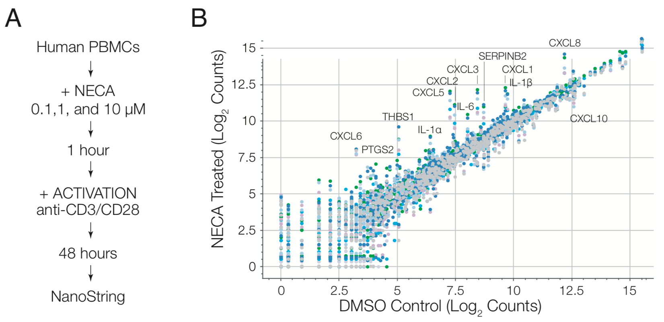

FIGURE S6: Characterization of gene expression signature related to adenosine exposure
A) Summary of experiment design. B) Representative graphical analysis of gene expression changes in human PBMCs following NECA stimulation, as characterized by NanoString PanCancer Immune Panel. The colors reflect different donors and concentrations of NECA.

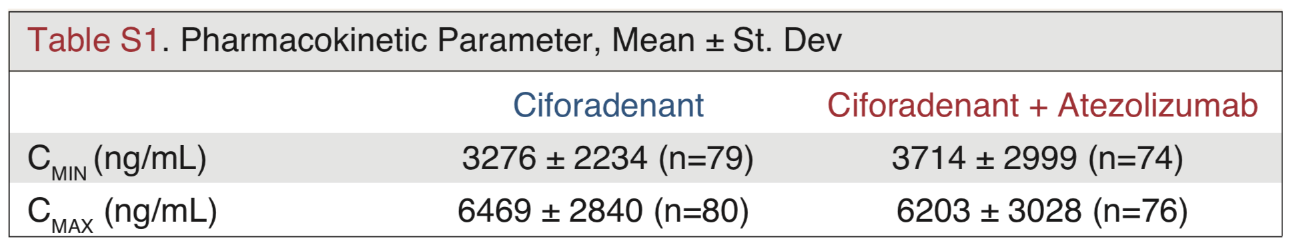

Table S1: Ciforadenant pharmacokinetics

Pharmacokinetic measurements (C_{min} obtained just prior to Day 14 dose and C_{max} obtained 1 hour after Day 14 dose) were performed in patients receiving 100 mg ciforadenant BID.

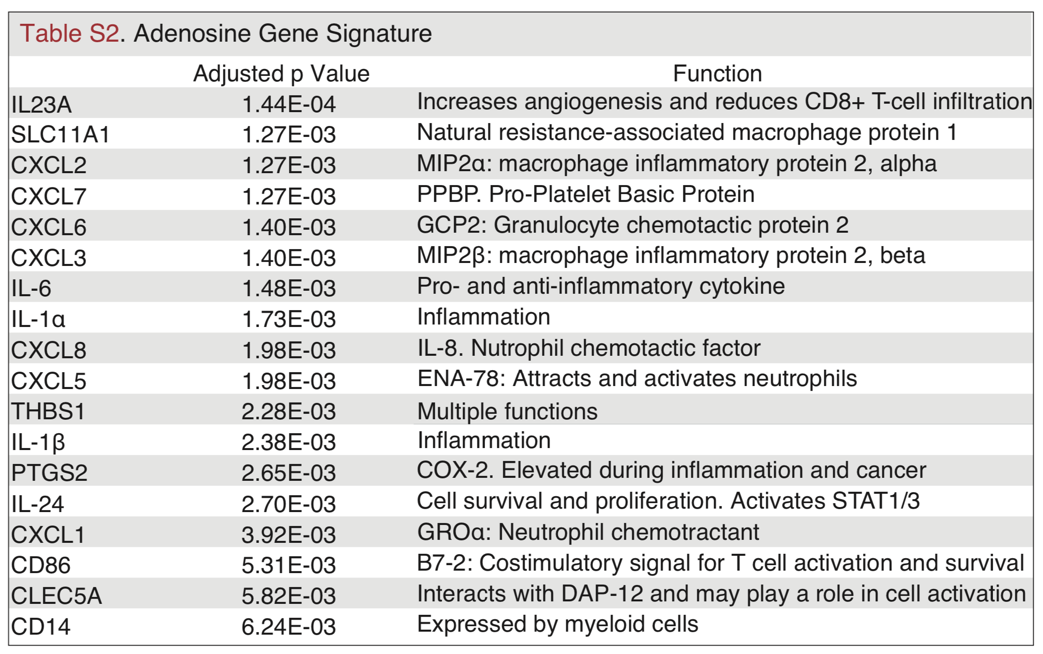
Table S2: Adenosine gene signature

Genes with most significant change in expression, as evaluated by NanoString analysis.

