## Supplementary Materials and Methods

## Cell culture

All human lymphoblastoid cell lines and tumor cells including MM253, SK-MEL-5, MM96L, MM127, HT144, C32, SK-MEL-28, JA, WW, MM649, A431, MCF7, Hela, K562, HT-29 and the neonatal fetal fibroblastic (NFF) cell line were maintained in complete RPMI 1640 media containing 10% fetal bovine serum, 1% L-glutamine and 1% penicillin/streptomycin. Mouse tumor cell lines including SM1WT1 melanoma and MCA1956 fibrosarcoma, 3LL lung carcinoma and 4T1.2 mammary carcinoma were maintained in complete RPMI 1640 media, and MC38 parental or OVA-expressing colorectal adenocarcinoma, HcMel3, HcMel12 melanoma, RM-1 prostate cancer cells in complete DMEM media containing 10% fetal bovine serum, 1% L-glutamine and 1% penicillin/streptomycin.

## Determination of MR1 expression on tumor and immune cells

For MR1 surface expression, human lymphoblastoid cell lines and mouse and human tumor cell lines were seeded into a 96-well plate and treated with various concentration of MAIT cell antigen 5-OP-RU or Ac-6-FP for the indicated time as described in the figure legends. After treatment, tumor cells were harvested and stained with anti-MR1 (clone 26.5, BioLegend) or isotype antibody for flow cytometry analysis. Dead cells stained with 7-AAD (BioLegend) or Zombie Aqua (BioLegend) were excluded from analysis.

Lung and thymus single cell suspensions were incubated for 4 h in the presence of 1 μmol/L 5-OP-RU. Cells then were stained with anti-MR1 (clone 26.5 or 8F2.F9) and antibody cocktails to determine the surface expression of MR1 on different immune populations. Purified anti-MR1 8F2.F9 was conjugated with Alexa Fluor™ 647 by using Antibody Labeling Kit (Invitrogen™, catalog#A20186). In some experiments, surface-stained cells were fixed with a Cytofix/Cytoperm kit (BD Biosciences) for 20 min followed by intracellular MR1 staining. Antibodies used to define immune cell populations were as follows: CD45.2 (104), CD45.2 (30-F11), TCRβ (H57-597), CD69 (H1.2F3), TCRγδ (GL3), NK1.1 (PK136), NKp46 (29A1.4), CD107a, (1D4B), CD11b (M1/70), B220 (RA3-6B2), F4/80 (BM8), CD11c (N418), MHC II (M5/114.15.2), Ly6G (1A8), Ly6C (AL-21), CD64 (X54-5/7.1) and CD24 (M1/69). 7AAD and Zombie Aqua were used to exclude dead cells. Immune populations were gated on CD45.2+  cells and defined as: B cells (CD19+ TCRβ-), CD4+ T cells (CD4+ TCRβ+), CD8+ T cells (CD8+ TCRβ+), γδ T cells (TCRγδ+ TCRβ-), NK cells (NK1.1+ NKp46+ TCRβ-), alveolar macrophages (Mϕ) (Ly6G- CD64+ CD24- CD11c+CD11b- cells), DCs (Ly6G-CD64-CD24+ MHCII+ CD11c+ cells), monocytes (Ly6G-MHCIIlow CD11b+ CD64+ cells), neutrophils (Ly6G+), eosinophils (Ly6G-CD64-CD24+CD11b+MHCII- cells), DP thymocytes (CD4+CD8+) and non-immune cells (CD45.2-). All data were collected on a Fortessa 4 flow cytometer (BD Biosciences) and analyzed with FlowJo v10 software (TreeStar, Inc.).

## *In vitro* co-culture assay

CellTrace™ Violet (CTV)(Invitrogen™; catalog #C34557)-labeled parental B16F10 cells were co-cultured with sorted MAIT cells or conventional T cells expanded from the splenocytes of C57BL/6 WT mice at a ratio of 1:4 in the presence of IL-2 (50 U/ml). During co-culture, 100 nmol/L 5-OP-RU or their respective DMSO control were added as indicated in the figure legend. After 24 h incubation, cells were collected and surface stained with anti-TCRβ (H57-597) and Zombie Aqua, followed by intracellular staining with anti-IFNγ (XMG1.2), anti-TNF (MP6-XT22) and anti-IL17A (TC11-18H10.1). B16F10 cell numbers were enumerated using flow cytometry cell counting beads (BD Biosciences).

## IncuCyte scratch and proliferation assay

Cell migration was determined as described (1) B16F10 and B16F10-MR1KO (sgR3) cells were cultured in 96-well plates and then scratched with a Scratch WoundMaker (Essen BioScience) when cell confluency reached 80%. The scratched fields were monitored with the IncuCyte Live Cell Imaging System (Essen BioScience). The degree of migration was analyzed using IncuCyte Scratch Wound Cell Migration Software and presented as a percentage of wound closure. For proliferation assay, B16F10 and B16F10-MR1KO (sgR3) cells were seeded in 96-well plate and cell confluency was assessed with the IncuCyte Live Cell Imaging System.

Table 1. MR1-sgRNA sequence

|  |  |
| --- | --- |
|  | Sequence |
| sgRNA1 | Forward: CACCGAGGTACACTCAGCTGCTAAG |
| Reverse: AAACCTTAGCAGCTGAGTGTACCTC |
| sgRNA2 | Forward: CACCGAGGCGGAGCTGAGGCACCTACAG |
| Reverse: AAACCTGTAGGTGCCTCAGCTCCGCCTC |
| sgRNA3 | Forward: CACCGACGAAAATATCTCAGCGAGT |
| Reverse: AAACACTCGCTGAGATATTTTCGTC |

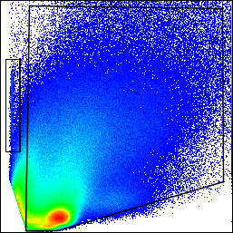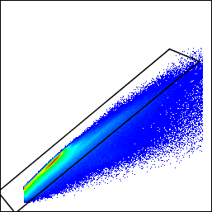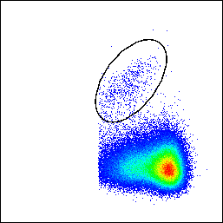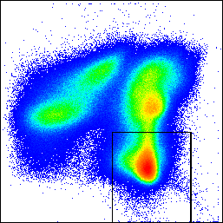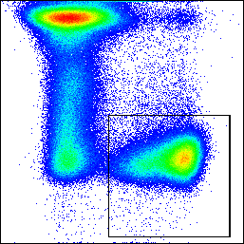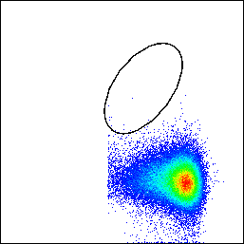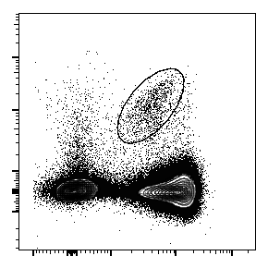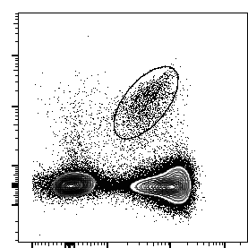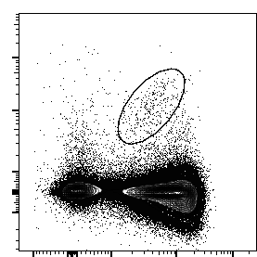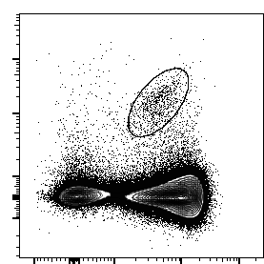**Supplementary Figure 1. Gating strategy to define MAIT cells**

WT mice

No transfer

*Mr1*-/- mice

MAIT cell transfer

MR1-5-OP-RU tetramer

TCRβ

Mouse 1

Mouse 2

Mouse 3

MR1-6-FP tetramer

TCRβ

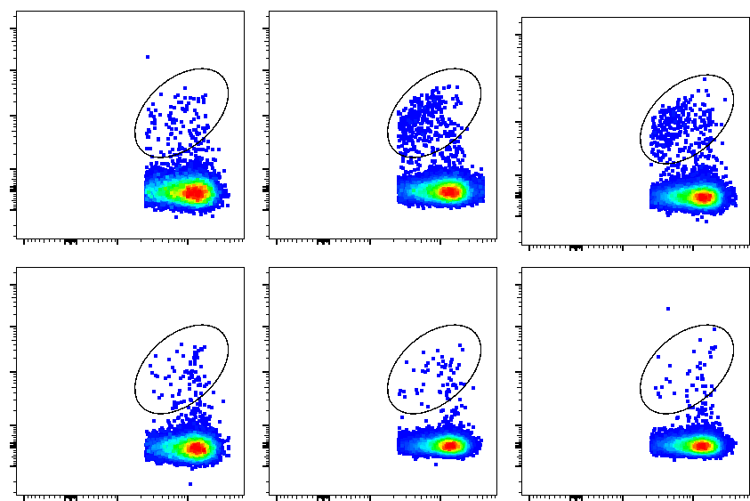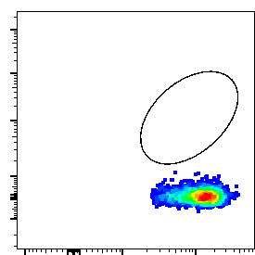

MAIT 0.48%

MAIT 1.04%

MAIT 0.75%

MAIT 0.36%

MAIT 0.15%

MAIT 0.11%

0.016%



*Tcrd*-/-

MAIT 0.13%

MAIT 0.04%

MAIT 0.3%

*Tcrd*-/-

MR1-5-OP-RU tetramer

MR1-6-FP tetramer

B220/ F4/80

FSC-H

Zombie aqua

Control staining

TCRβ+ cells

**C**

**G**

FSC-A

SSC-A

FSC-A

TCRβ

CD45.2

TCRβ

TCRβ

MAIT 0.0018%

**A**

TCRβ

MR1-5-OP-RU tetramer

WT

MAIT 1.1%

Lung

TCRβ

MR1-5-OP-RU tetramer

WT

Spleen

**D**

**E**

**F**

MAIT 0.59%

**B**

(**A**) Gating strategy to identify MAIT cells defined as B220- F4/80- MR1-5-OP-RU tetramer+ TCRβ+ CD45.2+ with MR1-6-FP tetramer used as a negative control. (**B**) From the experiment in Fig. 2B, the proportion of MAIT cells in the lungs of WT and *Mr1*-/- mice post transfer. After enumeration of lung metastases, lung single cell suspensions were generated from WT mice and MAIT🡪*Mr1*-/- mice for FACs analysis. The proportion of MAIT cells from three individual mice from the indicated groups are shown. (**C**) Representative FACs plots of MAIT cells and (**D**) the proportion of MAIT cells in total CD45.2+ cells in the lungs of naïve C57BL/6 WT and *Tcrd* mice. (**E**) Representative FACs plot of MAIT cells and (**F**) the proportion of MAIT cells in the total CD45.2+ cells in the spleens of naïve C57BL/6 WT and *Tcrd* mice. (**G**) Groups of C57BL/6 WT or *Mr1*-/- mice (n=5-6/group) were injected i.v. with 1 x 105 B16F10 melanoma cells. In some groups, sorted MAIT or T conventional cells (cT) (non-MAIT  T cells)(2 x 105 cells/mouse) from *Tcrd*  mice were i.v injected into the indicated groups of mice one day before tumor inoculation. On day 14 relative to tumor cell inoculation, lungs were harvested and the metastatic burden was quantified by counting colonies on the lung surface. Data presented as mean ± SEM and pooled from two independent experiments. Significant differences between groups as indicated by crossbars were determined by a one-way ANOVA followed by Tukey *post-hoc* test, **p<0.01, ***p<0.001.

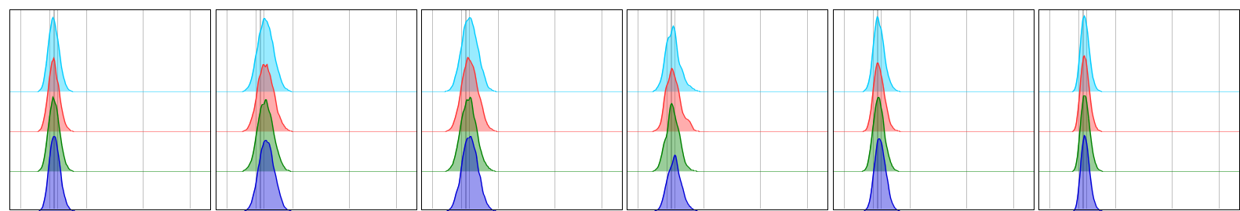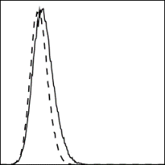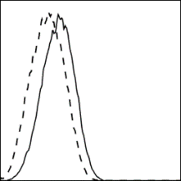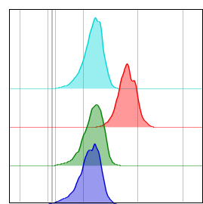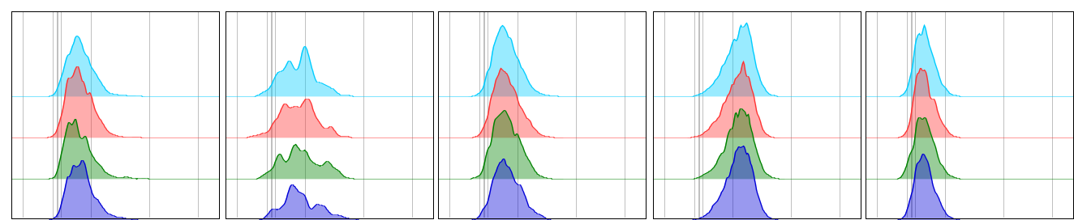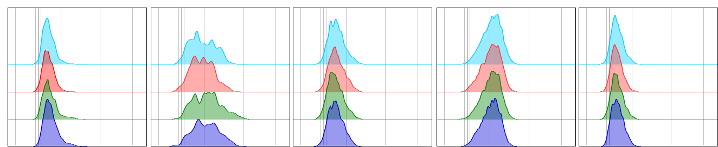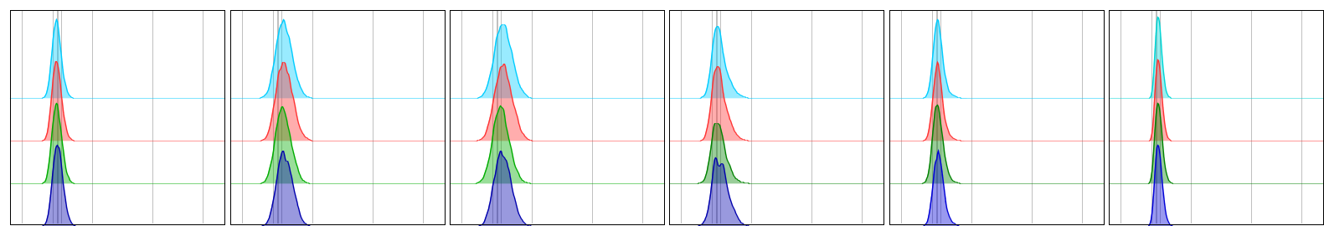

*Mr1*-/-

MR1WT

MR1 (clone 8F2.F9)

MR1 (clone 8F2.F9)

NK cells

γδ T cells

MR1 (clone 26.5)

MR1KO

eosinophils

neutrophils

monocytes

DCs

alveolar MΦ

CD45.2- cells

CD8+ T cells

CD4+ T cells

CD45.2- cells

CD8+ T cells

CD4+ T cells

B cells

5-OP-RU

DMSO

5-OP-RU

DMSO

5-OP-RU

DMSO

5-OP-RU

DMSO

5-OP-RU

DMSO

5-OP-RU

DMSO

5-OP-RU

DMSO

5-OP-RU

DMSO

B cells

WT

*Mr1*-/-

MR1 (clone 8F2.F9)

B16F10 cells

5-OP-RU

DMSO

5-OP-RU

DMSO

WT

*Mr1*-/-

**B**

**A**

MR1 (clone 26.5)

γδ T cells

NK cells

WT

alveolar MΦ

DCs

monocytes

neutrophils

eosinophils

WT

*Mr1*-/-

**C**

**D**

**E**

**F**

MR1 (clone 26.5)

Surface

MR1 (clone 26.5)

ICS

MR1 (clone 8F2.F9)

ICS

WT

*Mr1*-/-

WT

*Mr1*-/-

WT

*Mr1*-/-

**Supplementary Figure 2. MR1 surface expression is undetectable on the surface of hematopoietic and non-hematopoietic cells.**

Lung single cell suspensions generated from C57BL/6 WT and *Mr1*-/- mice were stimulated with 1 μmol/L 5-OP-RU for 4 h and analyzed by flow cytometry. MR1 surface expression on the different subsets of hematopoietic cells and non-hematopoietic cells as determined using anti-MR1 (**A**) clone 26.5 or (**B**) clone 8F2.F9. (**C**) MR1 surface expression in control B16F10 or B16F10-MR1KO (sgR3 clone) after stimulation with 100 nmol/L 5-OP-RU for 4 h. (**D-F**) MR1 intracellular expression or surface expression in CD4+CD8+ DPthymocytes after stimulation with 1 μmol/L 5-OP-RU for 4 h was determined using the indicated clone of anti-MR1 antibody.

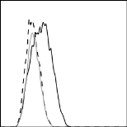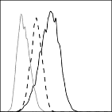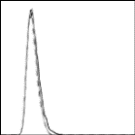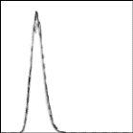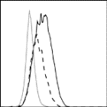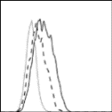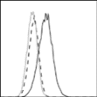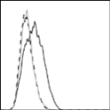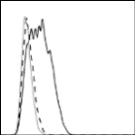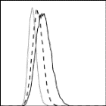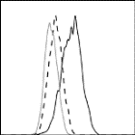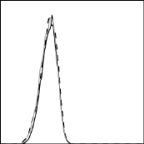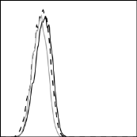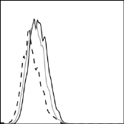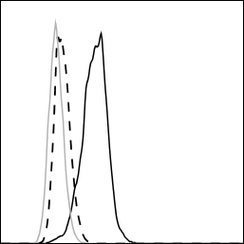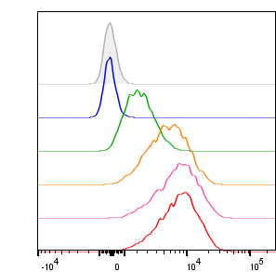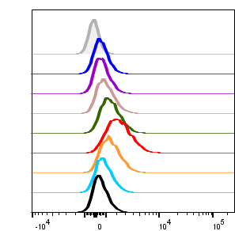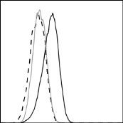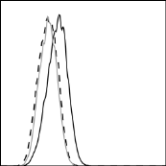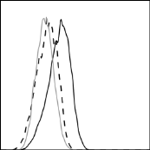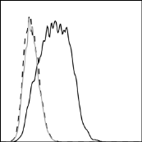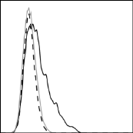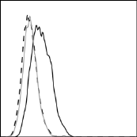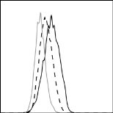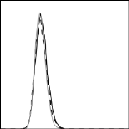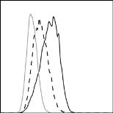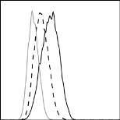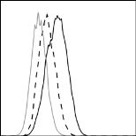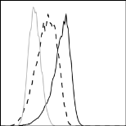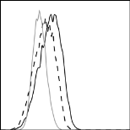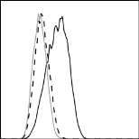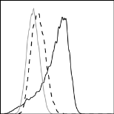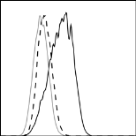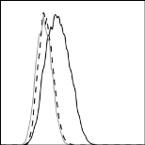

MM127

MM96L

MM253

MR1 (clone 26.5)

Isotype

Isotype

5-OP-RU

(nmol/L)

Isotype

5-OP-RU

10 nmol/L

DMSO

Isotype

**C**

0.5 h

1 h

2 h

4 h

8 h

12 h

24 h

0

10

100

1000

10000

MR1 (clone 26.5)

MR1 (clone 26.5)

**D**

**A**

MR1 (clone 26.5)

HcMel 3

3LL

HcMel 12

4T1.2

MCA1956

MR1 (clone 26.5)

SM1WT1

MC38

MC38-OVAdim

RM-1

**B**

DMSO

5-OP-RU

**H**

**F**

A431

MCF7

K562

027

043

MIRI

044

031

045

KH101

MR1 (clone 26.5)

**E**

Hela

HT-29

NFF

MR1 (clone 26.5)

HT144

C32

MM649

JA

SK-MEL-28

SK-MEL-5

WW

DMSO

5-OP-RU

**G**

**Supplementary Figure 3. Upregulation of MR1 on some mouse and human tumor cell lines following incubation with 5-OP-RU.**

(**A, B**) MR1 surface expression on the indicated mouse tumor cell lines after stimulation with DMSO or 100 nmol/L 5-OP-RU for 4 h. (**C, D**) Surface expression of MR1 on B16F10 melanoma cells as assessed by flow cytometry after (**C**) a 4 h stimulation with the indicated concentrations of 5-OP-RU or (**D**) after stimulation with 10 nmol/L 5-OP-RU for the indicated time. (**E-G**) Human EBV-transformed B cells and various human cell lines were cultured with or without 100 nmol/L 5-O-RU for 4 h. Cell surface MR1 levels on these cells were next determined by flow cytometry. Surface MR1 expression level on (**E**) EBV-transformed B cells from different individuals, (**F**) on human tumor cell lines and NFF cells. All experiments performed once. (**H**) Groups of C57BL/6 WT or *Mr1*-/- mice (n=6-8/group) were injected i.v. with 5 x 104 RM-1 prostate tumor cells. On day 14 relative to tumor cell inoculation, lungs were harvested and the metastatic burden was quantified by counting colonies on the lung surface. Data presented as mean ± SEM and pooled from two independent experiments.

CD107a

IFNγ

DMSO

5-OP-RU

**B**

**D**

i.v. inject 5-OP-RU-

pulsed B16F10 cells

**A**

Stimulate lung

suspension

11

0

Analyse

NK cell function

**C**

**E**

Day

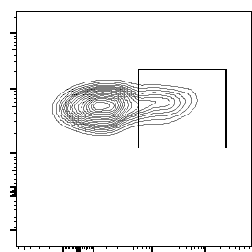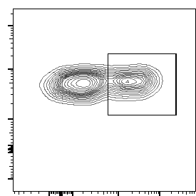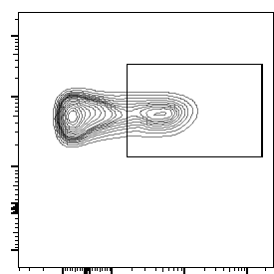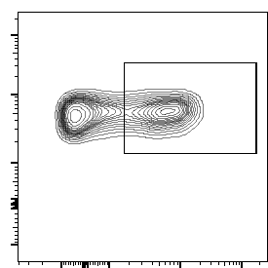

CD107a+ NK 31.1% 1.1%

CD107a+ NK 46.4%

IFNγ+ NK 21.3% 1.1%

IFNγ+ NK 37.1% 1.1%

NK1.1

NK1.1

**Supplementary Figure 4. Suppression of NK cell effector function in WT mice injected with 5-OP-RU-treated B16F10 cells.**

(**A**) Schematic to analyze NK cell effector function in the lungs of C57BL/6 WT mice injected with 5-OP-RU-pulsed B16F10. Groups of C57BL/6 WT mice (n= 5/group) were i.v. injected with 1 x 105 B16F10 cells stimulated with or without 5-OP-RU at the indicated concentrations for 4 h. Lungs of naïve or tumor-bearing mice were harvested on day 11 relative to tumor cell inoculation and single cell suspensions were stimulated with PMA/ionomycin plus protein transport inhibitors for 3 h. NK cell IFNγ production and degranulation (measured by CD107a expression) were determined by flow cytometry. (**B**) Representative FACS plots of IFNγ production by NK cells (NKp46+NK1.1+TCRβ- CD45.2+). (**C**) The proportions and geometric MFI of IFNγ+ NK cells amongst NK cells. (**D**) Representative FACS plots of CD107a expression on NK cells. (**E**) The proportions and MFI of CD107a+ NK cells amongst NK cells. Data presented as mean ± SEM. Experiment was performed once. Significant differences between groups as indicated by crossbars were determined by a one-way ANOVA followed by Tukey *post-hoc* test, *p<0.05, **p<0.01, ***p<0.001, ****p<0.0001.



**B**

**A**

**E**

**D**

**C**

**F**

**H**

**G**



**Supplementary Figure 5. MAIT cells produce inflammatory cytokines and display cytolytic function following co-culture with 5-OP-RU-treated B16F10 cells.**

CTV-labeled parental B16F10 cells were co-cultured with purified MAIT cells or conventional T cells (cT) (E:T: 4:1) in the presence of DMSO or 100 nmol/L 5-OP-RU. After 24 h, intracellular cytokine production from MAIT cells and cT cells and B16F10 cell number were determined by flow cytometry. (**A-C**) The proportions of IFNγ+, IL17A+ and TNF+ MAIT cells among MAIT cells. (**D-F**) The proportions of IFNγ+, IL17A+ and TNF+ cT cells among cT cells. (**G, H**) Number of B1F10 cells after co-culture with MAIT cells and cT cells, respectively. Data presented as mean ± SEM of three technical replicates. Experiment was performed once.

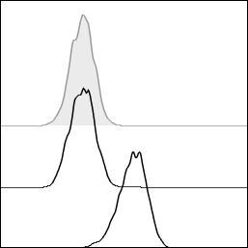

**B**

**E**

**A**

**D**

**C**

Vehicle

Isotype

Ac-6-FP

**F**

MR1 (clone 26.5)

**Supplementary Figure 6. Loss of MR1 in B16F10 cells does not affect their proliferation and migration.**

Parental B16F10, B16F10 vector control or B16F10-MR1KO (sgR3 clone) melanoma cells were cultured in 96-well plates at (**A**) 5000 cells/well or (**B**) 5 x 104 cells/well. (**A**) Cell proliferation was assessed by relative cell confluency and cell migration was assessed by analyzing their relative wound closure. (**C, D**) Parental B16F10 cells were cultured in 96-well plate in the presence of DMSO or 100 nmol/L 5-OP-RU, and (**C**) cell proliferation and (**D**) migration were assessed. Data presented as mean ± SEM of 5-6 technical replicates. (**E**) Groups of C57BL/6 WT mice (n= 6/group) were injected i.v. with 1 x 105 parental B16F10 cells and B16F10 vector control melanoma cells. On day 14 relative to tumor cell inoculation, lungs were harvested and the metastatic burden was quantified by counting colonies on the lung surface. Data presented as mean ± SEM. (**F**) B16F10 melanoma cells were stimulated *in vitro* with vehicle or Ac-6-FP (10 µmol/L) for 18 h before cell surface MR1 expression was determined by flow cytometry. All experiments were performed once.

## Reference

1. Li XY, Das I, Lepletier A, Addala V, Bald T, Stannard K, et al. CD155 loss enhances tumor suppression via combined host and tumor-intrinsic mechanisms. J Clin Invest. 2018;128:2613-25.