Adult low hypodiploid acute lymphoblastic leukemia emerges from pre-leukemic TP53-mutant clonal hematopoiesis

Rathana Kim et al.

Supplementary data

Supplementary Figures
Supplementary figure 1. Sequencing-based analysis of CNA and LOH in adult LH-ALL.
Supplementary figure 2. Representation of mutations in the frequent targeted genes in adult LH-ALL.
Supplementary figure 3. Longitudinal assessment of TP53-mutant cell fraction as determined by ddPCR along with clonal IG/TR-based MRD quantification in three patients with undetectable TP53 mutation at remission.
Supplementary figure 4. Merged single-cell analysis of cell-surface markers by ADT-sequencing of remission samples from three LH-ALL patients.
Supplementary figure 5. Individual single-cell analyses of cell-surface markers by ADT-sequencing of remission samples from three LH-ALL patients.
Supplementary figure 6. Individual analyses of single-cell immunophenotyping and genotyping of remission samples from three LH-ALL patients.
Supplementary figure 7. Evaluation of allelic dropout rate on heterozygous single nucleotide polymorphism (SNPs) in remission samples.
Supplementary figure 8. Individual single-cell analysis of cell-surface markers by ADT-sequencing of diagnosis samples from three LH-ALL patients.
Supplementary figure 9. Single-cell genotyping of heterozygous SNPs allowing LOH assessment in diagnosis samples from three LH-ALL patients.
Supplementary Figure 10. Distribution of single-cell genotypes of two LH-ALL patients with persistent TP53 and JAK2 (EI_046) or DNMT3A (EI_035) mutations in remission samples.

Supplementary Tables (see attached file)
Supplementary Table 1. Karyotypes of LH-ALL patients at diagnosis
Supplementary Table 2. Somatic variants detected in LH-ALL patients at diagnosis
Supplementary Table 3. ARCH related variants detected in LH-ALL patients at remission
Supplementary Table 4. Minimal residual disease values of remission samples used for mutation analysis
Supplementary Table 5. Somatic alterations in cell populations from diagnostic samples (BMMC) based on single-cell analyses
Supplementary Table 6. Somatic alterations in FACS-sorted cell populations from diagnostic samples
Supplementary Table 7. Panel of genes for targeted sequencing
Supplementary Table 8. Single cell DNA amplicons for genotyping and LOH analyses
Supplementary Table 9. Single cell DNA amplicons for B-ALL clono-specific IG/TR detection
Supplementary Table 10. ADT-seq panel and spike-in antibodies
Supplementary Table 11. Single cell sequencing metrics

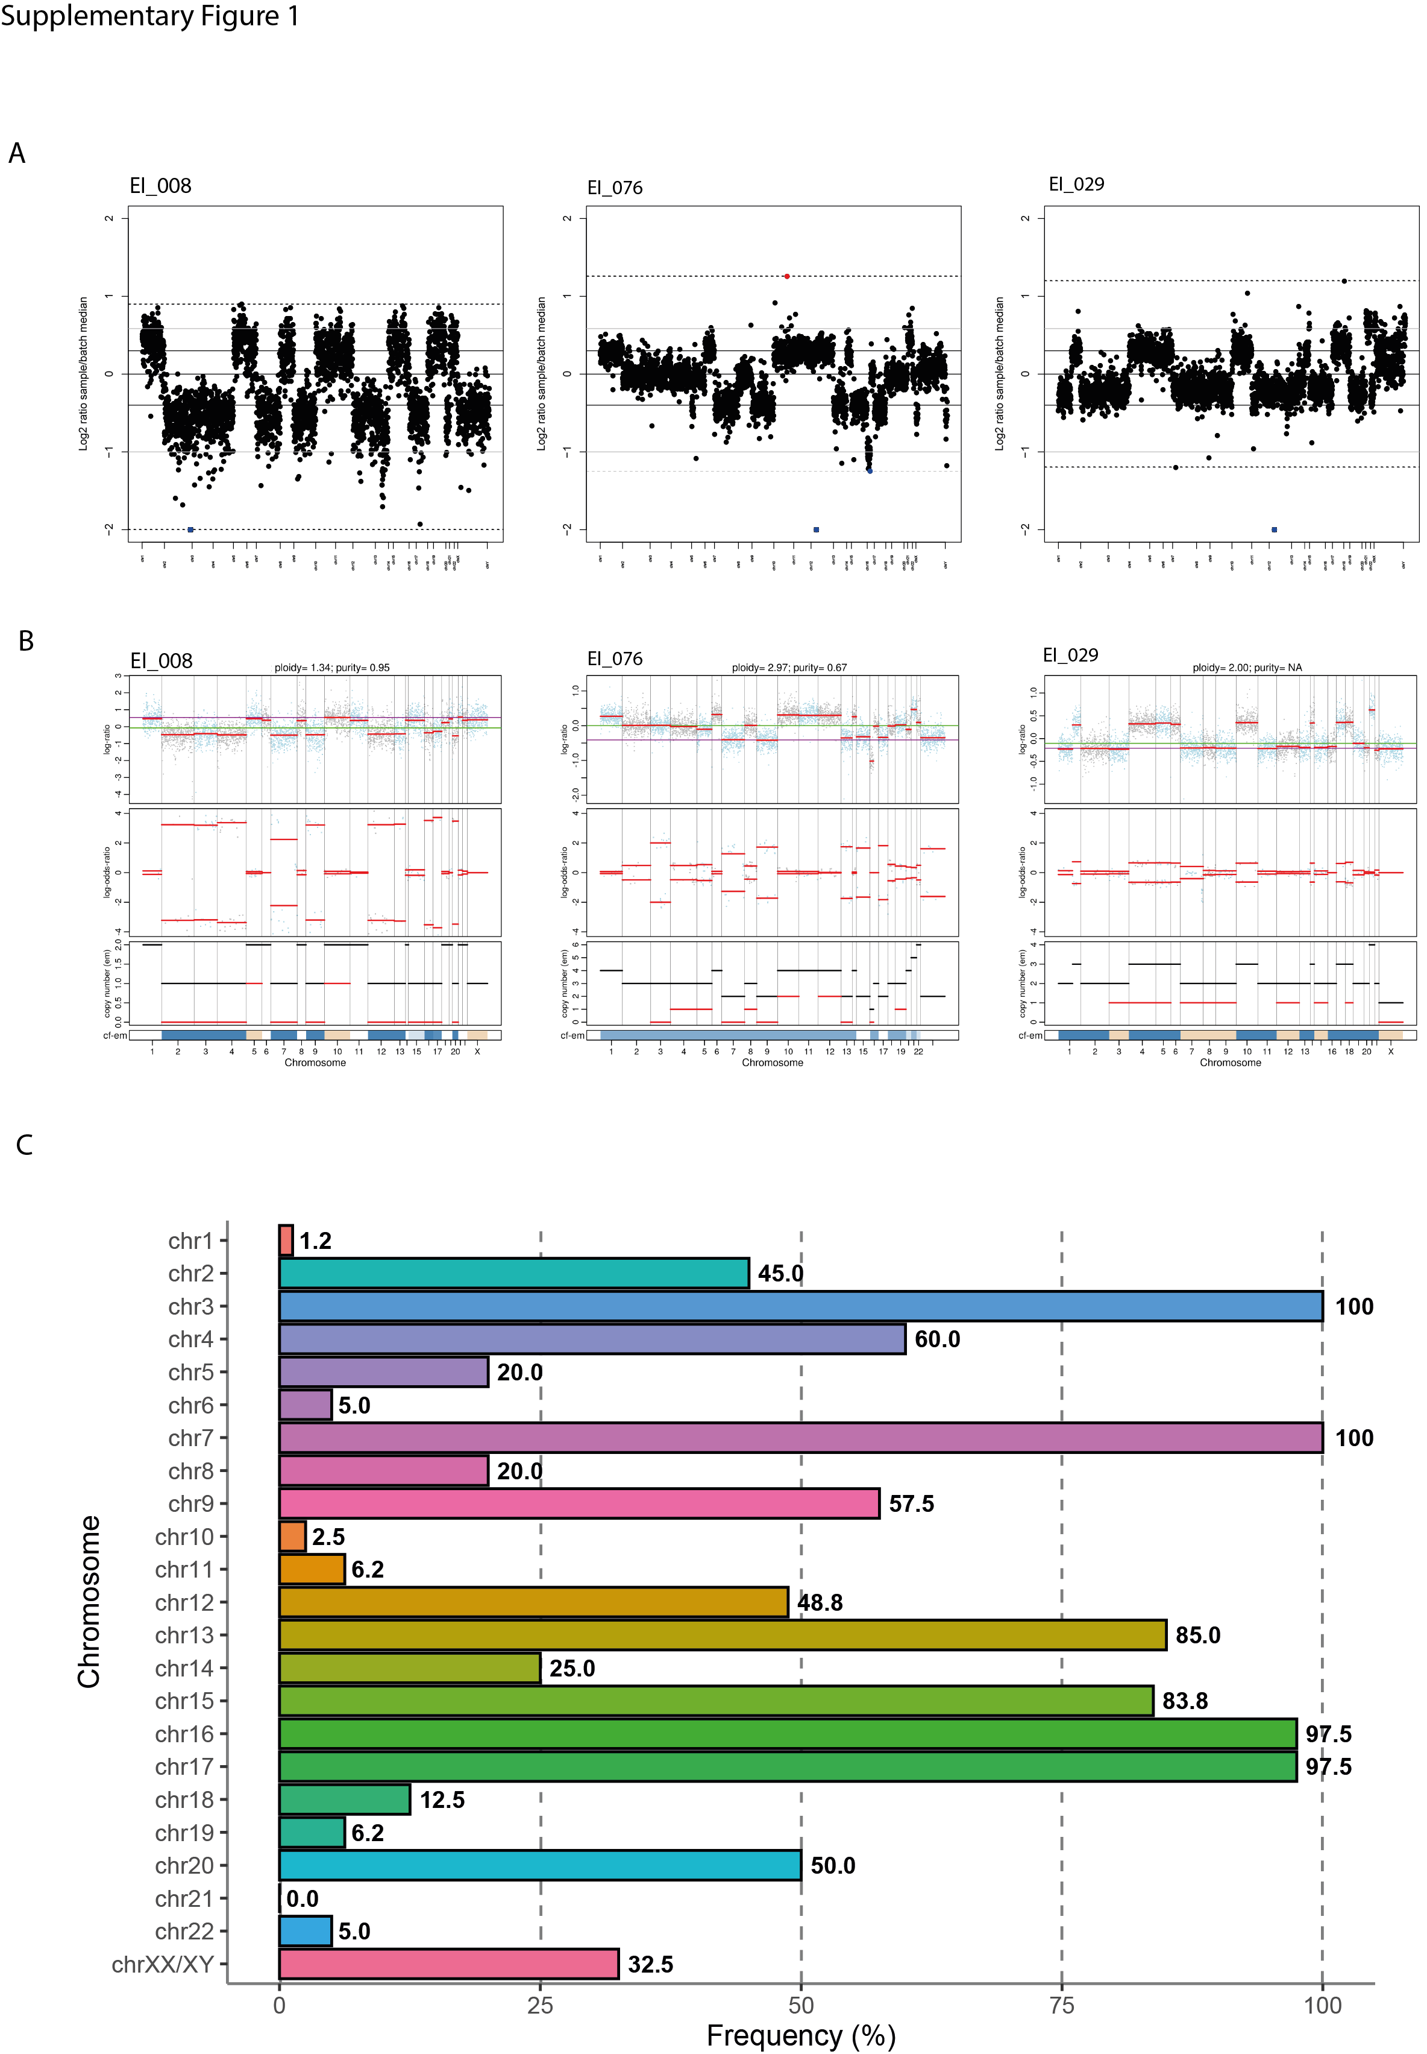
Supplementary figure 1. Sequencing-based analysis of CNA and LOH in adult LH-ALL. (A) Sequencing-based assessment of CNA using Viscap tool for three representative cases: low hypodiploid (left), duplicated low hypodiploid (middle) and high hyperdiploid ALL (right). (B) Sequencing-based assessment of LOH using Facets tool for the three same representative cases. (C) Frequency of specific chromosomal losses in the 80 LH-ALL cases. For duplicated LH-ALL cases, only primitive losses in the hypodiploid clone, as inferred by LOH were considered.
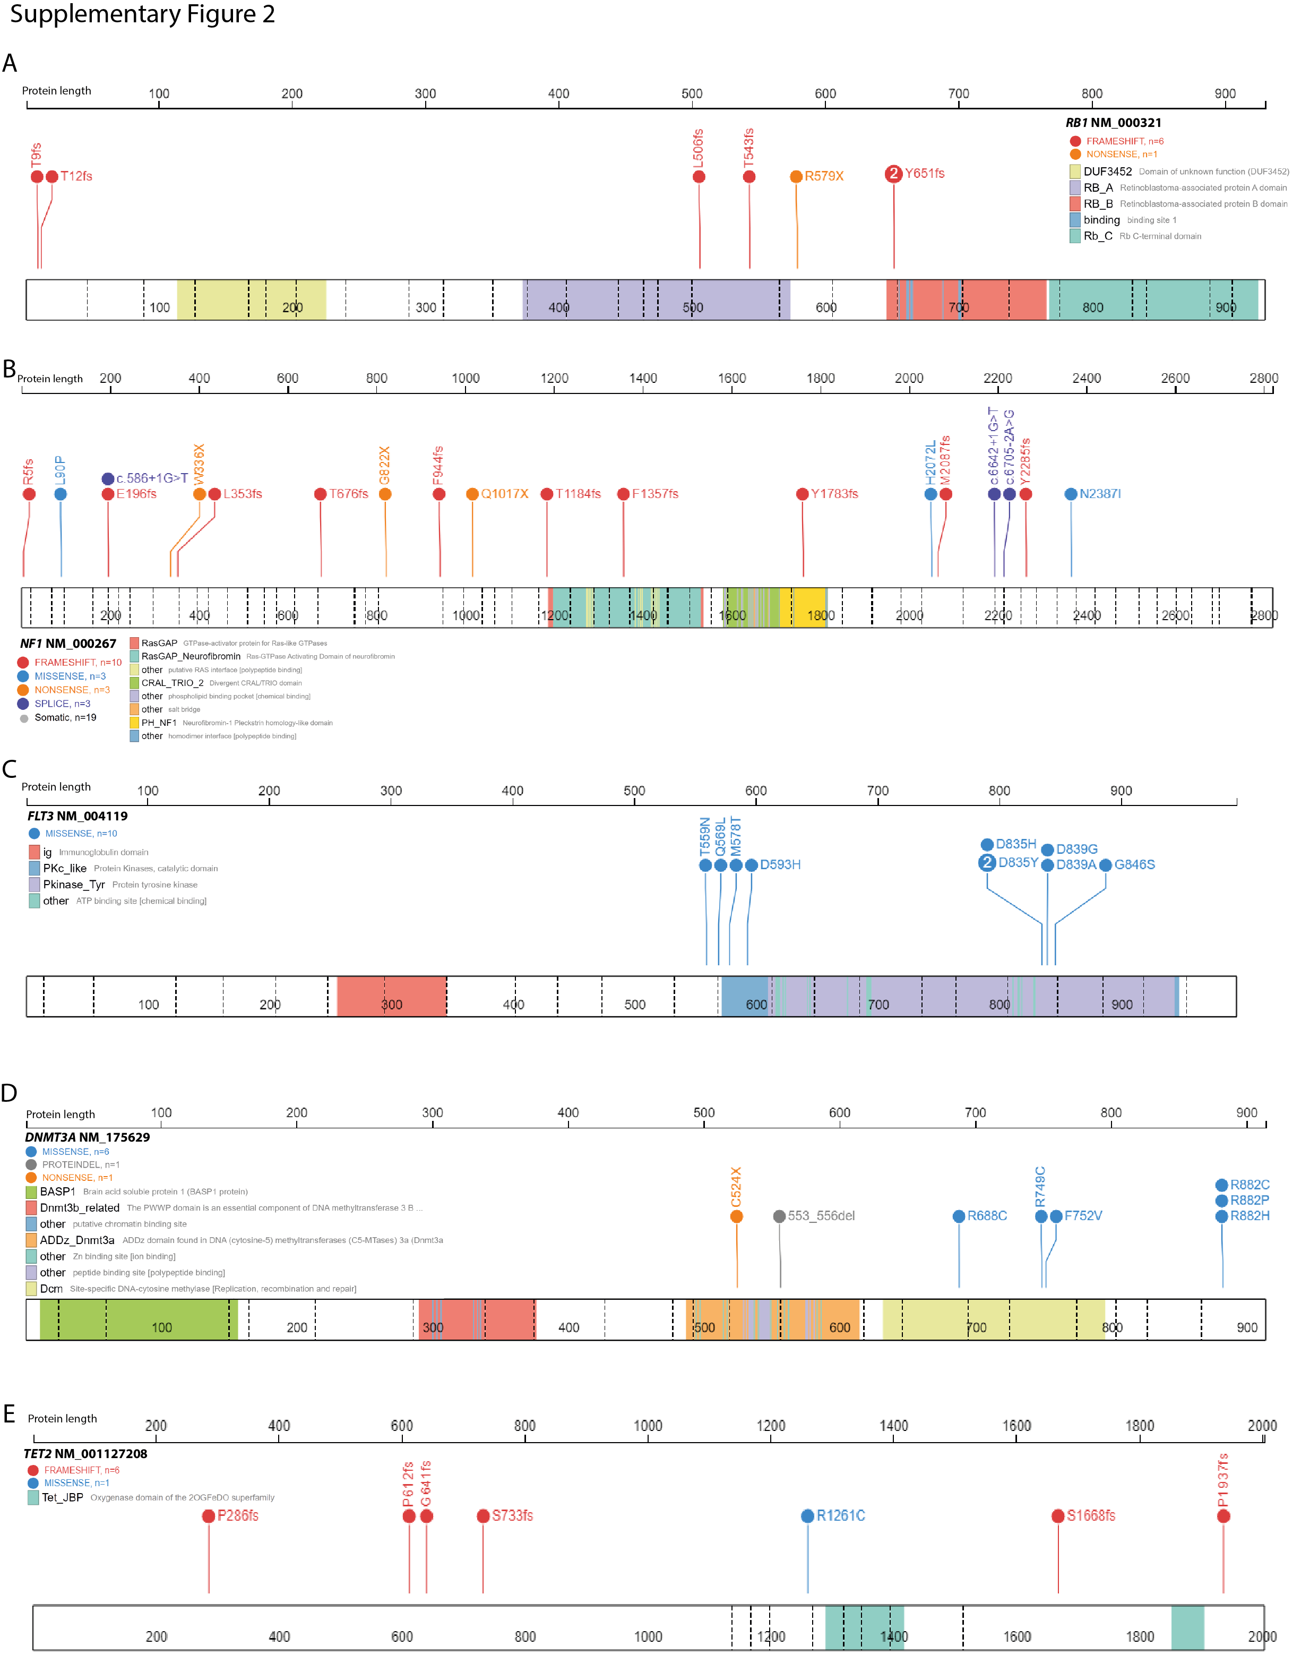
Supplementary figure 2. Representation of mutations in the frequent targeted genes in adult LH-ALL. Lollipop plots depicting the distribution of mutations in RB1 (A), NF1 (B), FLT3 (C), DNMT3A (D) and TET2 (E).
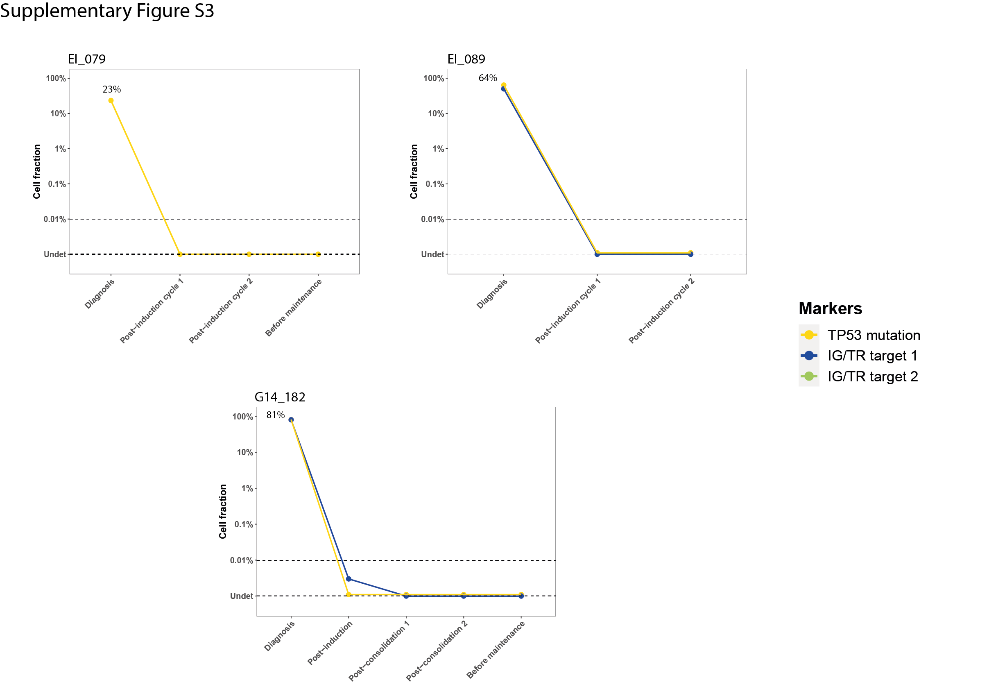
Supplementary figure 3. Longitudinal assessment of TP53-mutant cell fraction as determined by ddPCR along with clonal IG/TR-based MRD quantification in three patients with undetectable TP53 mutation at remission.

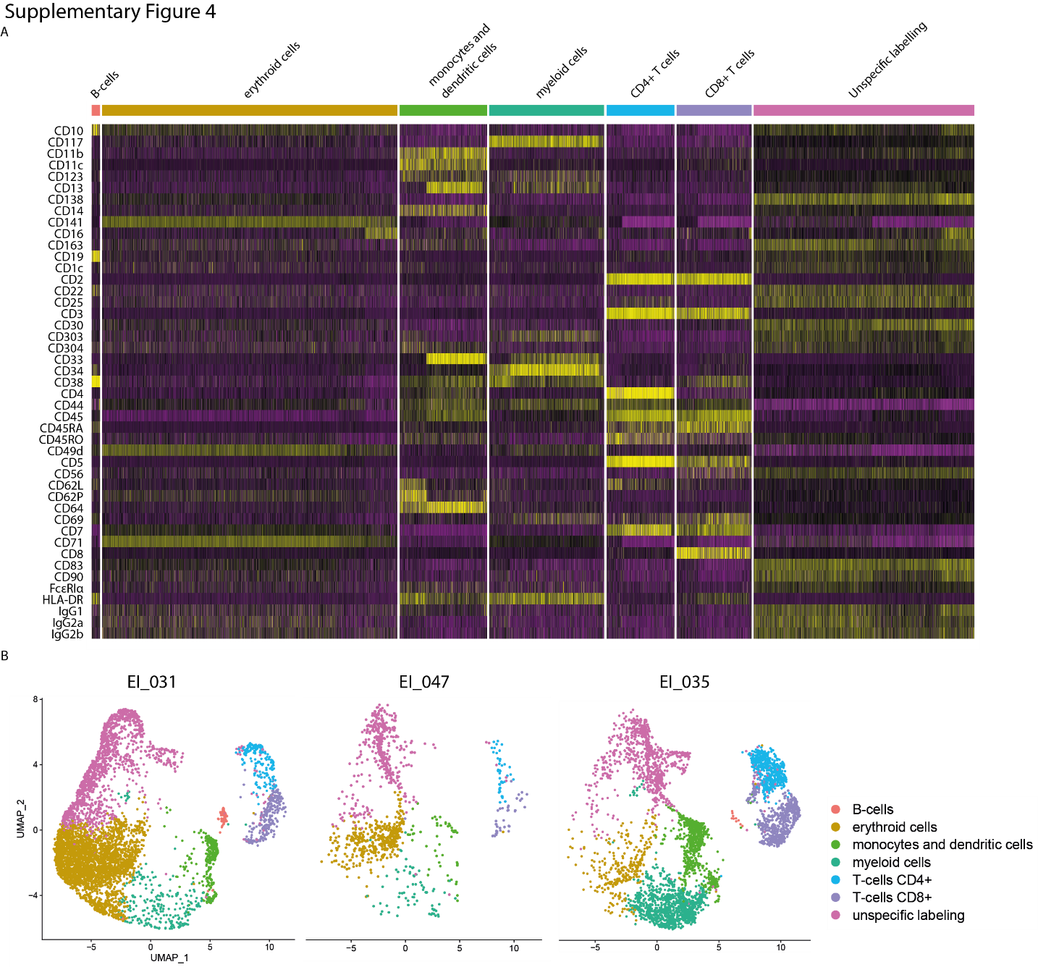
Supplementary figure 4. Merged single-cell analysis of cell-surface markers by ADT-sequencing of remission samples from three LH-ALL patients. (A) Heatmap of expression of cell-surface markers used for cell population assignment. (B) UMAP plots of each individual remission samples clustered by immunophenotype and colored by assigned cell populations. B-cells were recognized as CD10+ CD19+; erythroid cells as CD71+; monocytes and dendritic cells as CD11b+ CD11c+ CD14+ CD64+ CD123+; myeloid cells as CD117+ CD34+ CD33+; T cells as CD2+ CD3+ CD5+ CD7+.
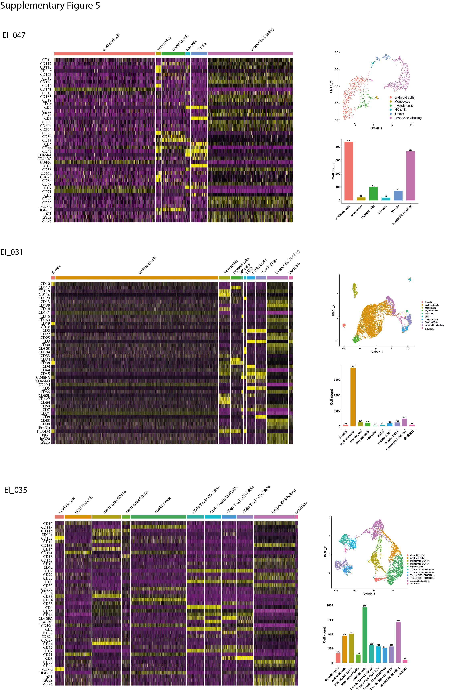
Supplementary figure 5. Individual single-cell analyses of cell-surface markers by ADT-sequencing of remission samples from three LH-ALL patients. Cell clusters were assigned as in Supplementary figure 4 and additional populations could be distinguished: NK-cells as CD2+ CD3- CD7+ CD16+ CD56+; monocytes as CD11b+ CD11c+ CD64+; plasmacytoid dendritic cells (pDCs) as CD123+ CD303+ CD304+; dendritic cells as CD123+ CD33+ FcꜪRIα+.
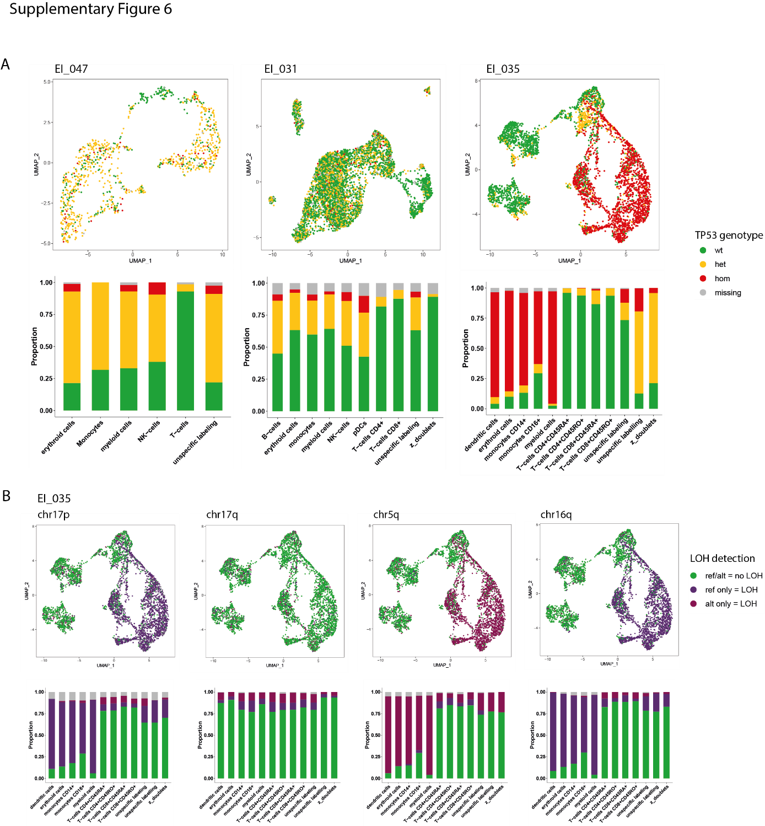

Supplementary figure 6. Individual analyses of single-cell immunophenotyping and genotyping of remission samples from three LH-ALL patients. UMAP plots (upper panels) of individual remission samples of three patients, with cells colored according to TP53 genotype. Histograms (lower panel) show the proportion of each TP53 genotype within each cell cluster.

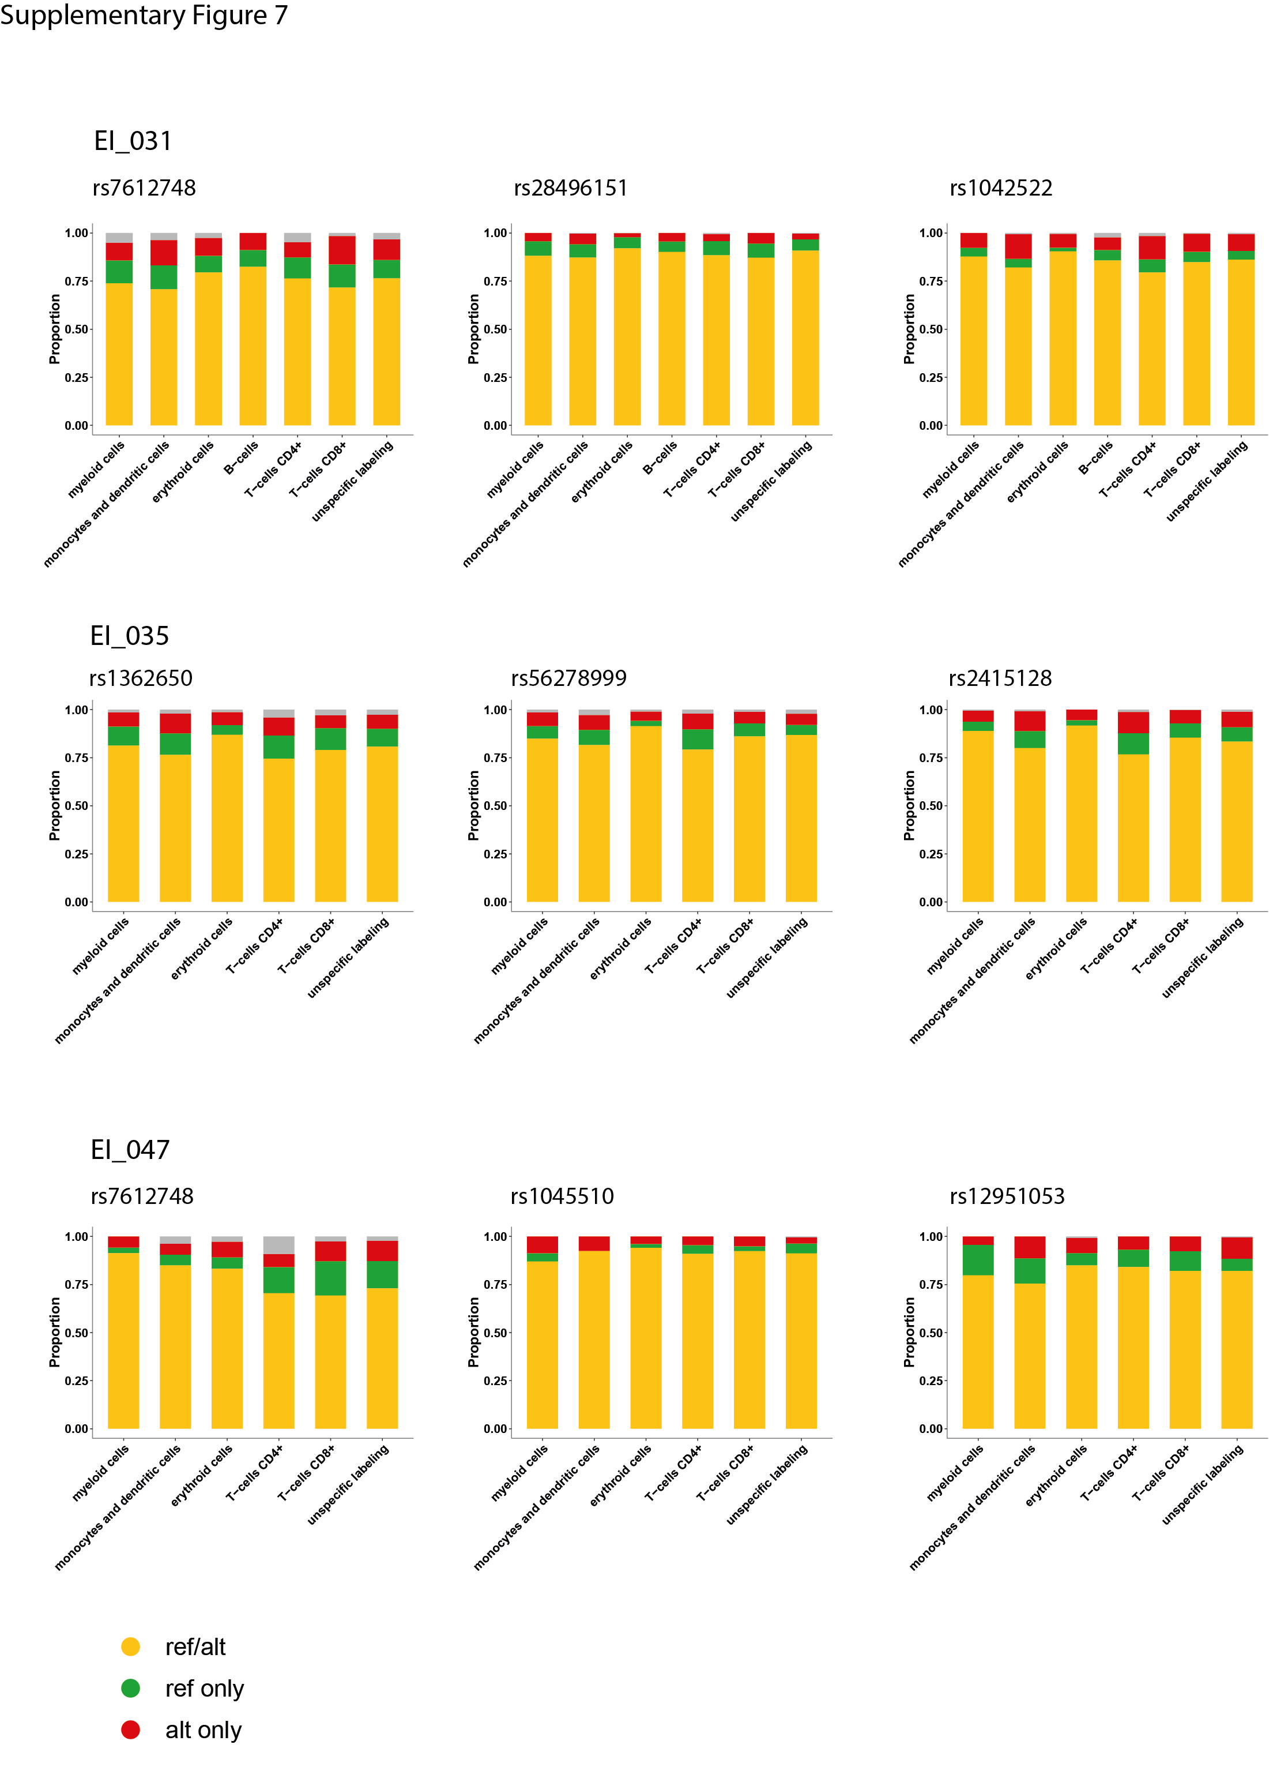
Supplementary figure 7. Evaluation of allelic dropout rate on heterozygous single nucleotide polymorphism (SNPs) in remission samples. Proportions of single-cell genotypes observed for heterozygous SNPs in different cell fractions. False homozygous genotypes related to allelic dropout are observed in 1-18% of cells.

Supplementary figure 8. Single-cell protein and LOH analyses of remission sample from patient EI_035. UMAP plots (upper panels) with cells colored according to genotype for several heterozygous SNPs allowing LOH assessment. Histograms (lower panel) show the proportion of each genotype within each cell cluster.

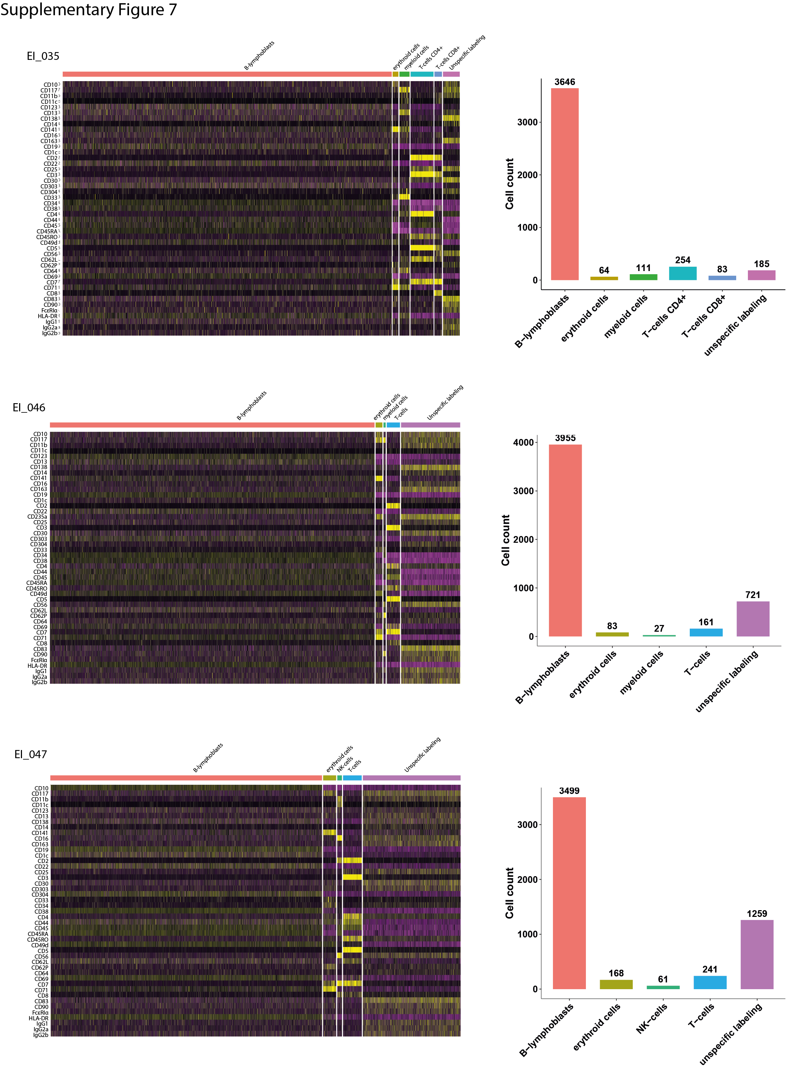Supplementary figure 9. Individual single-cell analysis of cell-surface markers by ADT-sequencing of diagnosis samples from three LH-ALL patients.

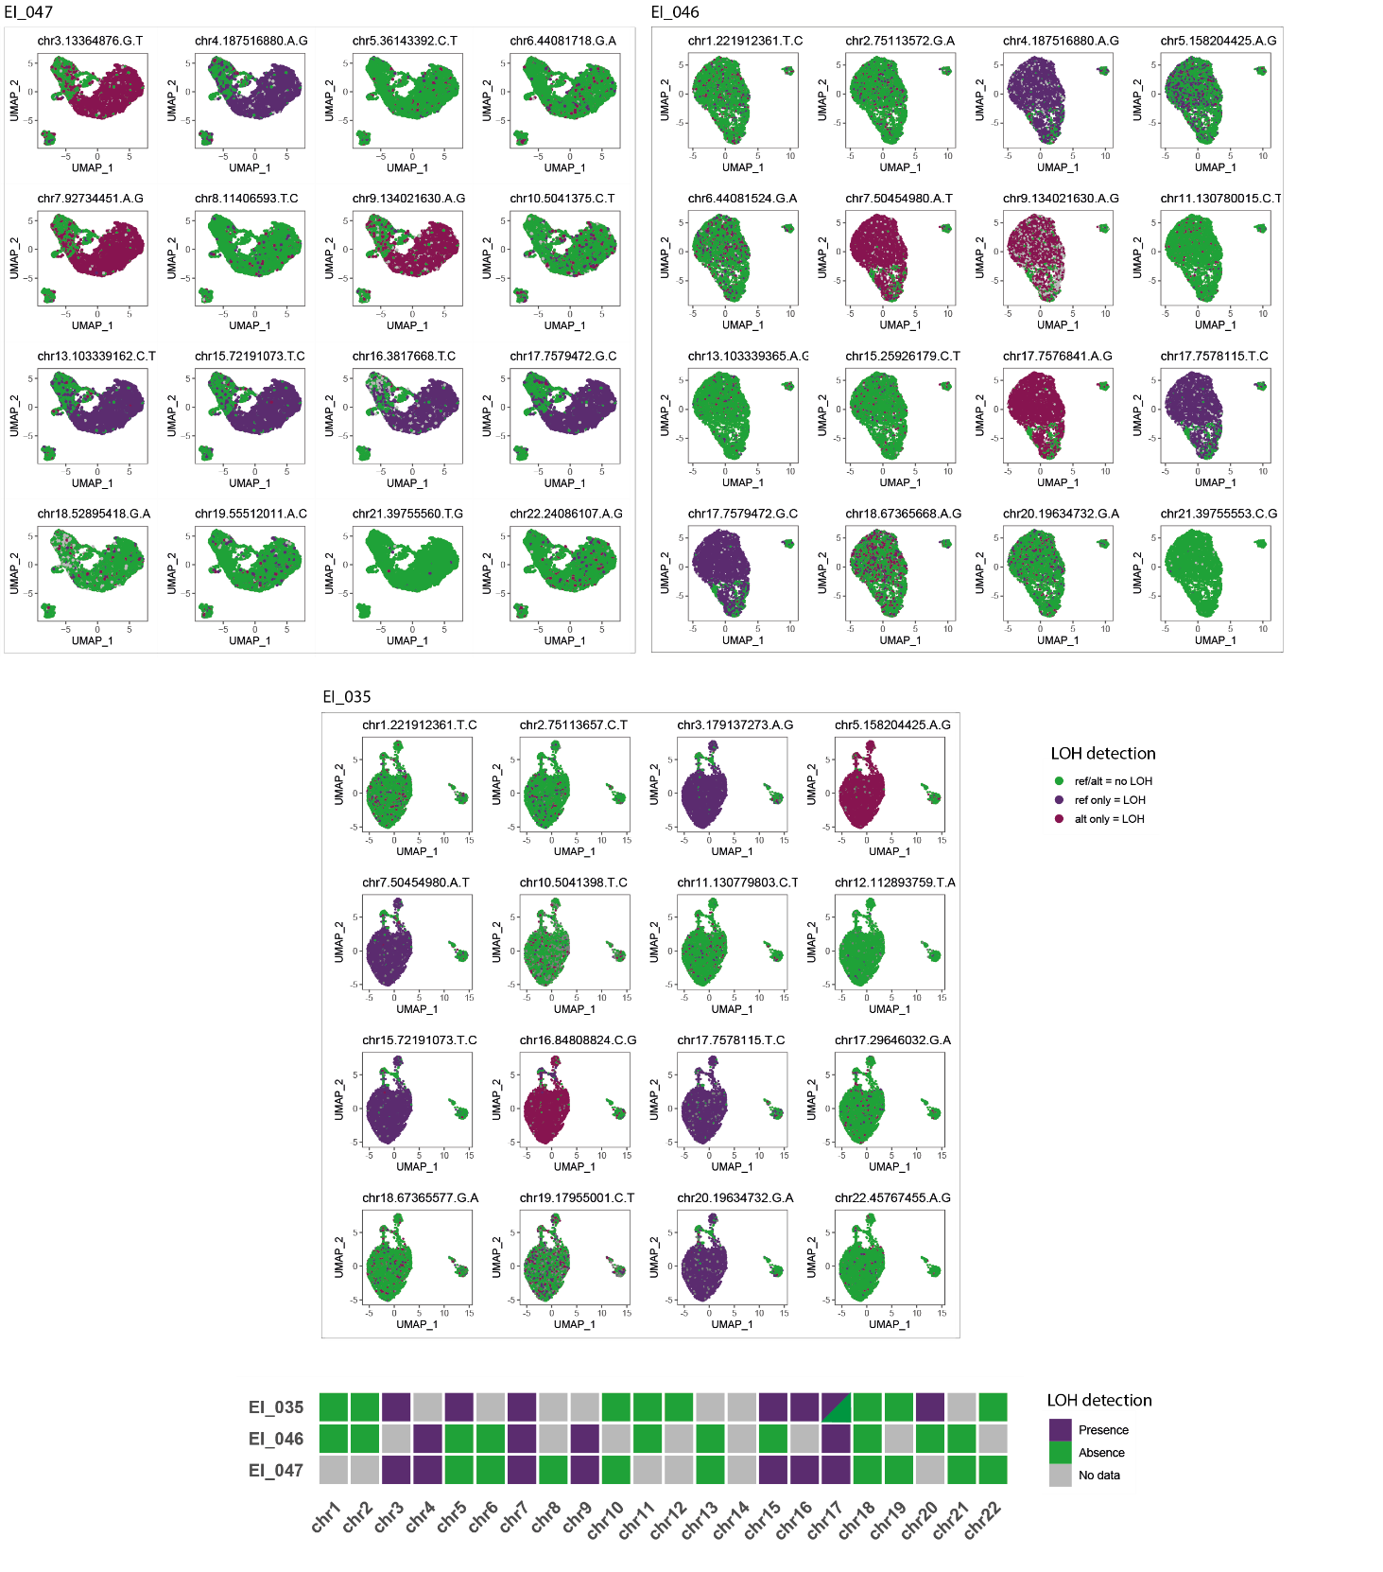
Supplementary figure 10. Single-cell genotyping of heterozygous SNPs allowing LOH assessment in diagnosis samples from three LH-ALL patients.

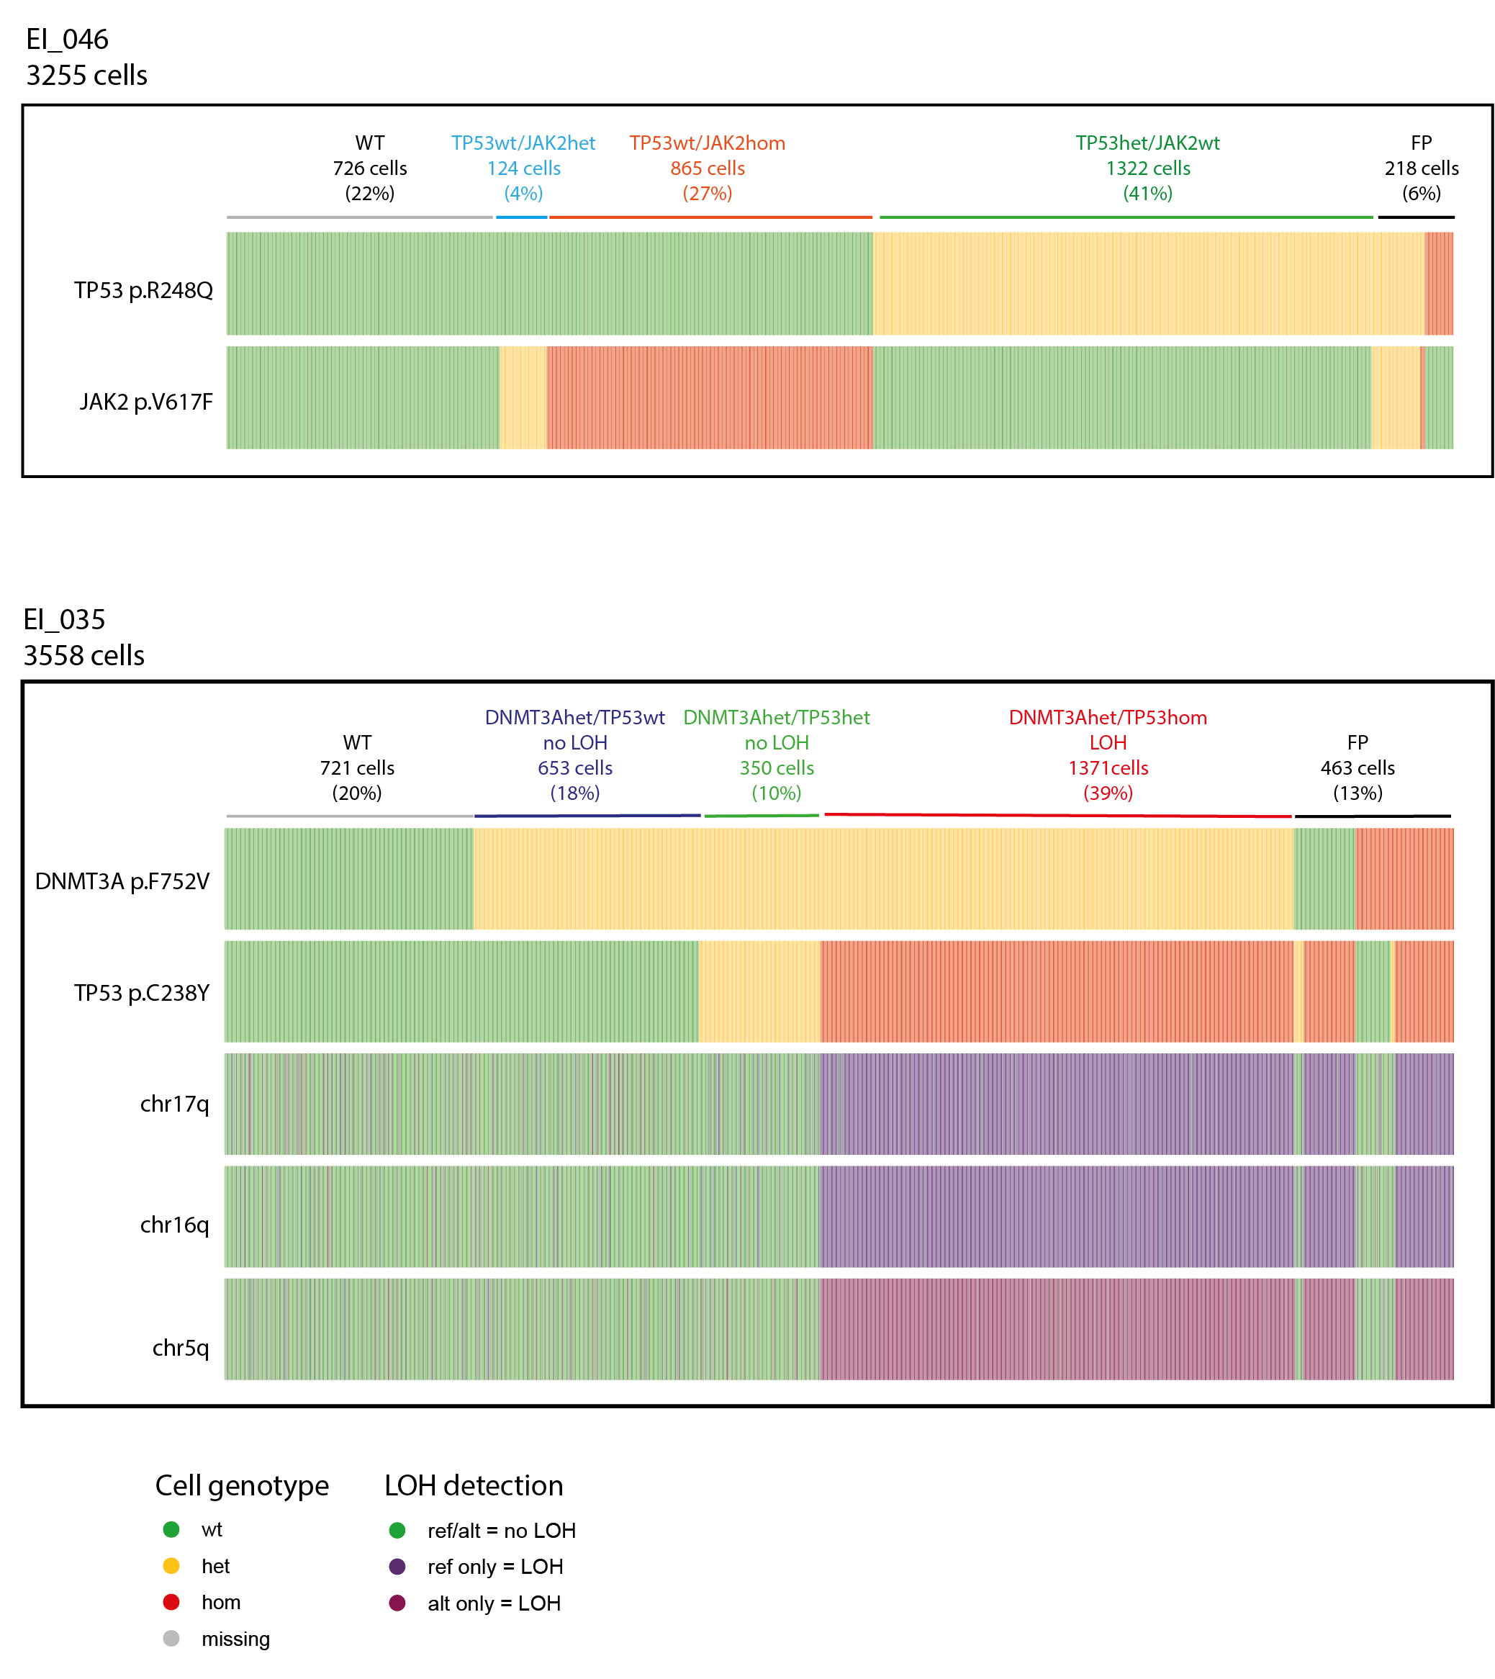

Supplementary Figure 11. Distribution of single-cell genotypes of two LH-ALL patients with persistent TP53 and JAK2 (EI_046) or DNMT3A (EI_035) mutations in remission samples. FP, false positive.

