SUPPLEMENTARY INFORMATION

SUPPLEMENTARY TABLES 3
Supplementary Table 1. Summary of published ZNF384-rearranged leukemia. 3
Supplementary Table 2. Patient samples and concominant lesions. 3
Supplementary Table 3. Summary of all mouse transplantation experiments. 3
Supplementary Table 4. Details of mouse transplantation experiments. 3
Supplementary Table 5. WES called mutations. 4
Supplementary Table 6. Sc-RNA-seq differentially expressed genes in each partition. 4
Supplementary Table 7. Enrichr results for differentially expressed genes in sc-RNA-seq partitions. 4
Supplementary Table 8. Summary of CD34 transplantation experiments. 4
Supplementary Table 9. Gene lists GREAT analysis. 5
Supplementary Table 10. Terms enriched for in regions with increased binding of ZNF384 fusion oncoproteins. 5
Supplementary Table 11. Peptides identified by RIME analysis. 5
Supplementary Table 12. Peptides identified by RIME analysis that are unique to ZNF384 fusion oncoproteins. 5
Supplementary Table 13. Supplementary Table 13. Primers used for breakpoint validation, cloning, and genotyping. 6
Supplementary Table 14. Gene sets used for GSEA to compare gene expression of mouse tumors to ZNF384r leukemia. 6
Supplementary Table 15. Fusion oncoprotein sequences used for RIME analysis. 6
SUPPLEMENTARY FIGURES 7
Supplementary Figure 1. ZNF384 FO and mutational landscape. 8
Supplementary Figure 2. Validation of ZNF384 FO expression in patient material. 9
Supplementary Figure 3. Mouse HSPC transformation and leukemia phenotype by expression of ZNF384 FO. 11
Supplementary Figure 4. Mouse HSPC transformation and leukemia development by expression of additional ZNF384 FO. 12
Supplementary Figure 5. Leukemia development in mice transplanted with ARF-null mouse HSPCs expressing TCF3::ZNF384 and NRAS G12D. 13
Supplementary Figure 6. Leukemia development in mice transplanted with ARF-null pre-B cells expressing ZNF384 FO and/or NRAS G12D. 15
Supplementary Figure 7. Generation of a mouse model that conditionally expresses Ep300::Znf384-V5-HA. 17
Supplementary Figure 8. Human CD34 cell differentiation and transplantation assay. 18
Supplementary Figure 9. Representative immunophenotypes from human CD34 colony assays. 20
Supplementary Figure 10. Analysis of sites with differential chromatin binding of ZNF384 FO and splicing isoforms. 21
Supplementary Figure 11. Analysis of ZNF384 FO splicing isoform usage in immunophenotypically distinct populations. 23
Supplementary Figure 12. ChIP–seq analysis. 24

SUPPLEMENTARY TABLES

Supplementary Table 1. Summary of published ZNF384-rearranged leukemia.
This table describes ZNF384-rearranged patients that have been reported in literature. Column header definitions: N terminal partner: the gene fused to ZNF384; Exon breakpoint: breakpoints reported for each partner, from exon of N terminal partner to exon of ZNF384: Age range: age at diagnosis; Age median: median age at diagnosis; B-ALL reports: number of patients reported with the particular ZNF384 fusion in B-ALL; MPAL reports: number of patients reported with the particular ZNF384 fusion in mixed phenotype acute leukemia (MPAL); References: Paper that reported the ZNF384-rearranged leukemia sample.

Supplementary Table 2. Patient samples and concominant lesions.
This table describes the concomitant lesions identified by whole exome sequencing (WES), whole genome sequencing (WGS), or copy number variation (CNV) in ZNF384-rearranged patient samples. Column header definitions: Patient: the patient identifier; Disease: leukemia diagnosis of B-cell acute lymphoblastic leukemia (B-ALL) or mixed phenotype acute leukemia (MPAL); Fusion: ZNF384 fusion identified by RNA-sequencing; Publication: paper(s) that reported ZNF384-rearranged patient previously; WES: whole exome sequencing data available; WGS: whole genome sequencing data available; CNV: copy number variant data available; gene columns listed with mutations identified.

Supplementary Table 3. Summary of all mouse transplantation experiments.
This table summarizes experimental design and results from mouse transplant experiments. Column header definitions: Experiment name: experiment identifier; Donor: lineage-negative bone marrow derived from C57BL/6J (BL/6) or ARF-null mice; Lentivirus; viral vector insert; n: number of mice in each arm; Median survival: median survival of mice in that arm; Diagnosis: diagnosis based on pathology, histology, and flow cytometry analysis.

Supplementary Table 4. Details of mouse transplantation experiments.
This table describes the experimental setup, survival, immunophenotype, secondary transplantation, and sequencing details of sick mice. Column header definitions: Mouse ID: mouse identifier; Experiment: experimental identifier; Genotype: lineage-negative bone marrow derived from C57BL/6J (WT BL6) or ARF-null mice; Insert: viral vector insert; Transduction efficiency: percent fluorescence positive cells transplanted; # of cells transplanted: number of unsorted cells transplanted into each mouse; Transplantation method: tail vein injection (TVI) of unsorted cells; Latency: number of days before sacrificing mouse; Flow notes; notes about material availability or analysis; Spleen GFP%: percent of live, single spleen cells that are GFP positive; Spleen RFP%: percent of live, single spleen cells that are RFP positive; Spleen DP%: percent of live, single spleen cells that are double positive (DP); Bone Marrow GFP%: percent of live, single bone marrow cells that are GFP positive; Bone Marrow RFP%: percent of live, single bone marrow cells that are RFP positive; Bone Marrow DP%: percent of live, single bone marrow cells that are double positive (DP); B220, CD19, CD3, Mac1, Gr1, CD41, Ter119: percent of color positive bone marrow cells that are positive for each marker; Lineage (-): percent of live, single bone marrow cells that are lineage negative; LSK % of lin-: percent of lineage negative cells that are lineage negative, Sca1 positive, Kit positive (LSK); GMP % of lin-: percent of lineage negative cells that are granulocyte-monocyte progenitors (GMP); CMP % of lin-: percent of lineage negative cells that are common myeloid progenitors (CMP); MEP % of lin-: percent of lineage negative cells that are megakaryocyte-erythroid progenitors (MEP); Diagnosis: diagnosis based on analysis of pathology and histology; Transplantable: are tumors serially transplantable; Comments: method used for secondary transplant; RNA-seq: RNA-sequencing data available; WES: whole exome sequencing data available.

Supplementary Table 5. WES called mutations.
This table describes the mutations identified in the mouse tumors by whole exome sequencing (WES). Column header descriptions: Group: fusion and/or mutations modeled; Sample: mouse identifier, tissue, and experiment name; VAF: variant allele frequency; SNP: dbSNP id; Location: genomic location of the mutation; Type: mutation type; Annotation: mutated gene, reference transcript ID, exon, codon and amino acid change.

Supplementary Table 6. Sc-RNA-seq differentially expressed genes in each partition.
This table describes differentially expressed genes between wild-type and EP300::ZNF384 expressing bone marrow cells in each partition (HSC/MPP/GMP/CLP, MPP/MEP, Neutrophil, Stem/neutrophil, or Stem/proB). Column header descriptions: Gene: differentially expressed gene; p_val: p-value; avg_logFC: average log fold change; pct1: percentage of cells where the gene is detected in cluster one; pct2: percentage of cells where the gene is detected in cluster two; p_val_adj: adjusted p-value.

Supplementary Table 7. Enrichr results for differentially expressed genes in sc-RNA-seq partitions.

This table describes the gene lists that are enriched for in differentially expressed partitions.

Supplementary Table 8. Summary of CD34 transplantation experiments.
This table describes the experimental setup, survival, immunophenotype, secondary transplantation, and sequencing details of mice transplanted with human CD34 cells. Column header definitions: Mouse ID: mouse identifier; Experiment: experimental identifier; Cord blood: the batch of cord blood used; Insert: viral vector insert (CHA, HA tag at C-terminus of FO; NHA, HA tag at N terminus of FO; EV, empty vector; -e8, FO without ZNF384 exon 8; +e8, ZNF384 FO with exon 8); Viral prep: the batch of virus used; Transduction efficiency: percent fluorescence positive cells transplanted; # of cells transplanted: number of unsorted cells transplanted into each mouse; Transplantation method: method used for transplantation; Recipient mouse: strain of mouse receiving the transplant; Latency: number of days before sacrificing mouse; Flow notes; notes about material availability or analysis; Bone Marrow hCD45%: percent of bone marrow cells expressing human CD45; Spleen hCD45%: percent of spleen cells expressing human CD45; Bone Marrow hCD45+ GFP%: percent of hCD45 positive bone marrow cells that express GFP; Spleen hCD45+ GFP%: percent of hCD45 positive spleen cells that express GFP; B220, CD34, CD38, CD34/38, CD19, CD33, CD19/33, CD10: percent of color positive bone marrow cells that are positive, or double positive, for each marker; Diagnosis: diagnosis based on analysis of pathology and histology; Transplantable: are tumors serially transplantable; Comments: method used for secondary transplant; RNA-seq: RNA-sequencing data available; WES: whole exome sequencing data available.

Supplementary Table 9. Gene lists GREAT analysis.
This table shows the list of corresponding genes used for GREAT analysis of regions with increased binding of fusion versus wild type (WT) ZNF384 or regions with increased binding of TCF3::ZNF384 isoform with exon 8 versus the isoform without exon 8.

Supplementary Table 10. Terms enriched for in regions with increased binding of ZNF384 fusion oncoproteins.
This table describes the GO terms that are enriched for in regions with increased binding of ZNF384 fusion oncoproteins compared to wild type ZNF384, using ClueGO analysis. Column header descriptions: ID: gene ontology (GO) term identifier; Term: descriptive name of GO term; Ontology Source: version of GO terms used for analysis; Term PValue: p-value for that term; Term PValue Corrected with Bonferroni step down: corrected p-value; Associated Genes Found: term genes identified in experimental gene list.

Supplementary Table 11. Peptides identified by RIME analysis.
This table describes the peptides identified in RIME analysis of fusion or wildtype replicates. Column header description: Accession: UniProt accession number; Gene: gene name that encodes the protein; Description: description of gene name; TAF15_Z1 Unique Peptides: number of unique peptides identified in TAF15::ZNF384 replicate 1; TAF15_Z2 Unique Peptides: number of unique peptides identified in TAF15::ZNF384 replicate 2; TCF3_Z1 Unique Peptides: number of unique peptides identified in TCF3::ZNF384 replicate 1; TCF3_Z2 Unique Peptides: number of unique peptides identified in TCF3::ZNF384 replicate 2; TCF3_Z3 Unique Peptides: number of unique peptides identified in TCF3::ZNF384 replicate 3; TCF3_Z+E81 Unique Peptides: number of unique peptides identified in TCF3::ZNF384 with exon 8 replicate 1; TCF3_Z+E82 Unique Peptides: number of unique peptides identified in TCF3::ZNF384 with exon 8 replicate 2; TCF3_Z+E83 Unique Peptides: number of unique peptides identified in TCF3::ZNF384 with exon 8 replicate 3; ZNF1 Unique Peptides: number of unique peptides identified in ZNF384 replicate 1; ZNF2 Unique Peptides: number of unique peptides identified in ZNF384 replicate 2; ZNF3 Unique Peptides: number of unique peptides identified in ZNF384 replicate 3.

Supplementary Table 12. Peptides identified by RIME analysis that are unique to ZNF384 fusion oncoproteins.

This table describes peptides that were identified in at least one fusion sample but not the empty vector control or wild type ZNF384 replicates. Column header description: Gene: gene name that encodes the protein; Description: description of gene name; TAF15-Z1 Unique Peptides: number of unique peptides identified in TAF15::ZNF384 replicate 1; TAF15-Z2 Unique Peptides: number of unique peptides identified in TAF15::ZNF384 replicate 2; TCF3-Z1 Unique Peptides: number of unique peptides identified in TCF3::ZNF384 replicate 1; TCF3-Z2 Unique Peptides: number of unique peptides identified in TCF3::ZNF384 replicate 2; TCF3-Z3 Unique Peptides: number of unique peptides identified in TCF3::ZNF384 replicate 3; TCF3-Z +e8 1 Unique Peptides: number of unique peptides identified in TCF3::ZNF384 with exon 8 replicate 1; TCF3-Z +e8 2 Unique Peptides: number of unique peptides identified in TCF3::ZNF384 with exon 8 replicate 2; TCF3-Z +e8 3 Unique Peptides: number of unique peptides identified in TCF3::ZNF384 with exon 8 replicate 3

Supplementary Table 13. Supplementary Table 13. Primers used for breakpoint validation, cloning, and genotyping.

This table lists the primer sequences used for breakpoint fusion validation, fusion cloning and genotyping of mice expressing Ep300::Znf384-V5-HA.

Supplementary Table 14. Gene sets used for GSEA to compare gene expression of mouse tumors to ZNF384r leukemia.

This table lists the gene sets that were used for GSEA analysis. Column header description: MOUSE_ZNF384_FUSION_VS_UNTRANSDUCED_UP: genes that are upregulated in ZNF384-rearranged mouse tumors compared to untransduced lineage negative bone marrow cells; MOUSE_ZNF384_FUSION_VS_UNTRANSDUCED_DOWN: genes that are downregulated in ZNF384-rearranged mouse tumors compared to untransduced lineage negative bone marrow cells.

Supplementary Table 15. Fusion oncoprotein sequences used for RIME analysis.
This table lists the protein sequences of ZNF384 or fusion oncoproteins that were included in the custom peptide database for RIME analysis.

SUPPLEMENTARY FIGURES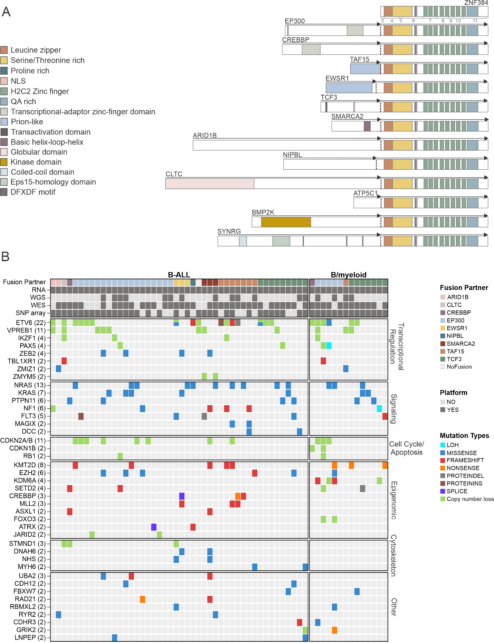

Supplementary Figure 1. ZNF384 FO and mutational landscape.
(A) Structure of wild type ZNF384 and all reported ZNF384 FO with the functional domains annotated. The most common breakpoint is shown for each, although, there are multiple reported breakpoints for EP300::ZNF384, CREBBP::ZNF384, TAF15::ZNF384, EWSR1::ZNF384, TCF3::ZNF384, ARID1B::ZNF384, and BMP2K::ZNF384. (B) Mutations observed in ZNF384r B-ALL (n = 46) and ZNF384r B/M MPAL (n = 14), showing similar mutational profile between the two phenotypically defined subtypes (1).

Supplementary Figure 2. Validation of ZNF384 FO expression in patient material.
(A) Validation of expression of ZNF384 fusion transcripts from a subset of patient samples. RT-PCR reactions from each patient amplified the fusion-specific breakpoint (BP) and an ACTIN control region (Ctrl) (left panel). Samples were validated by Sanger sequencing, a representative electropherogram of the CREBBP::ZNF384 fusion breakpoint is shown here (right panel). (B) Samples analyzed for FO expression by immunoblotting include: HEK293T cells transduced with Empty Vector, CREBBP::ZNF384 (kDa 120) or EP300::ZNF384 (kDa 120) and corresponding patient leukemia cells. Wild type ZNF384 (kDa 65) is endogenously expressed in all samples. Samples were run together on a gel; the vertical white bar indicates lanes cropped from the image.

Supplementary Figure 3. Mouse HSPC transformation and leukemia phenotype by expression of ZNF384 FO.
(A) Cells harvested from colony forming unit assay (CFU) after two or more replatings were subjected to flow cytometry and representative immunophenotype is shown of TCF3::ZNF384 expressing cells. Analysis was performed on live, single, GFP positive cells. (B) CFU of lineage-negative bone marrow cells expressing wild type or FO, with or without exon 8, grown in lymphoid differentiation conditions. Columns show means of three replicates ± SD.(C) Survival curves in primary recipients transplanted with indicated cells. (D-E) White blood cell (WBC) count (left panel) and spleen weight (right panel) at death in mice transplanted with indicated cells. The mean expression is shown by the horizontal line in the scatter dot plot and the error bars represent the SD. **** p<0.0001. NS, not significant.

Supplementary Figure 4. Mouse HSPC transformation and leukemia development by expression of additional ZNF384 FO.
(A) Hematoxylin and eosin staining (left panel) and MPO staining (middle panel) of sternal section and bone marrow cytospin (right panel) of a representative recipient mouse transplanted with cells expressing TCF3::ZNF384 and NRAS G12D. Scale bars represent 50 μM for sternal section and 110 μM for cytospin. (B) Immunophenotyping from a representative ZNF384 FO with NRAS G12D mouse showing tumors express Gr1 with variable expression of Mac1. Analysis was performed on live, single, GFP, RFP double positive cells. (C) Immunophenotyping from EP300::ZNF384 mouse showing tumor expresses Mac1 with some Gr1. Analysis was performed on live, single, GFP positive cells. (D) Immunophenotyping from EP300::ZNF384 secondary mouse showing tumor expresses Mac1, Gr1, and dim for CD19. Analysis was performed on live, single, GFP positive cells.

Supplementary Figure 5. Leukemia development in mice transplanted with ARF-null mouse HSPCs expressing TCF3::ZNF384 and NRAS G12D.
(A) Survival curves in primary recipients transplanted with indicated cells. (B) White blood cell (WBC) count at death in mice transplanted with indicated cells. The mean expression is shown by the horizontal line in the scatter dot plot and the error bars represent the SD. (C) Spleen weight at death in mice transplanted with indicated cells. The mean expression is shown by the horizontal line in the scatter dot plot and the error bars represent the SD. (D) Immunophenotyping from a representative mouse showing tumors express Mac1 and Gr1. Analysis was performed on live, single, GFP, RFP double positive cells. (E) Haematoxylin and eosin staining (left panel), MPO staining (left, middle panel), RFP staining (right, middle panel), and GFP staining (right panel) of spleen section. Scale bars represent 50 μM.

Supplementary Figure 6. Leukemia development in mice transplanted with ARF-null pre-B cells expressing ZNF384 FO and/or NRAS G12D.
(A) The workflow for transplantation assays. ARF-null pre-B cells transduced with empty vector, wild type, or representative fusions were transplanted directly into mice or transduced with NRAS G12D and then transplanted into mice. (B) Survival curves in primary recipients transplanted with indicated cells. Tumors arose from ARF-null pre-B cells and the expression of FO did not reduce the latency. (C) Survival curves in primary recipients transplanted with indicated cells. (D) Spleen weight at death in mice transplanted with indicated cells. The mean expression is shown by the horizontal line in the scatter dot plot and the error bars represent the SD. (E) White blood cell (WBC) count at death in mice transplanted with indicated cells. The mean expression is shown by the horizontal line in the scatter dot plot and the error bars represent the SD. (F) Immunophenotype, determined by flow. Columns show means of three replicates ± SD. (G) GSEA showing enrichment of genes that are differentially expressed in ZNF384r mouse tumors compared to the GEP of ZNF384r versus non-rearranged patient leukemia. Down-regulated genes in the model are also down-regulated in patients.

Supplementary Figure 7. Generation of a mouse model that conditionally expresses Ep300::Znf384-V5-HA.
(A) Validation of the genomic Ep300::Znf384-V5-HA fusion from the peripheral blood of mice by PCR. Position of primers used for each reaction are shown in Figure 2A. (B) Survival curves of Ep300::Znf384-V5-HA mice and litter mate controls. ****P<0.0001 (C) Spleen weight of mice transplanted with Ep300::Znf384 alone or with NRAS G12D (left panel), immunophenotype of bone marrow (middle panel) or spleen (right panel), determined by flow. Columns show means of four (EZ + MIG) or two (EZ + NRAS) replicates ± SD (D) UMAP dimensionality reduction for wild type (left panel) or EP300::ZNF384-V5-HA (right panel) bone marrow cells showing 20 independent clusters.

Supplementary Figure 8. Human CD34 cell differentiation and transplantation assay.
(A) The workflow for CD34 cell assays. CD34 cells isolated from cord blood and transduced for CFU assay or transplantation into immunocompromised mice or CD34 cells were sorted into stem and progenitor compartments, transduced with empty vector, wild type, or TCF3::ZNF384, single cells were sorted into myeloid differentiation media, and colony were assessed by immunophenotype 15 days later. (B) Cells harvested from CFU were subjected to flow cytometry. FO expressing cells have an expansion of CD45 and CD33 positive cells compared to controls. FO samples also have CD19, CD33 double positive cells. Analysis was performed on live, single, GFP positive cells. Representative immunophenotype is shown.

Supplementary Figure 9. Representative immunophenotypes from human CD34 colony assays.
(A) The fluorescence-activated cell sorting schema used to collect hematopoietic stem cell (HSC), multipotent progenitor (MPP), common myeloid progenitor (CMP), megakaryocyte-erythroid progenitor (MEP), or granulocyte-monocyte progenitor (GMP) populations. (B) An example of the immunophenotype criteria for designating colonies erythroid only (Er), myeloid only (My), megakaryocyte only (Mk), or a combination of cell types. Analysis was performed on live, single, GFP positive cells. (C) Representative immunophenotype of the colonies designated Other, which express only CD45 and CD33.

Supplementary Figure 10. Analysis of sites with differential chromatin binding of ZNF384 FO and splicing isoforms.
(A) Differential motif analysis comparing regions with increased binding of TCF3::ZNF384 versus regions with decreased binding. (B) Terms enriched for by GREAT analysis of gene regions with increased binding of the FO. Showing Go Biological Processes (left panel) and Mouse Phenotype Single KO (right panel). (C) Average log2 FPKM of expression in ZNF384r leukemia or non-ZNF384r leukemias. (D) H3K27ac HiChIP in ARF-null pre-B cells expressing ZNF384 (top panel) or TCF3::ZNF384 (bottom panel) at Cxcl2, highlighted in blue, and adjacent genes. Raw integration maps are displayed as heatmaps with a resolution of 10 kb.

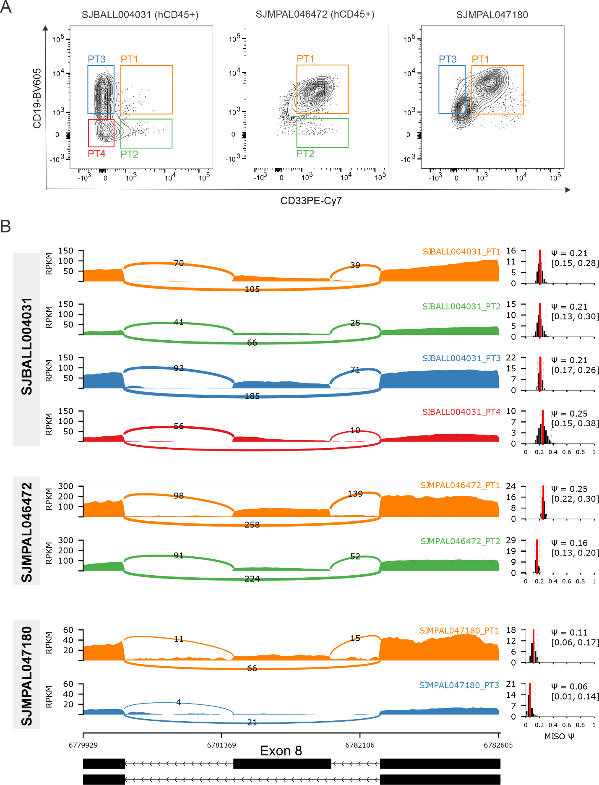

Supplementary Figure 11. Analysis of ZNF384 FO splicing isoform usage in immunophenotypically distinct populations.
(A) The fluorescence-activated cell sorting schema used to collect CD19+CD33+ (PT1), CD19-CD33+ (PT2), CD19+CD33- (PT3), or CD19-CD33- (PT4) populations for three patient samples. (B) Sashimi plot for the splicing patterns of exon 8 in ZNF384 gene for different tumor populations in 3 samples - SJBALL004031, SJMPAL046472 and SJMPAL047180. Genomic reads are converted into read densities (measured in RPKM) and junction reads are plotted as arcs whose width is determined by the number of reads aligned to the junction spanning the exons connected by the arc. The estimated splicing pattern measured by Percentage-Spliced-In (PSI, Ψ) are shown to the right, with the 95% confidence intervals for the estimate marked by dashed lines. Schematic of this splicing event is shown at the bottom.

Supplementary Figure 12. ChIP–seq analysis.
(A) Heat map showing the ChIP–seq signal, centered on ZNF384 peaks, of TCF3::ZNF384 with exon 8 compared to TCF3::ZNF384 without exon 8 (top panels). Peaks with increased binding of with exon 8 compared to without exon 8 proteins (middle panels). Peaks with decreased binding of with exon 8 compared to without exon 8 proteins (bottom panels). (B) Representative genomic regions with increased binding of the isoform with exon 8. (C) Terms enriched for by GREAT analysis of regions with increased binding of the FO isoform with exon 8. Showing Go Biological Processes (left panel) and Mouse Phenotype Single KO (right panel).

REFERENCE
1. Alexander TB, Gu Z, Iacobucci I, Dickerson K, Choi JK, Xu B, et al. The genetic basis and cell of origin of mixed phenotype acute leukaemia. Nature 2018;562(7727):373-9 doi 10.1038/s41586-018-0436-0.

