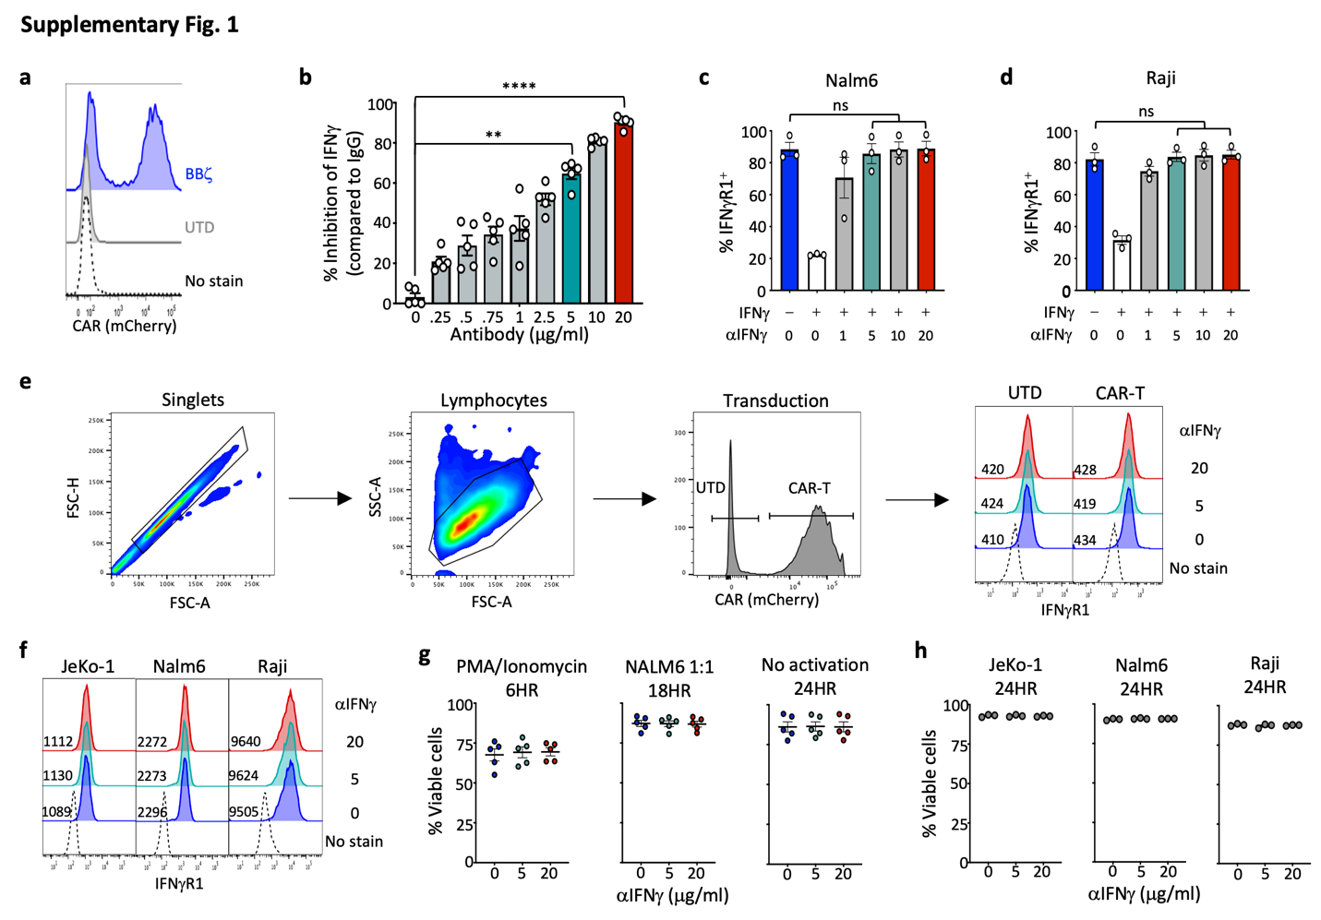
Supplementary Fig. 1: Antibody-mediated blockade of IFNγ in CAR T cells.
T cells isolated from healthy donors were stimulated with anti-CD3/CD28 Dynabeads for 24 hours before transducing with a lentiviral vector to express anti-CD19 CAR with a 4-1BB costimulatory domain. a, Transduction was confirmed by flow cytometry, representative data. b, CAR-T were activated with PMA/Ionomycin in varying doses of αIFNγ or isotype control (0.25 – 20ug/ml) and % inhibition of IFNγ was calculated based on ELISA data from Fig. 1d, n=5. c-d, IFNγR1 and pSTAT1 expression in Nalm6 (c) and Raji (d) cells treated with (+) or without (-) 10ng/ml rh IFNγ +/- αIFNγ blocking antibody (μg/ml) as shown by percent positive cells, n=3 experiments. e, Gating strategy for IFNγR1 expression on untransduced (UTD) and CAR-T following a 24hr incubation with IFNγ blocking antibody, representative; n=5. f, IFNγR1 expression on cancer cell lines +/- IFNγ blockade as shown by MFI, representative; n=3 experiments. g, CAR-T viability following incubation with αIFNγ blocking antibody at 6 hours post-PMA/Ionomycin, 18 hours post-Nalm6 and 24 hours on resting T cells, n=5. h, Tumor cell lines were incubated in αIFNγ blocking antibody for 24 hours prior to assessing cell viability by flow cytometry, n=3 experiments. Data are shown as mean ± s.e.m. with P values by one-way ANOVA. P: **<0.01, ****<0.0001, ns=not significant.

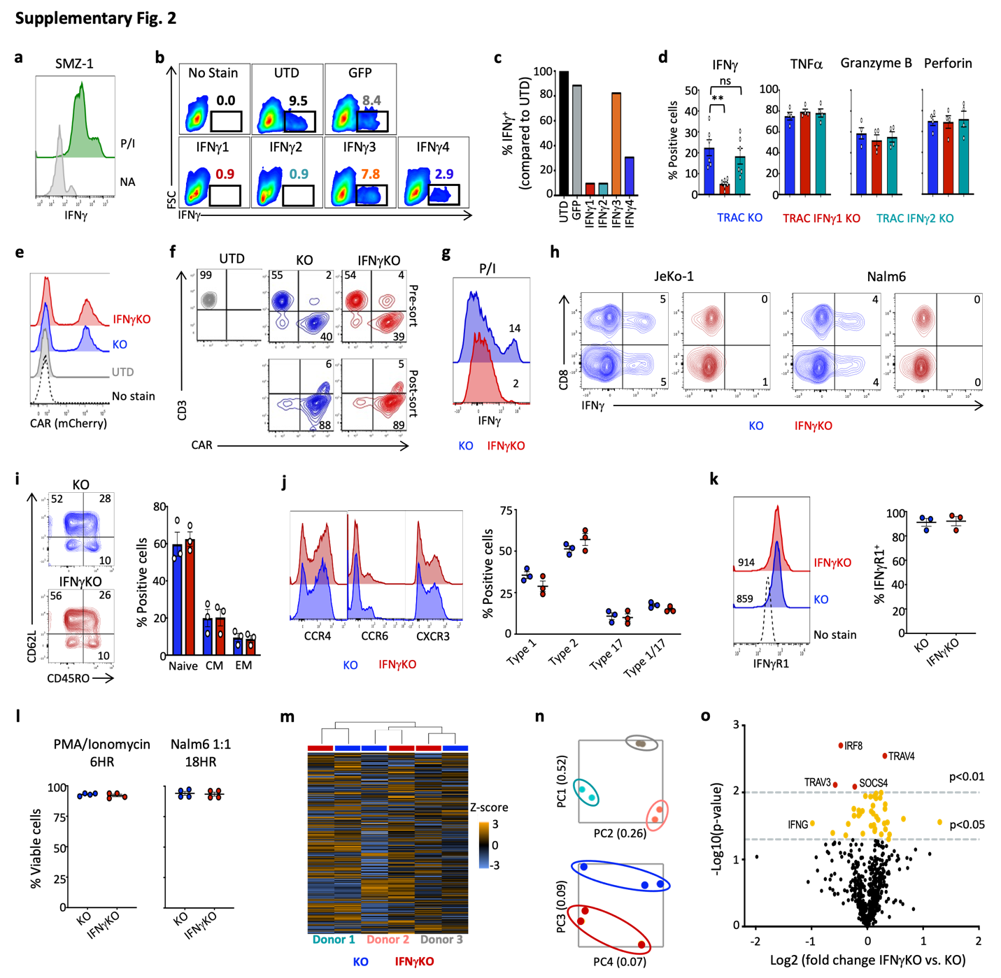
Supplementary Fig. 2. Generation of IFNγ knockout CAR-T.
a, SMZ-1 cells were activated with 4μg/ml PMA/Ionomycin (P/I) and assessed for IFNγ production by flow cytometry, representative; n=2 experiments. b,c, Four guides targeting IFNγ and a mock GFP guide from the Brunello library were assessed for their ability to knockout IFNγ in the SMZ-1 T cell line as shown by FACS plots (b) and percent expression compared to untransduced (UTD) cells (c), n=1. d, The top two guides (1 and 2) that knocked out IFNγ after P/I stimulation were chosen, incorporated into CAR constructs, and tested for successful knockout in primary human T cells, n=4-6. e,f, KO and IFNγKO CAR-T (using guide 1) were generated from healthy donors with a similar transduction efficiency (e) and efficient knockdown of TCR (CD3) expression (f). g,h, CD3⁻ CAR-T were sorted and IFNγ production determined by flow cytometry following either P/I (g) or antigen-specific (h) stimulation, representative; n=3. i-k, KO/IFNγKO CAR-T were assessed by flow cytometry for memory (i), chemokine receptors (j), and IFNγR1 expression (k), n=3-4. l, KO and IFNγKO CAR-T viability following activation for 6 hours with PMA/Ionomycin or 18 hours with Nalm6 cells, n=4. m-o, NanoString analysis of BBζ KO and IFNγKO CAR-T following a 5-day incubation with Nalm6 cells showing gene heatmap (m), PCA plots by donor (top) and CAR (bottom) (n) and volcano plot for fold change IFNγKO vs KO (o), n=3. Two adjusted P-value cutoffs are shown at <0.05 (bottom line), <0.01 (top line). Data are shown as mean ± s.e.m. with P values by one-way ANOVA. P: **<0.01, ns=not significant.

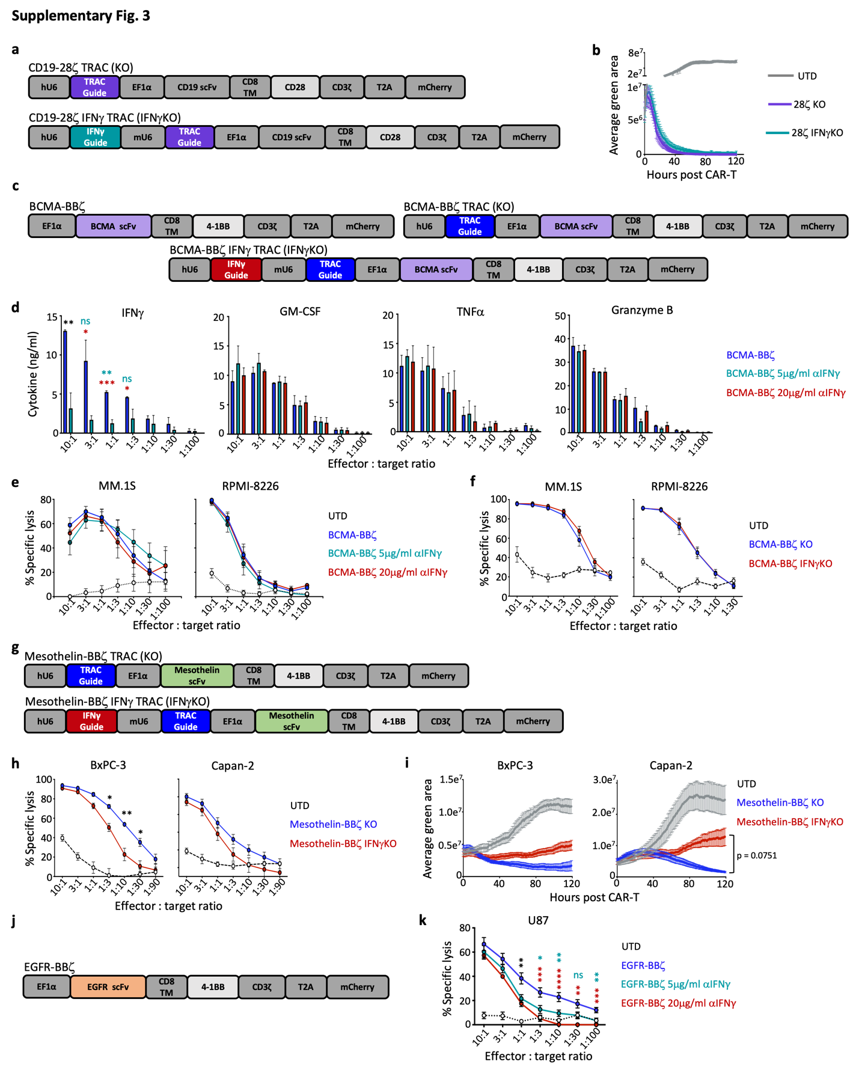
Supplementary Fig. 3: IFNγ may be differentially required for effective CAR-T therapy of hematologic and solid malignancies.
a,b, Healthy donor T cells were used to generate KO/IFNγKO CAR-T with a CD28 costimulatory domain (a) and specific lysis of Nalm6 target cells was performed using the Incucyte (b), n=5. c, CAR constructs targeting BCMA and using a 4-1BB costimulatory domain, with or without guide sequences to TRAC and/or IFNγ, were created. d, BCMA BBζ CAR-T were incubated overnight with the multiple myeloma cell line RPMI-8226 at varying E:T ratios and IFNγ, GM-CSF, TNFα, and Granzyme B expression was assessed by ELISA, n=5. e,f, Luciferase-based killing assay of BCMA BBζ with αIFNγ blocking antibodies (e; n=5) or BCMA KO/IFNγKO BBζ CAR-T (f; n=3) for both MM.1S and RPMI-8226 cell lines. g-i, Mesothelin-specific KO/IFNγKO BBζ CAR-T were generated using the constructs shown in g and killing of tumor cell lines BxPC-3 and Capan-2 was observed using luciferase-based (h) and real-time Incucyte (i) assays, n=5. j,k, BBζ CAR-T targeting the EGFR antigen were generated (j) and assessed by luciferase-based killing assays in the absence or presence of αIFNγ blocking antibodies (k), n=5. Data are shown as mean ± s.e.m. with P values by one-way ANOVA (antibody blockade) or unpaired t-tests (genetic knockout). For antibody blockade, statistics shown as BBζ vs. BBζ + 5μg/ml αIFNγ (turquoise), BBζ vs. BBζ + 20μg/ml αIFNγ (red), or BBζ vs. both αIFNγ concentrations (black). P: *<0.05, **<0.01, ***<0.001, ****<0.0001, ns=not significant.

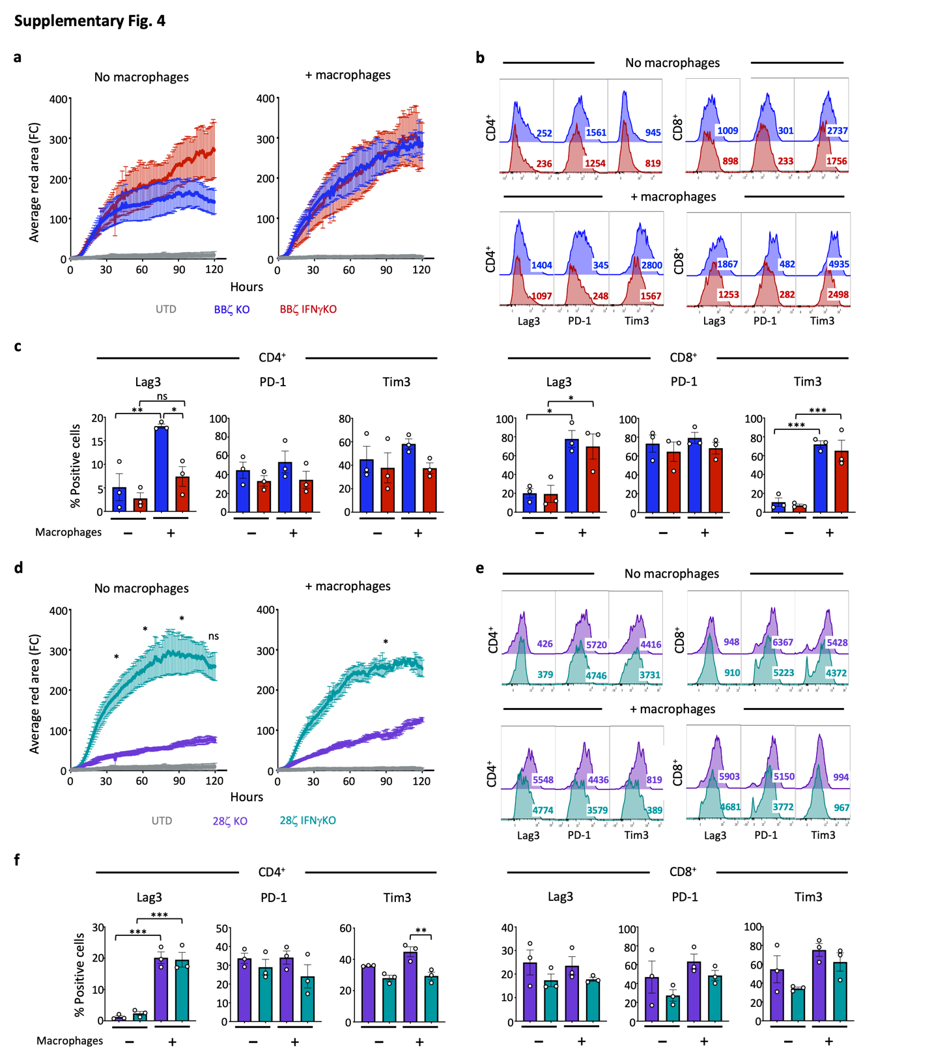
Supplementary Fig. 4: IFNγ deletion reduces immune checkpoint proteins and yields greater 28ζ CAR-T proliferation.
a-c, BBζ KO/IFNγKO CAR-T were generated from healthy donors and combined with Nalm6 cells at an effector-to-target (E:T) ratio of 1:10 plus or minus donor-matched GMCSF-activated macrophages (1E:10T:0.02M) for five days prior to assessment of CAR-T proliferation (a; Incucyte) and immune checkpoint proteins by flow cytometry (b-representative MFI, c-percent positive cells), n=3-5. d-f, 28ζ KO/IFNγKO CAR-T were generated from healthy donors and combined with Nalm6 cells at a 1:10 E:T ratio plus or minus donor-matched GMCSF-activated macrophages (1E:10T:0.02M) for five days prior to assessment of CAR-T proliferation (d; Incucyte) and immune checkpoint proteins by flow cytometry (e-representative MFI, f-percent positive cells), n=5. Data are shown as mean ± s.e.m. with P values by one-way ANOVA. P: *<0.05, **<0.01, ***<0.001, ns=not significant.

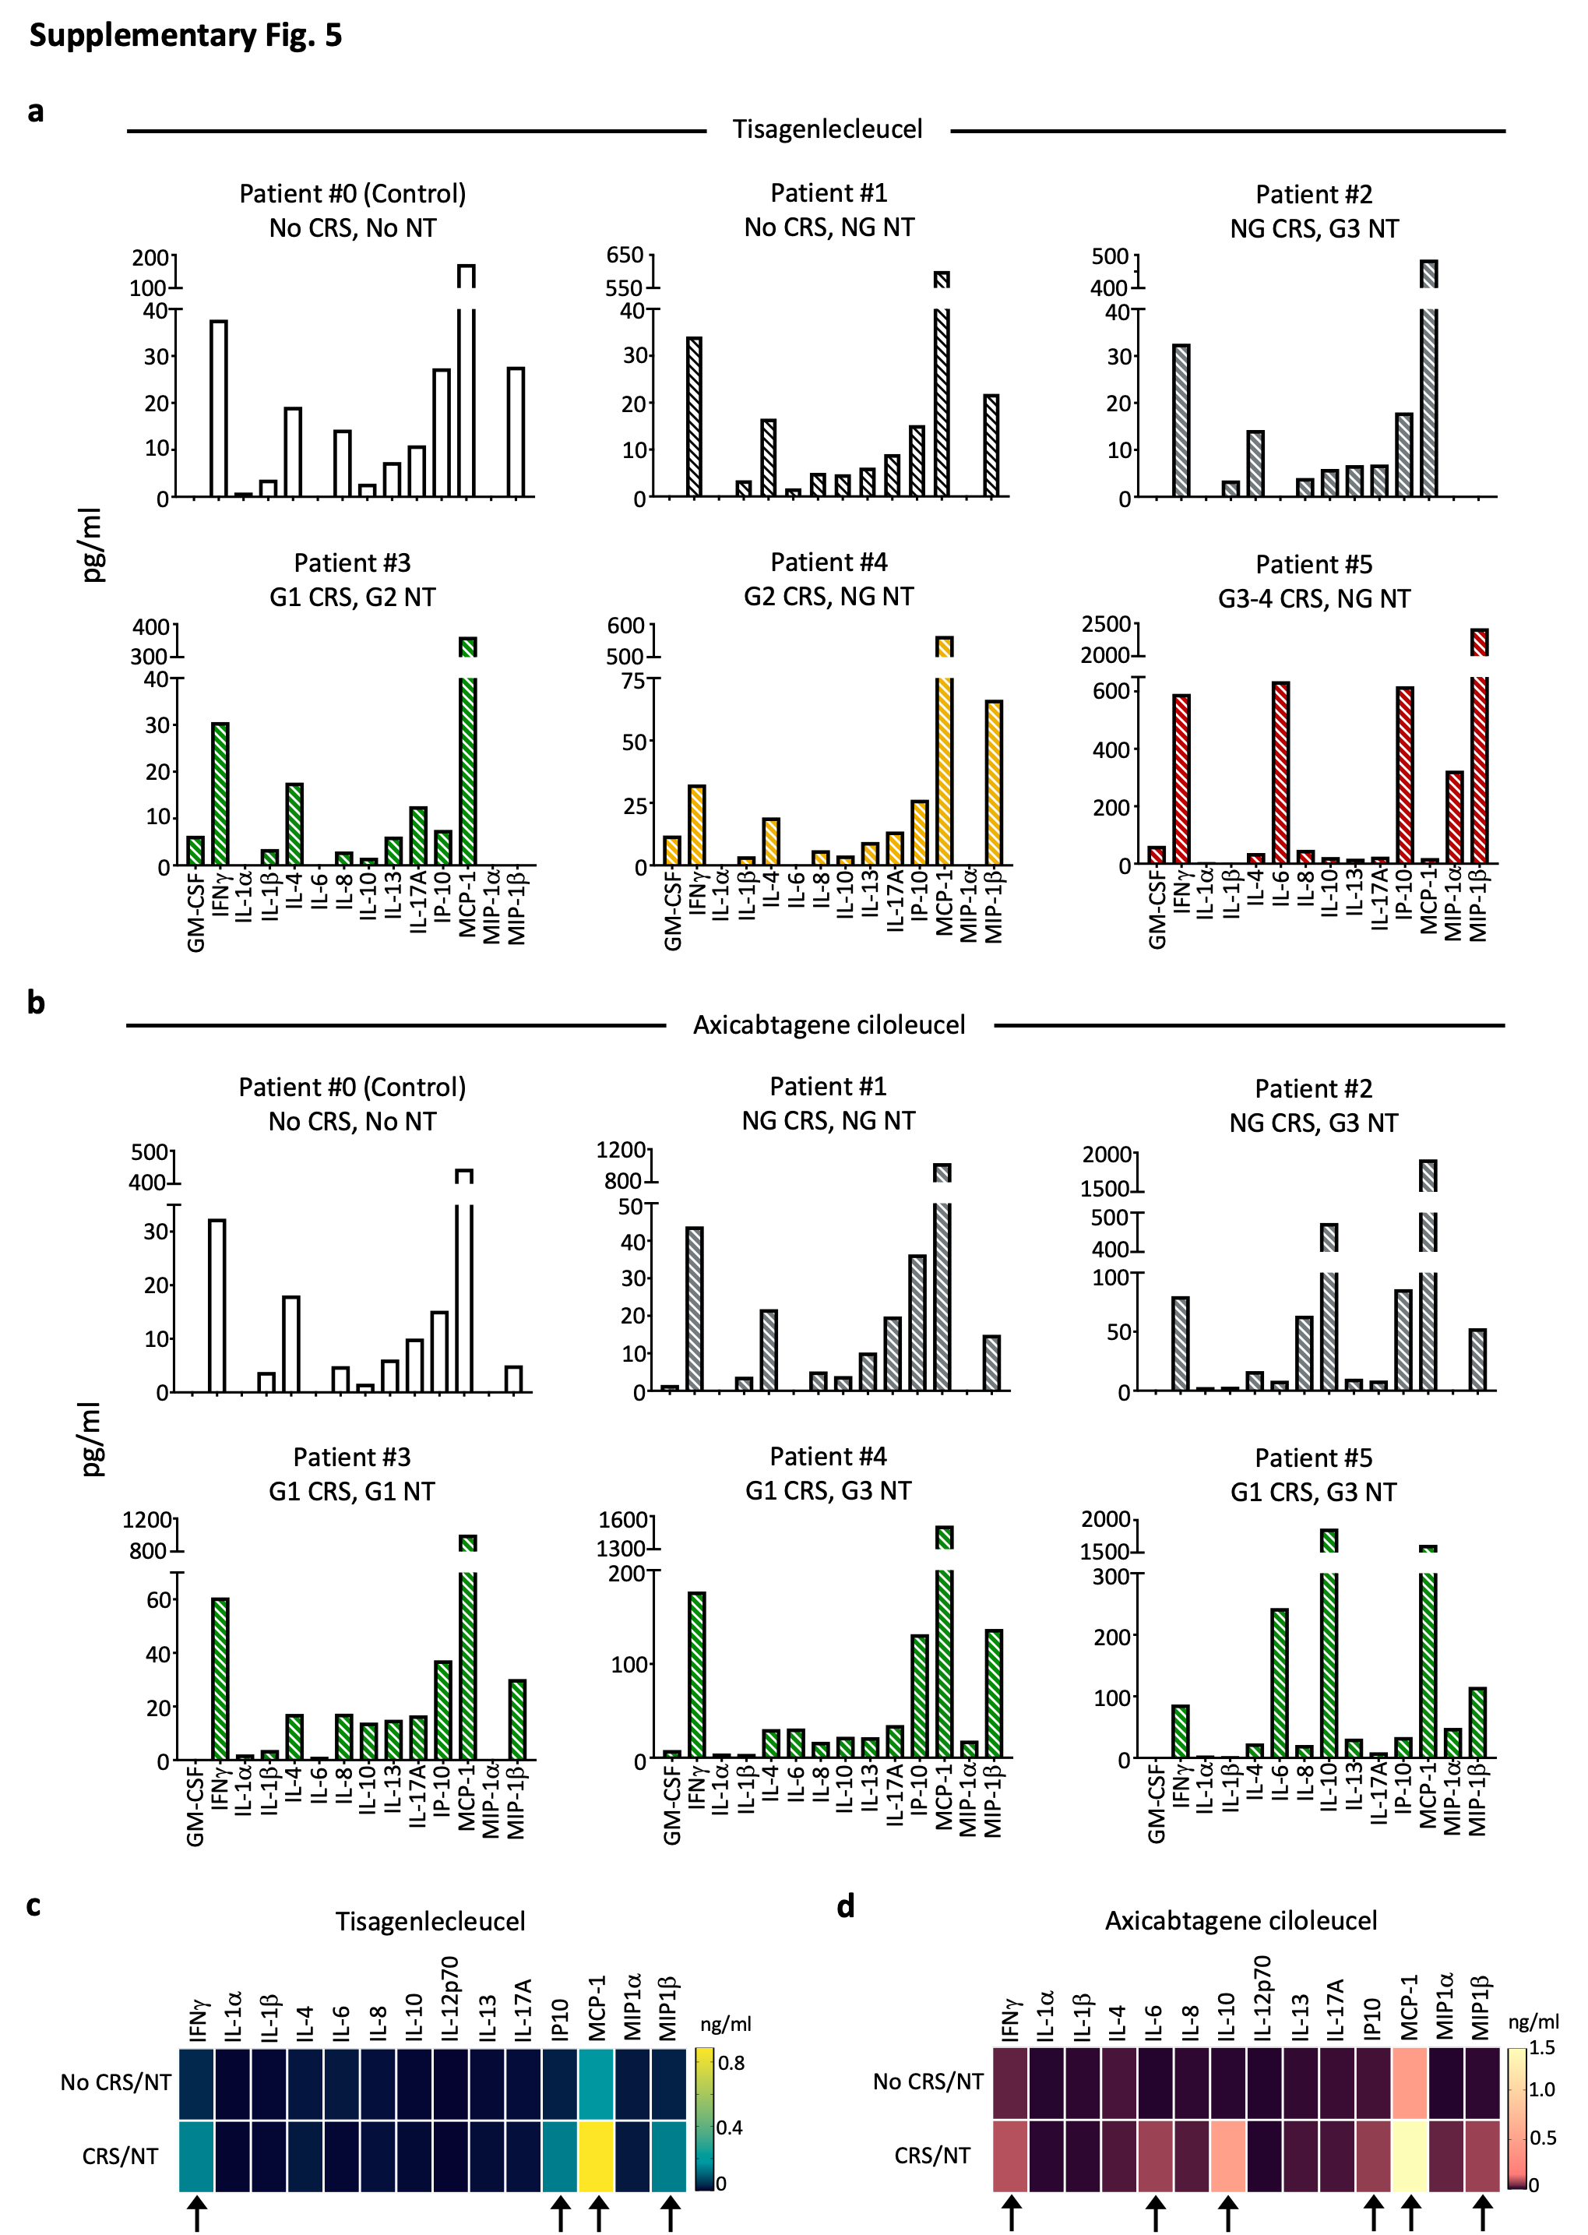
Supplementary Fig. 5: Increased IFNγ, IL-6, IL-10, IP-10, MCP-1, and MIP-1β correlates with clinical CRS and neurotoxicity.
Serum was collected from lymphoma patients 2-5 days after receiving tisagenlecleucel or axicabtagene ciloleucel CAR-T products and analyzed by Luminex. Individual data in a,b is graphed by color to denote CRS status: white (no CRS), green (grade 1; G1), yellow (grade 2; G2) and red (grade 3; G3) as well as by pattern to denote neurotoxicity (NT): no stripes (no NT), stripes (NT). NG=no grade. c,d, Patient data was combined and graphed as mean value with black arrows denoting the markers that were upregulated in CRS/NT patients (bottom row) compared to control patients who did not develop CRS or NT (top row), n=6 patients/treatment.

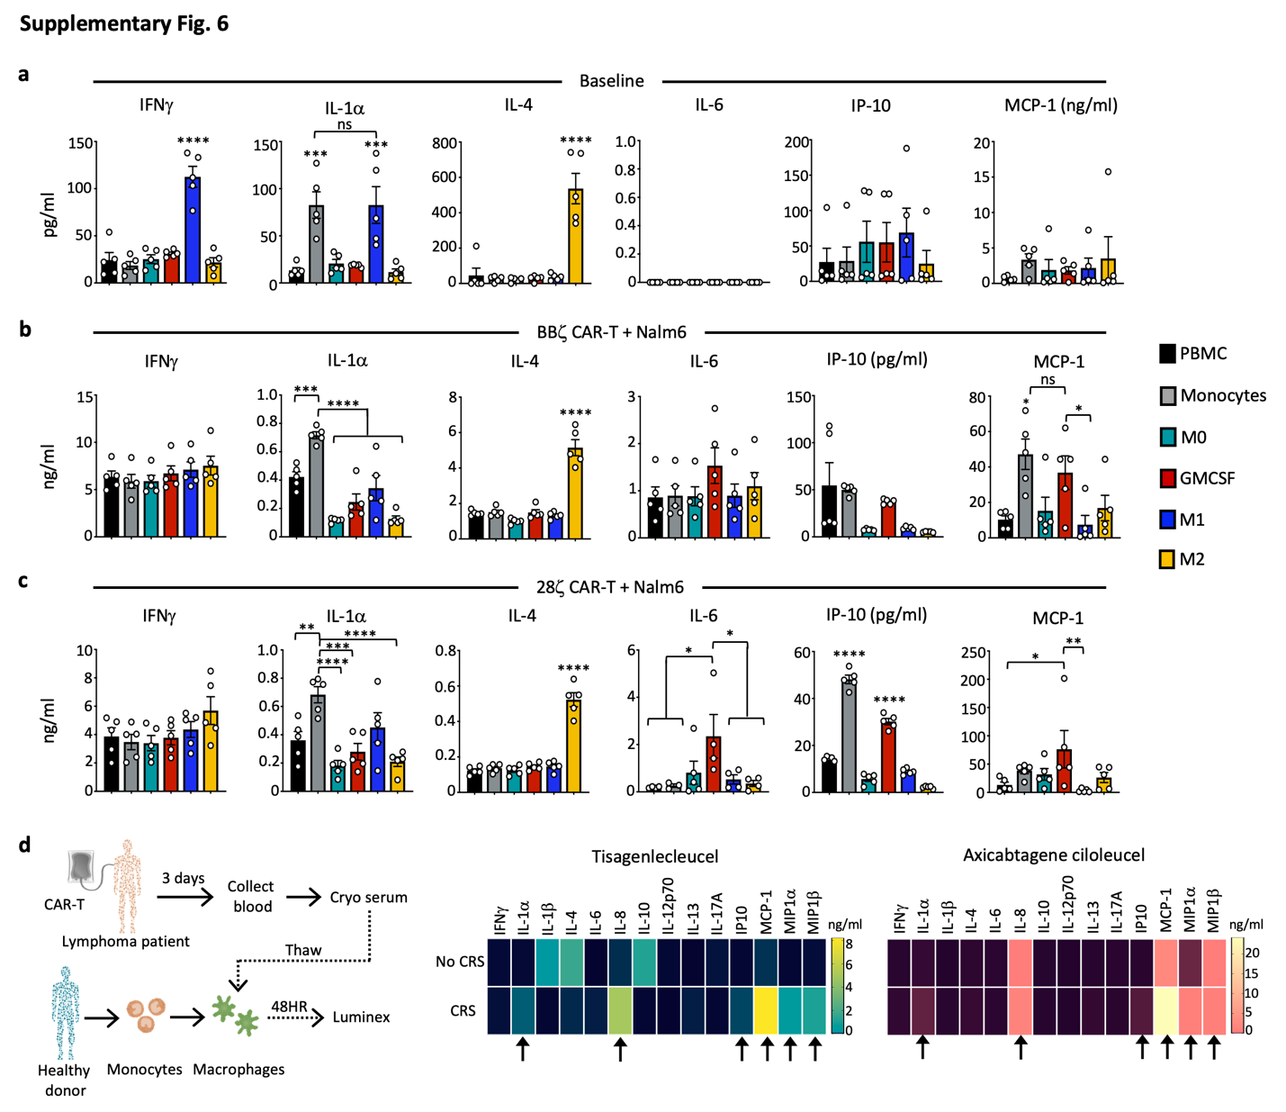
Supplementary Fig. 6: GMCSF-activated macrophages best mimic CRS in vitro.
a-c, PBMC and monocytes were isolated from healthy donors and used directly, or monocytes were differentiated into macrophages (M0, GMCSF-activated, M1, M2). Cytokine/chemokine profiles were determined at baseline (a) or 48 hours after treatment with supernatant from BBζ CAR-T/Nalm6 (b) or 28ζ CAR-T/Nalm6 (c) cultures, n=5. d, Serum collected from lymphoma patients 2-5 days post-treatment with tisagenlecleucel or axicabtagene ciloleucel CAR-T products was added to healthy donor GMCSF-activated macrophages in vitro and functional profile was determined using Luminex 48 hours later. Data is shown as mean values with black arrows indicating cytokines/chemokines that were upregulated in macrophage cultures treated with CRS/NT serum (bottom row) compared to control patients with no CRS/NT (top row). Data are shown as mean ± s.e.m. with P values by one-way ANOVA. P: *<0.05, **<0.01, ***<0.001, ****<0.0001, ns=not significant.

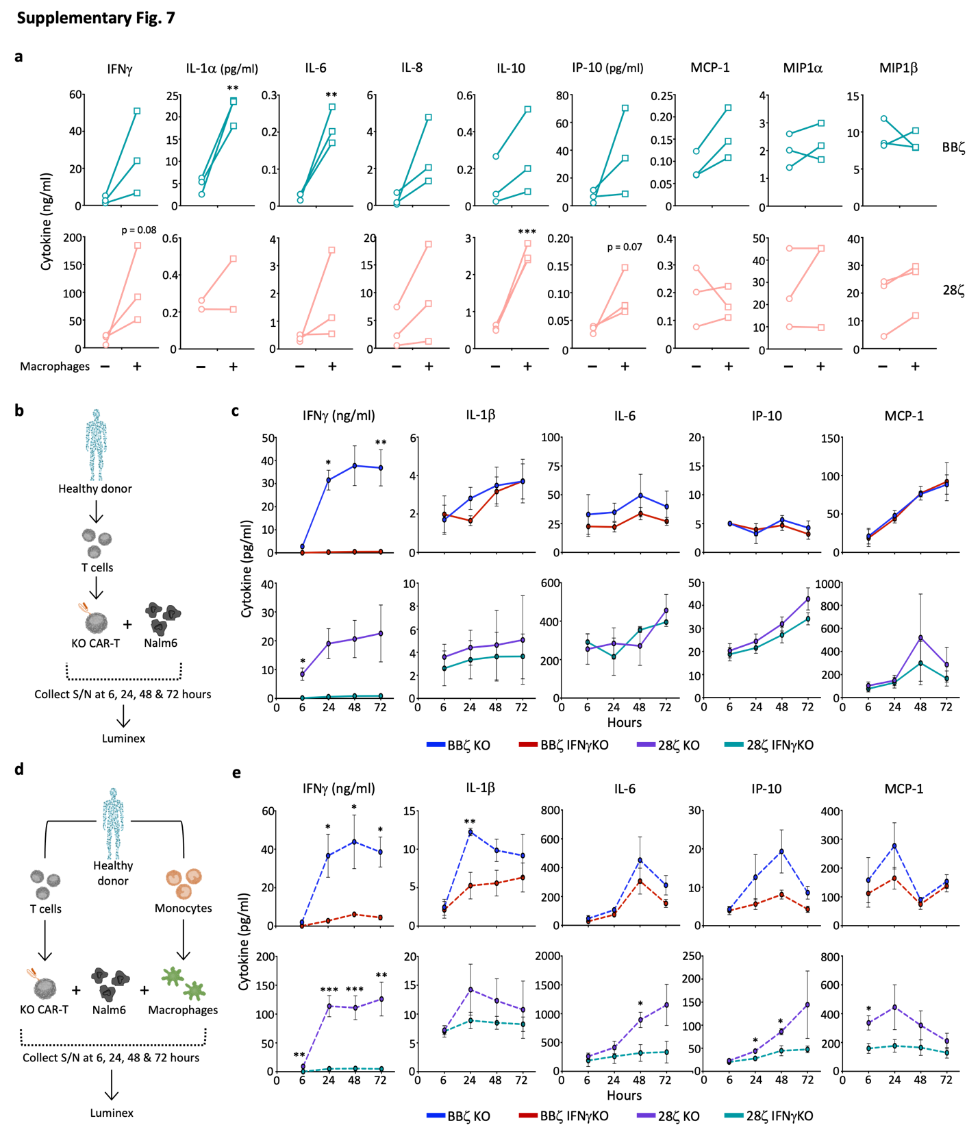
Supplementary Fig. 7: Loss of IFNγ yields decreased macrophage function.
a, BBζ and 28ζ KO CAR-T were combined with Nalm6 target cells with or without donor-matched GMCSF-activated macrophages at a 1E:1T or 1E:1T:0.02M ratio for 48 hours and supernatant was analyzed by Luminex, n=3. b-d, BBζ and 28ζ KO and IFNγKO CAR-T were generated from healthy donors, combined at a 1E:1T ratio with Nalm6 target cells (b,c) or with donor-matched GMCSF-activated macrophages and Nalm6 cells at a 1E:1T:0.02M ratio (d,e), and supernatant was collected and analyzed by Luminex at 6, 24, 48, and 72 hours, n=5. Data are shown as mean ± s.e.m. with P values by unpaired t-tests. P: *<0.05, **<0.01, ***<0.001.

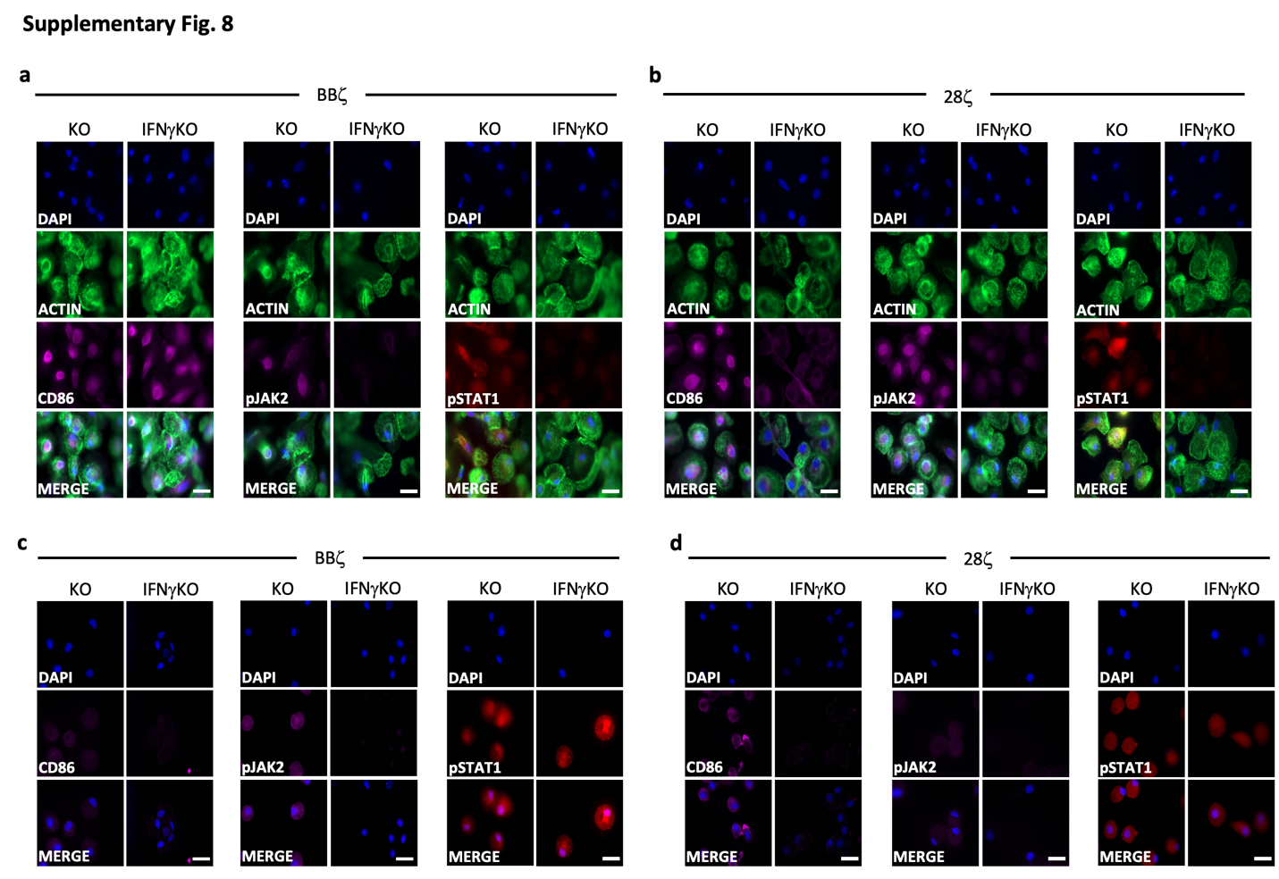
Supplementary Fig. 8: IFNγKO CAR-T reduce macrophage activation in multiple models.
a,b, KO/IFNγKO CAR-T from Fig. 5c were generated from healthy donors and combined with Nalm6 cells for 24 hours prior to supernatant collection and addition to donor-matched GMCSF-activated macrophages. 48 hours later, macrophages were fixed and stained for CD86, pJAK2, and pSTAT1 for both BBζ (a) and 28ζ (b) cultures, representative; n=2 (magnification 63x). Scale bars = 10μm. c,d, Serum from Nalm6-bearing NSG mice treated with KO or IFNγKO CAR-T (Fig. 6) was added to donor-matched GMCSF-activated macrophages in vitro. 48 hours later, macrophages were fixed and stained for CD86, pJAK2, and pSTAT1 for both BBζ (c) and 28ζ (d) cultures, representative; n=2 (magnification 63x). Scale bars = 10μm.

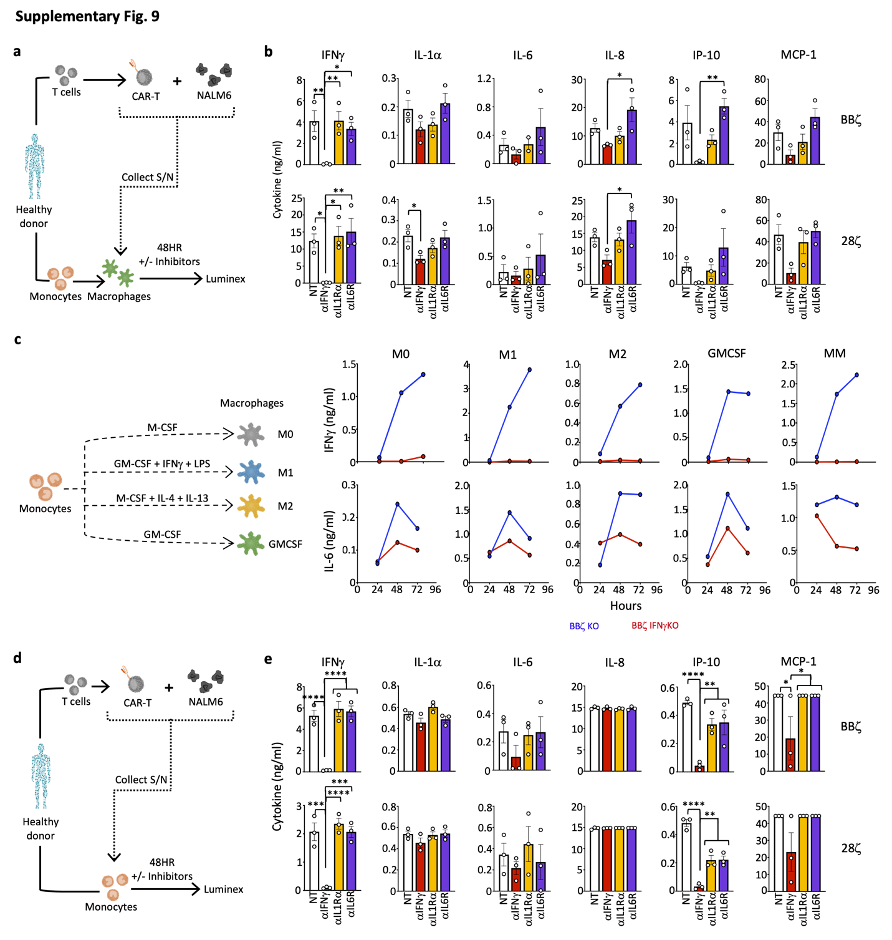
Supplementary Fig. 9: IFNγ blockade reduces function in both macrophages and monocytes.
a,b, CAR-T were combined with Nalm6 cells for 24 hours prior to supernatant collection and addition to donor-matched GMCSF-activated macrophages +/- blocking antibodies against IFNγ, IL-1Rα, and IL-6R and cytokines were assessed 48 hours later for BBζ (top) and 28ζ (bottom), n=3. c, Healthy donor monocytes were expanded into M0, M1, M2, and GMCSF-activated subsets and combined with donor-matched KO/IFNγKO CAR-T and Nalm6 target cells at a 1E:1T:0.02M ratio (individual macrophage groups or mixed macrophage--MM--containing an equal number of each subset). Supernatant was collected after 48 hours and assessed by ELISA, n=1. d,e, CAR-T were combined with Nalm6 cells for 24 hours prior to supernatant collection and addition to donor-matched monocytes +/- blocking antibodies against IFNγ, IL-1Rα, and IL-6R and cytokines were assessed 48 hours later for BBζ (top) and 28ζ (bottom), n=3. Data are shown as mean ± s.e.m. with P values by one-way ANOVA. P: *<0.05, **<0.01, ***<0.001, ****<0.0001.

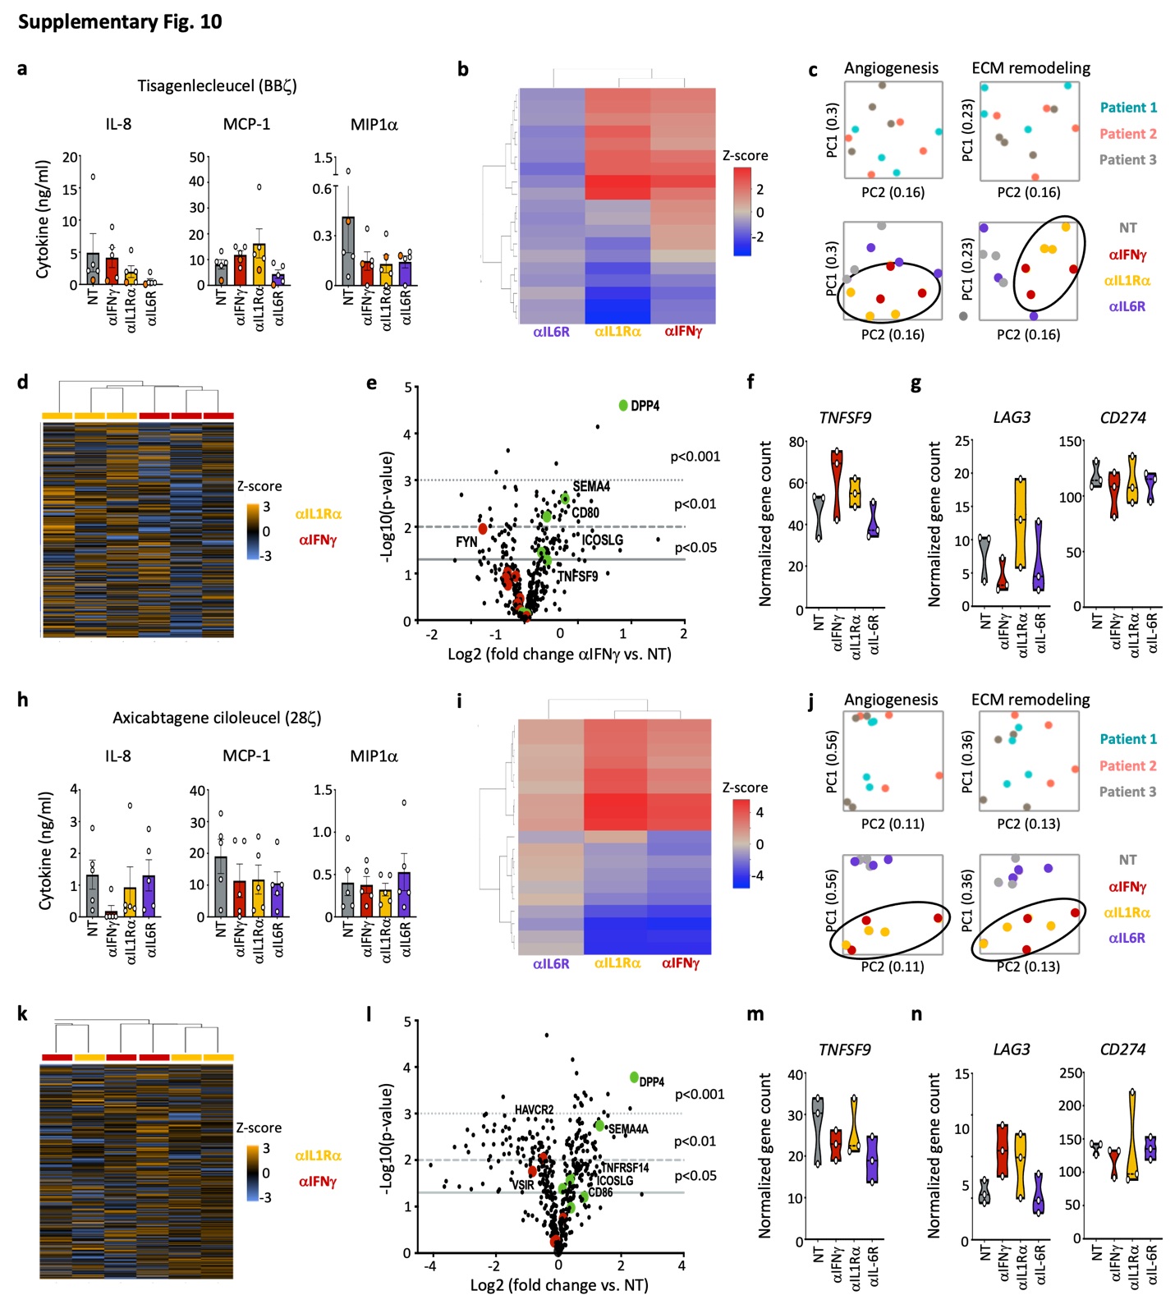
Supplementary Fig. 10: IFNγ blockade creates a distinct transcription profile in macrophages compared to anti-IL1Rα and anti-IL6R blocking antibodies.
Serum from patients receiving tisagenlecleucel or axicabtagene ciloleucel CAR-T products was collected 2-5 days post-CAR treatment, added to healthy donor-derived GMCSF-activated macrophages +/- blocking antibodies to IFNγ, IL-1Rα and IL-6R and were assessed 48 hours later. a, Cultures receiving serum from tisagenlecleucel patients were assessed by Luminex. b-g, Macrophages were analyzed by NanoString, and data is shown by direct global significance score (compared to no treatment (NT)) (b), PCA analysis (c), heatmap of all data (d), volcano plot (e) and normalized gene counts (f,g). Experiments above were repeated using serum from axicabtagene ciloleucel (h-n). Data are shown as mean ± s.e.m.

