SUPPLEMENTAL DATA
Table S1: Patient demographics

 |  | Healthy controls | Leukemia | Lymphoma | Multiple myeloma | All patients
Total Individuals |  | 69 | 157 | 173 | 221 | 551
Gender | Male | 15 (21.7%) | 95 | 101 | 114 | 310 (56.3%)
 | Female | 54 (78.3%) | 62 | 72 | 107 | 241 (43.7%)
Age: median (range) |  | 31 (22 – 67) | 66 (25 – 92) | 65 (22 – 97) | 65 (34 – 85) | 65 (22 – 97)
On treatment | No |  | 61 | 62 | 12 | 135 (24.5%)
 | Yes |  | 96 | 111 | 209 | 416 (75.5%)
Leukemia subtype | ALL |  | 9
 | AML |  | 10
 | CLL/SLL |  | 120
 | CML |  | 3
 | CMML |  | 3
 | HCL |  | 4
 | MDS |  | 3
 | MPN |  | 3
 | NK cell |  | 1
 | Other |  | 1
Lymphoma subtype | AITL |  |  | 4
 | DLBCL |  |  | 55
 | FL |  |  | 42
 | HL |  |  | 14
 | MCL |  |  | 13
 | MZL |  |  | 24
 | PTCL |  |  | 10
 | WM |  |  | 10
 | Other |  |  | 1
Multiple myeloma subtype | Smoldering |  |  |  | 10
 | Active |  |  |  | 211

Abbreviations: ALL, acute lymphoblastic leukemia; AML, acute myeloid leukemia; CLL/SLL, chronic lymphocytic leukemia/small lymphocytic lymphoma; CML, chronic myelogenous leukemia; CMML, chronic myelomonocytic leukemia; HCL, hairy cell leukemia; MDS, myelodysplastic syndrome; MPN, myeloproliferative neoplasm; NK cell, natural killer cell; AITL, angioimmunoblastic T-cell lymphoma; DLBCL, diffuse large B cell lymphoma; FL, follicular lymphoma; HL, Hodgkin lymphoma; MCL, mantle cell lymphoma; MZL, marginal zone lymphoma; PTCL, peripheral T-cell lymphoma; WM, Waldenstrom macroglobulinemia.

Figure S1. Study schema. Patients with hematologic malignancies (leukemia, lymphoma, and multiple myeloma) who received the mRNA-based vaccines, BNT162b2 and mRNA-1273, had humoral responses measured at 1 (pre-dose 2) and 3 months from initial vaccination. Note: “1 month” timepoint = 3 weeks from first BNT162b2 vaccine and 4 weeks from first mRNA-1273 vaccine. Parallel assessments from a healthy volunteer cohort provided controls.

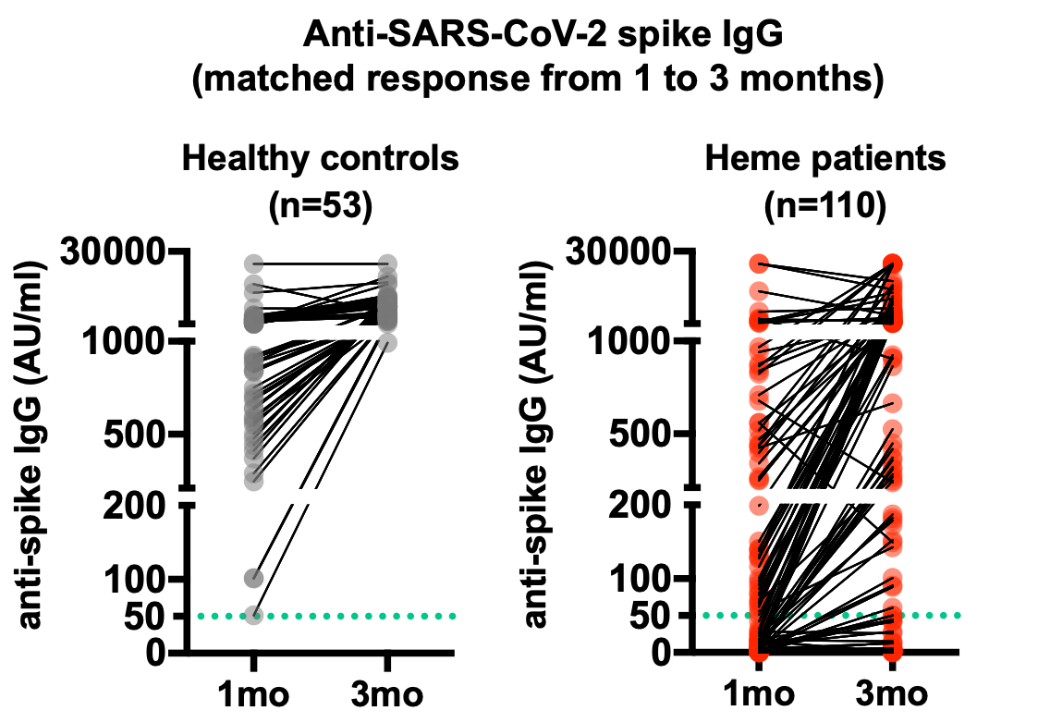

Figure S2. Serial humoral responses to COVID-19 vaccines. Anti-SARS-CoV-2 spike IgG antibody titers were measured at 1 and 3 months after initial COVID-19 vaccination and summarized using before-after scatter plots, comparing hematologic malignancy patients with healthy controls. Note: “1 month” timepoint = 3 weeks from first BNT162b2 vaccine and 4 weeks from first mRNA-1273 vaccine. Green dashed line denotes the threshold for a positive result (50.0 AU/ml).

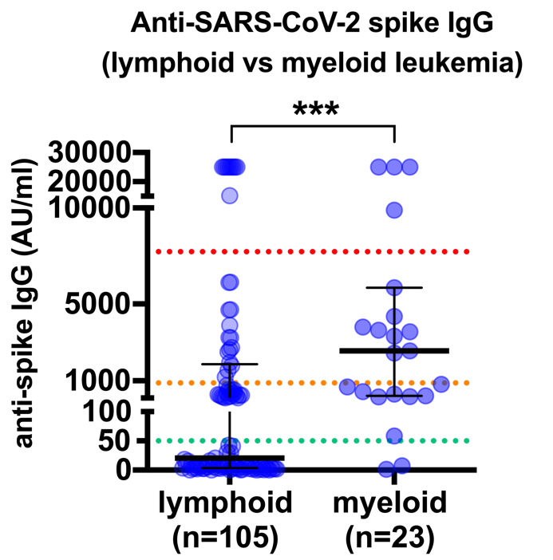

Figure S3. Lymphoid and myeloid leukemia humoral responses to COVID-19 vaccines. Anti-SARS-CoV-2 spike IgG antibody titers were measured at 3 months after initial COVID-19 vaccination for patients with lymphoid and myeloid leukemias and summarized using scatter plots with median and interquartile range. Green dashed line denotes the threshold for a positive result (50.0 AU/ml). Orange dashed line denotes the median value at 1 month for healthy controls (886 AU/ml). Red dashed line denotes the median value at 3 months for healthy controls (7720 AU/ml). ***P < .001.

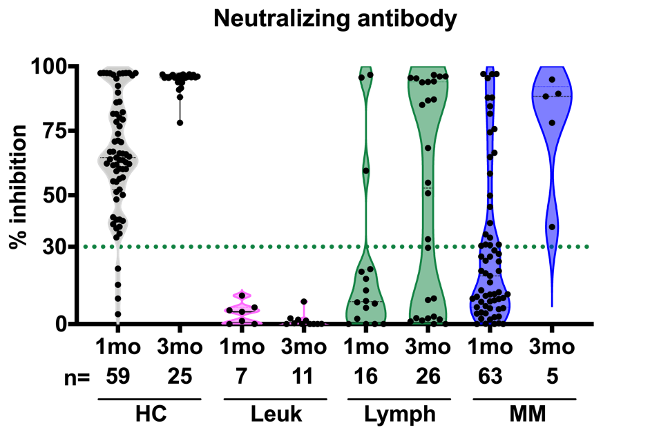

Figure S4. Neutralizing antibody levels after COVID-19 vaccines by hematologic malignancy subtype. Circulating neutralizing antibodies against SARS-CoV-2 were assessed at 1 and 3 months after initial COVID-19 vaccination. Note: “1 month” timepoint = 3 weeks from first BNT162b2 vaccine and 4 weeks from first mRNA-1273 vaccine. Violin plots comparing leukemia (Leuk; pink fill), lymphoma (Lymph; green fill), and multiple myeloma (MM; blue fill) patients with healthy controls (HC; gray fill). Green dashed line denotes the threshold for a positive result (30% inhibition). n= number of individuals per category.

