Supplemental Figures

Supplemental Figure 1:

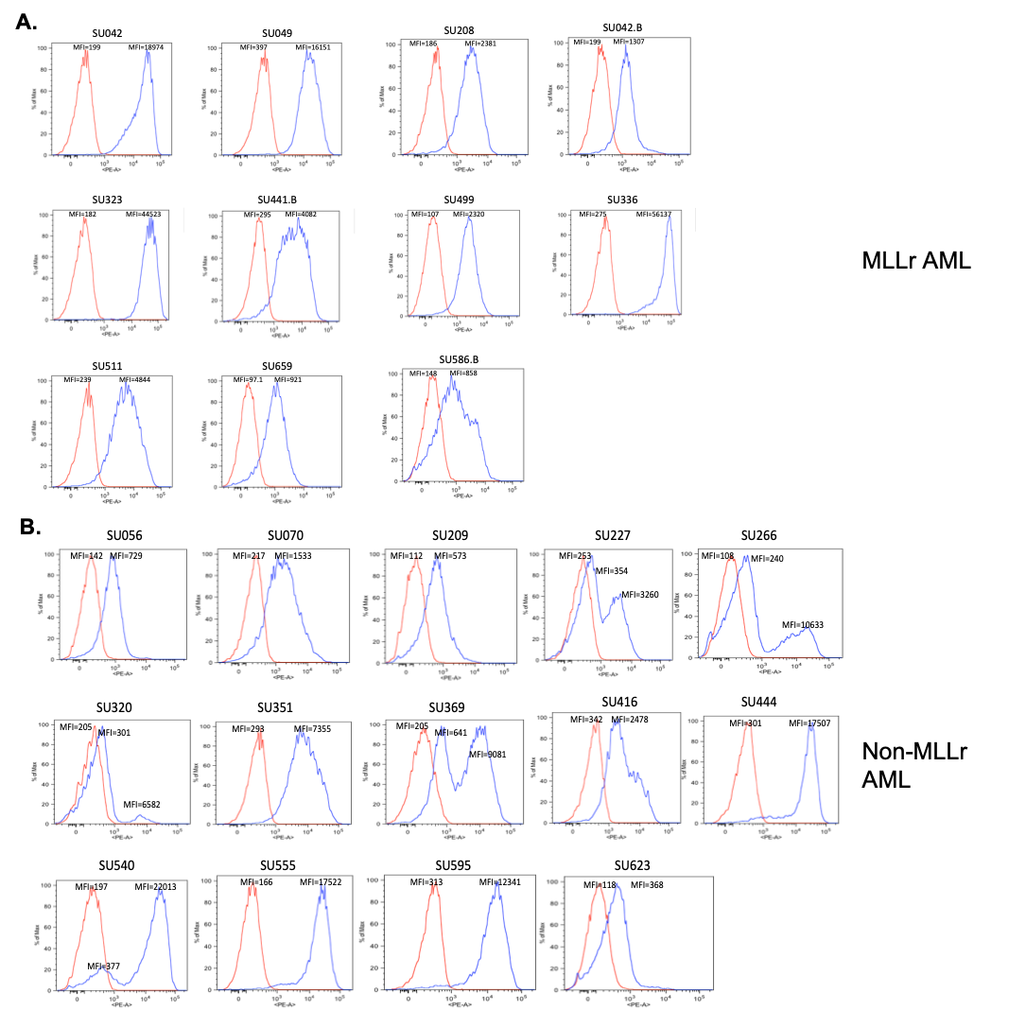

Supplemental figure 1: CD93 is expressed on primary patient-derived AML blasts in MLL-rearranged and non-MLL rearranged AML. (A) Primary patient-derived AML samples (n=11) were stained with CD93 (blue) or isotype (red). (B) CD93 is expressed in non-MLLr AML (n=14) but expression is more variable than in MLLr AML. Staining of non-MLLr primary patient samples was performed as in (A).

Supplemental Figure 2:
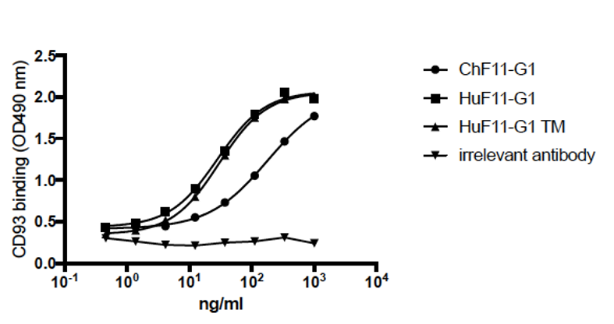

Supplemental figure 2: Humanized and chimeric F11 monoclonal antibodies bind human CD93 with similar affinity. Human CD93/Fc fusion protein was coated in a 96-well plate and different concentrations of the antibodies as indicated were added. HRP-conjugated anti-human Kappa antibody was used as a secondary antibody. CD93 binding activity was measured by reading signals at OD490mm.

Supplemental Figure 3:

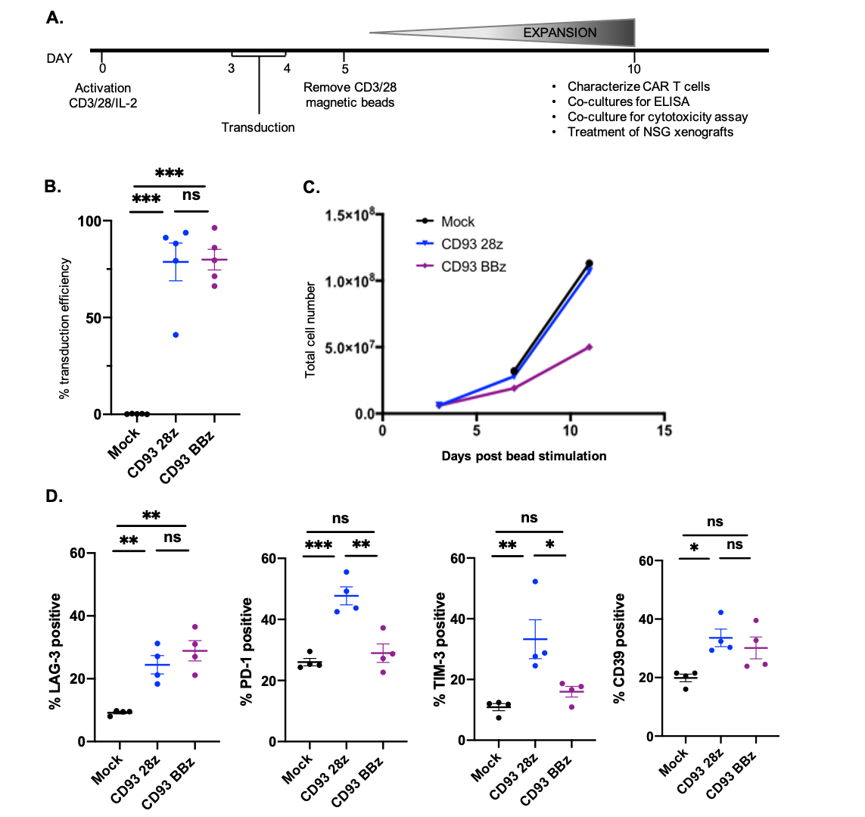

Supplemental figure 3: Characterization of CD93 CAR T cells after expansion in culture. (A) CAR T cell production schema. Primary human T cells were activated on day 0 with CD3/28 beads and cultured with IL-2 (100 IU/ml). Cells were transduced with retroviral vectors containing CAR constructs on consecutive days 3 and 4, and activation beads were removed on day 5. Cells were fed with new media every 2-3 days, analyzed for transduction efficiency and phenotype on day 10-11, and processed for downstream experiments. (B) Transduction efficiency was measured by flow cytometry with CD93-Fc protein on day 10 after T cell activation. (C) Expansion of CD93-CAR T cells over 10 days of culture, measured by total cell counts. Representative experiment shown. (D) Markers of activation/exhaustion including LAG-3, PD-1, TIM-3, and CD39 were measured by flow cytometry on day 10 after T cell activation, prior to downstream experiments. Summary data from n=4 donors is shown and were gated on CAR positivity for CD93-28z and CD93-BBz, and on live singlets for mock-transduced CAR T cells (unpaired t-test).

Supplemental Figure 4:

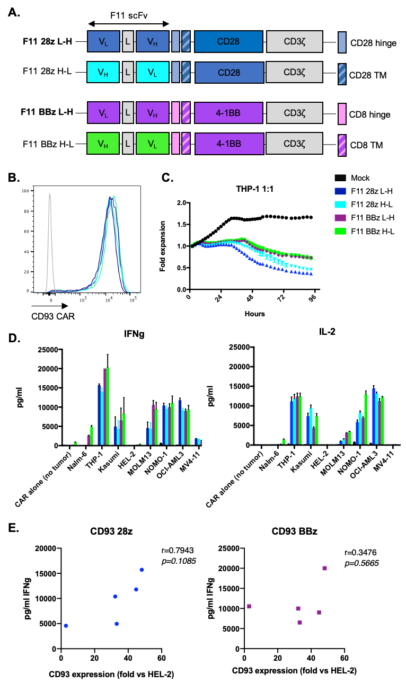
Supplemental figure 4: F11-based CD93 specific CARs show equivalent in vitro anti-tumor activity. (A) Schematic of F11-based CD93 CARs. Light (V_{L}) and heavy (V_{H}) chains were grafted onto a backbone of CD28 hinge/TM, CD28 costimulatory domain, and CD3ζ activation domain (28z) or CD8𝛼 hinge/TM, 4-1BB costimulatory domain, and CD3ζ activation domain. Bolded versions F11 28z L-H and F11 BBz L-H are used throughout the main body of the paper and named CD93-28z and CD93-BBz, respectively. (B) Primary T cells were transduced with F11-based CARs and CD93 CAR expression was analyzed with a CD93-Fc biotinylated protein followed by secondary antibody. (C) Mock-transduced or F11-based CAR T cells were co-cultured with THP-1 cells stably expressing GFP at a 1:1 E:T ratio and GFP expression was measured in an IncucyteTM for 72h. (D) Mock-transduced or F11-based CAR T cells were incubated at a 1:1 E:T ratio with various AML cells for 24h, and cytokine production was measured in the supernatant by ELISA. (E) IFN𝛾 production of CD93 CAR T cells correlates with MFI of CD93 on various AML cell lines, normalized to HEL-2, an AML cell line with low CD93 expression that does not induce cytokine production (linear regression analysis). Data in C-E are representative of experiments performed with at least n=2 donors.

Supplemental Figure 5:

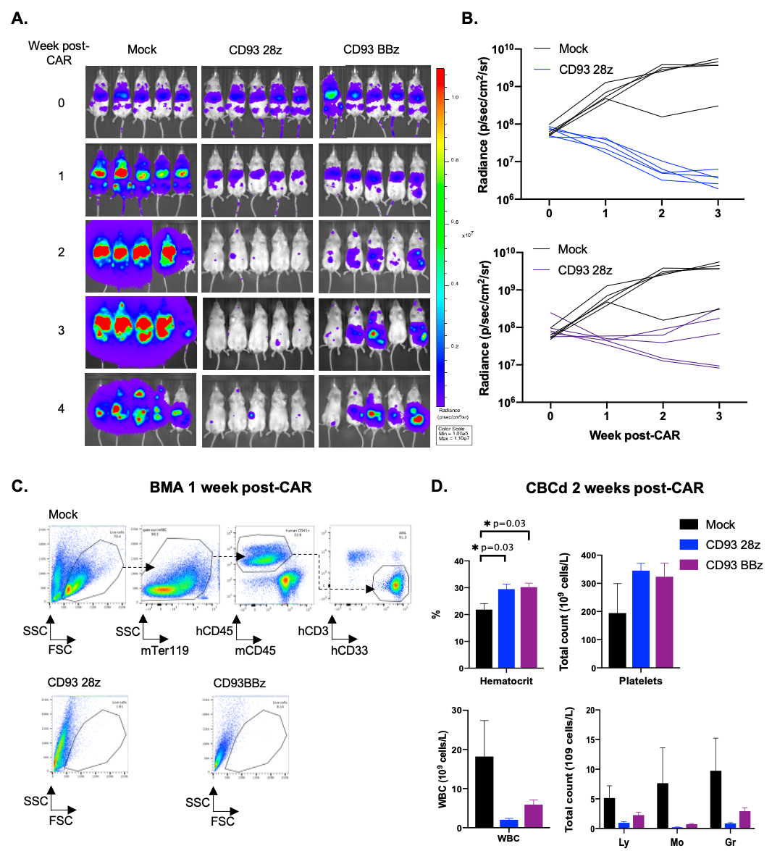

Supplemental figure 5: CD93 CAR T cells exert leukemic control in vivo. (A) Reduction of leukemic burden (THP-1) was observed in xenografted mice treated with CD93 CAR T cells but not in those treated with mock-transduced mice (n = 5 in each group), as measured by BLI radiance and displayed colorimetrically. Of note, mice experienced GVHD around 4 weeks post-CAR treatment prior to natural death from leukemic progression, so survival analysis without confounding was not possible. (B) BLI of individual mice treated with mock vs CD93-28z CAR or CD93-BBz CAR. (C) CD93 CAR T cells induce massive cell death within BM 1 week after CAR T cell infusion. BMA from mice treated with mock-transduced T cells confirms AML engraftment by gating on live cells (FSC vs SSC), non-mouse RBCs (mTer119), human hematopoietic cells (mCD45 vs hCD45), and AML (CD33 vs CD3). FSC and SSC gating shows very few live cells in CD93 CAR T cell treated groups, precluding further analysis of leukemic clearance at this time point. (D) Complete blood count (CBC) was performed after CAR T treatment to determine bone marrow recovery since BMA cannot be performed weekly. CBC was analyzed from peripheral blood 2 weeks post-CAR infusion. The mock-treated mice had a significantly lower hematocrit and trend toward thrombocytopenia and leukocytosis compared to CD93 CAR T cell-treated mice, consistent with leukemic progression in the mock group and leukemic control in the CAR-treated groups (unpaired t-test).

Supplemental Figure 6:

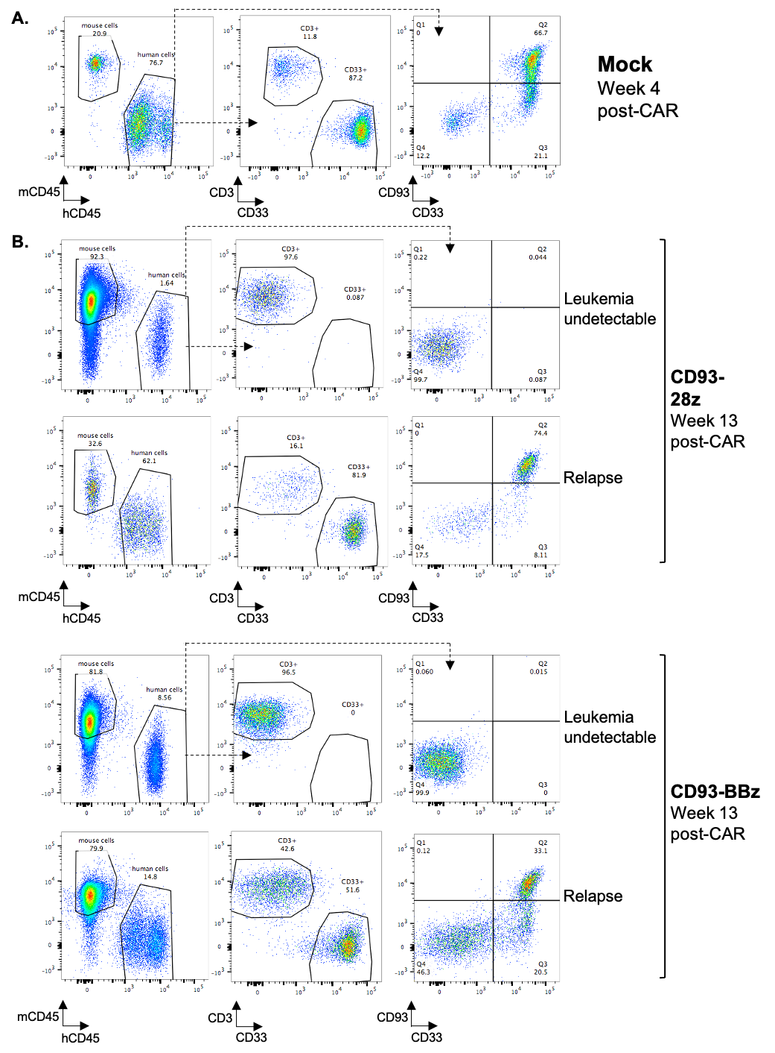

Supplemental figure 6: Relapses in a patient-derived xenograft model are not driven by CD93 negative AML. (A) Representative dot plots in a mouse with patient-derived, SU555 AML 4 weeks after treatment with mock-transduced CAR T cells. Live cells were gated on human CD45 then further analyzed for CD33 and CD3 expression to segregate human AML cells (CD33+CD3-) and human T cells (CD33-CD3+). CD33 positive cells were also analyzed for CD93 expression in the panel on the far right. (B) Bone marrow aspirate collected from mice treated with CD93-28z or CD93-BBz CAR T cells were analyzed as in (A). For each treatment group, representative dot plots are shown for a mouse without detectable leukemia in the bone marrow and a mouse with relapsed AML.

Supplemental Figure 7:

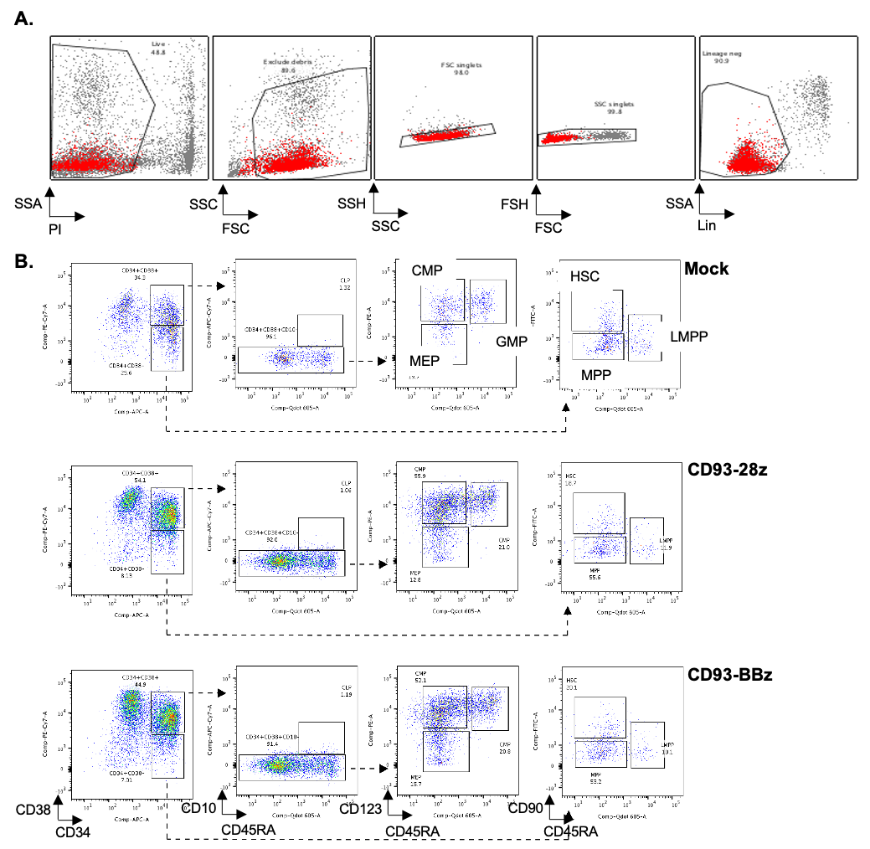

Supplemental figure 7: CD93 CAR T cells are not cytotoxic to hematopoietic progenitor populations. (A) Back-gating strategy prior to phenotypic analysis of hematopoietic progenitor subsets. CD34+ cells isolated by positive selection from cord blood underwent flow cytometry, and were first gated on live cells (PI-), non-debris (FSC vs SSC), singlets (SSC vs SSH and FSC vs FSH), and non-committed lineage negative cells (Lin-). (B) Gating strategy of lineage negative, hematopoietic progenitor populations. After 18h co-culture with CAR T cells, CD34+CD38+ cells were gated on CD10- cells, which were then gated on CD45RA and CD123 to analyze CMP (CD45RA-CD123+), GMP (CD45+CD123+), and MEP (CD45RA-CD123-). CD34+CD38- cells were separated into HSC (CD45RA-CD90+), MPP (CD45RA-CD90-), and LMPP (CD45RA+CD90-).

Supplemental Figure 8:

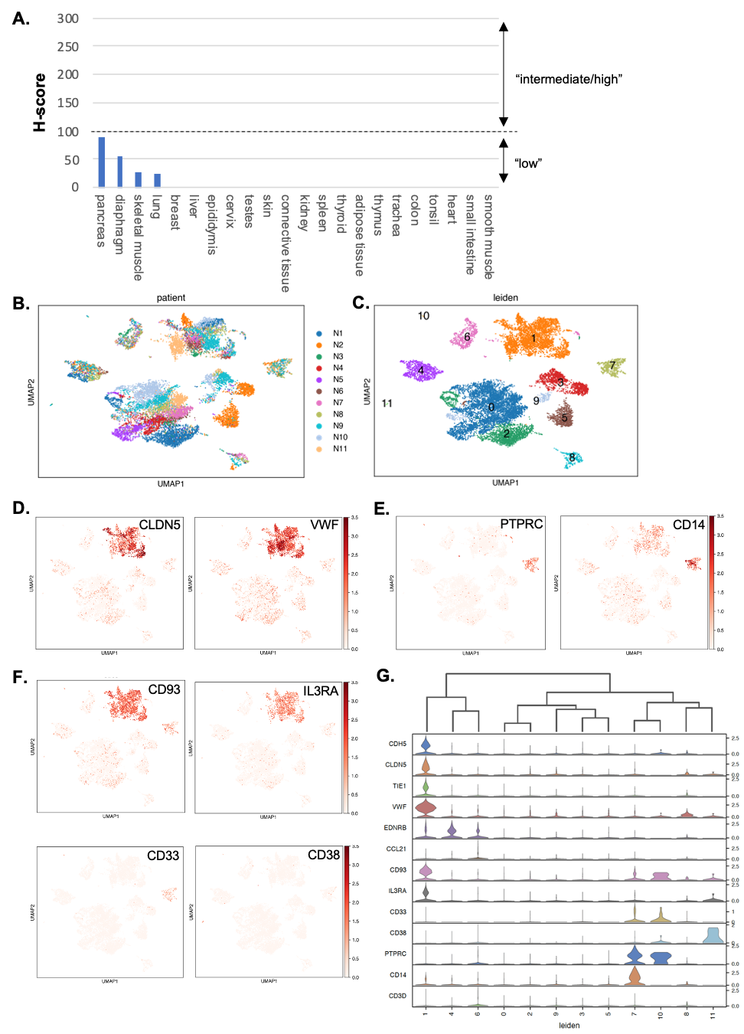
Supplemental Figure 8: CD93 and CD123 are expressed on normal myeloid and endothelial cells. (A) Quantification of CD93 expression on normal tissue by immunohistochemistry. CD93 antibody was applied to a normal tissue microarray and stained samples were digitized with the Leica SCN400 scanner. H-scores were calculated on a scale of 0-300 based on the formula: % positive cells x staining intensity (staining intensity determined on a 0-3 descriptive scale, 0=no staining, 1=low, 2=clearly positive, 3=strong expression). UMAP projection of single cells, colored either by (B) patient sample (N=11) (C) or leiden gene expression cluster. (D) UMAP projection of single cells, colored by expression of endothelial marker genes marking different endothelial subsets: CLDN5 and VWF mark an endothelial population (cluster 1) (E) UMAP projection of single cells, colored by expression of hematopoietic marker genes: PTPRC (CD45) and CD14 are expressed primarily within cluster 7. (F) UMAP projections of single cell, colored by expression of CD93 and IL3RA (CD123) demonstrated expression in endothelial cluster 1. CD33 and CD38 were not expressed at baseline in endothelial cells. (G) Violin plots displaying the expression level of tissue-specific markers representative of each cluster, with particular focus on endothelial and hematopoietic cells.

Supplemental Figure 9
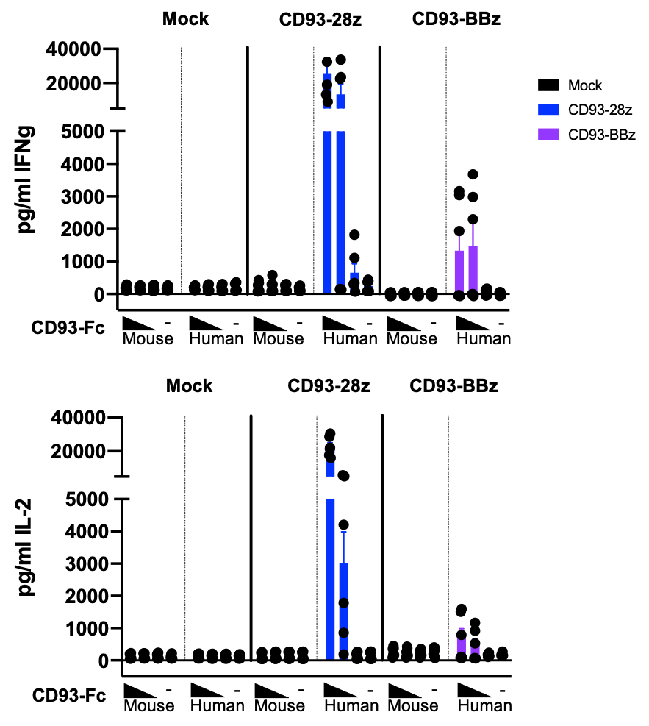

Supplemental Figure 9: Human CD93 CAR T cells do not cross-react with murine CD93. CD93-28z and CD93-BBz CAR T cells produce IFN𝛾 and IL-2 when stimulated with plate-bound human CD93-Fc protein but not when stimulated with plate-bound murine CD93-Fc. Cytokine production of CD93-CARs after exposure to decreasing concentration of plate-bound human or murine CD93-Fc (indicated by black triangles, ranging from 5 µg/ml to 0.05 µg/ml, or ”-” without any CD93-Fc) is compared to mock-transduced T cells.
Supplemental Figure 10
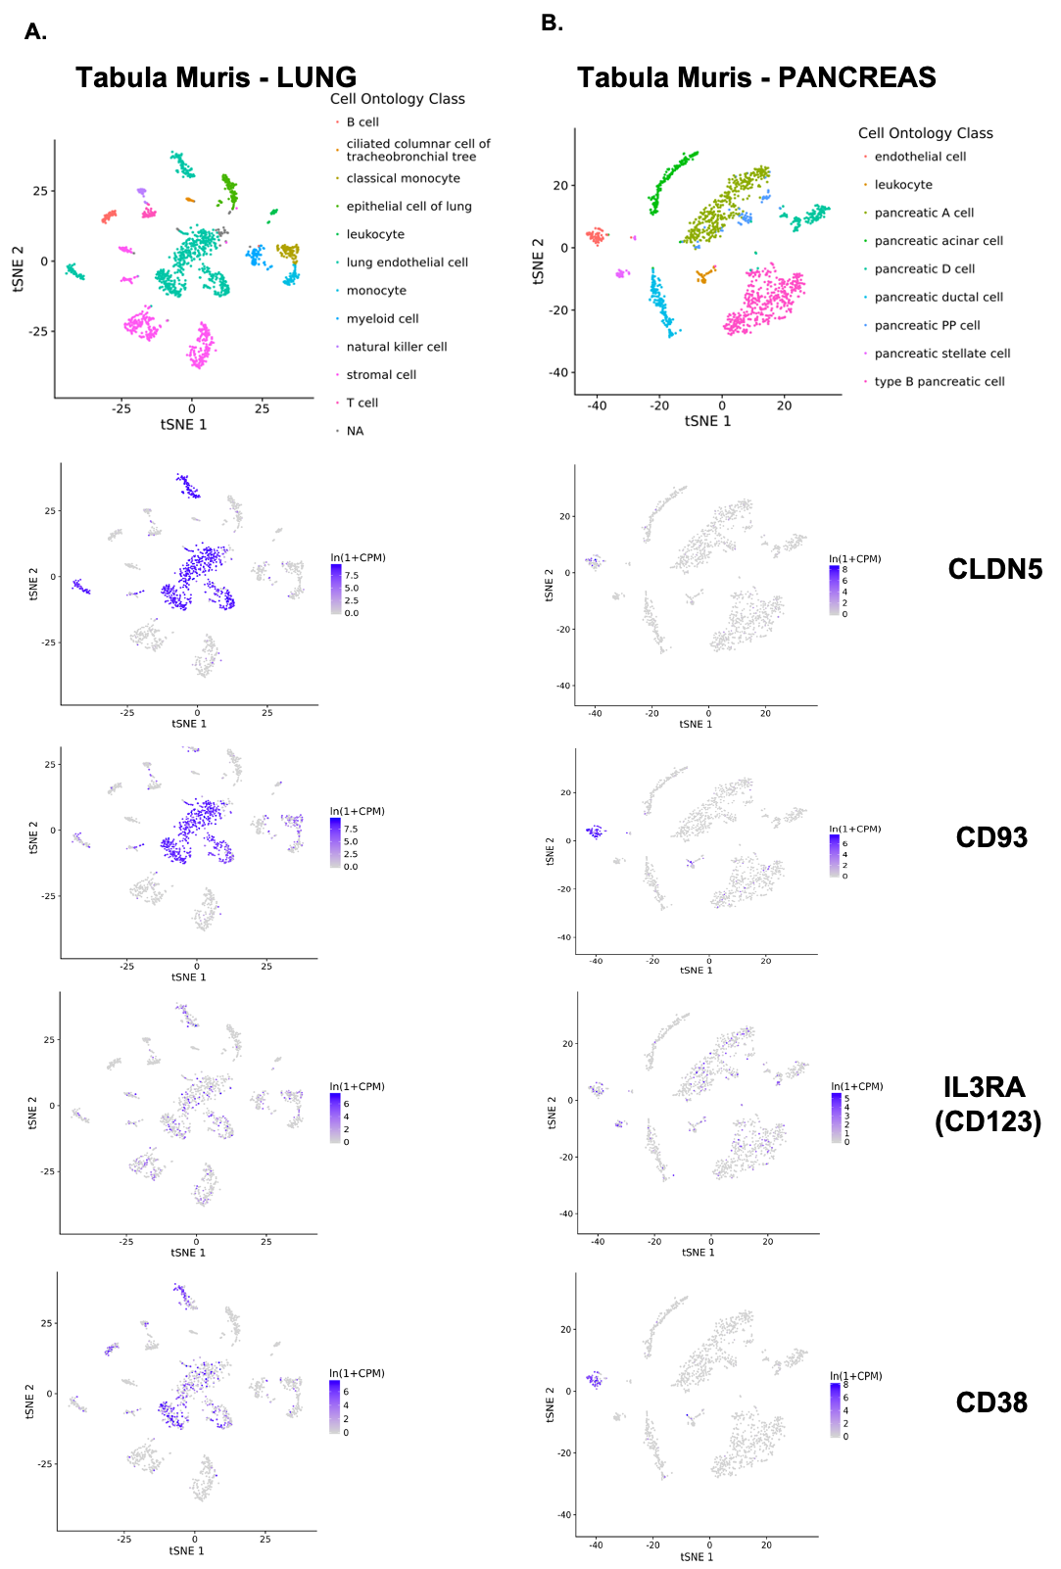
Supplemental Figure 10: CD93 and other AML targets are expressed in murine endothelial cells. UMAP projection of single cells from dissociation of (A) lung or (B) pancreas from the Tabula Muris database. Multi-colored plots highlight cell ontogeny based on gene expression profiles. The same clusters are then overlaid with expression profiles of endothelial cell marker CLDN5, or AML targets CD93, CD123, and CD38. Analyses were performed in murine lung and pancreas cells, similar to Figure 7 and Supplemental Figure 6.

Supplemental Figure 11

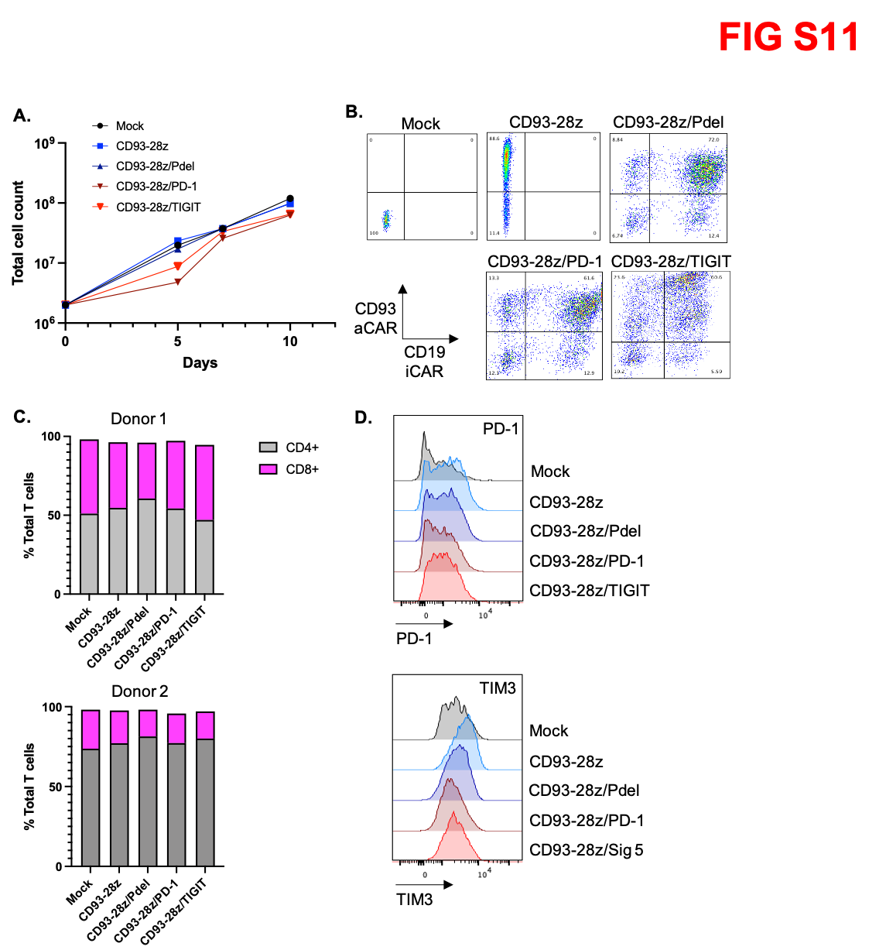

Supplemental figure 11: NOT-gated CAR T cell product characteristics. (A) Expansion of NOT-gated CARs in the first 10 days after CD3/28 activation as measured by total cell counts. (B) Flow cytometry dot lots demonstrating co-transduction efficiency of mock, CD93-28z alone, and CD93-28z/iCARs. CD93 CAR was detected with CD93-Fc and CD19 CAR was detected with anti-CD19 idiotype. (C) CD4/8 T cell ratios in NOT-gated CAR T cells. Results form T cell products derived from 2 separate donors are shown. (D) Expression of exhaustion markers PD-1 and TIM3 in NOT-gated CAR T cells compared to mock-transduced and CD93-28z CAR T cells as controls.

Supplemental Figure 12

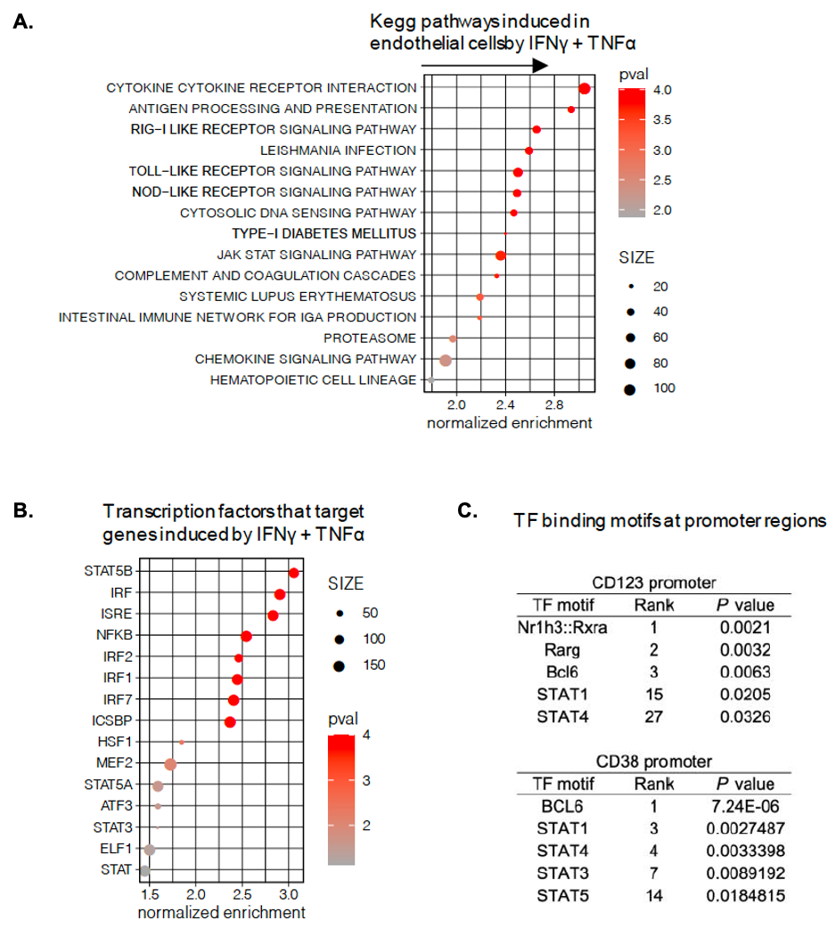

Supplemental Figure 12: Pathway analysis implicates JAK-STAT signaling in CD123 and CD38 upregulation in response to cytokines. (A) and (B) Gene Set Enrichment Analysis of the TIME and endothelial cell line transcriptome in response to inflammatory cytokines. Resting cells were compared to cells stimulated with IFNγ and TNFα. Positive enrichment scores indicate the gene set is enriched in the cytokine treated condition. Analysis was performed using the (A) KEGG subset of the Canonical Pathway Collection or (B) the Transcription Factor Targets Collection. The top 15 results are shown. (C) PSCAN analysis to identity overrepresented transcription factor binding motifs in the promoter regions of CD123 and CD38. Selected results are shown.

