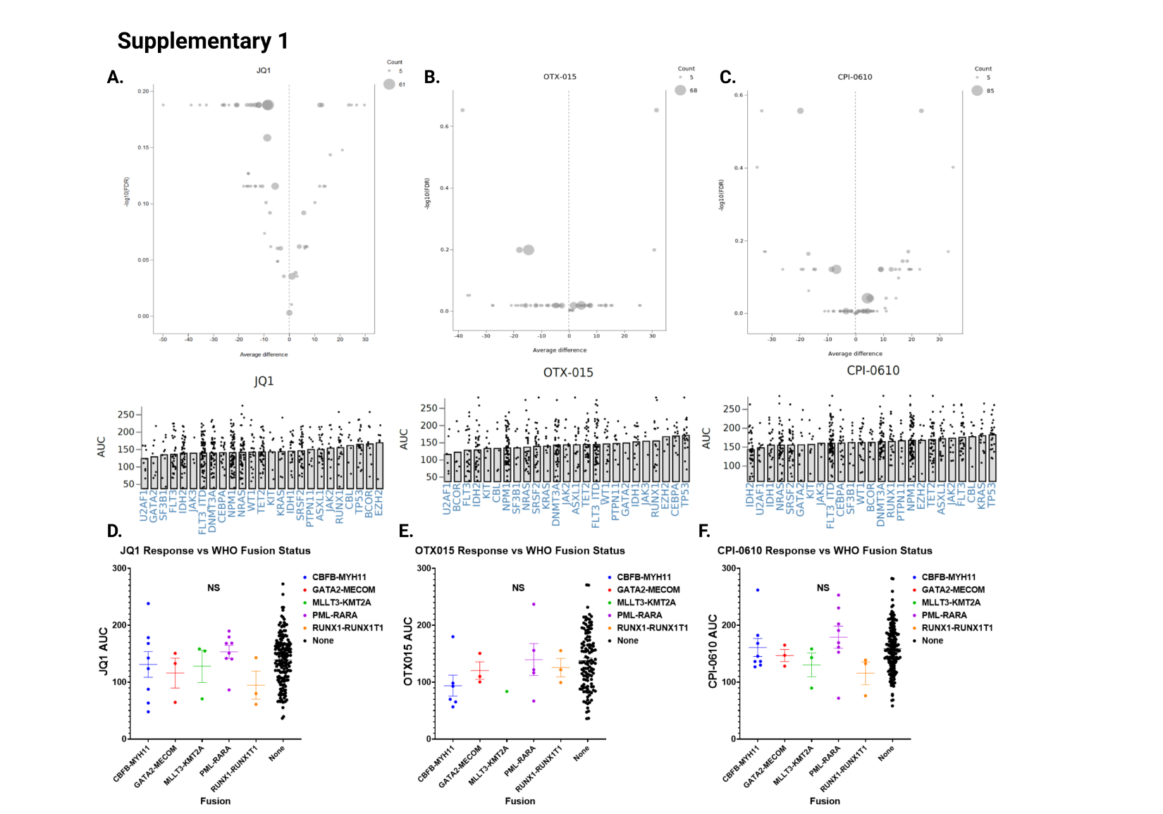Figure S1: Patient ex vivo BETi response vs recurrent genetic mutations
S1a-c.) Volcano plots correlating BETi (JQ1 left, OTX-015 middle, and CPI-0610 right) ex vivo sensitivity of 173 AML patient samples, as determined by MTS viability assay, with genetic mutations in the Beat AML database, as previously described and publically available at http://www.vizome.org/ (3) (no significance). Corresponding recurring genetic mutations vs individual AUCs are below the corresponding volcano plot (X-axis denotes a recurring genetic mutation, Y-axis the corresponding AUC, with each point representing a unique patient sample). In brief, recurring mutations (found in at least 5 patients) and inhibitor area-under-curves (AUC), as determined by MTS assay, were compared using a linear model and compared linear contrast (two-sided students T-test) of mutation/mutation sets to appropriate negatives (WT gene comparison). FDR was computed using the Benjamini-Hochberg method over all the drugs.
S1d-f.) Ex vivo MTS assay sensitivities in AML patient samples to JQ1, OTX-015, and CPI-0610 were stratified by WHO-FUSION status (common fusion protein alterations known to occur in AML) within the beat AML biorepository. Significance was determined by one-way ANOVA. No WHO-FUSIONS correlated with any BETi sensitivity or resistance.

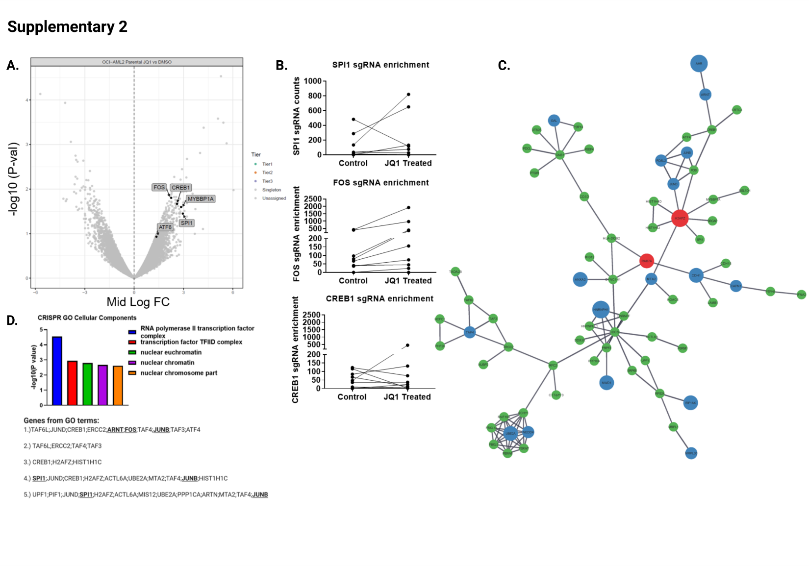
Figure S2: Whole-Genome CRISPR JQ1 Resistance Screens sgRNA Enrichments and full STRING Network
S2a.) Volcano plot comparing enrichment of sgRNAs relative to DMSO control in JQ1 treated OCI-AML2 cells versus -log10 transformed median p-value after 14 days with corresponding significance tiers. Enrichment and associates p-values calculated as described in the methods and for the CPI-0610 screen in Figure 2a. Y axis corresponds to –log₁₀ median p-value, X – axis corresponds to median log fold change (JQ1 treated/Control treated) sgRNA counts.
S2b.) Enrichment of cells containing the relative sgRNA KO targeting hematopoietic transcription factors SPI1 (Top), FOS (middle), and histone modifying machinery CREB1 (bottom) in JQ1 treated OCI-AML2. Each line represents the guide counts of the relevant unique sgRNA KOs in control or JQ1 treated cells.
S2c.) Full string network plot incorporating hits from both JQ1 and CPI-0610 resistance screens. Size of node denotes tier (largest = tier 1, smallest = unassigned), color denotes gene screen of origin.

S2d.) A GO Cellular Components Ontology, which identifies enriched ontological pathways from a gene list, was performed on the the combined JQ1 and CPI-0610 resistance screen hits and identifies RNA pol II transcription factor complex components as the most enriched ontological term.

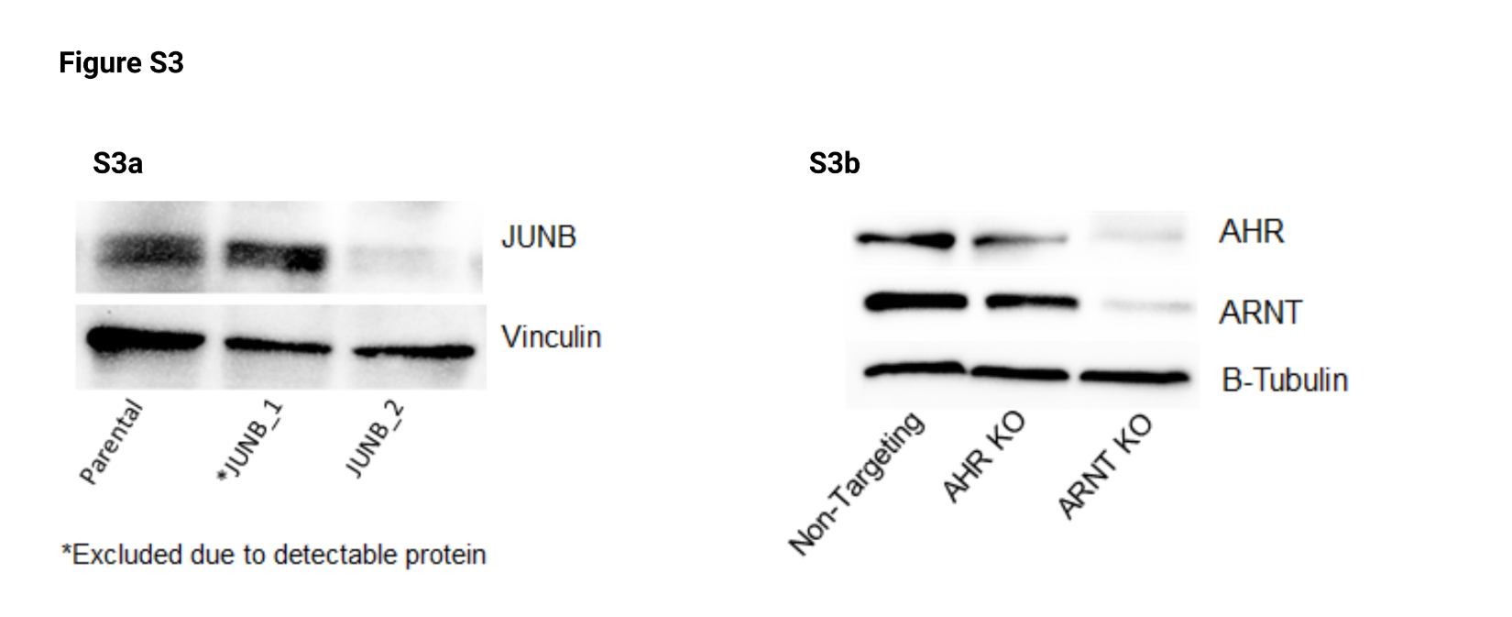
Figure S3: Western Blot Validation of JUNB, AHR, and ARNT KOs
S3a-b.) Whole-cell lysates of OCI-AML2 infected with lentiviral sgRNA constructs targeting a.) JUNB or b.) AHR and ARNT were analyzed by immunoblotting to assess expression of their target KO relative to a non-targeting control

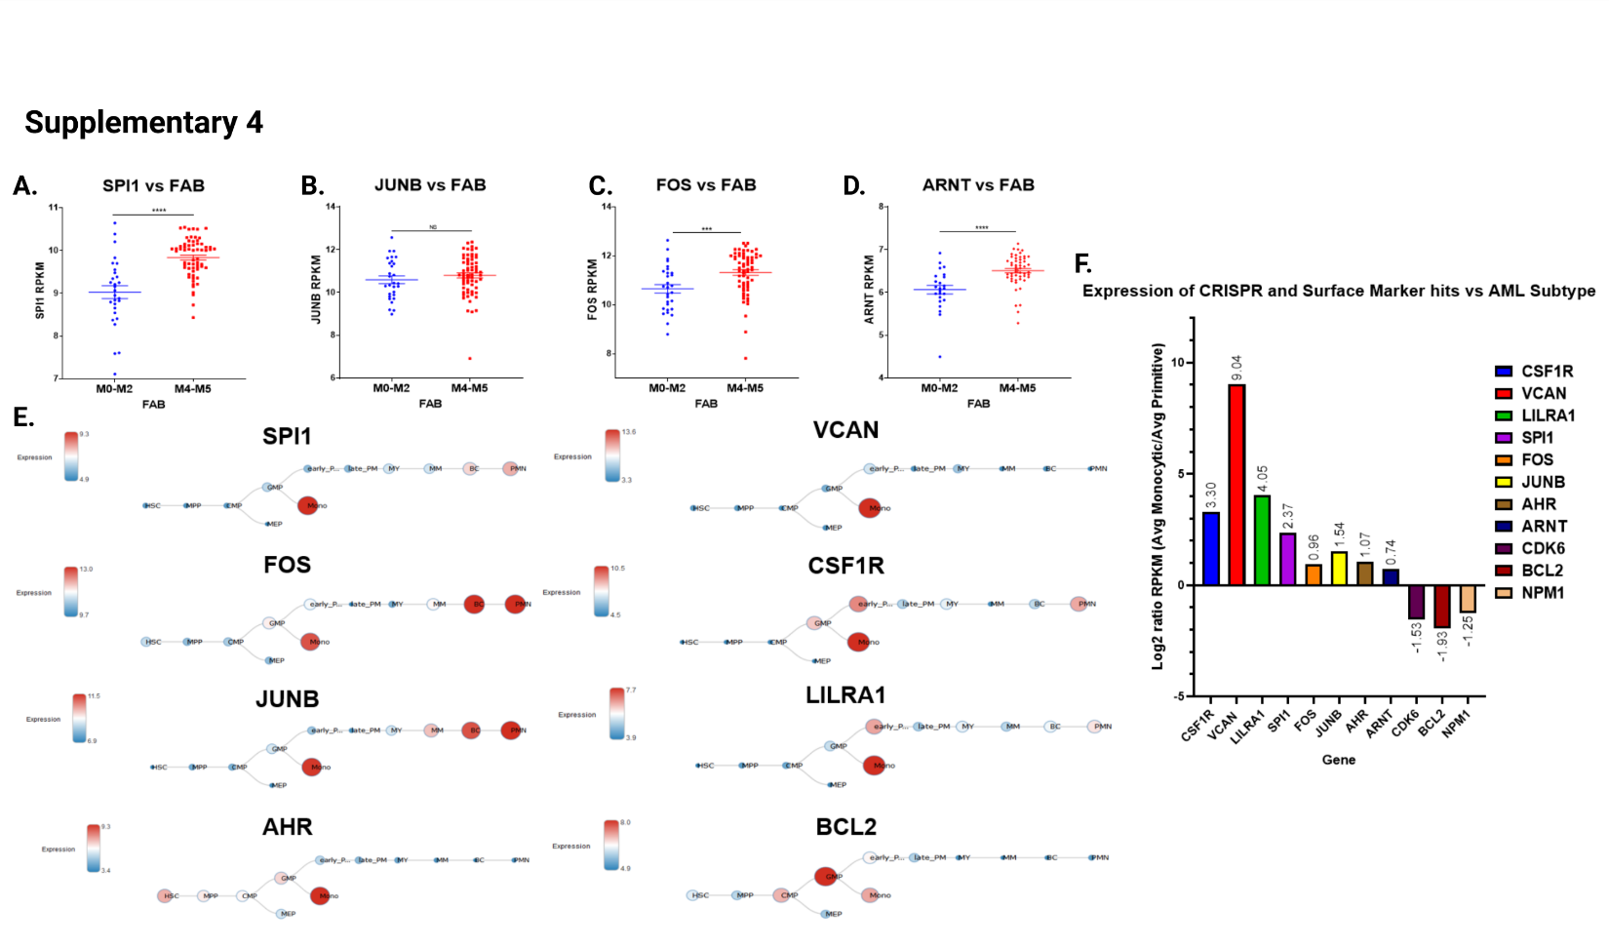
Figure S4: Beat AML, BloodSpot.eu, and Pei et al. expression data of identified CRISPR genes and surface markers vs. leukemia differentiation state
S4a-d.) Beat AML RNA expression data (3) comparing RNA expression of identified CRISPR hits (SPI1, JUNB, FOS, ARNT) vs FAB subtype (M0-M2 undifferentiated – 29 AML patients, M4-M5 monocytic – 34 AML patients) S4e.) Bloodspot.eu data comparing RNA expression of CRISPR hits and surface markers against differentiation state S4f.) RNA-seq data deposited by Pei et al. 2020 (29) comparing expression of CRISPR hits and surface markers against primitive and monocytic leukemia patient samples.

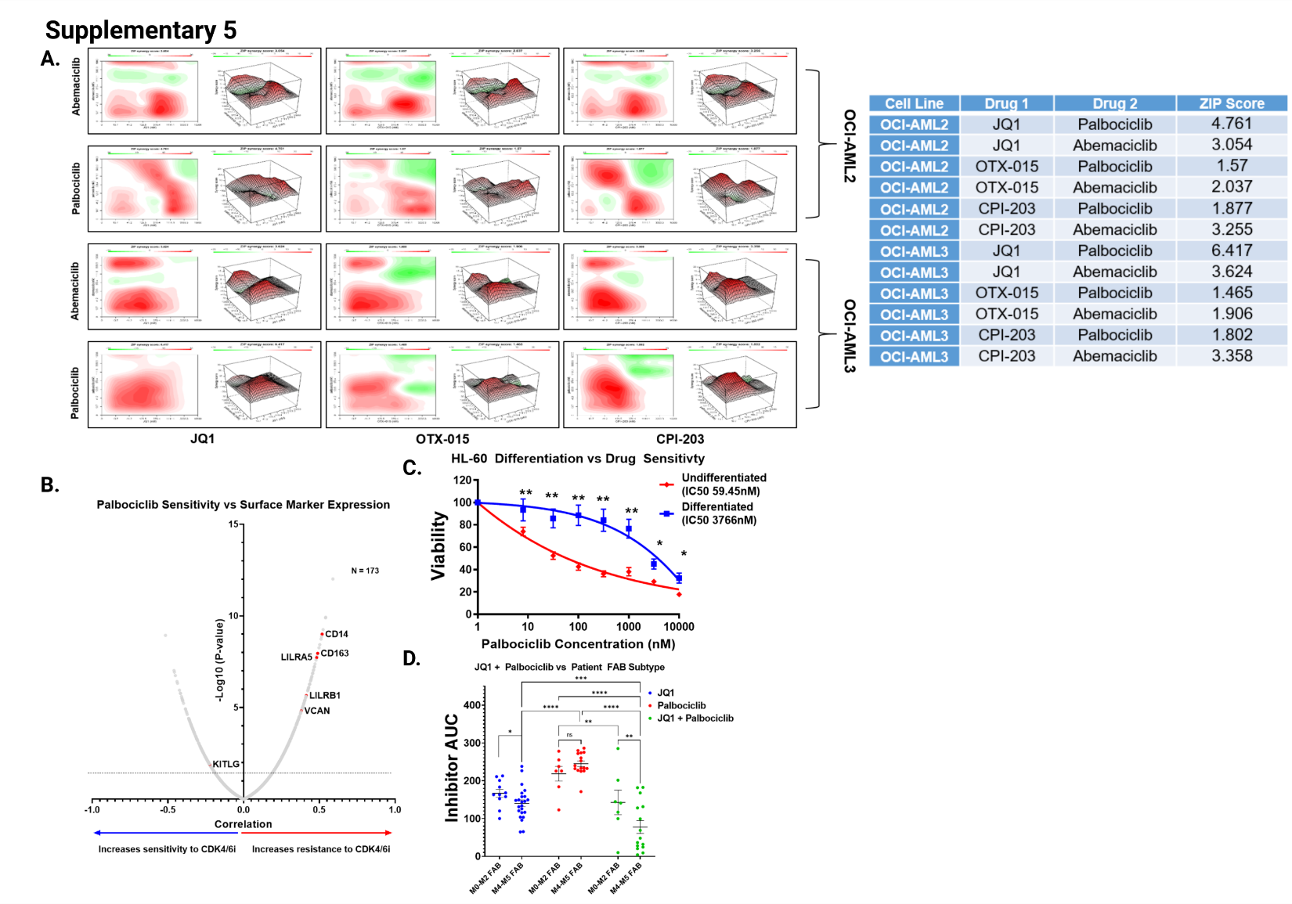
Figure S5: Synergistic combinations of BETi vs CDK4/6i and differentiation induced CDK4/6i resistance in HL-60s
S5a.) ZIP Synergy plots for drug combinations, tested over a 72 hour incubation, involving a BETi (JQ1, OTX-015, or CPI-203) and a CDK4/6i (palbociclib or abemaciclib) in OCI-AML2 and OCI-AML3 cells. Summary tables of all ZIP scores given to the right. The ZIP score average was computed across the dose matrix to provide an overall index of drug interaction. A positive average ZIP score indicates the combination was synergistic (red) whereas a negative average ZIP score indicates antagonism (green).
S5b.) Correlations derived from RNA expression of surface markers vs. ex vivo sensitivity to palbociclib collected in the Beat AML dataset as performed previously with BETi, figure 1a-b. Pearson correlation coefficients and associated p-values were derived from comparisons of inhibitor AUC to gene expression and corrected for multiple comparisons. Y-axis plots –log₁₀ p-val vs X-axis Pearson correlation between palbociclib and a given surface marker’s RNA expression.
S5c.) Drug dose response curve, as determined by MTS-assay, for CDK4/6i palbociclib in HL-60cells with vehicle or differentiated with ATRA for 72 hours prior to dosing with palbociclib. X-axis plots Palbociclib concentration (nM) vs Y-axis MTS-percent viability of HL-60 cells.
S5d.) ex vivo drug sensitivities in Beat AML patient samples, as determined by MTS assay, comparing responses to JQ1, Palbociclib, or JQ1 + Palbociclib combined and stratified by FAB subtype. Significance determined by two-way ANOVA as performed previously with venetoclax, figure 6d.

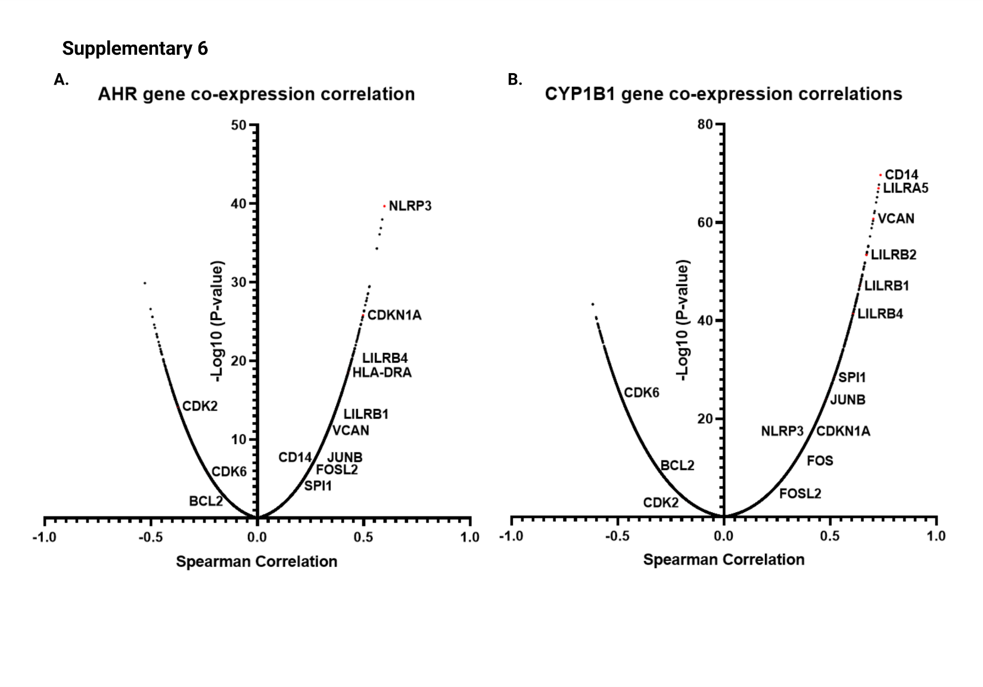
Figure S6: Beat AML patient sample co-expression data between AHR and AHR-target CYP1B1
S6a,b.) Volcano plot showing spearman correlations of genes co-expressed with AHR (left) and CYP1B1 (right) in AML patient samples within the Beat AML biorepository. Spearman correlations and corresponding p-values derived from cBioPortal analyses of the Beat AML biorepository (https://www.cbioportal.org/).

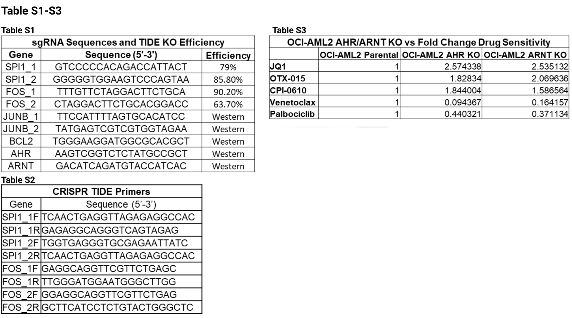
Table S1-S3: TIDE Analysis, sgRNA design, and evaluation of AHR/ARNT KO drug responses
Table S1: sgRNA sequences used to generate single sgRNA mediated KOs for target genes and corresponding TIDE efficiencies. sgRNA sequences designed using synthego sgRNA design tool (https://design.synthego.com/#/) and corresponding TIDE KO Efficiency as determined by TIDE tool (https://tide.nki.nl/).
Table S2: DNA primers used to amplify regions of DNA in OCI-AML2 cells to assess TIDE KO efficiency
Table S3: OCI-AML2 Parental cells, AHR KO, and ARNT KO cells were assessed for response to JQ1, OTX-015, CPI-0610, Venetoclax, and palbociclib by MTS assay. Here we represent the fold change in IC50 for corresponding inhibitor compared to parental cells.

