Supplementary Data

Supplementary Table S1. Demographic characteristics, molecular subtype, MRD levels, treatment risk group and outcome of Total 16 patients
Provided as an excel tab in “Supplementary Tables.xlsx”

Supplementary Table S2. Treatment outcome based on leukemia cell subtype and minimal residual disease in blood at day 8 of induction
Provided as an excel tab in “Supplementary Tables.xlsx”

Supplementary Table S3. Clinical outcome according to treatment risk-group and leukemia subtypes
Provided as an excel tab in “Supplementary Tables.xlsx”

Supplementary Table S4. Treatment risk groups, sequential MRD levels, and clinical outcome of molecular subgroups of T-ALL
Provided as an excel tab in “Supplementary Tables.xlsx”

Supplementary Table S5. Molecular subgroups for T-ALL and ETP subtypes
Provided as an excel tab in “Supplementary Tables.xlsx”

Supplementary Table S6. Matrix of normalized and regularized log transformed (rlog) gene expression values from RNA-seq
Provided as an excel tab in “Supplementary TableS6.xlsx”

Supplementary Table S7. Remission induction, consolidation, and continuation/reinduction therapy

Supplementary Figure S1. CONSORT Flow Diagram

Supplementary Figure S2. Molecular classification schema and criteria for B-ALL subtyping

Supplementary Figure S3. Molecular classification schema for T-ALL

Supplementary Figure S4. Identification of molecular subgroups in Total 16 cohort

Supplementary Figure S5. Estimated frequencies of specific subtypes of childhood acute lymphoblastic leukemia

Supplementary Figure S6. Overall-survival for common leukemia subtypes

Supplementary Table S7. Remission induction, consolidation, and continuation/reinduction Therapy

Remission induction therapy
Participants | Agents | Dosages and routes | No. Doses | Schedules
All participants
 | Prednisone | *40 mg/m2 per day PO (t.i.d.) | 84 | Days 1-28
 | Vincristine | 1.5 mg/m2 IV (max 2 mg) | 4 | Days 1, 8, 15, 22€
 | Daunorubicin | 25 mg/m2 IV | 2 | Days 1 and 8
 | PEG-asparaginase | 3,000 units/m2 IV | 1 | Day 3, (15) †
 | Triple intrathecal | Age-dependent | 2-6 | ** Days 1, (4), (8), (11), 15, (22)
Day 15 MRD < 5% (excluding infants with KMT2A)
 | Cyclophosphamide | 1000 mg/m2 IV | 1 | Day 22
 | Cytarabine | 75 mg/m2 IV | 8 | Days 23-26, 30-33
 | Thioguanine (Mercaptopurine for thiopurine methyltransferase intermediate or poor metabolizers) | 60 mg/m2 per dose PO | 14 | Days 22-35
Day 15 MRD > 5% (excluding infants with KMT2A)
 | Cyclophosphamide | 300 mg/m2 IV | 4 | q12 hours, Days 22-23
 | Cytarabine | 75 mg/m2/dose IV | 8 | Days 23-26, 30-33
 | Thioguanine (Mercaptopurine for thiopurine methyltransferase intermediate or poor metabolizers) | 60 mg/m2/dose PO | 14 | Days 22-35
Infants with KMT2A
 | Clofarabine | 40 mg/m2/dose IV | 5 | Days 22-26
 | Etoposide | 100 mg/m2/dose IV | 5 | Days 22-26
 | Cyclophosphamide | 300 mg/m2/dose IV | 5 | Days 22-26

*Prednisone was substituted by dexamethasone (10 mg/m2 per day on days 1-21, 4 mg/m2 per day on days 22-24, and 2 mg/m2 per day on days 25-28) in patients with early T-cell precursor ALL. † Extra dose of PEG-asparaginase was given to patients with MRD≥1% on day 15.
**Triple intrathecal treatment (methotrexate 6, 8, 10 or 20 mg; hydrocortisone 12, 16, 20 or 24 mg, and cytarabine 18, 24, 30 or 36 mg for ages <1, 1 to 1.99, 2 to 2.99 and ≥3 years, respectively); extra triple intrathecal treatment on days 8 and 22 for patients with BCR-ABL1, KMT2A rearrangement, hypodiploidy (< 44 chromosomes), or WBC >100 x10³/µL at presentation; extra triple intrathecal treatment on days 4, 8, 11, and 22 for patients with T-cell ALL, TCF3-PBX1, CNS-2 status, CNS-3 status or traumatic lumbar puncture with blasts. Leucovorin rescue (5 mg/m2/dose, max 5 mg) PO was given at 24 and 30 hours after each triple intrathecal treatment during remission induction. In patients presenting with renal function impairment, serum methotrexate level was measured 24 hours after intrathecal therapy and those with delayed methotrexate clearance were rescued with leucovorin until level was no longer measurable. €Day 22 vincristine omitted for infants with KMT2A rearrangement.
Except for vincristine, all dosages given to infants (< 1 year) were based on body surface area. For infants < 1 month of age, or < 3 months and born prematurely, a 50% reduction in dosages of daunomycin, asparaginase, etoposide, methotrexate, thiopurines, cyclophosphamide, clofarabine, and cytarabine were made. The vincristine dosage for patients < 12 months of age or < 10 kg weight was 0.05 mg/kg/dose.

Consolidation therapy

Agent | Dosage and Route | # Doses | Schedule
High Dose Methotrexate* | 2.5 g/m2 (or targeted 33µM, low risk), 5.0 g/m2 (or targeted 65 μM, standard-/high-risk) | 4 | Days 1, 15, 29 and 43
Mercaptopurine | 50 mg/m2/day | 56 | Days 1 to 56
Triple intrathecal | Age-dependent | 4 | Days 1, 15, 29, and 43
*Patients with Down Syndrome received 500 mg/m2 irrespective of risk group. Dasatinib was held 24 hours before the administration and resumed when methotrexate level was below the threshold for stopping leucovorin rescue. Methotrexate dosage was adjusted according to pharmacokinetic data to achieve a steady-state concentration of 65 μM in standard-risk or high-risk patients and to 33µM in some low-risk patients. Leucovorin, 15 mg/m2 (IV or PO) for standard-risk or high-risk patients and 10 mg/m2 (PO or IV) for low-risk cases, was initiated at 42 hours after the start of methotrexate infusion and repeated every 6 hours for a total of three doses, with adjustments based on plasma methotrexate levels.

Continuation/reinduction therapy
Week | Low-risk Patients | Standard- or high-risk Patients
1 | Mercaptopurine + Dexamethasone + vincristine | PEG-asparaginase + Mercaptopurine + Dexamethasone + Vincristine+ doxorubicin
2 | Mercaptopurine + Methotrexate | Mercaptopurine
3* | Mercaptopurine + Methotrexate | PEG-asparaginase + Mercaptopurine
4 | Mercaptopurine + Dexamethasone + Vincristine | Mercaptopurine + Dexamethasone + Vincristine + Doxorubicin
5 | Mercaptopurine + Methotrexate | PEG-asparaginase + Mercaptopurine
6 | Mercaptopurine + Methotrexate | Mercaptopurine
7* | Reinduction I  PEG-asparaginase + Dexamethasone + Vincristine + Doxorubicin | ¥ Reinduction I  PEG-asparaginase + Dexamethasone + Vincristine + Doxorubicin (excluding KMT2A+ infants)
8 | Reinduction I Vincristine | Reinduction I  Vincristine + Doxorubicin
9 | Reinduction I  PEG-asparaginase + Dexamethasone + Vincristine | Reinduction I  PEG-asparaginase + Dexamethasone + Vincristine (excluding KMT2A+ infants) ¥
10 | Mercaptopurine + Methotrexate | Mercaptopurine
11 | Mercaptopurine + Methotrexate | PEG-asparaginase + Mercaptopurine + Vincristine + Doxorubicin
12* | Mercaptopurine + Methotrexate | Mercaptopurine
13 | Mercaptopurine + Methotrexate | PEG-asparaginase + Mercaptopurine
14 | Mercaptopurine + Dexamethasone + Vincristine | Mercaptopurine + Dexamethasone + Vincristine  + Doxorubicin
15 | Mercaptopurine + Methotrexate | PEG-asparaginase + Mercaptopurine
16 | Mercaptopurine + Methotrexate | Mercaptopurine
17* | Reinduction II  PEG-asparaginase + Dexamethasone + Vincristine | Reinduction II  PEG-asparaginase + Dexamethasone + Vincristine
18 | Reinduction II Vincristine | Reinduction II Vincristine
19 | Reinduction II  PEG-asparaginase + Dexamethasone + Vincristine | Reinduction II  PEG-asparaginase + Dexamethasone +Vincristine + High-dose cytarabine
20 | Mercaptopurine + Methotrexate | ---
21 | Mercaptopurine + Methotrexate | PEG-asparaginase + Mercaptopurine
22 | Mercaptopurine + Methotrexate | Mercaptopurine
23 | Mercaptopurine + Methotrexate | PEG-asparaginase + Mercaptopurine
24 | Mercaptopurine + Methotrexate | Cyclophosphamide + Cytarabine
25* | Mercaptopurine + Dexamethasone + Vincristine | PEG-asparaginase + Dexamethasone + Vincristine
26 | Mercaptopurine + Methotrexate | Mercaptopurine
27 | Mercaptopurine + Methotrexate | PEG-asparaginase + mercaptopurine
28 | Mercaptopurine + Methotrexate | Cyclophosphamide + Cytarabine
29* | Mercaptopurine + Dexamethasone + Vincristine | PEG-asparaginase + Vincristine + Dexamethasone
30 | Mercaptopurine + Methotrexate | Mercaptopurine + Methotrexate
31 | Mercaptopurine + Methotrexate | Mercaptopurine + Methotrexate
32 | Mercaptopurine + Methotrexate | Cyclophosphamide + Cytarabine
33* | Mercaptopurine + Dexamethasone + Vincristine | Dexamethasone + Vincristine

*For low-risk ALL, triple intrathecal chemotherapy was given to patients with CNS-1 status and WBC <100 x10³/µL on weeks 7, 12, 17, 25, 33, 41, and 49, and to those with CNS-2 status, traumatic lumbar puncture with blasts status, or WBC >100 x 10 9/L at presentation on weeks 3, 7, 12, 17, 25, 29, 33, 37, 41, 45 and 49. For standard-risk or high-risk ALL, triple intrathecal treatment was given on weeks 7, 12, 17, 25, 29, 33, 37, 41, 45 and 49 and to those with additional WBC >100 x10³/µL at presentation, T-cell immunophenotype, TCF3-PBX1, BCR-ABL1, KMT2A rearrangement, hypodiploidy, CNS-2 status, CNS-3 status, or traumatic lumbar puncture with blasts on weeks 3, 7, 12, 17, 25, 29, 33, 37, 41, 45, 49, 57, 65, 73, 81, 89 and 97. Leucovorin was not given routinely after consolidation therapy
¥ For infants with KMT2A rearrangement, vincristine and doxorubicin were substituted with clofarabine, etoposide and cyclophosphamide (same doses as given during initial remission induction); dexamethasone and PEG-asparaginase dose schedule was not altered.
Mercaptopurine - 75 mg/m2 PO daily for 7 days for low-risk group; 50 mg/m2 PO daily for 7 days between weeks 1 and 19 and 75 mg/m2 after week 19 for standard- and high-risk groups. The starting dose for patients with heterozygous deficiency (intermediate metabolizers) of thiopurine methyltransferase was 60 mg/m2 instead of 75 mg/m2. The starting dose for poor metabolizers of thiopurine methyltransferase was 10 mg/m2 thrice weekly instead of 75 mg/m2/day.
Dexamethasone - 8 mg/m2 PO per day in 3 divided doses for 5 days for low-risk group and 12 mg/m2 PO per day in 3 divided doses for standard-risk and high-risk groups until week 69; 8 mg/m2 on days 1 to 8 and days 15 to 21 during reinduction I (weeks 7 to 9) and reinduction II (weeks 17-19) for both groups; dose was reduced to 6 mg/m2 PO per day in 3 divided doses for 5 days for both groups on weeks 69-101.
Methotrexate – 40 mg/m2 IV; Doxorubicin - 30 mg/m2 IV; Vincristine - 2 mg/m2 IV and 1.5 mg/m2 IV during reinductions I and II (maximum 2 mg; 0.05 mg/kg for patients <1 year of age or <10 kg in body weight); Cyclophosphamide: 300 mg/m2 IV; Cytarabine: 300 mg/m2 IV
PEG-asparaginase 2,500 units/m2 or 3,500 units/m2 IV based on randomization
High-dose Cytarabine: 2 gm/m2 IV q 12 hr x 4 doses on days 15 and 16 of Reinduction II in standard-risk and high-risk groups
After week 30, low-risk patients received daily mercaptopurine and weekly methotrexate which were interrupted by pulses of dexamethasone, vincristine and mercaptopurine every 4 weeks up to week 101, after which only mercaptopurine and methotrexate were given until week 120; while standard-risk and high-risk (not-transplanted) patients received three drug pairs given in 4-week blocks: mercaptopurine plus methotrexate in the first and second weeks, cyclophosphamide plus cytarabine in the third week (replaced by mercaptopurine plus methotrexate after week 68), and dexamethasone plus vincristine in the fourth week (replaced by mercaptopurine plus methotrexate after week 101).

Supplementary Figure S1. CONSORT Flow Diagram

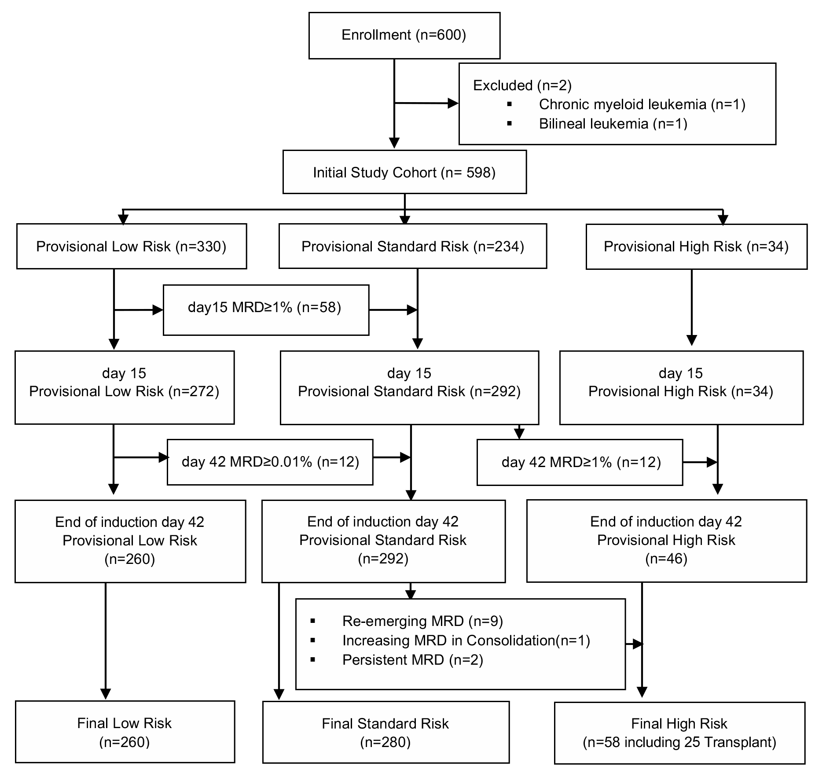

Enrollment, provisional risk assignment (based on presenting age, leukocyte count, cytogenetic and immunophenotype), and final risk assignment (based on sequential minimal residual disease measurement). MRD, minimal residual disease.

Supplementary Figure S2. Molecular classification schema and criteria for B-ALL subtyping

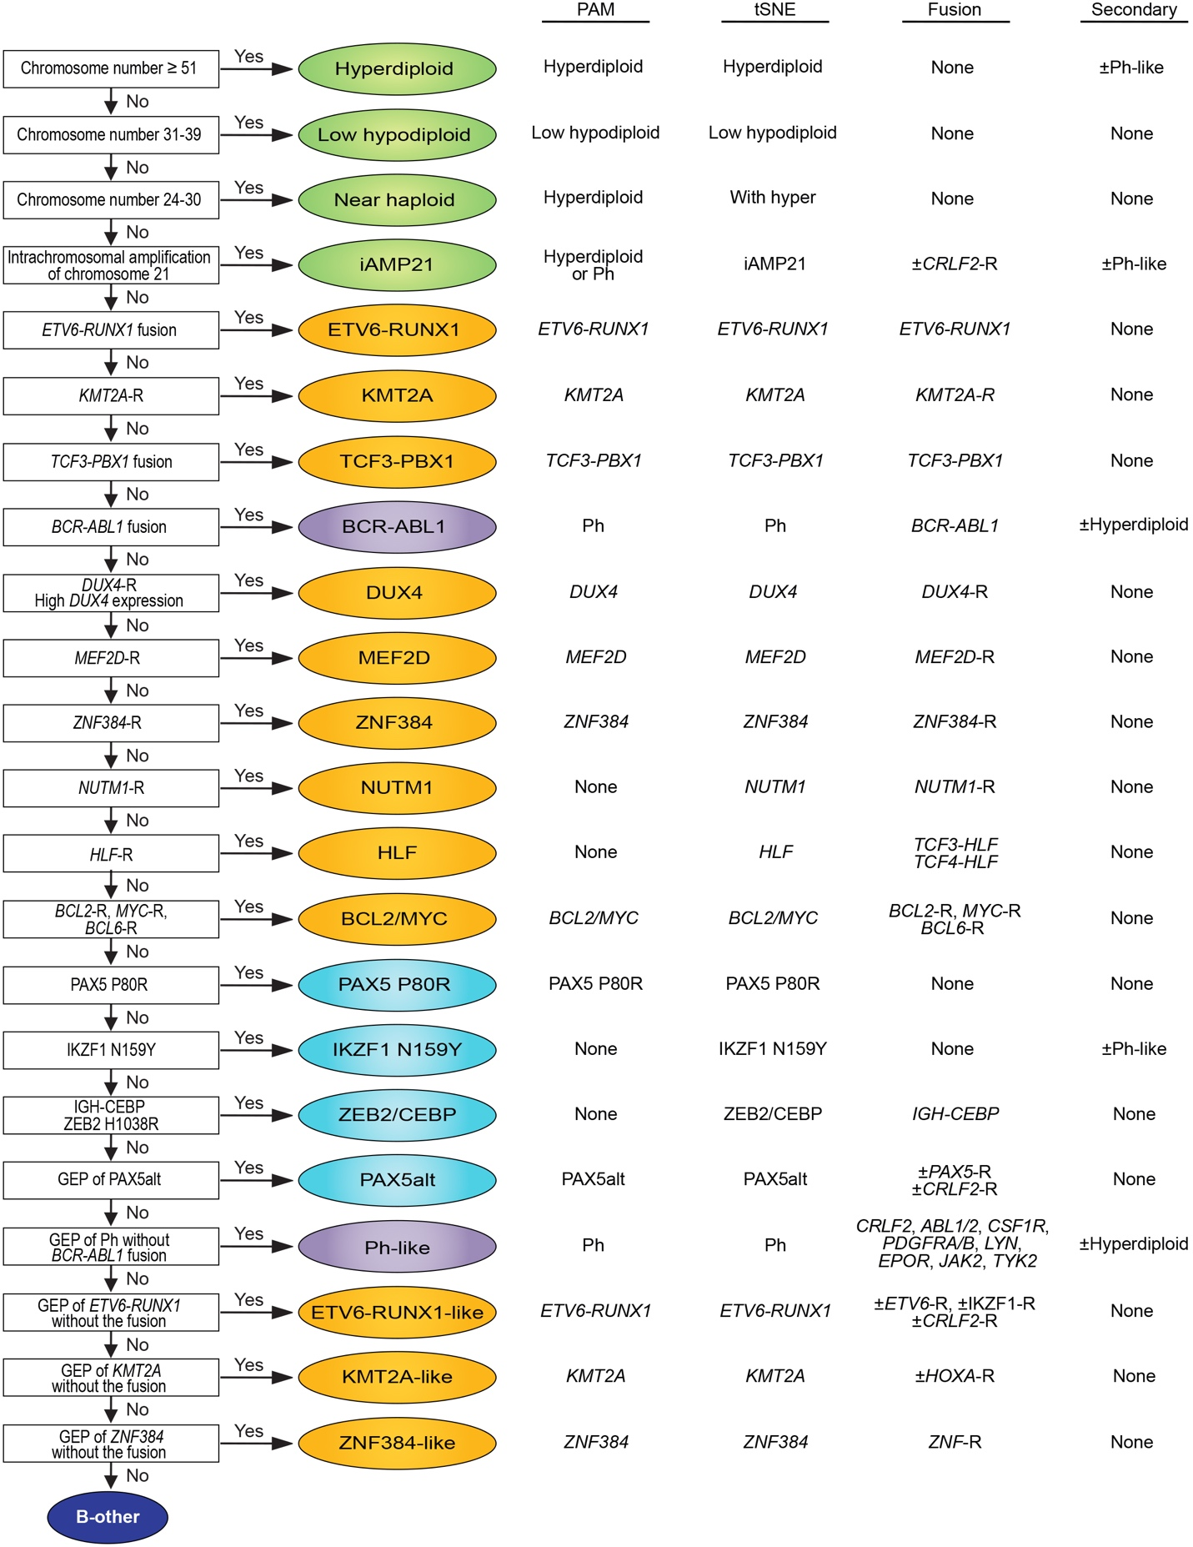
Hyperdiploidy with greater than 50 chromosomes, Chromosome number determined by cytogenetics or whole transcriptome sequencing (RNA-seq) analysis of copy number alteration (CNA). Hyperdiploid gene expression signature by Prediction Analysis of Microarrays (PAM) and distinct tSNE cluster. For cases that have greater than 50 chromosomes and cluster with hyperdiploid by tSNE, but have a Ph-positive gene expression signature by PAM with no kinase fusion, we designate hyperdiploid as the primary and Ph-like as the secondary subgroup. Duplication of a hypodiploid genome must be excluded (e.g. by inspection of the gained chromosomes, patterns of copy-neutral loss of heterozygosity) as near haploid and masked near haploid cases exhibit a similar gene expression profile to high hyperdiploid ALL.
Low hypodiploid, Chromosome number determined by cytogenetics or RNA-seq CNV. Low hypodiploid gene expression signature by PAM and distinct tSNE cluster. Includes cases with masked low hypodiploidy, with doubling of the hypodiploid genome.
Near haploid, Chromosome number determined by cytogenetics or RNA-seq CNV. Gene expression profile (GEP) by PAM similar to hyperdiploid, and cases cluster with hyperdiploid on tSNE. Important to distinguish between near haploid and hyperdiploid by gross chromosomal number. Includes cases with masked low hypodiploidy, with doubling of the hypodiploid genome.
iAMP21, Defined as presence of intrachromosomal amplification of chromosome 21 detected by DNA CNA. A subset of cases have the Ph-like gene expression signature by PAM, which is designated as a secondary subtype. Also associated with CRLF2 rearrangements, most commonly P2RY8-CRLF2, which are typically secondary or subclonal to the iAMP21 alteration.
ETV6-RUNX1, Presence of ETV6-RUNX1 fusion by FISH or RNA-seq. Distinct gene expression profile (PAM) and tSNE cluster.
KMT2A-R, Presence of KMT2A-rearrangement by FISH or RNA-seq. Many partner genes identified. Distinct gene expression profile (PAM) and tSNE cluster.
TCF3-PBX1, Presence of TCF3-PBX1 fusion by FISH or RNA-seq. Distinct gene expression profile (PAM) and tSNE cluster.
BCR-ABL1, Presence of BCR-ABL1 fusion by FISH or RNA-seq. Distinct gene expression profile (PAM) and tSNE cluster. Subset of BCR-ABL1 cases are hyperdiploid, which is designated as a secondary subtype.
DUX4-R, Presence of DUX4 rearrangement (most commonly IGH-DUX4) or high DUX4 expression by RNA-seq. Distinct gene expression profile (PAM) and tSNE cluster.
MEF2D-R, Presence of MEF2D-rearrangement by RNA-seq. Many partner genes identified. Distinct gene expression profile (PAM) and tSNE cluster.
ZNF384-R, Presence of ZNF384-rearrangement by RNA-seq. Many partner genes identified. Distinct gene expression profile (PAM) and tSNE cluster.
NUTM1-R, Presence of NUTM1-rearrangement by RNA-seq. Many partner genes identified. Distinct tSNE cluster.
HLF-R, Presence of HLF-rearrangement by RNA-seq, most commonly TCF3-HLF and TCF4-HLF. Distinct tSNE cluster.
BCL2/MYC, Presence of BCL2, MYC or BCL6-rearrangement by RNA-seq. Commonly associated with multiple rearrangements per patient (double-hit). Distinct gene expression profile (PAM) and tSNE cluster.
PAX5 P80R, Presence of PAX5 P80R mutation (usually hemizygous due to deletion of wild type PAX5, or compound heterozygous with loss of function PAX5 mutations) by RNA-seq or DNA-seq. Distinct gene expression profile (PAM) and tSNE cluster. Rarely, cases with heterozygous PAX5 P80R mutations, with retention of a wild type PAX5 allele, are observed outside of this cluster.
IKZF1 N159Y, Presence of IKZF1 N159Y mutation by RNA-seq or DNA-seq. Distinct tSNE cluster. A subset of IKZF1 N159Y cases also have Ph-like gene expression signature (by PAM), which is designated as secondary subtype.
ZEB2/CEBP, Presence of ZEB2 H1038R mutation and/or IGH-CEBPE or IGH-CEBPA rearrangement by RNA-seq. Distinct tSNE cluster.
PAX5alt (PAX5 altered), Defined by gene expression profile of PAX5alt by PAM (coefficient ≥0.75) and/or grouping with PAX5alt tSNE cluster. Associated with diverse PAX5 alterations (rearrangements, sequence mutation and focal/intragenic amplifications). The commonest PAX5 alterations are PAX5-ETV6 and PAX5-NOL4L. A small subset of PAX5alt cases also harbor CRLF2 rearrangements, most commonly P2RY8-CRLF2.
Ph-like, Defined by gene expression profile of Ph by PAM (coefficient ≥0.75) and/or grouping with Ph tSNE cluster, but lacking BCR-ABL1 fusion. Commonly associated with tyrosine kinase and cytokine receptor rearrangements. For cases that have greater than 50 chromosomes but have a Ph-positive gene expression signature by PAM, cluster with Ph by tSNE and harbor a kinase fusion, we designate Ph-like as the primary and hyperdiploid as the secondary subgroup.
ETV6-RUNX1-like, Defined by gene expression profile of ETV6-RUNX1 by PAM (coefficient ≥0.95) and grouping with ETV6-RUNX1 tSNE cluster, but lacking ETV6-RUNX1 fusion. Commonly associated with other ETV6 rearrangements, also IKZF1-R and CRLF2-R (commonly P2RY8-CRLF2).
KMT2A-like, Defined by gene expression profile of KMT2A by PAM (coefficient ≥0.95) and grouping with KMT2A tSNE cluster, but lacking KMT2A rearrangement. Commonly associated with HOXA gene rearrangements.
ZNF384-like, Defined by gene expression profile of ZNF384 by PAM (coefficient ≥0.95) and grouping with ZNF384 tSNE cluster, but lacking ZNF384 rearrangement. Commonly associated with other ZNF gene rearrangements.

Supplementary Figure S3. Molecular classification schema for T-ALL

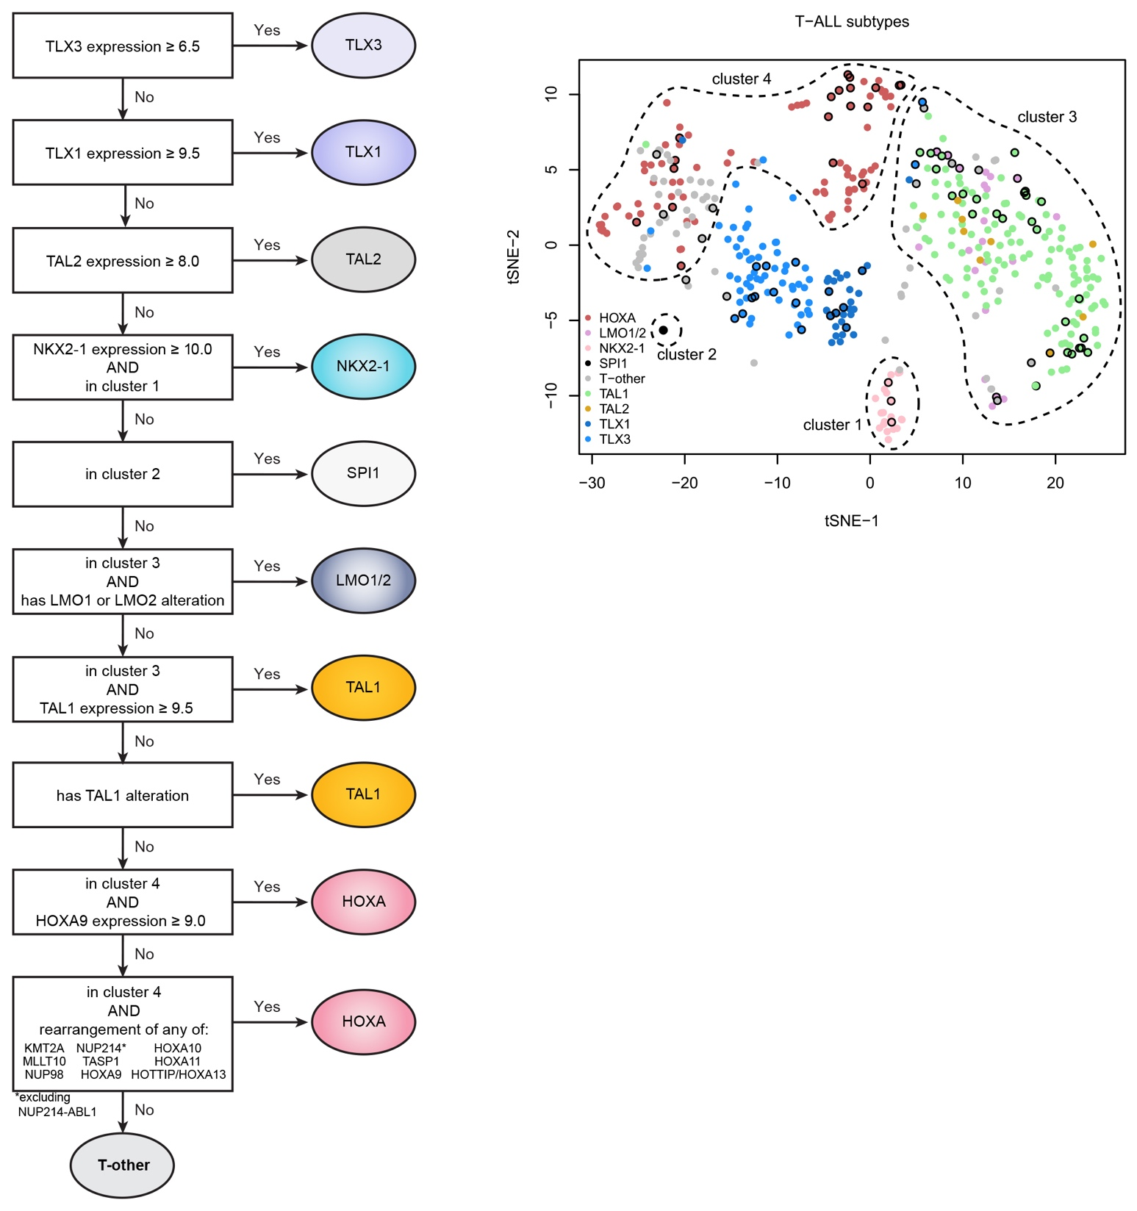

Gene expression profiling of 451 T-ALL cases shown in a two-dimensional tSNE plot. The 96 Total 16 T-ALL cases are indicated by black circles. Additional cases were included in the visualization for refined definition of the clusters. The classification of T-ALL subtypes was based on gene expression levels and gene alterations as outlined in the flow chart, and inclusion in clusters 1-4 as drawn on the tSNE plot.

Supplementary Figure S4. Identification of molecular subgroups in Total 16 cohort

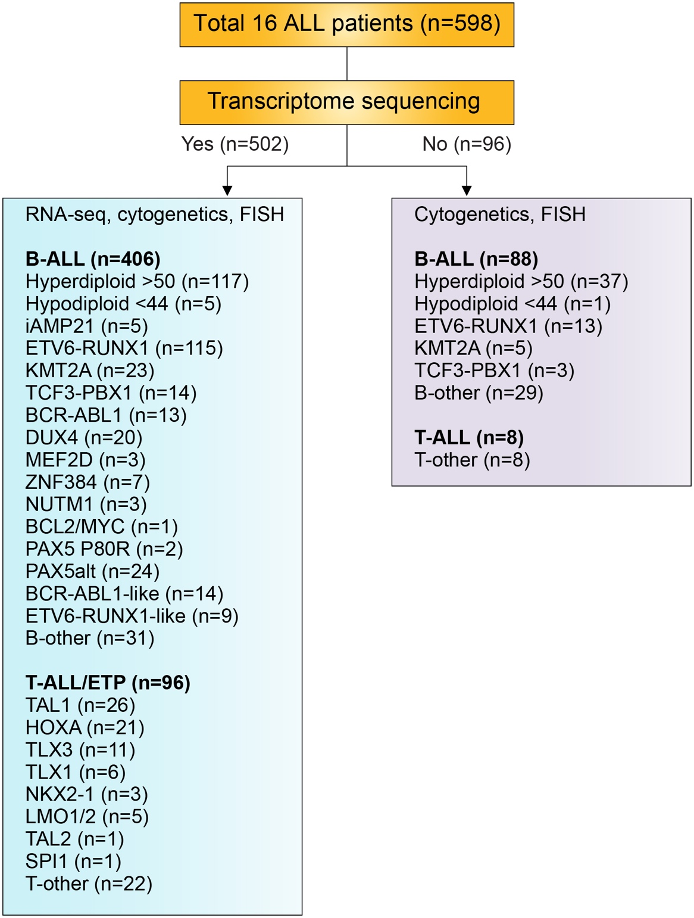

In the Total 16 cohort, 502 cases had transcriptome sequencing (RNA-seq) data available in addition to cytogenetic data and FISH for ETV6-RUNX1, TCF3-PBX1, BCR-ABL1 and KMT2A-rearrangement. Molecular classification for B-ALL and T-ALL was based on the schemas presented in Supplementary Figures S2 and S3, the subgroups identified in this cohort are listed below (left column). The RNA-seq results correlated with the clinically available cytogenetic and FISH data. We identified one BCL2/MYC case that was excluded from downstream analyses due to small numbers. For the 96 cases that only had cytogenetic and FISH data, clinical subgroups were determined as listed (right column).

Supplementary Figure S5. Estimated frequencies of specific subtypes of childhood acute lymphoblastic leukemia.

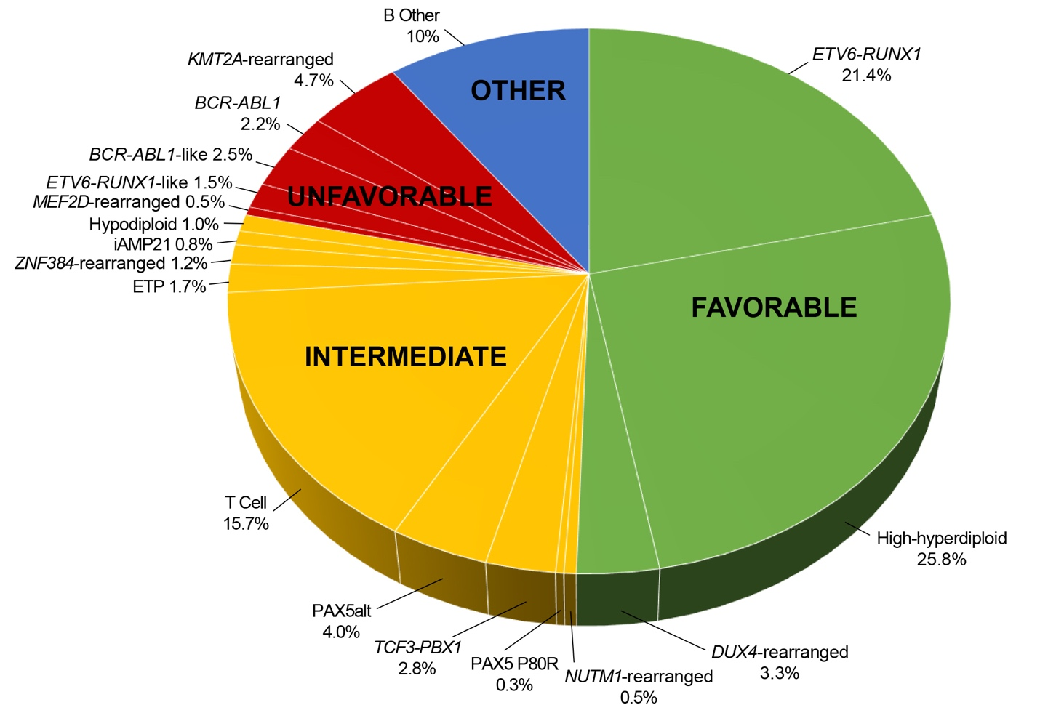

The pie chart depicts the estimated frequencies of each subtypes of ALL among patients treated in St. Jude Total Therapy Study 16. Favorable subtypes had the best 5-year event-free survival rates (95% to 98.4%), intermediate subtypes had intermediate rates (80.0% to 88.2%), and unfavorable subtypes had the worst rates (64.1% to 76.2%). B other comprises cases that could not be classified by cytogenetic, genetic, or transcriptomic analyses.

Supplementary Figure S6. Overall-survival for common leukemia subtypes.

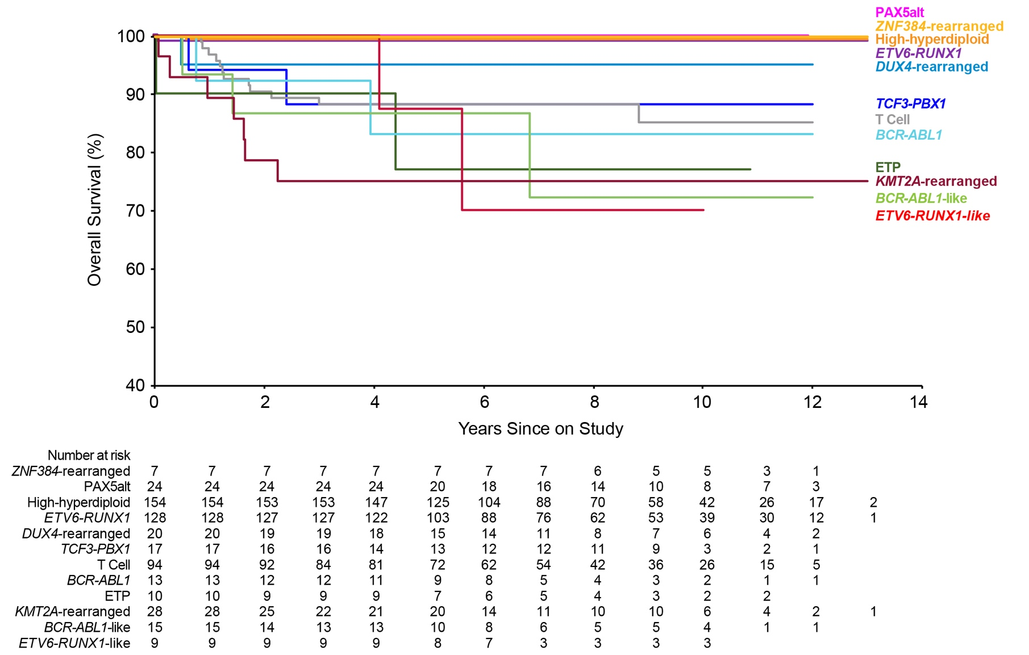

Patients with high-hyperdiploid, ETV6-RUNX1, DUX4-rearranged, PAX5alt, and ZNF384-rearranged ALL had the highest overall survival rates, those with TCF3-PBX1, T-cell and BCR-ABL1 ALL had intermediate survival rates, and patients with ETP, KMT2A-rearranged, BCR-ABL1-like and ETV6-RUNX1-like ALL had the lowest survival rates. Results for some of the subtypes had wide 95% confidence intervals due to small number of patients (see Table 1), and those for iAMP21, hypodiploid, MEF2D-rearranged, NUTM1-rearranged, and PAX5 P80R are not shown due to very small number.

