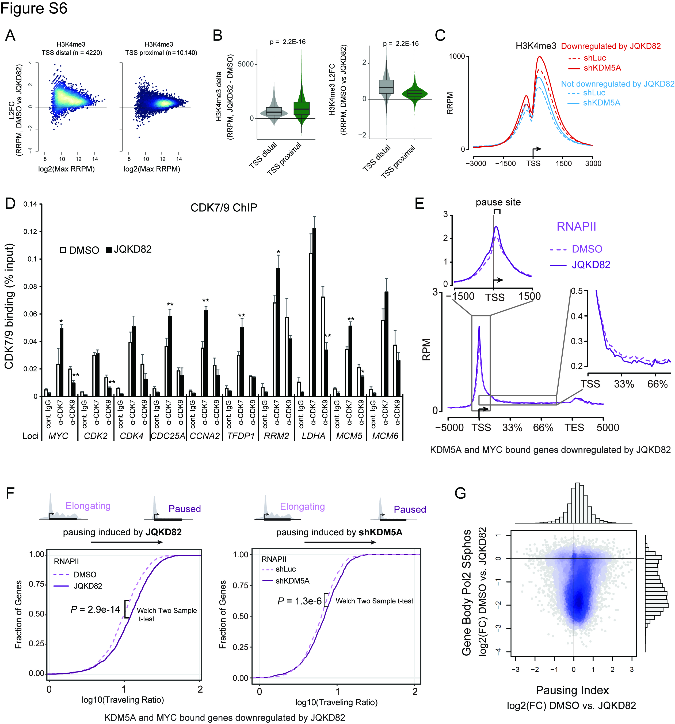
Supplementary Figure S6. Genome-wide H3K4me3 and RNAPII changes after treatment with JQKD82 or knockdown of KDM5A in MM.1S cells
A, MA plots representing global increase in H3K4me3 level after treatment with 1 µM of JQKD82 for 48 h in MM.1S cells. Data are separated into transcriptional start site (TSS) distal (left) and TSS proximal (right). H3K4me3 level was measured by spike-in normalized ChIP-Rx. Color scale indicates degree of overlapping points on the scatter plot, with dark blue showing low-numbers of overlapping points, while white-gold color indicates the greatest amount of point overlap (and, high data density).
B, Absolute increase in H3K4me3 level is greater at TSS proximal sites (combining both -1 nucleosome and +1 nucleosome regions) compared to TSS distal sites after treatment with 1 µM of JQKD82 for 48 h in MM.1S cells. Left shows absolute changes (delta) and on the right shows the log2 fold changes (L2FC). P values were calculated with a two sided t-test with Welch’s correction.
C, ChIP-Rx metagene plot of H3K4me3 signal at TSS for genes downregulated, or not by JQKD82, after knockdown of KDM5A or control shRNA (shLuc) in MM.1S cells.
D, ChIP analysis showing CDK7 or CDK9 occupancy at the MYC target gene loci after treatment with 1 µM of JQKD82 or DMSO for 48 h in MM.1S cells. Normal rabbit IgG was used as negative control for ChIP. Percent recovery over the input was determined by quantitative PCR. Data represent mean ± s.d. of triplicate measurements. *P < 0.05, **P < 0.01 compared with DMSO-treated cells; unpaired Student’s t-test.
E, Distribution of RNAPII to measure pausing/elongation at all genes after 1 µM of JQKD82 or DMSO for 48 h in MM.1S cells
F, Traveling ratio of RNAPII after JQKD82 treatment compared with DMSO treatment (left panel) or after knockdown of KDM5A, compared with control shRNA knockdown (right panel), in MM.1S cells. P value was calcuated using a two sample t-test with Welch’s correction. The TSSR, the transcriptional start site region, begins -30 bp upstream of the TSS and ends 300 bp after the TSS.
G, Scatter Plot of ChIP-seq analysis on RNAPII Ser5p on the gene body versus pausing index after JQKD82 treatment compared to DMSO.

