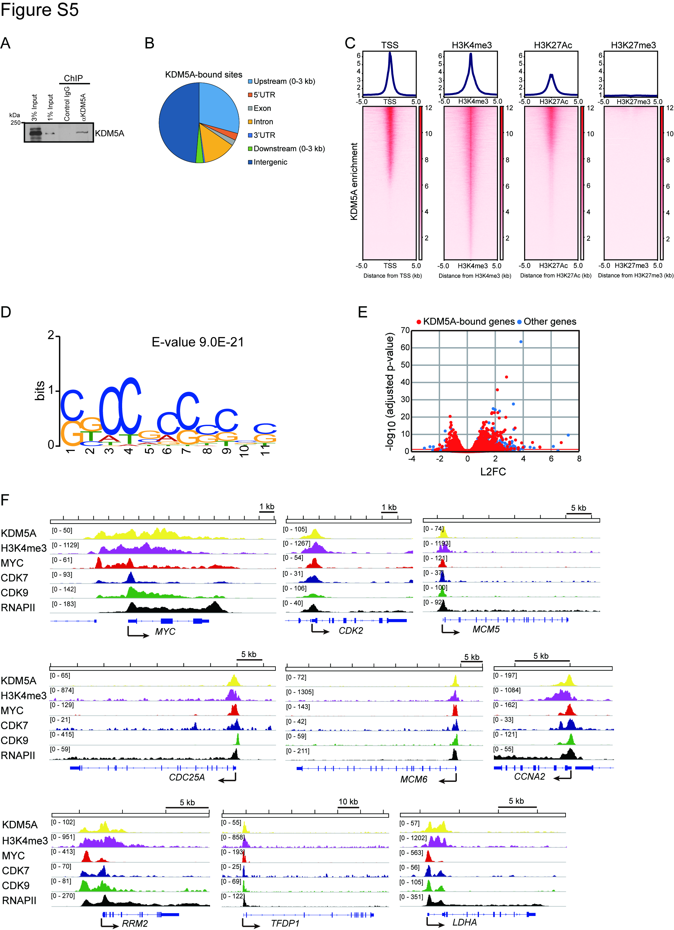
Supplementary Figure S5. Genome-wide localization of KDM5A in MM.1S cells
A, ChIP was carried out with KDM5A antibody (rabbit polyclonal) or control normal rabbit IgG, followed by immunoblot analysis for KDM5A in MM.1S cells.
B, Genome-wide KDM5A-bound sites were determined by ChIP-seq in MM.1S cells. Distribution of KDM5A-bound sites in MM.1S cells.
C, Heatmap representing enrichment of KDM5A around the transcriptional start site (TSS). H3K4me3-, H3K27Ac-, or H3K27me3-marked regions in MM.1S cells. + 5 kb from TSS or each histone modification-marked region is shown.
D, Motif analysis of KDM5A-bound sites (top 200) was performed by MEME_ChIP. Shown is the position-weight matrix of the most enriched motif, which includes KDM5A consensus motif (CCGCCC).
E, Volcano plot depicting the expression changes of KDM5A-bound genes after treatment with JQKD82 at 1 µM for 48h in MM.1S cells, compared with DMSO control. Red indicates KDM5A-bound genes, and blue indicates genes not bound by KDM5A. L2FC = log2 fold change.
F, Gene tracks representing enrichment of KDM5A, H3K4me3, MYC, CDK7, CDK9, and RNAPII at the representative MYC target gene loci in MM.1S cells.

