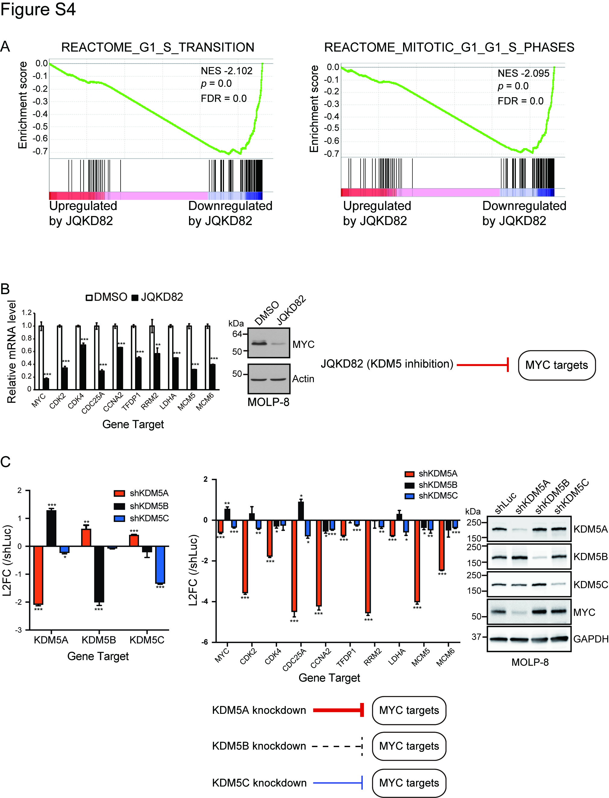
Supplementary Figure S4. KDM5 inhibition or KDM5A knockdown downregulates MYC target genes in MM
A, GSEA plots showing downregulation of cell cycle-related gene expression after treatment with JQKD82 in MM.1S cells. RNA-seq was performed with MM.1S cells treated with 1 µM of JQKD82 for 48 h. n=2 independent biological replicates.
B, Expression levels of representative MYC target genes were assessed by quantitative real-time PCR after treatment with 1 µM of JQKD82 for 48 h in MOLP-8 cells (left panel). Data is normalized against the housekeeping control gene RPLP0. The expression relative to DMSO (control) is shown as mean ± s.d. of triplicate measurements. **P < 0.01, ***P < 0.001 compared with control; unpaired Student’s t-test. Immunoblot analysis for MYC and actin (loading control) after treatment with JQKD82 at 1µM, or DMSO for 48 h in MOLP-8 cells (right panel).
C, Expression levels of representative MYC target genes were assessed by quantitative real-time PCR after transduction of shKDM5A, shKDM5B or shKDM5C in MOLP-8 cells (left panel). The expression relative to shLuc (log₂ fold change, L2FC) is shown as mean ± s.d. of triplicate measurements. *P < 0.05, **P < 0.01, ***P < 0.001 compared with shLuc (control); unpaired Student’s t-test. Immunoblot analysis for KDM5A, KDM5B, KDM5C, MYC and GAPDH (loading control) after transduction of shKDM5A, shKDM5B, shKDM5C or shLuc in MOLP-8 cells (right panel).

