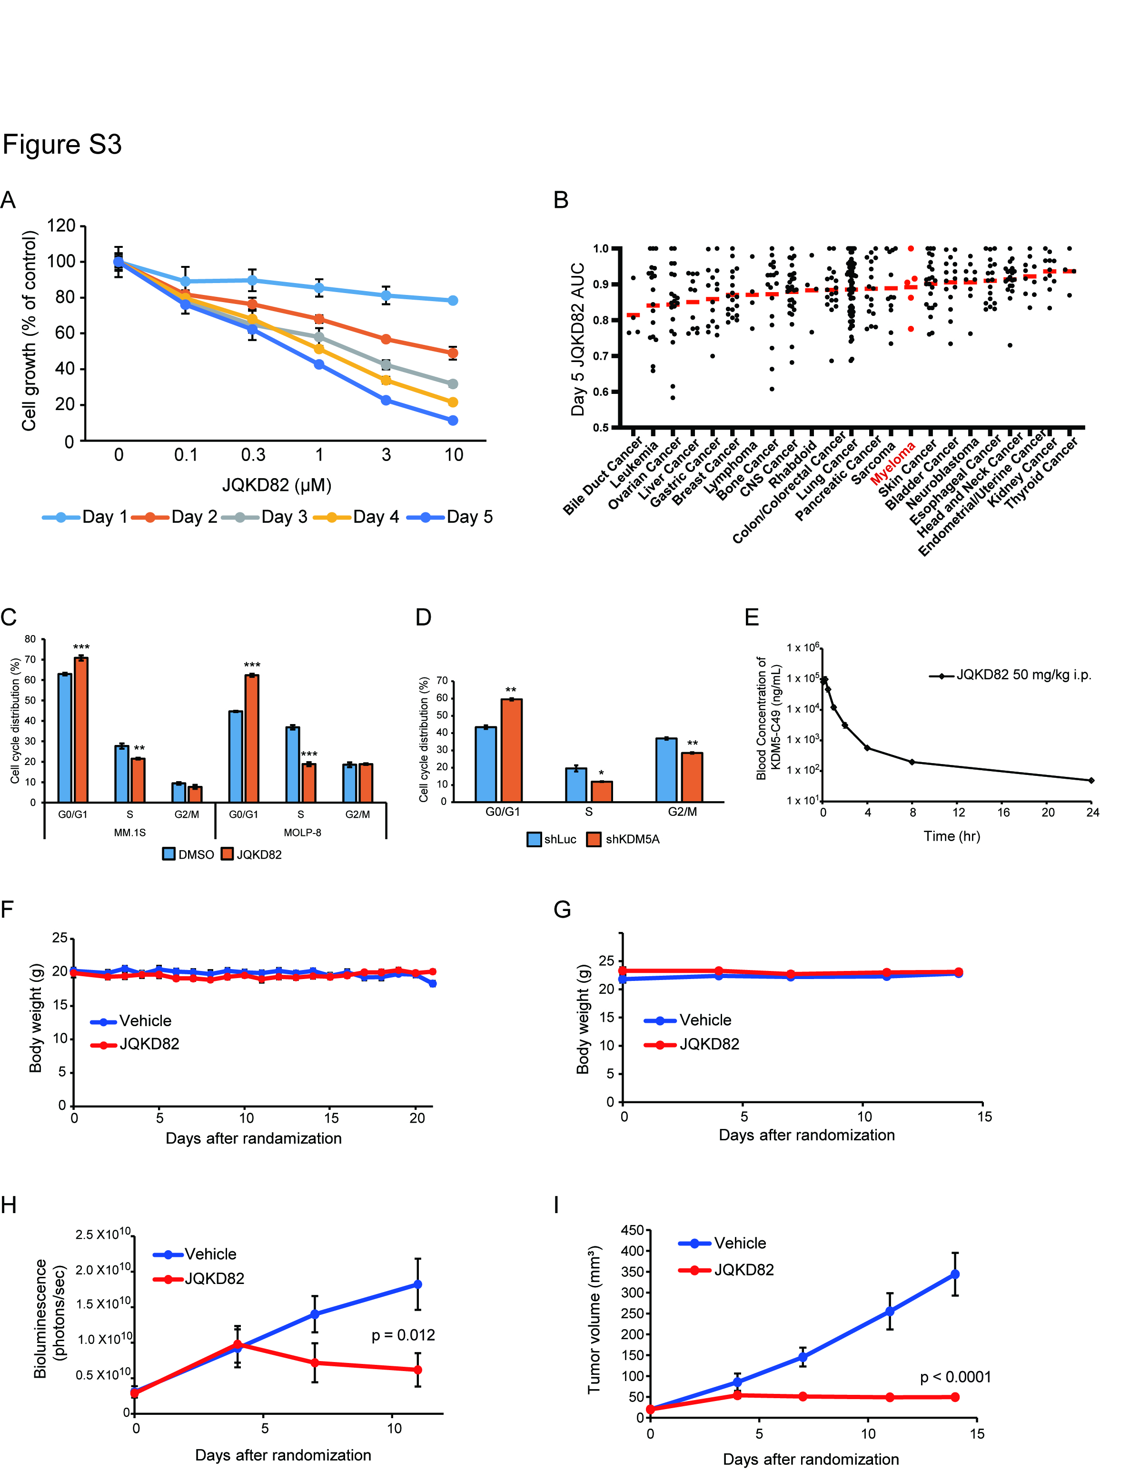
Supplementary Figure S3. JQKD82 inhibits MM cell growth
A, MM.1S cells were cultured with the indicated concentrations of JQKD82 for 1-5 days. Viable cells were determined by MTT assay, and the cell growth relative to untreated control cells are shown. Data represent mean ± s.d. of triplicate cultures.
B, Growth response by PRISM assay of 367 distinct barcoded tumor cell lines in response to a dilution series of JQKD82. n=3 independent measurements for each dose. Assay was performed at day 5 of treatment. Individual dots represent distinct tumor cell lines, stratified by tumor lineage. Bar represents median of area under the curve (AUC) measurement for all treated cell lines in a lineage. Measurements represent the mean of duplicate AUC measurements.
C, MM.1S and MOLP-8 cells were incubated with 1 µM of JQKD82 for 96 h prior to analysis of cell cycle profiles by propidium iodide-flow cytometry.
D, MOLP-8 cells were transduced with shKDM5A or shLuc, and were harvested after 4 days. Cells were fixed, stained with propidium iodide, and analyzed for cell cycle distribution using flow cytometry (C and D). Data represent mean ± s.d. of triplicate (C) or duplicate (D) samples. *P < 0.05, **P < 0.01, ***P < 0.01 compared with control; unpaired Student’s t-test.
E, Pharmacokinetics study of JQKD82. Three CD1 mice were intraperitoneally injected with JQKD82 at 50mg/kg, and blood samples were collected at 0, 0.083, 0.25, 0.5, 1, 2, 4, 8 and 24 h. Shown is blood concentration of KDM5-C49 (active metabolite of JQKD82) measured by quantitative LC/MS/MS at each time point. Data represent mean ± s.d.
F, Body weight of the disseminated MM model mice treated intraperitoneally with JQKD82 at 50 mg/kg or vehicle twice a day for 3 weeks is shown. Data represent mean ± s.e.m. n = 9 per group.
G, Body weight of the plasmacytoma model mice treated intraperitoneally with JQKD82 at 75 mg/kg or vehicle twice a day for 2 weeks is shown. Data represent mean ± s.e.m. n = 10 per group.
H-I, MOLP-8 TurboGFP-Luc cells were subcutaneously injected into NSG mice. After tumor engraftment, the mice were randomized to JQKD82 or vehicle groups, and treated with JQKD82 at 75 mg/kg or vehicle, respectively, by intraperitoneal injection twice a day. Tumor growth was serially evaluated by bioluminescent imaging (BLI) (H) or tumor measurement by calipers (I). n = 10 mice per group. Data represent mean ± s.e.m. p=0.012 (H), p<0.0001 (I) comparing treatment group against control group by unpaired Student’s t-test.

