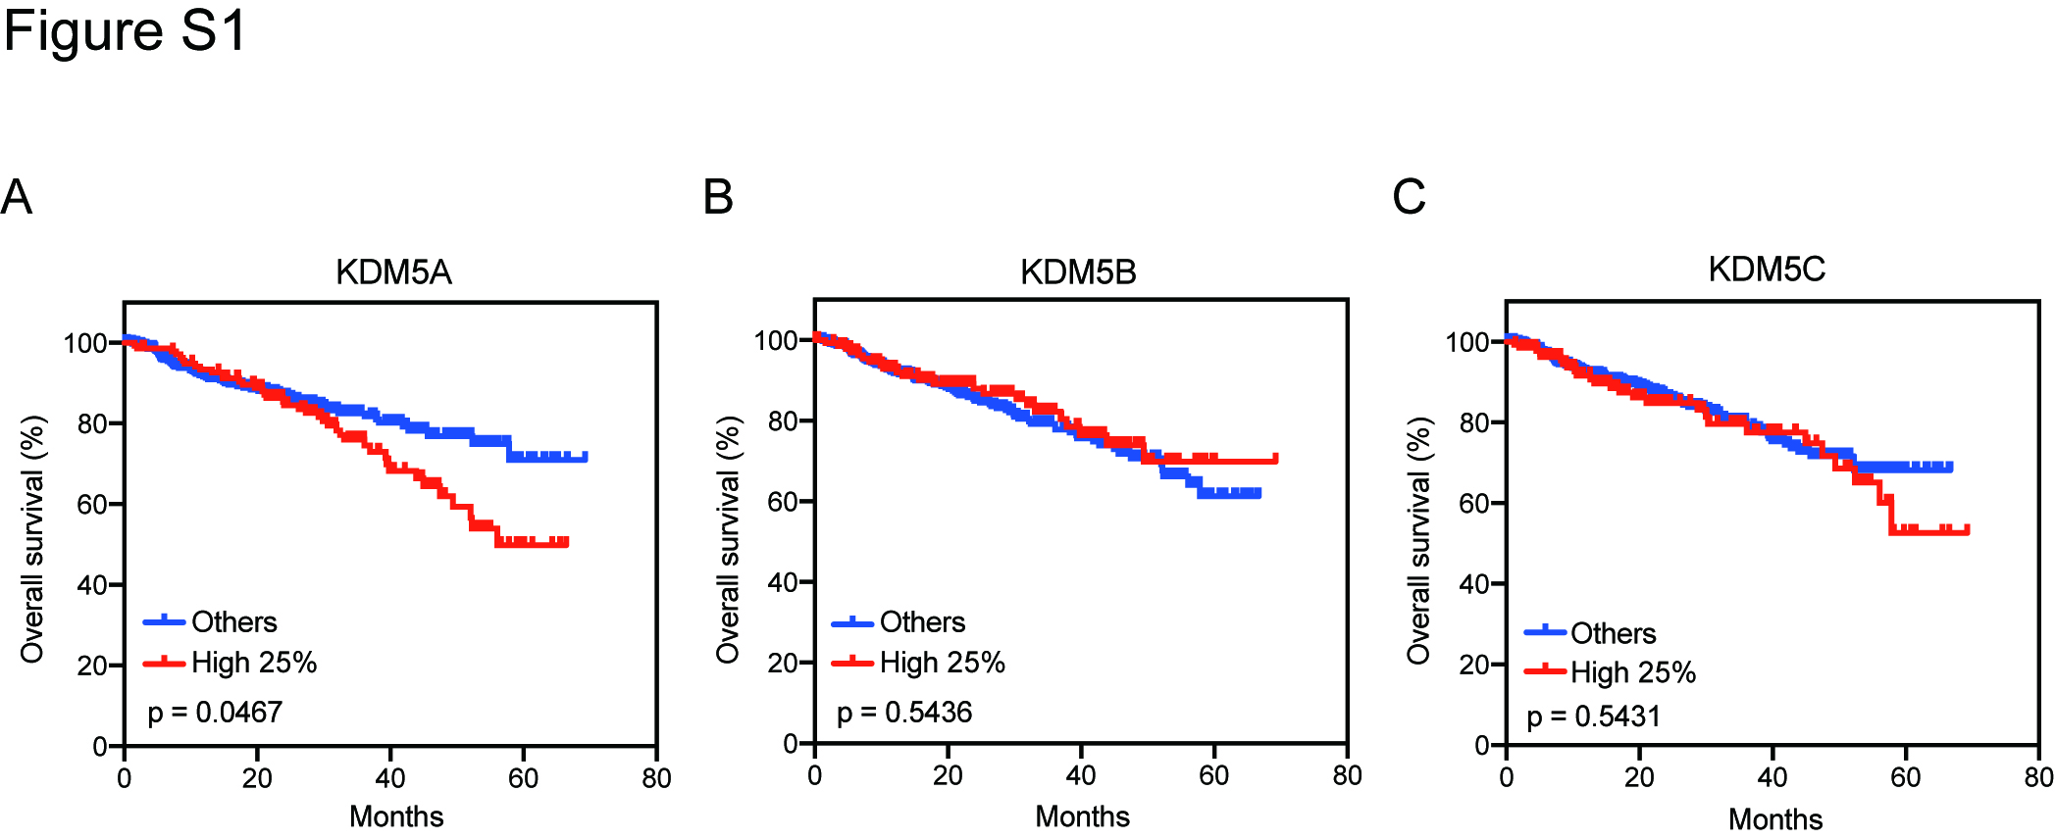
Supplementary Figure S1. Higher KDM5A expression is associated with poor prognosis in MM
A-C, Kaplan-Meier curves comparing overall survival of newly diagnosed MM patients based on KDM5A (p=0.0467) (A), KDM5B (p=0.5436) (B), KDM5C (p=0.5431) (C) expression (GSE2658, n = 559). Data was analyzed by the log-rank test.

